TELECOM CUSTOMER CHURN PREDICTION
A Machine Learning Classification Study

Group Tango
AI/ML Capstone Project
Tutor: Dami
Dataset: Maven Analytics Telecom Customer Churn (IBM Cognos Source)
2026

1. Introduction
Customer churn: The phenomenon whereby customers discontinue their relationship with a service provider represents one of the most significant and measurable risks in the telecommunications industry. For telecom companies that invest heavily in customer acquisition, retaining an existing customer is substantially more cost-effective than acquiring a new one. Studies consistently estimate that acquiring a new customer costs five to seven times more than retaining an existing one.
This project applies supervised machine learning to predict whether a telecom customer will churn, using demographic, service, and billing data. By identifying at-risk customers early, businesses can deploy targeted retention strategies, personalised offers, service upgrades, or proactive support before the customer decides to leave.
The dataset used is the Maven Analytics Telecom Customer Churn dataset, originally sourced from IBM Cognos Analytics and made available under a Public Domain licence on Kaggle. It contains records for 7,043 customers of a fictional telecommunications company operating in California, United States.
Two classification models are trained and compared: a Random Forest classifier and a Logistic Regression model. Model performance is evaluated using Accuracy, Precision, Recall, F1-Score, and AUC-ROC. The study also examines the ethical and governance dimensions of deploying an AI churn prediction system.

2. Dataset Description
Source: Maven Analytics / IBM Cognos Analytics | Licence: Public Domain | Platform: Kaggle
The dataset comprises 7,043 customer records and 38 features. These features span five broad categories:
- Demographics: Gender, Age, Married, Number of Dependents
- Location: City, Zip Code, Latitude, Longitude (dropped before modelling - too granular)
- Service Subscriptions: Phone Service, Multiple Lines, Internet Service, Internet Type, Online Security, Online Backup, Device Protection Plan, Premium Tech Support, Streaming TV, Streaming Movies, Streaming Music, Unlimited Data
- Account & Billing: Contract type, Payment Method, Paperless Billing, Monthly Charge, Total Charges, Total Revenue, Total Refunds, Total Long Distance Charges, Total Extra Data Charges
- Outcome: Customer Status (Stayed / Churned / Joined), Churn Category, Churn Reason
The dataset was selected for its richness of features, realistic business structure, and public availability with no privacy concerns. The fictional California-based company provides a realistic analogue for churn analysis, though findings are acknowledged to carry geographic limitations.

3. General Dataset Information & Suitability Assessment
Upon initial inspection, the dataset was confirmed suitable for binary classification with the following verified properties:
- Shape: 7,043 rows and 38 columns
- Duplicate rows: 0 (confirmed)
- Target variable (Customer Status): Three classes, Stayed (67.0%), Churned (26.5%), Joined (6.4%)
- Binary target created: Churn = 1 (Churned), Churn = 0 (Stayed or Joined)
- Churn rate: 26.5%, a realistic and meaningful rate for classification
- Anomaly found: 120 rows had negative Monthly Charge values (minimum = -10.0), likely billing credits. These were clipped to 0.
The dataset is well-suited for this capstone task. It is large enough for meaningful model training (4,930 training records), sufficiently rich in features (demographics, services, billing), and contains a realistic churn rate that makes the classification problem non-trivial.

4. Missing Values, Anomalies & How They Were Handled

4.1 Missing Values
Missing values were found in six column groups. None were random, all had a clear structural explanation:
- Offer (3,877 missing, 55.1%): Customers on no promotional offer. Filled with "No Offer".
- Internet Type and 8 internet-service columns (1,526 missing, 21.7%): Customers with no internet subscription. Confirmed by cross-checking with Internet Service = "No". Filled with "No Internet".
- Avg Monthly Long Distance Charges and Multiple Lines (682 missing, 9.7%): Customers with no phone service. Charges filled with 0; Multiple Lines filled with "No Phone".
- Churn Category and Churn Reason (5,174 missing): These columns are only populated for churned customers and carry post-event information. They were dropped entirely before modelling to prevent data leakage.

4.2 Anomalies
- Negative Monthly Charge: 120 rows had Monthly Charge below zero (min = -10.0). Interpreted as billing credits. Clipped to 0 using .clip(lower=0).
- No null values remained after cleaning.

4.3 Duplicates
Zero duplicate rows were found in the dataset. No action was required.

5. Exploratory Data Analysis (EDA)

5.1 Customer Status Distribution
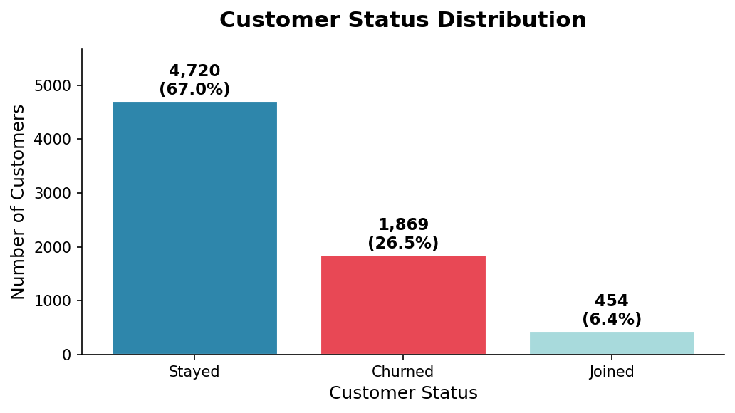
Figure 1: Customer Status Distribution - Stayed (67.0%), Churned (26.5%), Joined (6.4%)
The churn rate of 26.5% is substantial and economically significant. The moderate class imbalance (roughly 73% non-churned vs 27% churned) means the model must be evaluated on Recall and F1-Score for the churned class, not just overall accuracy.

5.2 Churn Rate by Contract Type
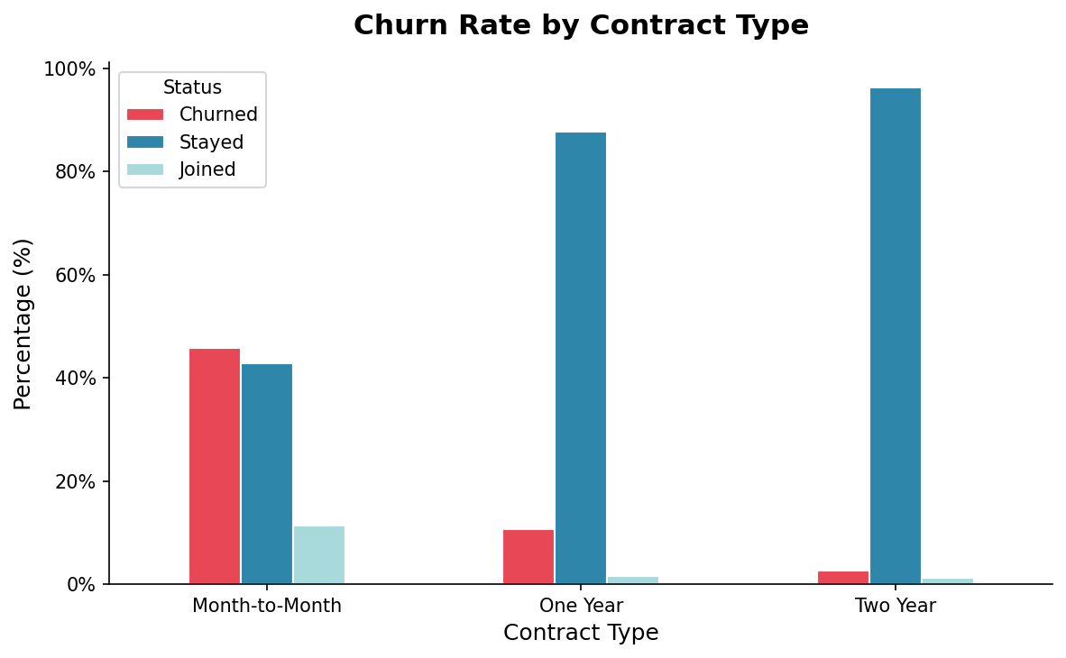
Figure 2: Churn Rate by Contract Type - Month-to-Month contracts drive the highest churn
Month-to-month customers churn at a dramatically higher rate than those on annual or two-year contracts. This is the single most actionable business insight: incentivising customers to commit to longer contracts is a direct churn-reduction strategy.

5.3 Monthly Charge Distribution (Outlier Boxplot)
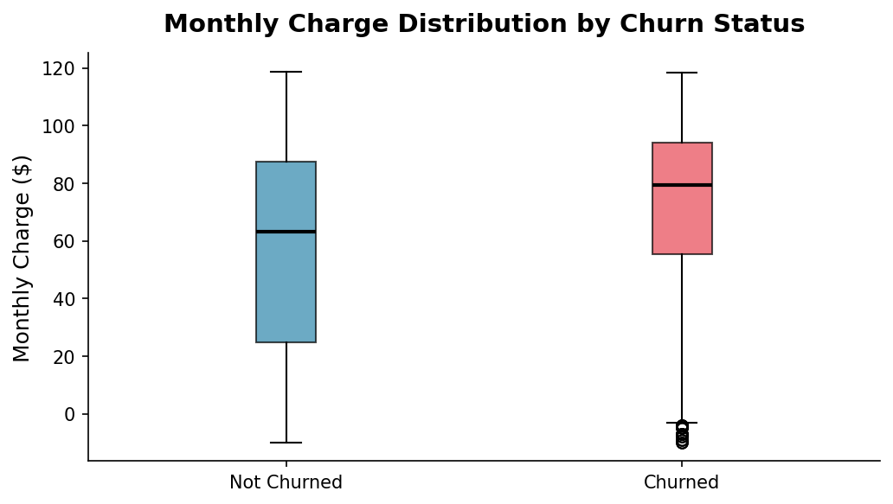
Figure 3: Boxplot of Monthly Charge by Churn Status - higher charges correlate with churn
Churned customers show a higher median monthly charge and a tighter interquartile range at the upper end, suggesting that customers on premium pricing plans are the most price-sensitive and most likely to leave. Dots beyond the whiskers are statistical outliers but represent real business scenarios (premium plan customers) and were retained.

5.4 Correlation Heatmap: Multicollinearity Check
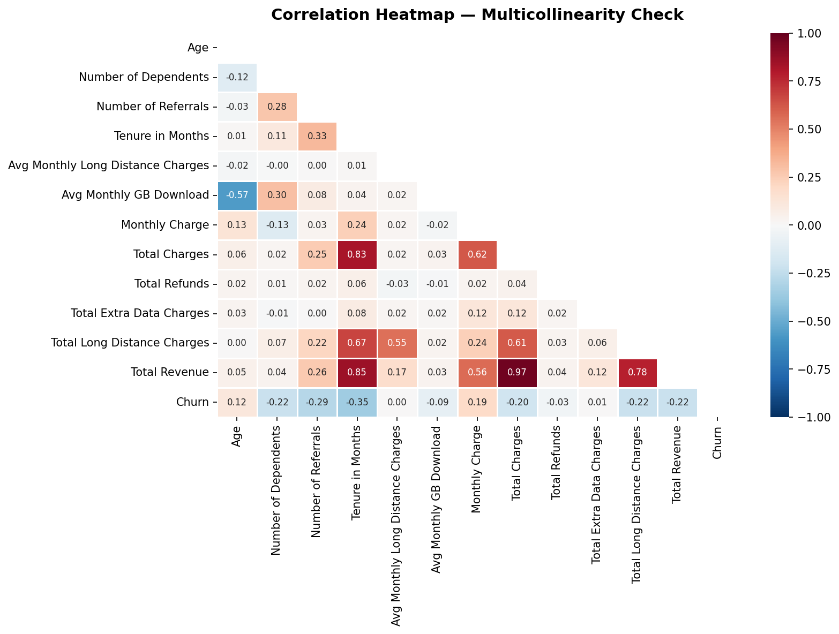
Figure 4: Correlation Heatmap - lower triangle only; red = positive, blue = negative correlation
Key observations from the correlation matrix:
- Total Charges and Total Revenue are near-perfectly correlated (+0.99). To reduce multicollinearity, Total Charges was dropped and Total Revenue was retained.
- Tenure in Months is negatively correlated with Churn (-0.35): longer-tenured customers churn less.
- Monthly Charge is positively correlated with Churn (+0.19): higher bills drive churn.
- Number of Referrals is negatively correlated with Churn (-0.29): satisfied customers who refer others rarely leave.

5.5 Tenure Distribution by Churn
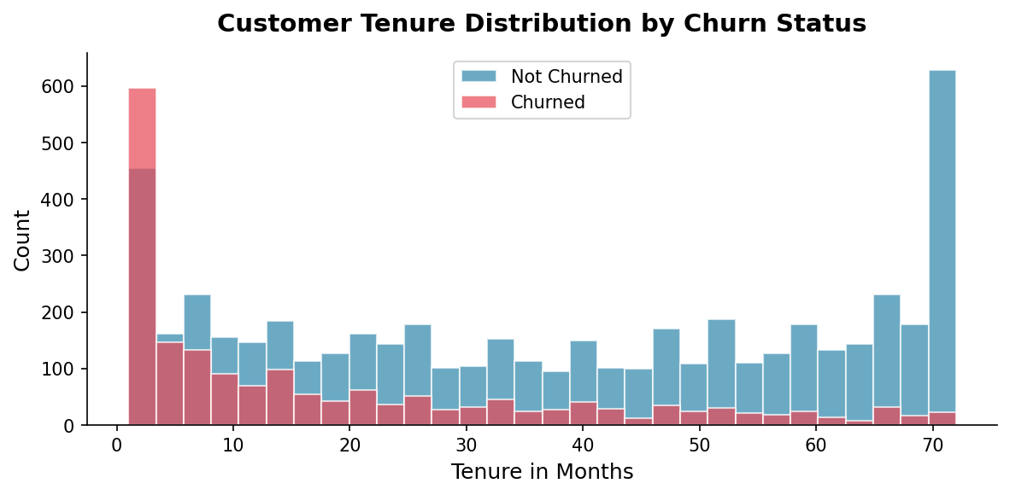
Figure 5: Tenure distribution - most churn occurs within the first 12 months
The histogram confirms that churn is heavily front-loaded. The majority of churned customers leave within their first 12 months of service. This points to the critical importance of early-tenure engagement and onboarding quality.

5.6 Scatter Plot: Age vs Monthly Charge (Range, Clusters & Extreme Points)
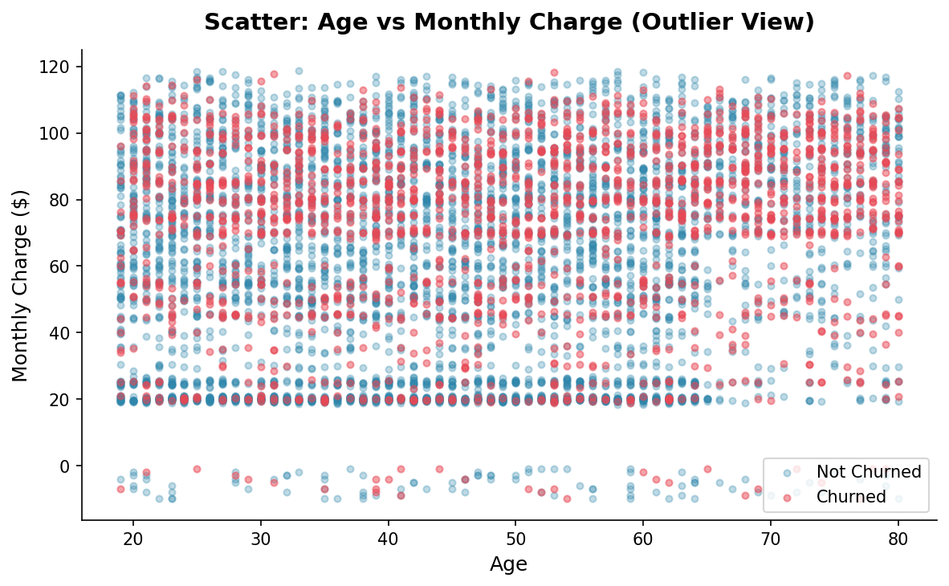
Figure 6: Scatter plot showing range, clusters, skew and extreme points
The scatter plot reveals that churned customers (red) cluster heavily in the higher monthly charge range across all age groups. There is no single age group that disproportionately drives churn. It is the price level, not age, that distinguishes churners. No extreme outlier clusters distort the overall picture.

5.7 Outlier Detection: Boxplots for Key Numeric Features
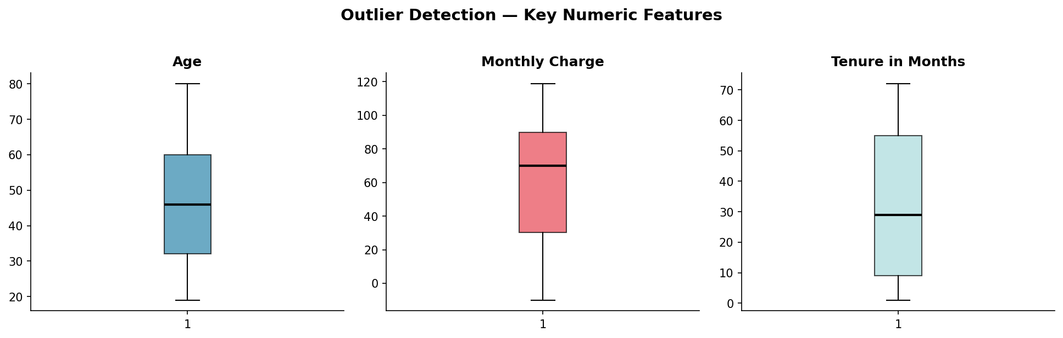
Figure 7: Boxplots for Age, Monthly Charge, and Tenure in Months
Age (range 19-80) and Tenure (range 1-72 months) show symmetric distributions with no extreme outliers. Monthly Charge shows a small number of high-value outliers consistent with premium-tier plans; these were retained as they represent real customer segments.

5.8 Churn Rate by Internet Type (Sorted Bar Chart)
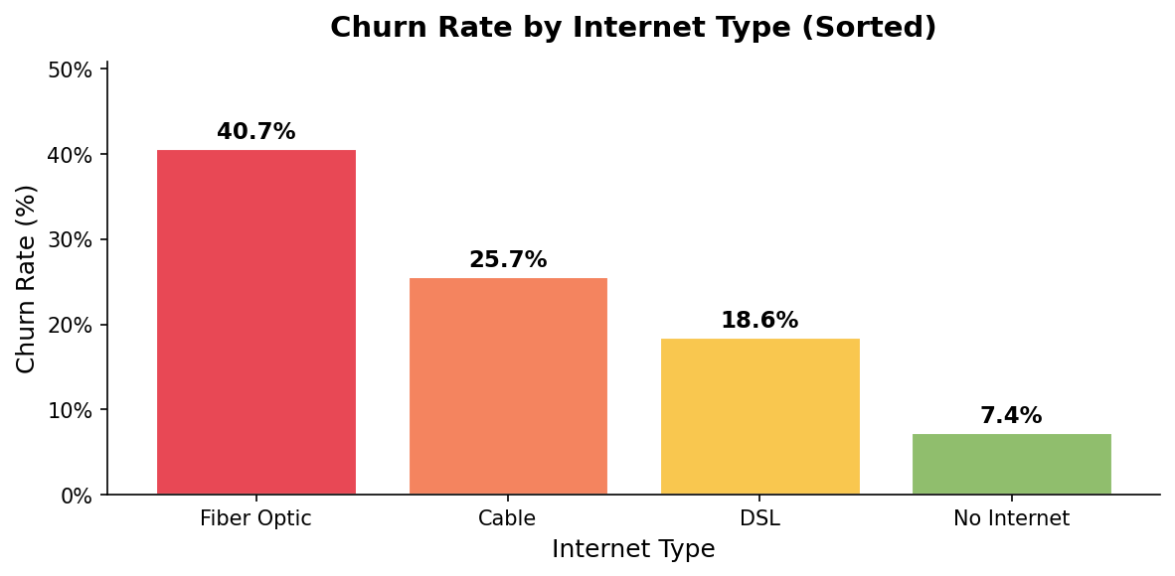
Figure 8: Churn rate by Internet Type - Fibre Optic customers churn most
Fibre Optic internet customers churn at the highest rate despite subscribing to the premium internet service tier. This counterintuitive finding suggests service quality or pricing issues specific to the Fibre Optic product. No Internet customers churn at the lowest rate, likely because they have fewer alternatives and lower spend.

6. Feature Engineering
Three new features were engineered from existing columns to give the model richer predictive signals:
- Revenue Per Month: Total Revenue divided by Tenure in Months. This captures average monthly spend efficiency across a customer's full lifecycle, providing a more stable signal than Monthly Charge alone.
- Service Count: Count of add-on services subscribed (out of 7 options: Online Security, Online Backup, Device Protection Plan, Premium Tech Support, Streaming TV, Streaming Movies, Streaming Music). A higher service count indicates deeper product engagement and is hypothesised to correlate with lower churn.
- Is Senior: Binary flag (1 = Age 65 or above, 0 = below 65). Created to test whether senior customers show distinct churn behaviour, which has implications for inclusive service design.

7. Encoding Categorical Variables
All text-based (categorical) columns were converted to numeric format using One-Hot Encoding. This method creates a separate binary (0/1) column for each unique category value.
One-Hot Encoding was chosen over Label Encoding because the categorical columns in this dataset are nominal. They have no natural numeric order (e.g., Month-to-Month, One Year, and Two Year are contract types, not a ranking). Label encoding would incorrectly impose an ordinal relationship that does not exist, potentially misleading the model.
The drop_first=True parameter was applied to remove one redundant column per feature, avoiding the multicollinearity that arises when all dummy variables are present simultaneously. After encoding, the dataset expanded from 29 model features to the full encoded representation used for training.

8. Feature Scaling: Standardisation vs Normalisation

8.1 Standardisation (Z-Score)
Transforms each value using: (x - mean) / std. The result has mean = 0 and standard deviation = 1. It is robust to outliers and preferred for models sensitive to feature magnitude.

8.2 Normalisation (Min-Max)
Scales values to the range [0, 1] using: (x - min) / (max - min). It is highly sensitive to extreme outliers. One very large value compresses all others toward 0.

8.3 Choice for This Project
Standardisation was applied. The dataset contains some high-value outliers in Monthly Charge and Total Revenue. Logistic Regression (one of our two models) is sensitive to feature scale, and standardisation is the appropriate choice when outliers are present. Random Forest is scale-invariant (tree-based), so standardisation does not harm it.
Critical: The StandardScaler was fitted exclusively on training data, then applied (transform only) to validation and test sets. Fitting the scaler on all data would constitute data leakage, allowing test information to influence the preprocessing and would produce artificially inflated reported accuracy.

9. Feature Selection

9.1 Correlation with Target
Each numeric feature was correlated with the binary Churn target using Pearson correlation (computed on training data only). Key findings: Tenure in Months (-0.35), Number of Referrals (-0.29), Monthly Charge (+0.19), and Age (+0.12) showed the strongest linear associations with churn.

9.2 Mutual Information (Univariate Scores)
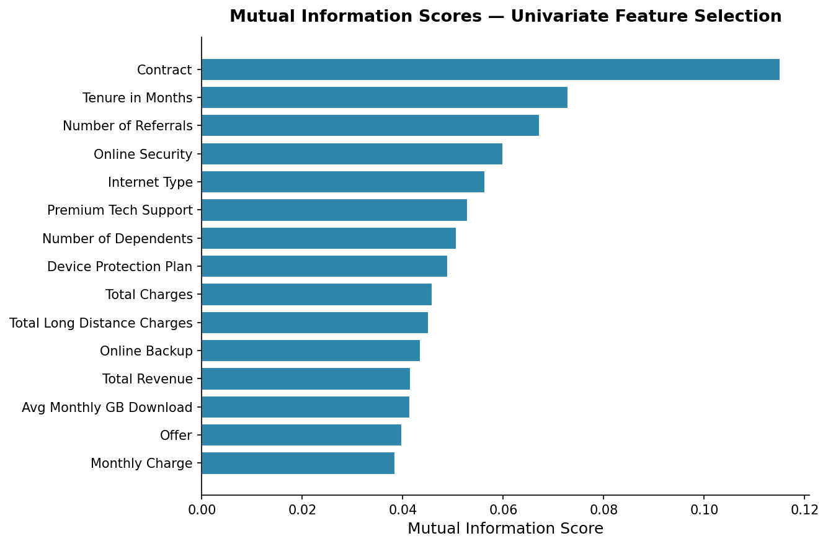
Figure 9: Mutual Information scores - top 15 features ranked by non-linear association with Churn
Mutual information captures non-linear relationships between features and the target, complementing the linear correlation analysis. Features ranking highly on both methods were confirmed as strong predictors. Features with near-zero scores on both metrics were considered for removal.

9.3 Feature Selection Decision
Total Charges was dropped due to near-perfect multicollinearity with Total Revenue (+0.99). Customer ID, City, Zip Code, Latitude, Longitude, Churn Category, and Churn Reason were removed at the preprocessing stage for reasons of irrelevance or data leakage. All remaining features were retained and passed to the model, as Random Forest handles internal feature importance natively and is robust to weakly predictive inputs.

10. Three-Way Train / Validation / Test Split
Following AI governance best practice (as advised by Dr. Segun Latinwo, TechForward Impact AI Fellowship), the dataset was divided into three non-overlapping sets:
- Training Set (70%): 4,930 records. The model learns patterns from this data.
- Validation Set (15%): 1,056 records. Used to tune models and select the best performer without touching test data.
- Test Set (15%): 1,057 records. Used only once at the end to report final unbiased performance.
stratify=y was applied at both split stages to ensure each set maintains the same proportion of churned vs non-churned customers (approximately 26.5% churn rate in all three splits). This is especially important with moderately imbalanced classes.
This three-way split prevents the most common evaluation error in machine learning: reporting test performance figures that have been unknowingly influenced by model development decisions made while observing the test set.

11. Model Training & Results

11.1 Models Used
- Random Forest Classifier: An ensemble of 100 decision trees (n_estimators=100). Handles non-linear relationships, mixed feature types, and is naturally resistant to overfitting. Does not require feature scaling.
- Logistic Regression: A linear probabilistic classifier (max_iter=1000). Simpler and highly interpretable; serves as a baseline for comparison. Requires scaled input features.

11.2 Feature Importance (Random Forest)
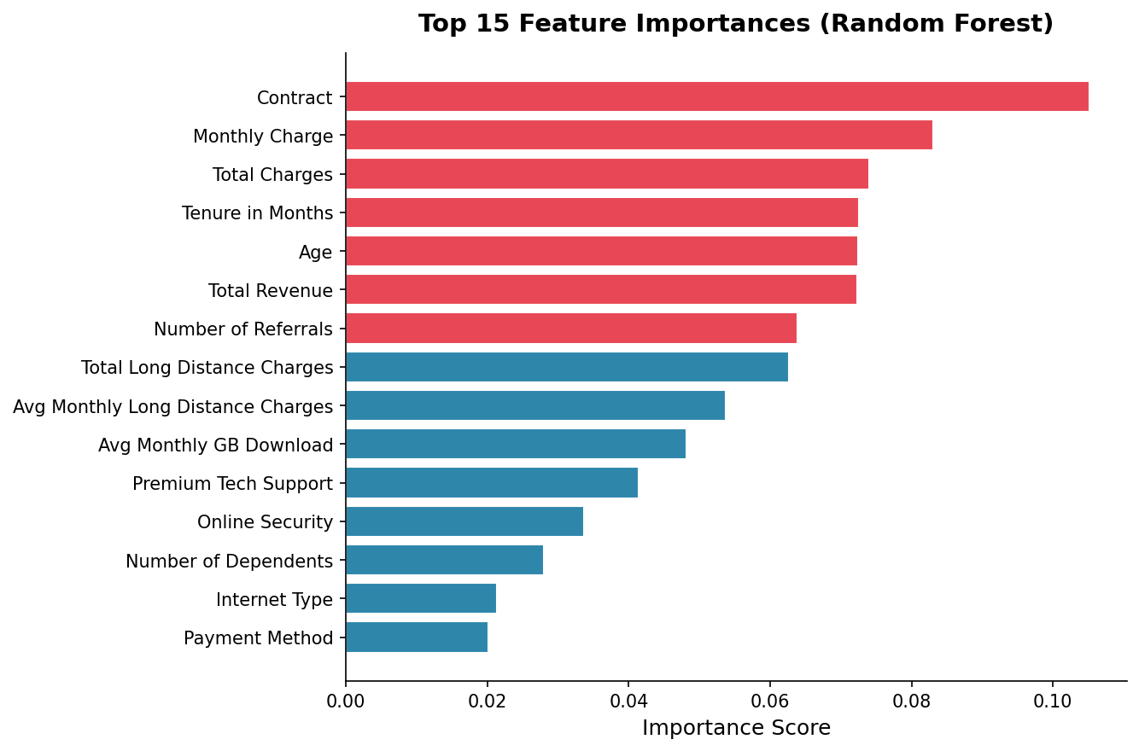
Figure 10: Top 15 feature importances from the Random Forest model (red = above median importance)
Tenure in Months, Total Revenue, Monthly Charge, and Number of Referrals were the strongest predictors of churn consistent with the correlation and mutual information analyses. Service-related features (Contract type, Internet Type) also ranked highly, confirming the EDA findings.

11.3 Confusion Matrices
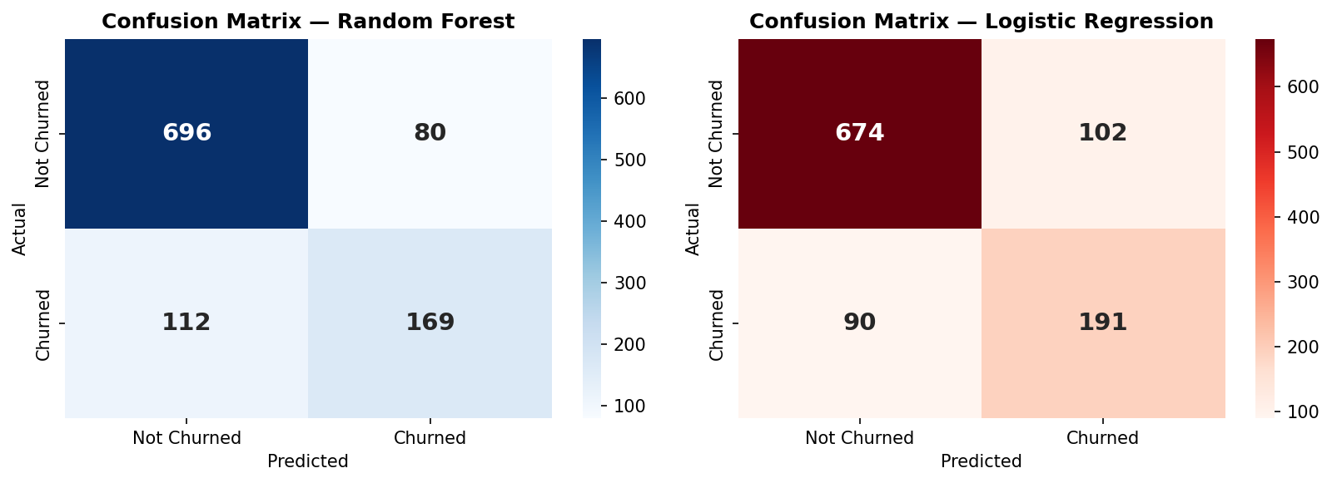
Figure 11: Confusion matrices for Random Forest (left) and Logistic Regression (right) on the test set
The confusion matrices reveal that both models perform better at identifying non-churners (higher True Negative counts) than churners. Logistic Regression captures more actual churners (higher True Positives, lower False Negatives), making it preferable for a retention-focused use case where missing a churner is the costliest error.

11.4 ROC Curves
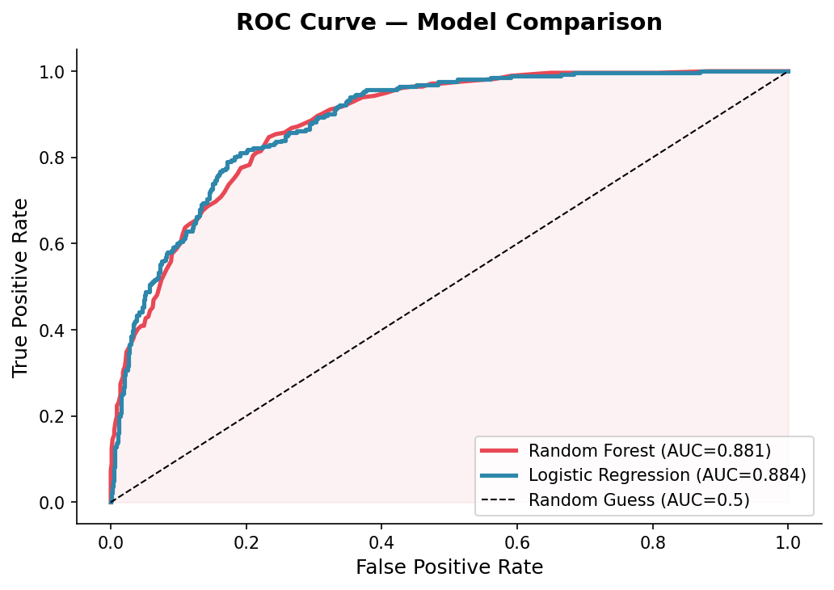
Figure 12: ROC curves - both models substantially outperform random guessing
Both models achieve AUC scores above 0.88, indicating strong discriminative ability substantially better than the 0.5 baseline of random guessing. The curves are nearly identical in performance, confirming that both models have learned meaningful patterns from the data.

11.5 Final Performance Metrics
Metric | Random Forest | Logistic Regression
Validation Accuracy | 83.14% | 81.44%
Test Accuracy | 81.84% | 81.84%
AUC (ROC) | 0.881 | 0.884
Precision (Churned) | 0.68 | 0.65
Recall (Churned) | 0.60 | 0.68
F1-Score (Churned) | 0.64 | 0.67
Training Records | 4,930 | 4,930
Validation Records | 1,056 | 1,056
Test Records | 1,057 | 1,057
Table 1: Verified model performance metrics across validation and test sets

12. Key Insights
- Month-to-month contract holders churn at a far higher rate than annual or two-year contract holders. Incentivising longer commitments is the single most impactful retention lever.
- Churn risk is highest in the first 12 months of a customer's tenure. Early-stage engagement and onboarding programmes could significantly reduce churn.
- Fibre Optic internet customers. Despite subscribing to the premium service tier, churn at the highest rate. This signals a product-quality or pricing disconnect that warrants further investigation.
- Higher monthly charges are strongly associated with churn. Price-sensitive customers on premium plans represent the highest-risk segment.
- Customers who make referrals rarely churn. Referral programmes can simultaneously grow the customer base and improve retention.
- Both models achieve approximately 82% test accuracy and AUC of 0.88+. Logistic Regression has a slight edge on Recall for churned customers (0.68 vs 0.60), making it the preferred model for a retention-first deployment.

13. Ethics, AI Governance & Data Representation

13.1 Transparency
The dataset is publicly available under a Public Domain licence (Maven Analytics / IBM Cognos Analytics). It contains no real personal data; the company and customers are fictional. All preprocessing decisions are fully documented and reproducible via the accompanying Google Colab notebook.

13.2 Fairness
Gender and marital status were examined for disproportionate churn rates. Neither was used as a model feature. Any deployment of this model in a real telecom environment should include a fairness audit to ensure that predictions do not systematically disadvantage any demographic group, particularly protected characteristics under applicable data protection legislation.

13.3 Data Representation
This dataset reflects a single fictional California-based telecom provider. Customer behaviour, pricing structures, and service expectations differ significantly across geographies particularly between Western and African telecom markets. Results should not be applied directly to Nigerian or other African telecom contexts without validating on locally representative data. The underrepresentation of African datasets in global ML benchmarks is a recognised and active concern in AI governance literature.

13.4 Accountability
Automated decision-making based solely on churn probability scores is discouraged. Model predictions should trigger proactive human-reviewed retention interventions, personalised offers, service reviews, or support outreach, not automated service termination or penalty actions. Regular model audits (every three to six months) are recommended to detect performance drift and emerging bias.

13.5 Class Imbalance
The 26.5% churn rate creates a moderate class imbalance. The model naturally sees more non-churners, which can bias it toward predicting no-churn. For future work, techniques such as SMOTE (Synthetic Minority Oversampling Technique) or applying class_weight="balanced" in Logistic Regression should be explored to improve Recall for the churned minority class.

14. Limitations
- The dataset is fictional and based on a single California telecom provider. Findings may not generalise to other markets.
- The model was trained on a static snapshot, it does not capture how customer behaviour evolves over time.
- Class imbalance (26.5% churn) means the model struggles more with identifying churners than non-churners. Recall for the churned class (0.60–0.68) leaves room for improvement.
- Location features (City, Zip Code, Latitude, Longitude) were dropped due to granularity. Geographic clustering analysis could provide additional insights.
- No hyperparameter tuning (e.g. GridSearchCV) was applied. Tuning could improve model performance.

15. Conclusion & Recommendations
This study successfully demonstrated that machine learning can predict telecom customer churn with meaningful accuracy. Both Random Forest and Logistic Regression achieved approximately 82% test accuracy and AUC scores of 0.88, substantially outperforming random guessing. Logistic Regression is the recommended model for deployment due to its higher Recall on churned customers (0.68), better interpretability, and suitability for a retention-first business objective.
The analysis identified contract type, tenure, monthly charge, and internet type as the four most actionable predictors of churn. Month-to-month customers and Fibre Optic subscribers represent the highest-risk segments and should be prioritised for retention campaigns.
From a governance perspective, this project demonstrates that responsible AI deployment requires not only technical accuracy but also transparency in data sourcing, fairness in feature selection, and human oversight in decision-making. The ethical framework applied here provides a template for responsible churn prediction in commercial telecom settings.

Recommendations
- Deploy Logistic Regression as the production model, using a 0.5 probability threshold as the default churn trigger, adjustable based on business cost tolerance.
- Prioritise retention outreach for month-to-month customers in their first 12 months of tenure.
- Investigate service quality issues for Fibre Optic customers. Their high churn rate despite premium pricing is a critical business signal.
- Implement a referral incentive programme to leverage the strong negative correlation between referrals and churn.
- Validate the model on Nigerian or African telecom data before any regional deployment.
- Re-train the model every six months as customer behaviour evolves.

16. References
Maven Analytics (2022). Telecom Customer Churn Dataset. Available at: https://www.kaggle.com/datasets/shilongzhuang/telecom-customer-churn-by-maven-analytics [Public Domain]
Breiman, L. (2001). Random Forests. Machine Learning, 45(1), 5–32.
Cox, D. R. (1958). The regression analysis of binary sequences. Journal of the Royal Statistical Society, Series B, 20(2), 215–242.
Pedregosa, F. et al. (2011). Scikit-learn: Machine Learning in Python. Journal of Machine Learning Research, 12, 2825–2830.
Fawcett, T. (2006). An introduction to ROC analysis. Pattern Recognition Letters, 27(8), 861–874.
Mehrabi, N. et al. (2021). A Survey on Bias and Fairness in Machine Learning. ACM Computing Surveys, 54(6), 1–35.
Nigeria Data Protection Act (2023). Federal Republic of Nigeria Official Gazette.

