Research Repository: Storing Research Artifacts in GitHub
Compliance & Risk one-pager

What we're asking
Confirmation that we may store the following research artifacts in our existing GitHub repository:
- Qualitative research data — notes, observations, open-ended responses, and transcripts (transcripts go through the approved PII-stripping process before entry)
- Quantitative research data — survey responses and structured numeric data
- Synthesized findings — deliverables produced from the above, such as findings memos, theme summaries, and hypothesis docs

How Claude and GitHub work together
- Claude — Anthropic's AI assistant. It produces text outputs (analysis, summaries, drafts) by following instructions and reading the inputs we provide.
- Skills — reusable instruction sets, written in plain text and managed like code, that tell Claude how to perform a specific research task the same way every time.
- GitHub — a version-controlled file repository with access controls, a full change history, and audit logs. Already approved at our standard for code storage.
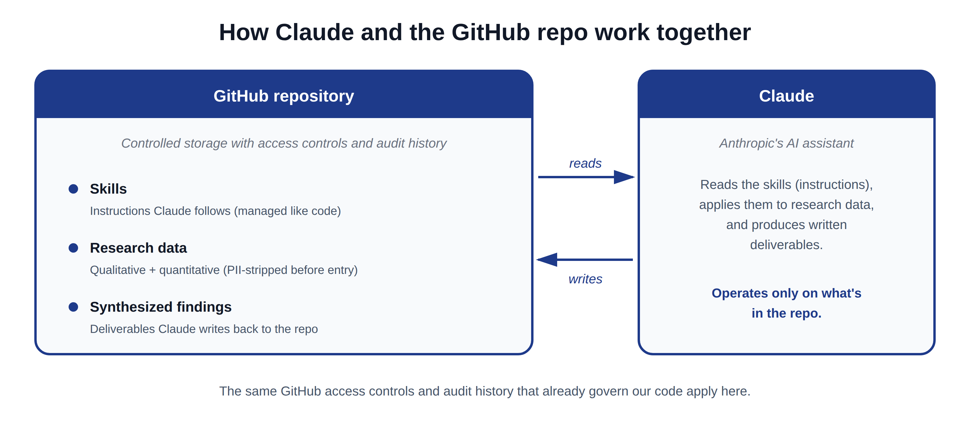

What is already approved (not part of this ask)
- GitHub as a storage location — covered by existing code-storage policy.
- Skills — instructions written like code that tell Claude how to perform a specific research task the same way every time. These fall under the same code-storage policy.
- The PII-stripping process — the process applied to transcripts before they enter the repo is already defined and approved.

What we will not store
- Video recordings of research sessions
- Audio recordings of any kind
- Anything containing PII — no raw transcripts or notes enter the repo until they have been through the approved stripping process

Why this fits within existing controls
- GitHub's access controls and audit history are already approved at our standard — the same controls that already govern our code.
- Quantitative data and synthesized findings are non-personal by design.
- Transcripts are sanitized through an approved process before entering the repo.
- Excluding video and audio removes the highest-risk artifact types.
- Centralizing inputs, methodology (skills), and outputs in one repo gives us a single auditable record per study.

Scope at a glance
