Case Study

IDM 232: Scripting II

**─**

Samiha Shoshi

12/08/2022

# Overview

This case study discusses the process I went through when creating Kazi’s Kitchen. I was introduced to PHP (Hypertext Preprocessor) and SQL and had to apply what I already knew about coding to create a website that connected to a database to auto populate information. I will talk about the design choices I made and the steps I had to take to successfully code what I had planned to do for Kazi’s Kitchen. For the final project, I was able to code my website using HTML, CSS, JavaScript, PHP and SQL.

# Context and Challenges

This was a project I worked on for my IDM 232 Scripting II class during the Fall 2022 term. In this class, I learned about what PHP is, the importance of it, the logic of how it works front- and back-end, as well as its structure. We learned how to create and use a database, and write code to add functions like create, edit, delete to the admin side of the website. As well as functions like the search and auto-populating information (from the database), which is seen on the user’s end of the website.

I started off by researching some websites, trying to figure out what my website should be about. I decided to do a recipe site using recipes that my mom uses, which is why I branded the site as Kazi’s Kitchen. To ensure I was not over budgeting my time, I planned out the design and information structure using Figma. After wireframing and getting approval, I began to code my homepage, header, and footer in HTML and PHP.

## Problem

This project was assigned to challenge my new knowledge of PHP and SQL, as well as help me make the connections on how PHP works by working through it. This project required me to apply and create connections between the content I already knew and what I just learned in class. From the class, I learned that PHP and SQL are an important piece to incorporate into website with large amount of content that may need to be updated frequently.

## Goals

1. Understanding PHP and SQL
2. Maintaining organization both in my files and directory
3. Creating components in PHP for any repetitive content
4. Creating forms for the admin to Create, Edit, and Delete content.
5. Creating a website using my new knowledge of PHP and SQl

# Process and Insight

## Style Tile

Before building my wireframes, I started by created a style title for the site to make sure that the site was not too colorful. I began by designing the logo. The text was inspired by flames, and I wanted to keep the color scheme to represent the client’s theme. The client loves vibrant colors, which lead me to the colors that I selected for the site.

## Alpha Design

Next, I worked on planning out what pages I would be including on my website and created a quick sitemap for myself. Once I finished these steps, I began to wireframe and then stylized the content on each page.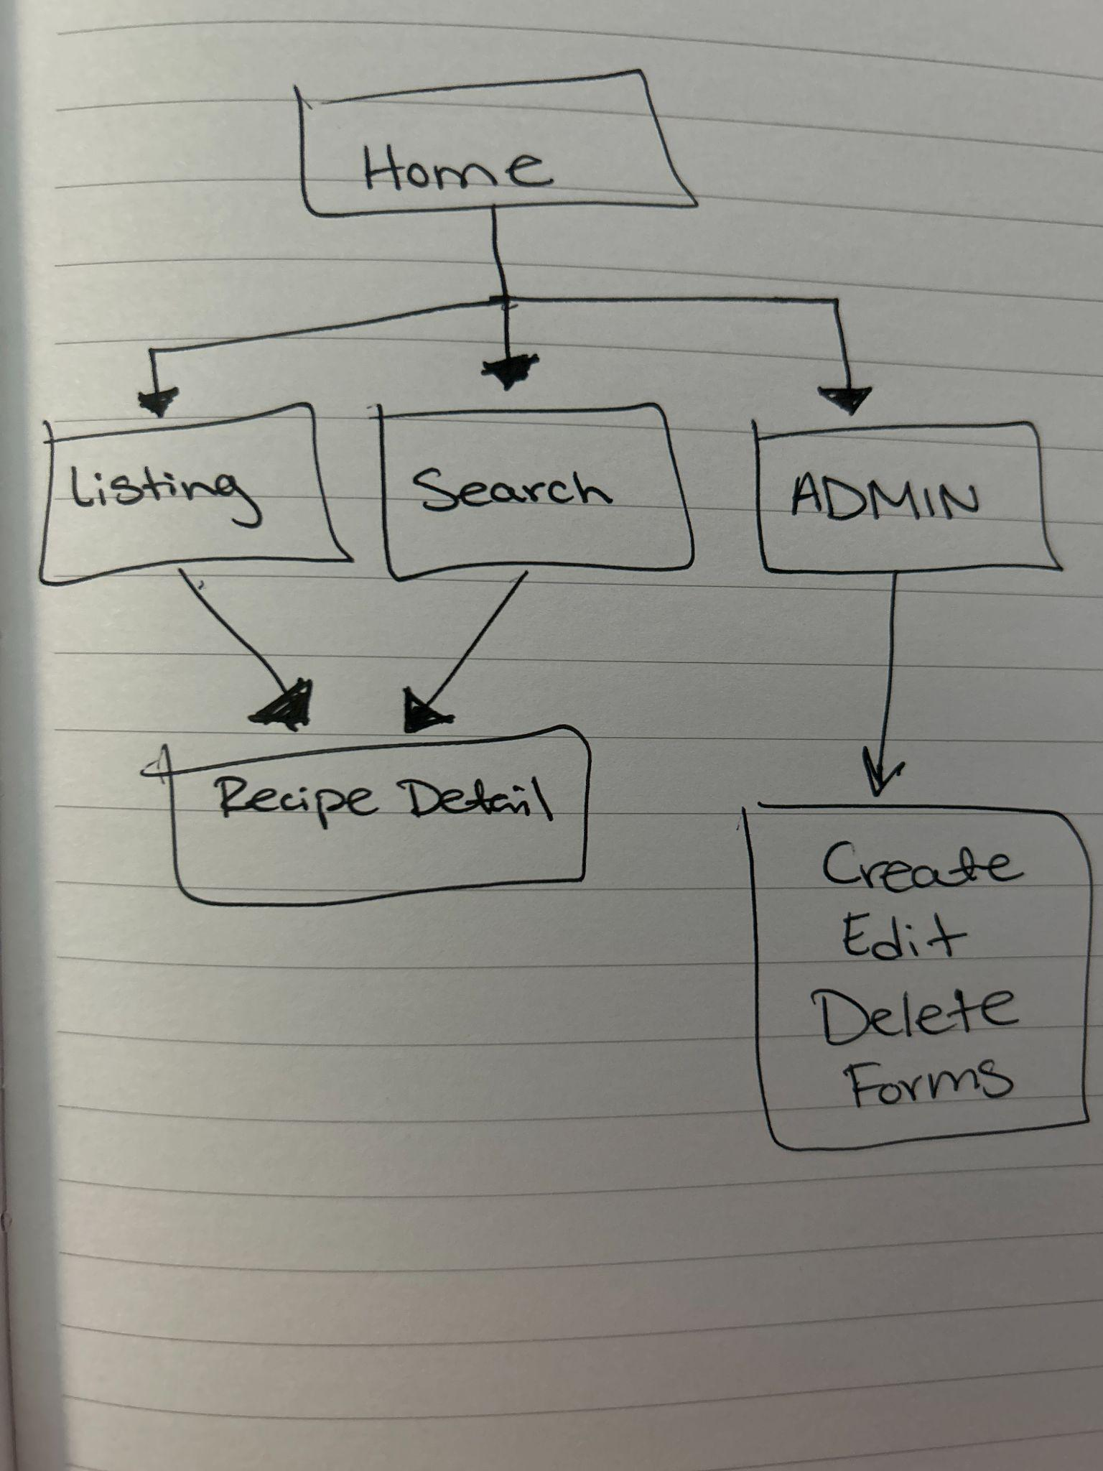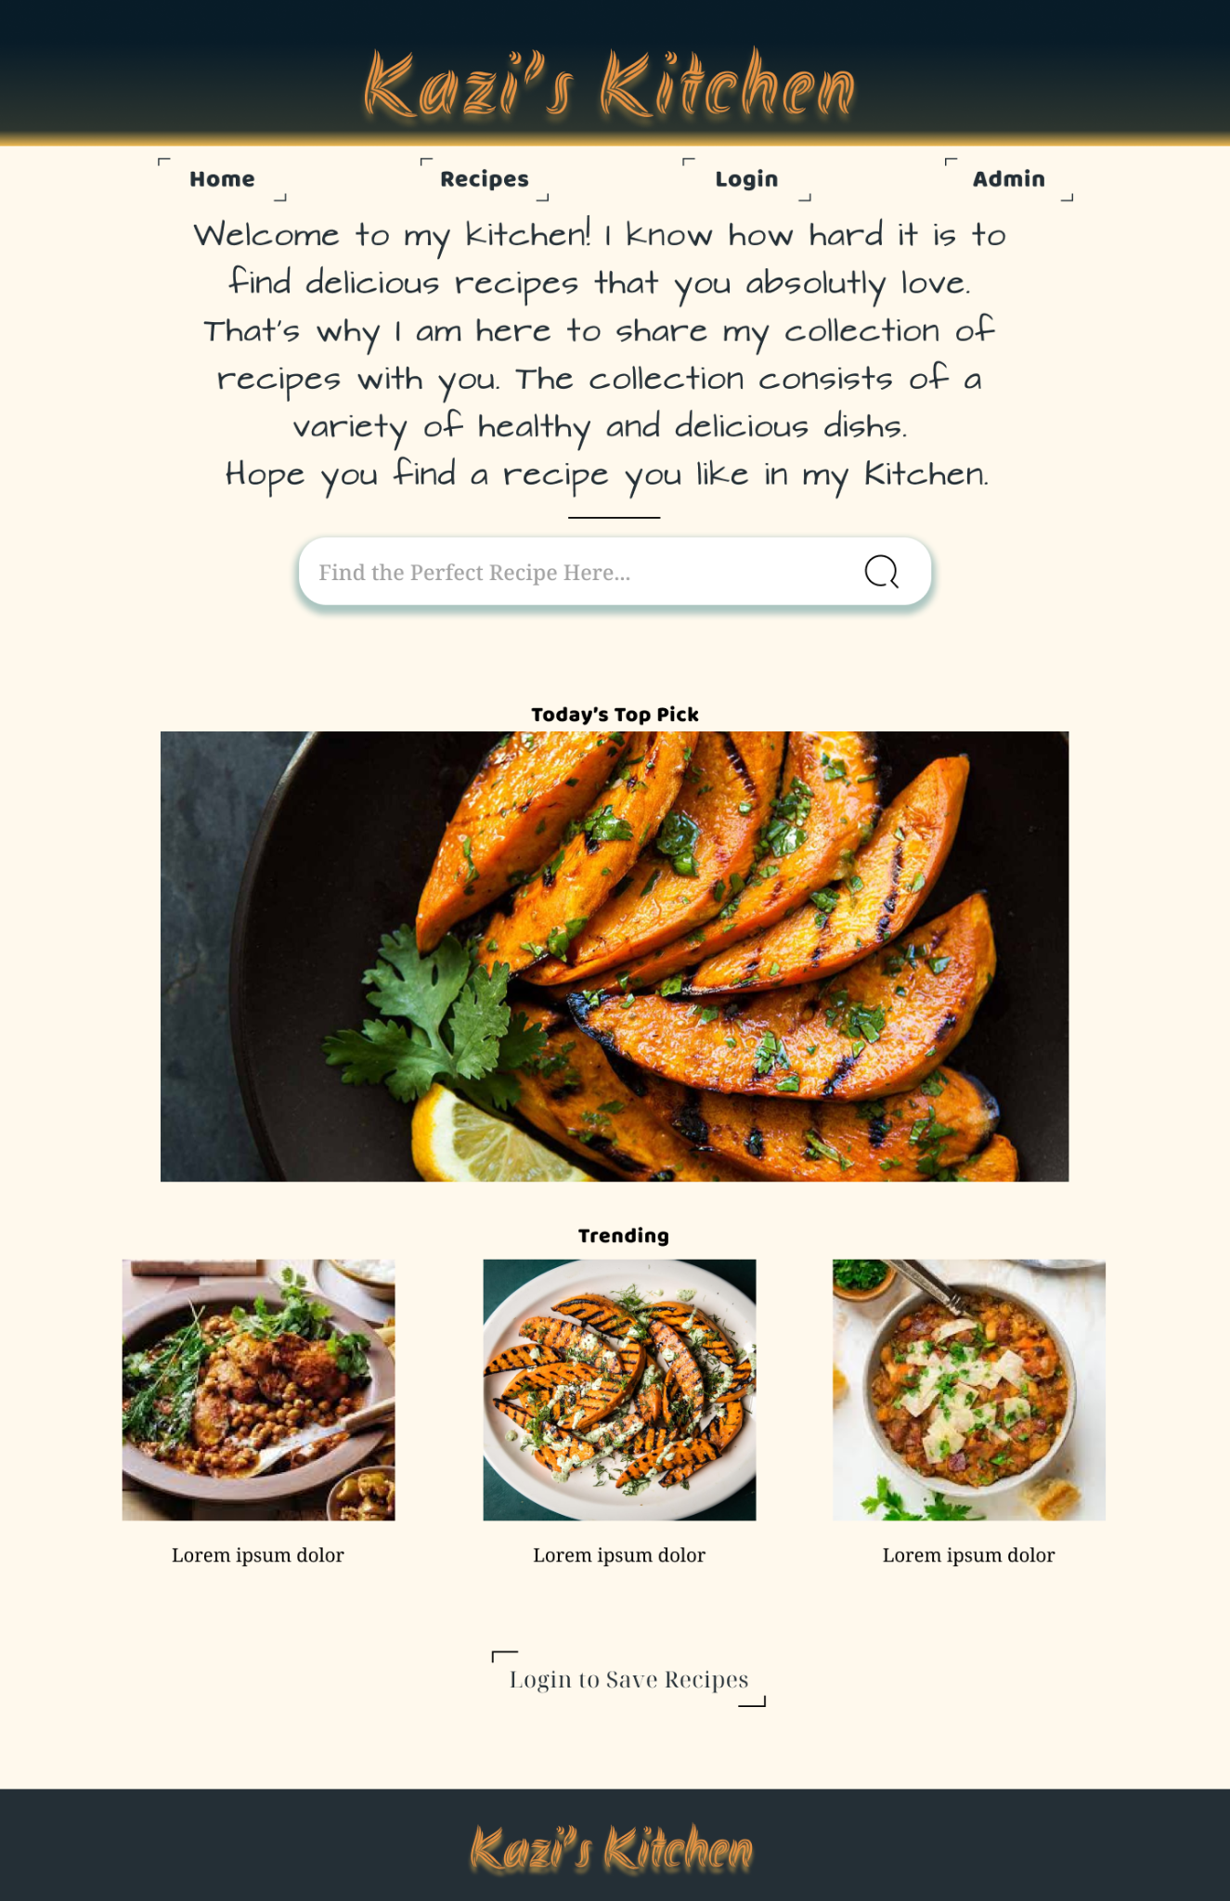

## Code/Dev

While learning about PHP in class, I decided to start recreating my wireframes using HTML and CSS. The reason I did this is because the HTML and CSS portion will not be affected by the PHP. At this point, I knew that all I would have to do later is swap in my PHP code for specific content. If I have my general layout set up, it will make the process of adding PHP and SQL more efficient.

During this time, I really focused on staying organized and naming my files and class names mindfully. I did this to prevent any future frustrations that could result for randomly naming items. This first step was simple as I was just coding in HTML and CSS. I was able to implement concepts that I had previously learned in other classes to make this site stand out from others.

## Implementing PHP

At this stage, I was applying what I just learned throughout the class into my beta assignment. I had to figure out how to structure the content in my new PHP code, so it displayed the content exactly how I designed the structure to be in my wireframes. This was a challenge, as this is my first-time using PHP. After rewatching lecture videos and going through my notes, things like how the variables carry over and why a line of PHP has to be written a specific way all started to make more sense. In the end, I was able to convert my HTML pages to PHP files. I remember really struggling with connecting to my datebase, using the .env files. I tried to figure it out, but could understand why my local host would not connect properly. After research, I found that I needed to change some code in the xampp download files, to resolve this issue.

## Final Project

For my Final project, I needed to figure out how code PHP for my recipe details page. The recipe details page is the page that a user is redirected to after clicking on a specific recipe. For the longest time, I could wrap my head around how it would connect to it to pull specific repices. At one point, the learned material just clicked and I just knew what I had to do to code this page out. It was the best and weirdest feeling. After creating this page and my Admin view all, create, and edit pages, I started inserting all of the client’s recipes.

# Results

After hours of coding, I was able to create the Kazi’s Kitchen site using HTML, CSS, JavaScript, PHP, and SQL. Through this journey, I learned the importance of wireframing, sitemapping, and how to connect a site to pull information from a database, based off of the page they are on. I was very thankful for my organizational skills as this was important to ensure files were not miss places or incorrectly labeled. Overall, I am excited to see how and when I can use the PHP and SQL I learn on future projects.

# [View my final project!](https://samihashoshi.com/idm232/final/)

