- Step 1: Create a project
- Step 2: Initiate node.js (npm init -y)

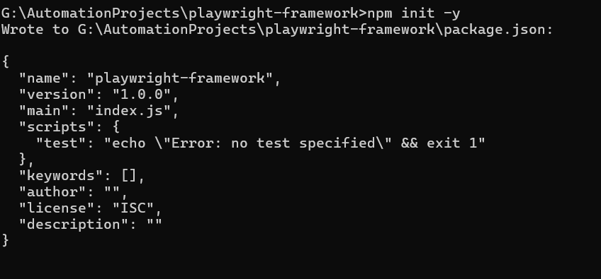

- Step 3: Install Playwright and TypeScript
- npm install --save-dev @playwright/test typescript ts-node @types/node
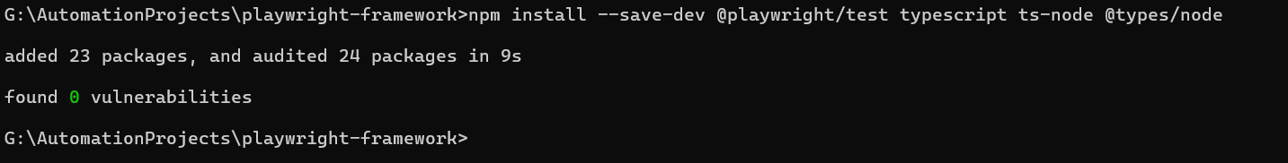
- Open the project in IDE(VS Code or other)
- Step 4: Create tsconfig.json at the root of the project
- Add below details in the json file:
{
"compilerOptions": {
"target": "ES2020",
"module": "commonjs",
"lib": ["ES2020"],
"strict": true,
"esModuleInterop": true,
"skipLibCheck": true,
"outDir": "./dist",
"rootDir": "./",
"resolveJsonModule": true,
"baseUrl": ".",
"paths": {
"@pages/*": ["src/pages/*"],
"@fixtures/*": ["src/fixtures/*"],
"@utils/*": ["src/utils/*"],
"@data/*": ["src/data/*"]
}
},
"include": ["src/**/*", "tests/**/*"],
"exclude": ["node_modules", "dist"]
}

Step 5: Create playwright.config.ts
Create a file named playwright.config.ts in the root of your project and add this:
import { defineConfig, devices } from '@playwright/test';

export default defineConfig({
testDir: './tests',
timeout: 30000,
expect: {
timeout: 5000,
},
fullyParallel: true,
forbidOnly: !!process.env.CI,
retries: process.env.CI ? 2 : 0,
workers: process.env.CI ? 4 : undefined,
reporter: [
['list'],
['html', { outputFolder: 'playwright-report', open: 'never' }],
],
use: {
baseURL: process.env.BASE_URL || 'https://your-app.com',
headless: true,
screenshot: 'only-on-failure',
video: 'retain-on-failure',
trace: 'retain-on-failure',
},
projects: [
{
name: 'chromium',
use: { ...devices['Desktop Chrome'] },
},
{
name: 'firefox',
use: { ...devices['Desktop Firefox'] },
},
{
name: 'webkit',
use: { ...devices['Desktop Safari'] },
},
],
});

Step 6: Create the Folder Structure
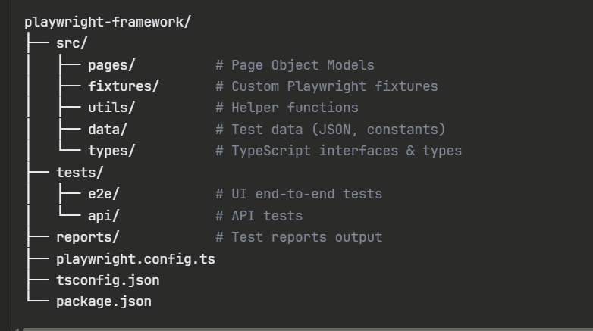

Step 7: Setup Environment Configuration
First, install dotenv: (npm install dotenv)
- Now create a .env file in the root:
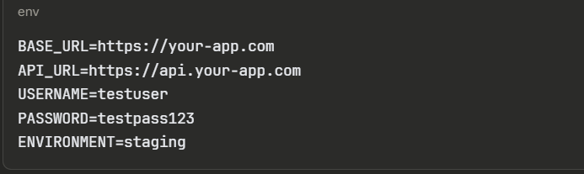
Step 8: Create Environment Config Loader
Create a file src/utils/config.ts:
