Checkstyle/JaCoCo final report

## Checkstyle

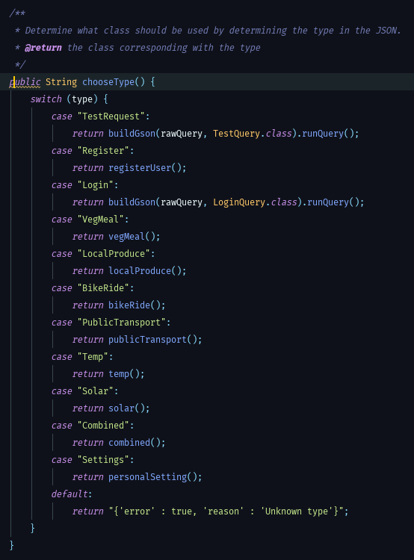

Warning 1: Cyclomatic complexity is 12 (max allowed is 10)

As you can see in the warning 1 our switch-case statement consists of 12 cases. Even though this warning could have been easily resolved by splitting this method into two we have chosen not to. We think that leaving this method as a whole is much more convenient and readable. Therefore we decided to leave this method for what it is and ignore the warning.

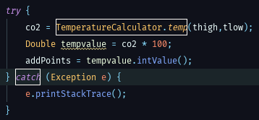

Warning 2: Catching exception is not allowed

In warning 2 we have used a try-catch block that has triggered the second warning. The only alternative to solve this issue was by throwing the exception as oppose to catching it. Because this method is inherited by a different method and that method is inherited by a different method etc., the throw clause must be cascaded as well. We have encountered several issue with this potential solution. One of which was that up to a certain point a certain method was not able to catch the exception nor throw it. Therefore we’ve decided to keep our code simple and maintainable by leaving in the try-catch block.

## Code Coverage

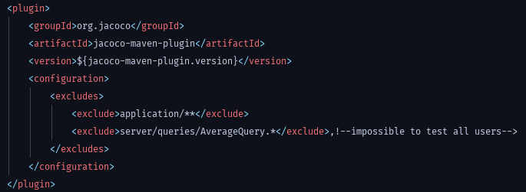

Figure Pom.xml

In figure 1 it is shown we have excluded two different things. The top exclusion is used to exclude the whole GUI package. The bottom exclusion is used to exclude a specific file. This file is used to calculate the global average amount of CO2 saved. In order to test this multiple users must be used. After several attempts we found out that it is very difficult to keep the test consistent. To keep the data in the database consistent and other tests passing we haven chosen to exclude this file only.