Exercise 5:

Story 1: Startup

|  |  |  |
| --- | --- | --- |
|  |  | **Variants** |
|  |  | $1.1 |
| **Conditions** | JPacman GUI is launched | Y |
| Start button has been pressed | Y |
| **Actions** | Game starts | Y |

Story 2: Move the player

|  |  |  |  |  |  |  |
| --- | --- | --- | --- | --- | --- | --- |
|  |  | **Variants** | | | | |
|  |  | $2.1 | $2.2 | $2.3 | $2.4 | $2.5 |
| **Conditions** | Game has started | Y | Y | Y | Y | Y |
| Pacman is next to square with pellet | Y | N | N | N | N |
| Arrow has been pressed towards that square | Y | Y | Y | Y | Y |
| Pacman is next to empty square | N | Y | N | N | Y |
| Pacman is next to cell containing wall | N | N | Y | N | N |
| Pacman is next to square with ghost | N | N | N | Y | N |
| Pacman has eaten last pellet | N | N | N | N | Y |
|  | | | | | | |
| **Actions** | Move to square | Y | Y | N | N | N |
| Remove pellet and earn points | Y | N | N | N | Y |
| Pacman dies | N | N | N | Y | N |
| Player wins | N | N | N | N | Y |
| Game is over | N | N | N | Y | Y |

Story 3: Move the Ghost

|  |  |  |  |  |  |
| --- | --- | --- | --- | --- | --- |
|  |  | **Variants** | | | |
|  |  | $3.1 | $3.2 | $3.3 | $3.4 |
| **Conditions** | Game has started | Y | Y | Y | Y |
| Ghost next to empty cell | Y | N | N | N |
| Tick event occurs | Y | Y | Y | Y |
| Ghost is next to cell with pellet | N | Y | N | N |
| Ghost is on the cell with pellet | N | N | Y | N |
| Ghost is next to cell containing the player | N | N | N | Y |
|  | | | | | |
| **Actions** | Move to cell | Y | Y | N | Y |
| Move away from cell | N | N | Y | N |
| Pellet is visible | dc | N | Y | dc |
| Player dies | N | N | N | Y |
| Game is over | N | N | N | Y |

Story 4: Suspend the Game

|  |  |  |  |
| --- | --- | --- | --- |
|  |  | **Variants** | |
|  |  | $4.1 | $4.2 |
| **Conditions** | Game has started | Y | N |
| Stop button has been clicked | Y | N |
| Game has been suspended | N | Y |
| Start button has been clicked | N | Y |
|  | | | |
| **Actions** | All moves from ghosts and player are suspended | Y | N |
| Game is resumed | N | Y |

Exercise 15:

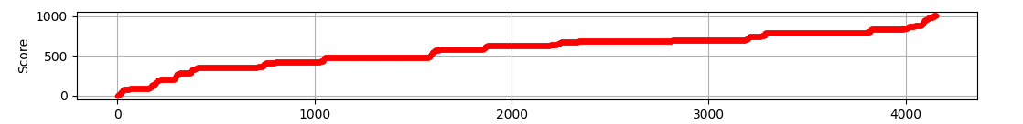

**normal**

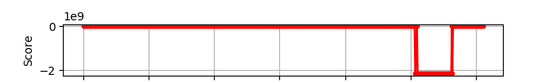

abnormal

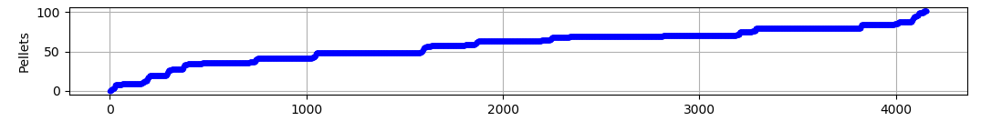

**normal**

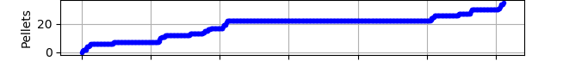

abnormal

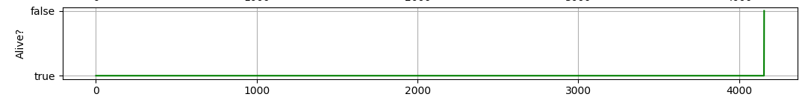

**normal**

normal

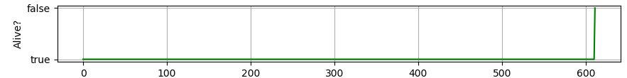

abnormal

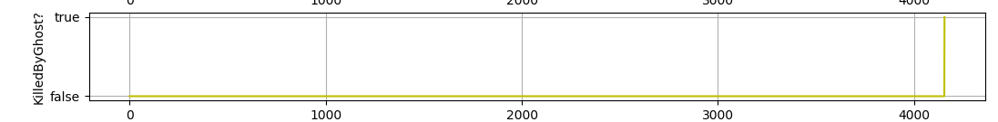

**normal**

normal

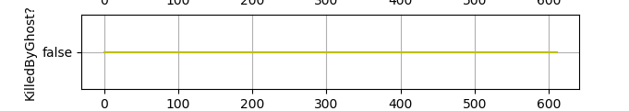

abnormal

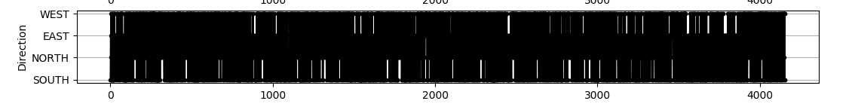

**normal**

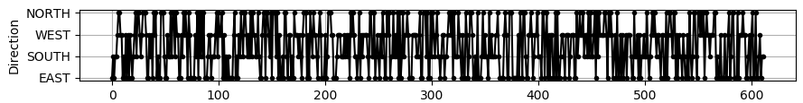

abnormal

**Anomaly 1:**

*The score counter seems to suddenly change to an enormous negative number, possibly due to an overflow, after eating around 15 pellets or more and facing West.*

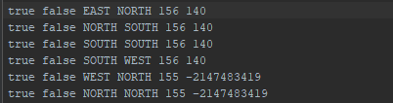

From the generated logs we can see that after 140 points (around 14 pellets), there occurs an anomaly namely the sudden change to an enormous negative number. This didn’t affect the current number of pellets at that time, if the player is alive or if the player has collided. The only two things that could have affected it were the current points and the direction. Since the current points stayed the same for a while, it probably had to do with the direction. In this case going from West to West. Since earlier in the logs the player already did the same movement to the West direction, the anomaly probably occurs after a certain amount of pellets have been eaten and the direction changes from West to West.

**Anomaly 2:**

*After eating around 28 pellets or more, the PointCalculator deducts 15 points after each pellet.*

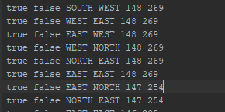

*As can be seen from the log the log around the 269 points (~27 pellet) the points have been increasing. But when the 28th pellet has been eaten the points suddenly decrease by 15.*

**Anomaly 3:**

*After eating more than 34 pellets and facing North direction the game stops, and you get a Runtime exception*

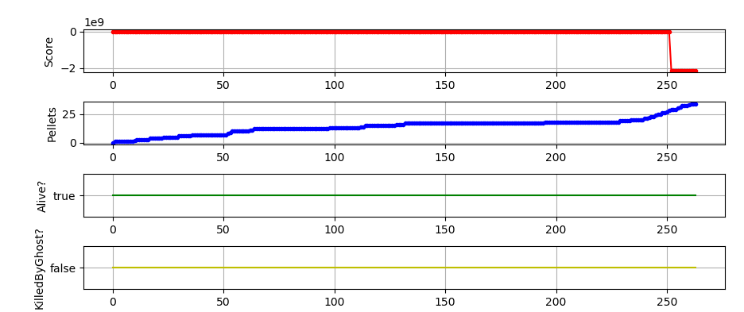

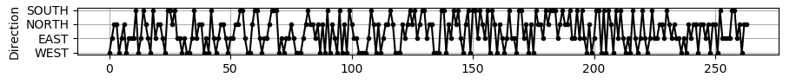

*(this is another graph from the abnormal behavior)*. So the only difference is the amount of pellets, the score and the direction.



Since the total amount of pellets is 178, this log shows the game ended after the 34th pellet (*178-144 = 34).* The score roughly corresponds to the change in pellets so we can ignore that here.We can also see that the direction changed from North to North so this means that the exception occurred after more than 34 pellets have been eaten and the player moved North.

**Anomaly 4:**

*After eating more than 34 pellets Pacman suddenly dies, without any of the ghosts killing it.*

From the graphs created out of the generated logs *(not the ones from anomaly 3*), we can already see that the player with the abnormal behavior is almost never killed by the ghosts.

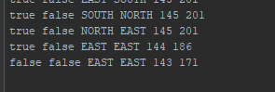

However the status from the player is set to False. We can further see that the amount of pellets and the score have changed while the direction stayed the same with one iteration before. Since the player Alive status has been set to false at around 143 pellets left this means that around the 35th pellet the player has been killed without any of the ghost having collided with the player. So this means that if pacman eats more than 34 pellets, and not faces north direction afterward *(no runtime exception so we must exclude the case for anomaly 3 since that one is almost the same),* he dies.

**16:**

