نتایج ارزیابی برای دیتاست CIFAR10:
Batch Size = 150
Epoch = 300
Time of training = about 8 hours
Training from Scratch (Without using pretrain weights)
Number of Test data = 10000
Number of Training data= 50000
مقدار رم GPU 4060 درگیر در حالت SNN حدودا 16 گیگ بوده ولی با همین تنظیمات در حالت ANN حجم اشغالی حدودا 23 گیگ بود.

Test: [ 0/45] eta: 0:09:37 loss: 0.2137 (0.2137) acc1: 95.5556 (95.5556) acc5: 99.5556 (99.5556) time: 12.8435 data: 11.7839 max mem: 3920
Test: [10/45] eta: 0:00:48 loss: 0.2137 (0.2350) acc1: 95.5556 (95.2323) acc5: 99.5556 (99.6768) time: 1.3763 data: 1.0714 max mem: 3920
Test: [20/45] eta: 0:00:20 loss: 0.2401 (0.2415) acc1: 94.6667 (94.9630) acc5: 99.5556 (99.7249) time: 0.2197 data: 0.0001 max mem: 3920
Test: [30/45] eta: 0:00:09 loss: 0.2405 (0.2407) acc1: 95.1111 (95.2545) acc5: 99.5556 (99.6703) time: 0.2074 data: 0.0001 max mem: 3920
Test: [40/45] eta: 0:00:02 loss: 0.2400 (0.2406) acc1: 95.5556 (95.3171) acc5: 99.5556 (99.6748) time: 0.1954 data: 0.0001 max mem: 3920
Test: [44/45] eta: 0:00:00 loss: 0.2400 (0.2414) acc1: 95.5556 (95.2900) acc5: 99.5556 (99.6800) time: 0.1899 data: 0.0001 max mem: 3920
Test: Total time: 0:00:22 (0.4941 s / it)
* Acc@1 95.290 Acc@5 99.680 loss 0.241
Accuracy of the network on 10000 test images: 95.29000%

نتایج بررسی Sparsity :

Batch [1/67] Accuracy: 96.00% | Avg Layer Sparsity: 33.20%
Batch [10/67] Accuracy: 95.00% | Avg Layer Sparsity: 33.22%
Batch [20/67] Accuracy: 95.03% | Avg Layer Sparsity: 33.33%
Batch [30/67] Accuracy: 94.96% | Avg Layer Sparsity: 32.98%
Batch [40/67] Accuracy: 95.18% | Avg Layer Sparsity: 33.33%
Batch [50/67] Accuracy: 95.29% | Avg Layer Sparsity: 33.18%
Batch [60/67] Accuracy: 95.32% | Avg Layer Sparsity: 33.31%
=======================
FINAL EVALUATION RESULTS For SPARSITY
=======================
Overall Accuracy: 95.29%
Overall Average Sparsity: 0.33%
Total samples evaluated: 7500
Per-Layer Average Sparsities:
downsample_layers: 0.00%
head: 99.64%
stages: 0.00%

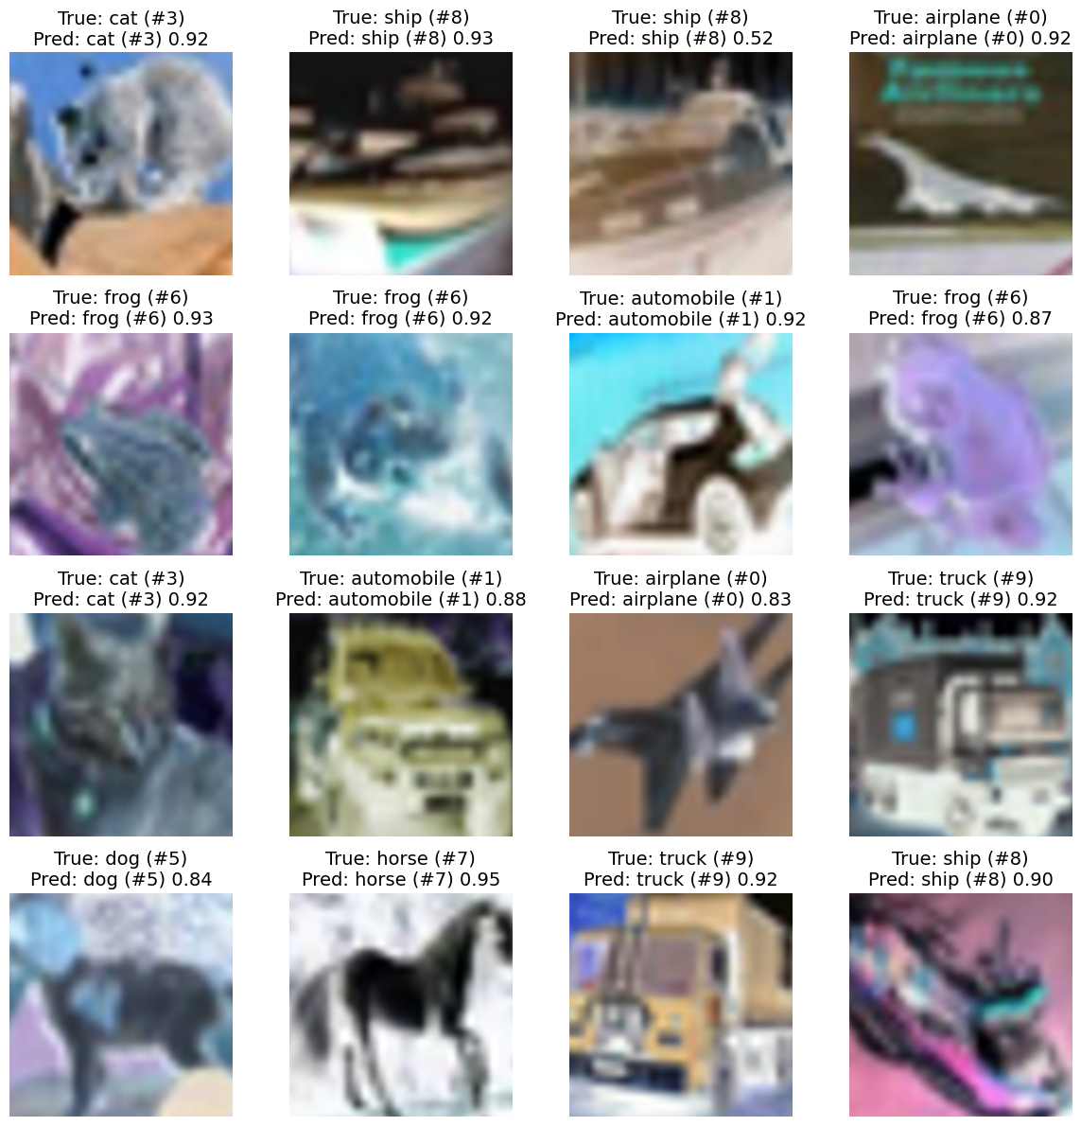

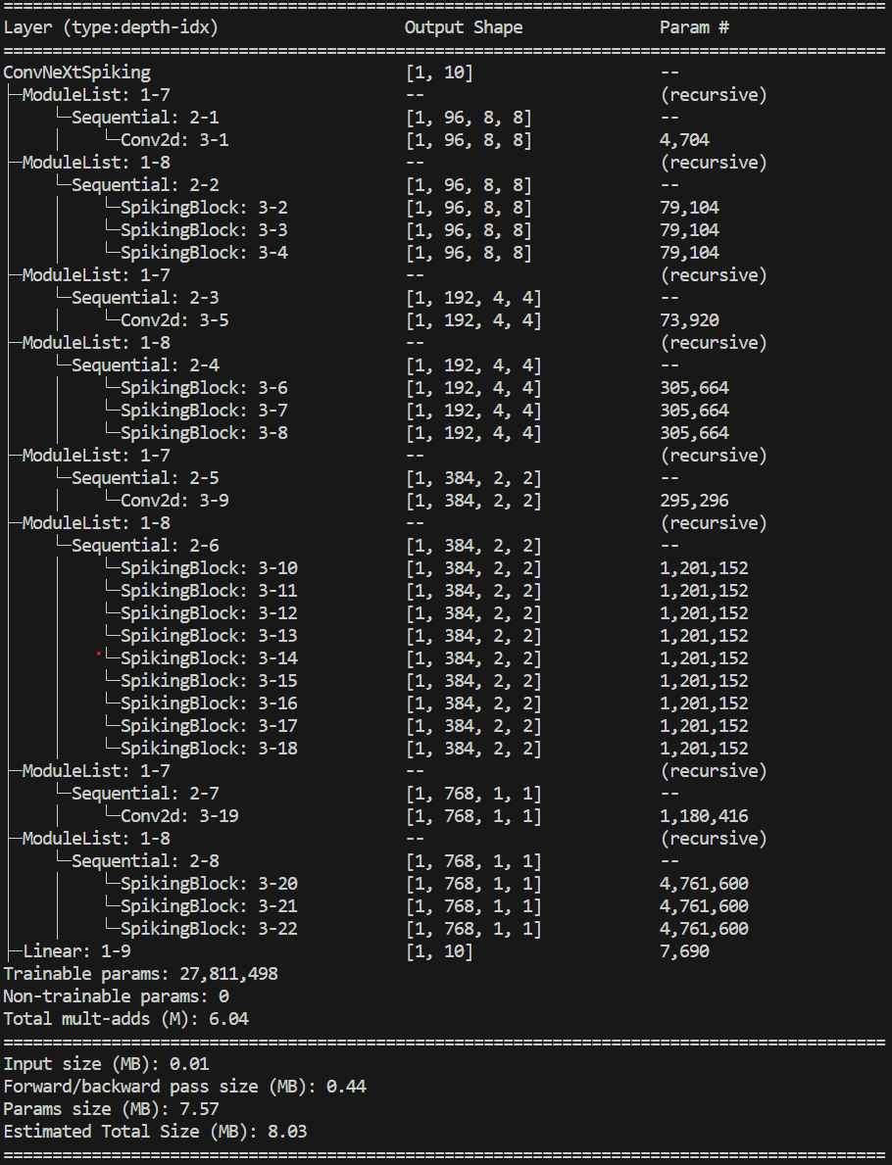

Model = ConvNeXtSpiking(
(downsample_layers): ModuleList(
(0): Sequential(
(0): Conv2d(3, 96, kernel_size=(4, 4), stride=(4, 4))
)
(1): Sequential(
(0): Conv2d(96, 192, kernel_size=(2, 2), stride=(2, 2))
)
(2): Sequential(
(0): Conv2d(192, 384, kernel_size=(2, 2), stride=(2, 2))
)
(3): Sequential(
(0): Conv2d(384, 768, kernel_size=(2, 2), stride=(2, 2))
)
)
(stages): ModuleList(
(0): Sequential(
(0): SpikingBlock(
(dwconv): Conv2d(96, 96, kernel_size=(7, 7), stride=(1, 1), padding=(3, 3), groups=96)
(pw1): Linear(in_features=96, out_features=384, bias=True)
(pw2): Linear(in_features=384, out_features=96, bias=True)
(drop_path): Identity()
)
(1): SpikingBlock(
(dwconv): Conv2d(96, 96, kernel_size=(7, 7), stride=(1, 1), padding=(3, 3), groups=96)
(pw1): Linear(in_features=96, out_features=384, bias=True)
(pw2): Linear(in_features=384, out_features=96, bias=True)
(drop_path): Identity()
)
(2): SpikingBlock(
(dwconv): Conv2d(96, 96, kernel_size=(7, 7), stride=(1, 1), padding=(3, 3), groups=96)
(pw1): Linear(in_features=96, out_features=384, bias=True)
(pw2): Linear(in_features=384, out_features=96, bias=True)
(drop_path): Identity()
)
)
(1): Sequential(
(0): SpikingBlock(
(dwconv): Conv2d(192, 192, kernel_size=(7, 7), stride=(1, 1), padding=(3, 3), groups=192)
(pw1): Linear(in_features=192, out_features=768, bias=True)
(pw2): Linear(in_features=768, out_features=192, bias=True)
(drop_path): Identity()
)
(1): SpikingBlock(
(dwconv): Conv2d(192, 192, kernel_size=(7, 7), stride=(1, 1), padding=(3, 3), groups=192)
(pw1): Linear(in_features=192, out_features=768, bias=True)
(pw2): Linear(in_features=768, out_features=192, bias=True)
(drop_path): Identity()
)
(2): SpikingBlock(
(dwconv): Conv2d(192, 192, kernel_size=(7, 7), stride=(1, 1), padding=(3, 3), groups=192)
(pw1): Linear(in_features=192, out_features=768, bias=True)
(pw2): Linear(in_features=768, out_features=192, bias=True)
(drop_path): Identity()
)
)
(2): Sequential(
(0): SpikingBlock(
(dwconv): Conv2d(384, 384, kernel_size=(7, 7), stride=(1, 1), padding=(3, 3), groups=384)
(pw1): Linear(in_features=384, out_features=1536, bias=True)
(pw2): Linear(in_features=1536, out_features=384, bias=True)
(drop_path): Identity()
)
(1): SpikingBlock(
(dwconv): Conv2d(384, 384, kernel_size=(7, 7), stride=(1, 1), padding=(3, 3), groups=384)
(pw1): Linear(in_features=384, out_features=1536, bias=True)
(pw2): Linear(in_features=1536, out_features=384, bias=True)
(drop_path): Identity()
)
(2): SpikingBlock(
(dwconv): Conv2d(384, 384, kernel_size=(7, 7), stride=(1, 1), padding=(3, 3), groups=384)
(pw1): Linear(in_features=384, out_features=1536, bias=True)
(pw2): Linear(in_features=1536, out_features=384, bias=True)
(drop_path): Identity()
)
(3): SpikingBlock(
(dwconv): Conv2d(384, 384, kernel_size=(7, 7), stride=(1, 1), padding=(3, 3), groups=384)
(pw1): Linear(in_features=384, out_features=1536, bias=True)
(pw2): Linear(in_features=1536, out_features=384, bias=True)
(drop_path): Identity()
)
(4): SpikingBlock(
(dwconv): Conv2d(384, 384, kernel_size=(7, 7), stride=(1, 1), padding=(3, 3), groups=384)
(pw1): Linear(in_features=384, out_features=1536, bias=True)
(pw2): Linear(in_features=1536, out_features=384, bias=True)
(drop_path): Identity()
)
(5): SpikingBlock(
(dwconv): Conv2d(384, 384, kernel_size=(7, 7), stride=(1, 1), padding=(3, 3), groups=384)
(pw1): Linear(in_features=384, out_features=1536, bias=True)
(pw2): Linear(in_features=1536, out_features=384, bias=True)
(drop_path): Identity()
)
(6): SpikingBlock(
(dwconv): Conv2d(384, 384, kernel_size=(7, 7), stride=(1, 1), padding=(3, 3), groups=384)
(pw1): Linear(in_features=384, out_features=1536, bias=True)
(pw2): Linear(in_features=1536, out_features=384, bias=True)
(drop_path): Identity()
)
(7): SpikingBlock(
(dwconv): Conv2d(384, 384, kernel_size=(7, 7), stride=(1, 1), padding=(3, 3), groups=384)
(pw1): Linear(in_features=384, out_features=1536, bias=True)
(pw2): Linear(in_features=1536, out_features=384, bias=True)
(drop_path): Identity()
)
(8): SpikingBlock(
(dwconv): Conv2d(384, 384, kernel_size=(7, 7), stride=(1, 1), padding=(3, 3), groups=384)
(pw1): Linear(in_features=384, out_features=1536, bias=True)
(pw2): Linear(in_features=1536, out_features=384, bias=True)
(drop_path): Identity()
)
)
(3): Sequential(
(0): SpikingBlock(
(dwconv): Conv2d(768, 768, kernel_size=(7, 7), stride=(1, 1), padding=(3, 3), groups=768)
(pw1): Linear(in_features=768, out_features=3072, bias=True)
(pw2): Linear(in_features=3072, out_features=768, bias=True)
(drop_path): Identity()
)
(1): SpikingBlock(
(dwconv): Conv2d(768, 768, kernel_size=(7, 7), stride=(1, 1), padding=(3, 3), groups=768)
(pw1): Linear(in_features=768, out_features=3072, bias=True)
(pw2): Linear(in_features=3072, out_features=768, bias=True)
(drop_path): Identity()
)
(2): SpikingBlock(
(dwconv): Conv2d(768, 768, kernel_size=(7, 7), stride=(1, 1), padding=(3, 3), groups=768)
(pw1): Linear(in_features=768, out_features=3072, bias=True)
(pw2): Linear(in_features=3072, out_features=768, bias=True)
(drop_path): Identity()
)
)
)
(head): Linear(in_features=768, out_features=10, bias=True)
)
number of params: 27811498
LR = 0.00040000
Batch size = 150
Update frequent = 1
Number of training examples = 50000
Number of Epoch: 300
Number of training training per epoch (iteration) = 333

