Methods | Year | Parameters | Dice | iou | Input size
TransNetR (4) | 2023 | 27.27 | 87.06 | 80.16 | ?
SegMed-Net (8) | 2026 | 59.9 | 90.8 | 83.70 | 352*352
PVT-Cascade (3) | 2023 | 35.2 | 91.1 | 86.3 | 352*352
MegaNet (2) | 2024 | 44.1 | 91.3 | 86.3 | 352*352
Fu-TransHNet (5) | 2023 | ? | 91.6 | 86.6 | 352*352
LiteBoundD (1) | 2026 | 32.8 | 91.9 | 84.1 | 352*352
AAPCNet (7) | 2025 | 38.2 | 92.10 | 86.9 | 256*256
DVFIP-Net | 2026 | 45.62 | 92.20 | 87.40 | 352*352
SAM2-FNet | 2026 | 27.2 | 92.40 | 87.40 | 352*352
MLB-Net | 2026 | 87.7 | 92.60 | 87.80 | 352*352
MSPN | 2026 | 28.56 | 92.70 | 87.90 | 352*352
HCA-Net | 2026 | 89.70 | 93.60 | 89.7 | 352*352
Ours | 2026 | 38.5 | 93.89 | 88.66 | 352*352
PolyMamba-Net (6) | 2026 | 25.3 | 94.2 | 89.1 | 352*352

- Sharpening Lightweight Models for Generalized Polyp Segmentation: A Boundary Guided Distillation from Foundation Models
- “Meganet: Multi-scale edge-guided attention network for weak boundary polyp segmentation
- “Medical image segmentation via cascaded attention decoding
- TransNetR: Transformer-based Residual Network for Polyp Segmentation with Multi-Center Out-of-Distribution Testin
- Cooperation Learning Enhanced Colonic Polyp Segmentation Based on TransformerCNN Fusion
- PolyMamba-Net: a lightweight and boundary-aware network for real-time polyp segmentation in colonoscopy
- Attention-Guided Asymmetric Multiscale Polyp Segmentation Network
- SegMed-Net: a domain-aware dual encoder-decoder network with dense feature fusion for enhanced medical image segmentation

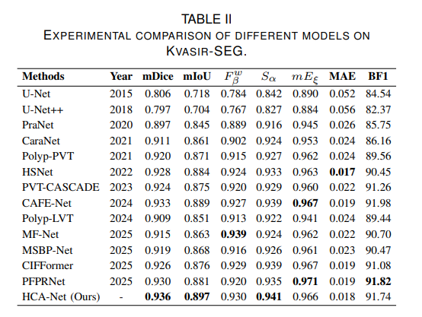

Boundary-Frequency Injection Module:
- Decomposing frequency components
  - Frequency Feature Decomposer (FFD)
  - Spilt skip features into high-frequency and low-frequency using 2D FFT
    - High-frequency -> Boundaries, edges
    - Low-frequency -> semantic content
- Using boundary information for better feature guidance
  - Boundary-guided Squeeze-Excitation Injection (BSEI)
  - Uses Sobel operators to detect boundaries in skip features
  - Creates spatial attention maps from boundary information
  - Uses cross-attention between decoder features and boundary-weighted encoder features

- Adaptively fusing these different feature representations
  - Multi-scale Frequency Adaptive Fusion (MFAF)
  - Learns soft weights to combine high-frequency, low-frequency, and boundary-enhanced features
  - Uses channel-wise gating to decide the importance of each component

Purpose:
The BFIM replaces standard skip connections to:
- Better preserve boundary information during up-sampling
- Adaptively emphasize important frequency components
- Improve segmentation accuracy especially for object boundaries
- Provide learnable fusion instead of simple concatenation

Models | Seen |  |  |  | Unseen |  |  |  |  |  | Epoch
Models | Kvasir-Seg |  | ClinicDB |  | CVC-300 |  | ColonDB |  | ETIS
Models | Dice | iou | Dice | iou | Dice | iou | Dice | iou | Dice | iou
HCA-Net | 93.6 | 89.7 | 95.6 | 90.9 | 91.2 | 87.3 | 83.4 | 76.9 | 83.3 | 78.9
Ours | 92.40 | 86.08 | 95.19 | 90.84 | 91.49 | 84.32 | 81.26 | 70.44 | 87.39 | 77.61 | 1370
Ours-2 | 92.58 | 86.41 | 95.31 | 91.04 |  |  | 81.45 | 70.95 |  |  | 1405
 | 92.03 |  | 95.27 | 90.97 |  |  | 83.34 | 73.75

Models | Seen |  |  |  | Unseen |  |  |  |  |  | Epoch
Models | Kvasir-Seg |  | ClinicDB |  | CVC-300 |  | ColonDB |  | ETIS
Models | Dice | iou | Dice | iou | Dice | iou | Dice | iou | Dice | iou
HCA-Net | 93.6 | 89.7 | 95.6 | 90.9 | 91.2 | 87.3 | 83.4 | 76.9 | 83.3 | 78.9
Ours | 92.58 | 86.41 | 95.31 | 91.04 | 91.49 | 84.32 | 83.34 | 73.75 | 87.39 | 77.61 | 1370

