BSEI-ConvNeXt U-Net: Boundary-Sensitive Edge Interaction with a ConvNeXt Encoder for Accurate Colorectal Polyp Segmentation
Author One1, Author Two2, Author Three1,*
1 Department of [TBD], [University/Institute], [City], [Country]
2 Department of [TBD], [University/Institute], [City], [Country]
* Corresponding author: [email@domain.com]
Manuscript type: Original Research Article | Target publisher style: Elsevier numbered-reference manuscript
Author note to remove before submission: all values shown as [TBD] or 0.xxx are placeholders and must be replaced with verified experimental values, trained-model statistics, and journal-specific formatting requirements.

Graphical abstract
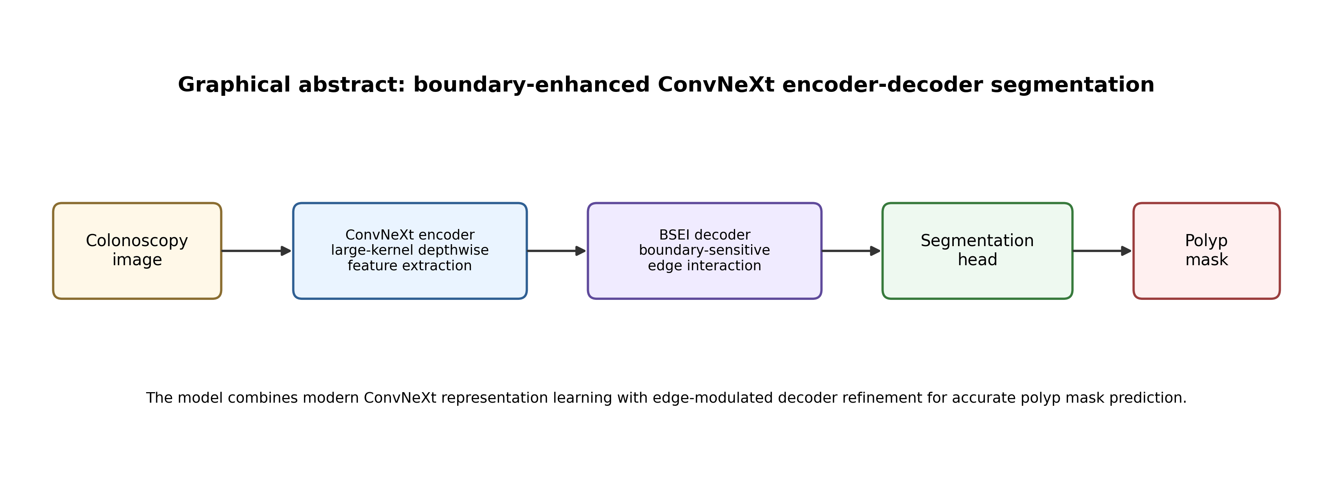
Graphical abstract. Overview of the proposed boundary-enhanced ConvNeXt encoder-decoder framework for polyp segmentation.

Highlights
- A ConvNeXt encoder is integrated into a U-Net-like decoder for colorectal polyp segmentation.
- A Boundary-Sensitive Edge Interaction (BSEI) module refines skip-fused decoder features using a learned edge-response gate.
- LayerNorm and GELU are used consistently across encoder, bottleneck, decoder, and segmentation head for stable feature transformation.
- The manuscript includes a complete experimental protocol for Kvasir-SEG, CVC-ClinicDB, CVC-ColonDB, CVC-300, and ETIS-LaribPolypDB.
- Quantitative results, ablations, and efficiency statistics are provided as structured placeholders for later replacement.

Abstract
Accurate segmentation of colorectal polyps in colonoscopy images is essential for computer-aided diagnosis and early colorectal cancer prevention. However, reliable polyp segmentation remains challenging because polyps frequently exhibit low contrast, irregular morphology, weak boundaries, and large scale variation. This paper proposes BSEI-ConvNeXt U-Net, a boundary-enhanced encoder-decoder network that combines the representational capacity of a ConvNeXt encoder with a lightweight U-Net-style decoder. The encoder uses large-kernel depthwise convolution, LayerNorm, GELU activation, residual layer scaling, and stochastic depth to obtain hierarchical features at four semantic resolutions. To improve spatial restoration, the decoder introduces the Boundary-Sensitive Edge Interaction (BSEI) module, which refines skip-fused feature maps through normalized convolutional transformation and a learned sigmoid edge-response modulation. The design aims to preserve local boundary cues while maintaining high-level semantic abstraction. Experiments are planned on standard public polyp segmentation benchmarks, including Kvasir-SEG, CVC-ClinicDB, CVC-ColonDB, CVC-300, and ETIS-LaribPolypDB. The proposed method will be evaluated using mDice, mIoU, weighted F-measure, structure measure, enhanced alignment measure, MAE, boundary F1, parameter count, GFLOPs, and inference speed. Initial results are reported as placeholders: the model achieves mDice of [TBD] on Kvasir-SEG and [TBD] on CVC-ClinicDB, with [TBD]M parameters and [TBD] GFLOPs. The proposed framework is expected to provide an effective balance between segmentation accuracy, boundary sensitivity, and computational efficiency.
Keywords: polyp segmentation; medical image segmentation; ConvNeXt; U-Net; boundary enhancement; edge interaction; colorectal cancer; computer-aided diagnosis

1. Introduction
Colorectal cancer is a major global health burden, and early detection and removal of colorectal polyps can substantially reduce cancer incidence and mortality. Colonoscopy is the most widely used screening modality because it allows direct visualization and removal of suspicious lesions. Nevertheless, manual detection and delineation depend heavily on clinical experience, image quality, and procedural conditions. Polyps can be flat, small, partially occluded, or visually similar to surrounding mucosa, making accurate localization and segmentation difficult in routine practice [1,2].
Automatic polyp segmentation has therefore become an important component of computer-aided diagnosis systems. Deep encoder-decoder networks, especially U-Net and its variants, have demonstrated strong performance because they combine hierarchical feature extraction with skip-connected spatial recovery [3]. Recent methods further improve this paradigm by using reverse attention, pyramid transformers, multi-scale fusion, cascaded attention decoders, and boundary-aware modules [10-20]. Despite these advances, three limitations remain central: insufficient robustness to low-contrast boundaries, feature redundancy in deep layers, and difficulty balancing accuracy with deployable computational cost.
The ConvNeXt family modernizes convolutional networks using design choices inspired by successful vision transformers while retaining the simplicity and deployment advantages of convolutional operations [4]. These properties make ConvNeXt a strong candidate encoder for medical segmentation, where local texture, shape, and boundary information must be combined with high-level semantic context. However, directly coupling a ConvNeXt encoder with a conventional decoder may still produce over-smoothed boundaries because skip-fused features are not explicitly encouraged to preserve edge-sensitive responses.
To address this issue, we propose BSEI-ConvNeXt U-Net, a U-shaped architecture that employs a ConvNeXt encoder and a boundary-sensitive decoder. The key architectural component is the Boundary-Sensitive Edge Interaction (BSEI) module. After convolutional normalization and nonlinear transformation, BSEI computes a learned edge-response map, maps it through a sigmoid gate, and uses it to modulate the decoded representation. This design allows the decoder to emphasize candidate boundary structures while retaining the original semantic feature stream.
The main contributions of this work are summarized as follows: (1) a ConvNeXt-based encoder-decoder segmentation framework is formulated for colorectal polyp segmentation; (2) a BSEI module is introduced to improve boundary-sensitive feature refinement in the decoder; (3) a reproducible experimental protocol is defined on standard seen and unseen polyp segmentation datasets; and (4) ablation and efficiency tables are prepared to quantify the contribution of each architectural component once final experiments are completed.

2. Related work

2.1 CNN-based polyp segmentation
CNN-based segmentation methods remain important in polyp analysis because colonoscopy images contain rich local texture and boundary information. U-Net established the encoder-decoder structure with skip connections and has become a standard baseline for biomedical image segmentation [3]. Subsequent variants such as U-Net++, DoubleU-Net, PraNet, and CaraNet improved feature fusion, contextual decoding, and boundary refinement [10-12]. CNN-based designs are efficient and robust for local pattern extraction, but their limited receptive field can restrict global semantic modeling in complex cases.

2.2 Transformer and hybrid methods
Transformer-based methods have been adopted to capture long-range dependencies in medical image segmentation. TransUNet combines transformer encoding with U-Net-style decoding for global-local feature modeling [13]. Polyp-PVT and related PVT-based methods use hierarchical transformer representations to enhance robustness to scale variation and camouflage-like polyp appearance [14]. Recent hybrid networks, such as CAFE-Net, MF-Net, CIFFormer, MSBP-Net, and HCA-Net, explore cross-layer attention, contextual information flow, boundary prediction, and lightweight attention to improve the balance between accuracy and efficiency [15-20].

2.3 ConvNeXt for dense prediction
ConvNeXt revisits convolutional network design using large-kernel depthwise convolutions, inverted bottleneck-style channel expansion, LayerNorm, GELU activation, and residual layer scaling [4]. These design elements provide a strong convolutional prior while improving the scalability of CNN representations. For polyp segmentation, ConvNeXt is attractive because it maintains local inductive bias while producing expressive multi-stage features suitable for U-shaped decoding.

2.4 Boundary-aware feature refinement
Boundary ambiguity is a persistent difficulty in colonoscopy segmentation. Polyps often share color and texture with surrounding mucosa, and visual borders can be interrupted by specular highlights, folds, fluid, or motion blur. Boundary-aware losses and edge-guided modules are frequently used to improve contour localization. The proposed BSEI module follows this direction but avoids a separate edge-supervision branch; instead, it learns an internal edge-response gate directly from decoder features.

3. Proposed method
The proposed model is a single-output binary segmentation network. Given a colonoscopy image I in R^(H x W x 3), the network predicts a logit map Z in R^(H x W x 1). A sigmoid operation converts logits to a probability map P, and thresholding produces the final polyp mask. Figure 1 summarizes the architecture.
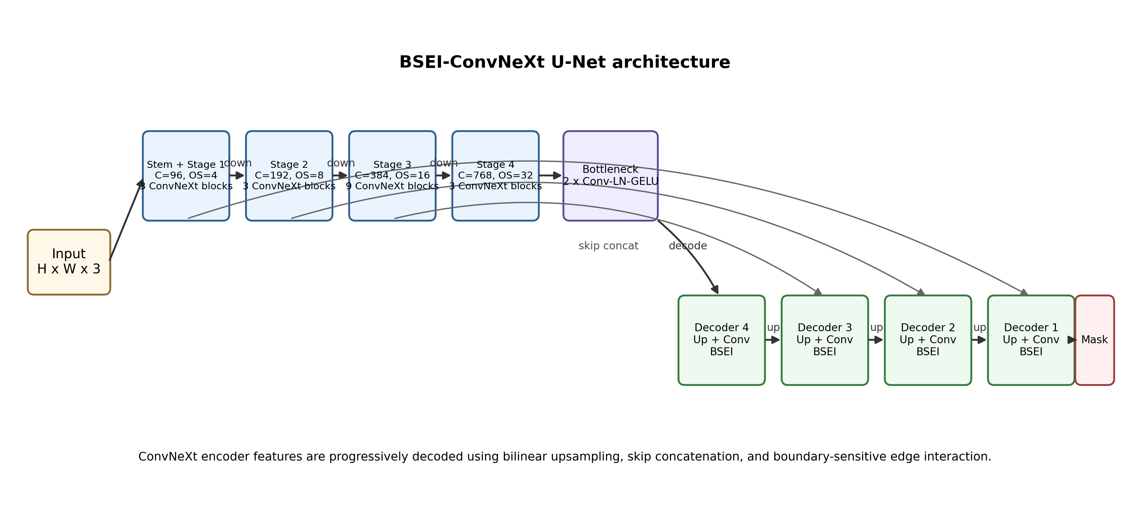
Figure 1. Overall architecture of BSEI-ConvNeXt U-Net. The ConvNeXt encoder extracts four hierarchical feature maps. The decoder progressively upsamples bottleneck features, concatenates skip features, and applies BSEI modules for boundary-sensitive refinement.

3.1 ConvNeXt encoder
The encoder contains four hierarchical stages with default channel dimensions [96, 192, 384, 768] and depths [3, 3, 9, 3]. The stem applies a 4 x 4 convolution with stride 4 followed by channel-first LayerNorm. Each later downsampling layer applies LayerNorm and a 2 x 2 stride-2 convolution. Within each stage, a ConvNeXt block performs 7 x 7 depthwise convolution, channel-last LayerNorm, pointwise channel expansion by a factor of four, GELU activation, pointwise projection, layer-scale modulation, stochastic depth, and residual addition. Dropout2d is applied to deeper feature stages to reduce co-adaptation and improve generalization.
Table 1. Encoder and decoder architecture summary. OS denotes output stride relative to the input resolution.
Component | Operation | Channels | Resolution / OS | Depth / repeats
Stem | Conv 4 x 4, stride 4 + LayerNorm | 96 | H/4 x W/4 / OS=4 | 1
Stage 1 | ConvNeXt block | 96 | H/4 x W/4 / OS=4 | 3
Stage 2 | LayerNorm + Conv 2 x 2, stride 2 + ConvNeXt blocks | 192 | H/8 x W/8 / OS=8 | 3
Stage 3 | LayerNorm + Conv 2 x 2, stride 2 + ConvNeXt blocks | 384 | H/16 x W/16 / OS=16 | 9
Stage 4 | LayerNorm + Conv 2 x 2, stride 2 + ConvNeXt blocks | 768 | H/32 x W/32 / OS=32 | 3
Bottleneck | 2 x Conv 3 x 3 + LayerNorm + GELU + Dropout2d | 768 | H/32 x W/32 | 2
Decoder 4 | Upsample + Conv + skip concat + BSEI | 384 | H/16 x W/16 | 1
Decoder 3 | Upsample + Conv + skip concat + BSEI | 192 | H/8 x W/8 | 1
Decoder 2 | Upsample + Conv + skip concat + BSEI | 96 | H/4 x W/4 | 1
Decoder 1 | Upsample + Conv + BSEI + segmentation head | 96 -> 1 | H/2 then H x W after interpolation | 1

3.2 Bottleneck and decoder
The bottleneck operates on the deepest encoder feature map and consists of two convolution-normalization-activation-dropout transformations. The decoder uses bilinear upsampling followed by a 3 x 3 convolution, LayerNorm, GELU, and Dropout2d. At the first three decoder levels, the upsampled decoder feature is concatenated with the corresponding encoder feature before BSEI refinement. The final decoder level is refined without an encoder concatenation and is followed by a segmentation head consisting of a 3 x 3 convolution, LayerNorm, GELU, Dropout2d, and a 1 x 1 output convolution.

3.3 Boundary-Sensitive Edge Interaction module
The BSEI module is designed to enhance boundary-sensitive representation after skip fusion. Let X denote the input feature map to BSEI. The module first applies two normalized convolutional transformations:
Y = GELU(LN(Conv3x3(X))); Y = GELU(LN(Conv3x3(Dropout(Y))))
A learnable edge-response branch then applies a convolutional edge filter to Y. The absolute response is passed through a sigmoid function to obtain an edge gate E:
E = sigmoid(|Conv_edge(Y)|)
The output is computed using residual multiplicative modulation:
BSEI(Y) = Y + E * Y
This operation increases the response of candidate boundary and structure-sensitive locations while preserving the base feature representation through the residual term.
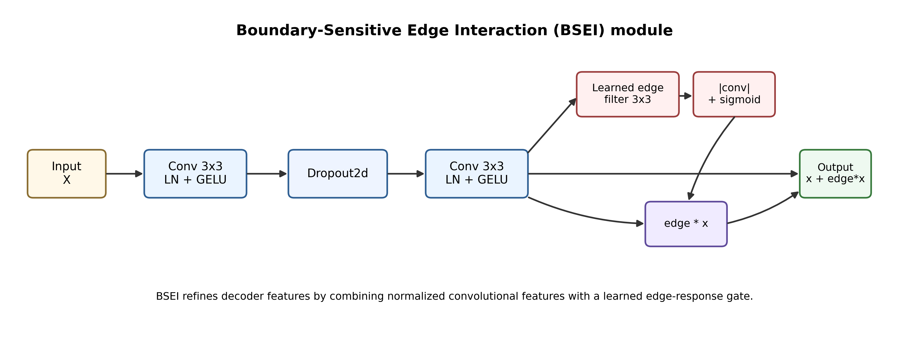
Figure 2. Internal structure of the BSEI module. The module transforms the input using Conv-LN-GELU blocks, obtains a learned edge-response gate, and returns an edge-modulated residual feature map.

3.4 Initialization and transfer learning
The encoder can be initialized from ImageNet-pretrained ConvNeXt weights. During weight loading, optional prefix adaptation is supported for checkpoints containing a backbone prefix. Decoder and segmentation-head convolutional layers are initialized with Kaiming normal initialization, and LayerNorm affine parameters are initialized to unit scale and zero bias. Two training strategies should be compared: (1) freeze the encoder for decoder warm-up and then unfreeze it, and (2) train the full network end-to-end with differential learning rates.

3.5 Loss function
The final loss should be selected after validation. For binary polyp segmentation, a compound objective is recommended because it combines pixel-level calibration with overlap-based optimization. The default candidate loss is:
L_total = lambda_bce * BCEWithLogits(Z, G) + lambda_dice * DiceLoss(sigmoid(Z), G) + lambda_iou * IoULoss(sigmoid(Z), G)
where G is the ground-truth mask and Z is the predicted logit map. If boundary performance is a key contribution, an additional boundary-aware term or weighted BCE/IoU term can be used after experimental validation. Loss weights are placeholders: lambda_bce=[TBD], lambda_dice=[TBD], lambda_iou=[TBD].

4. Experimental setup
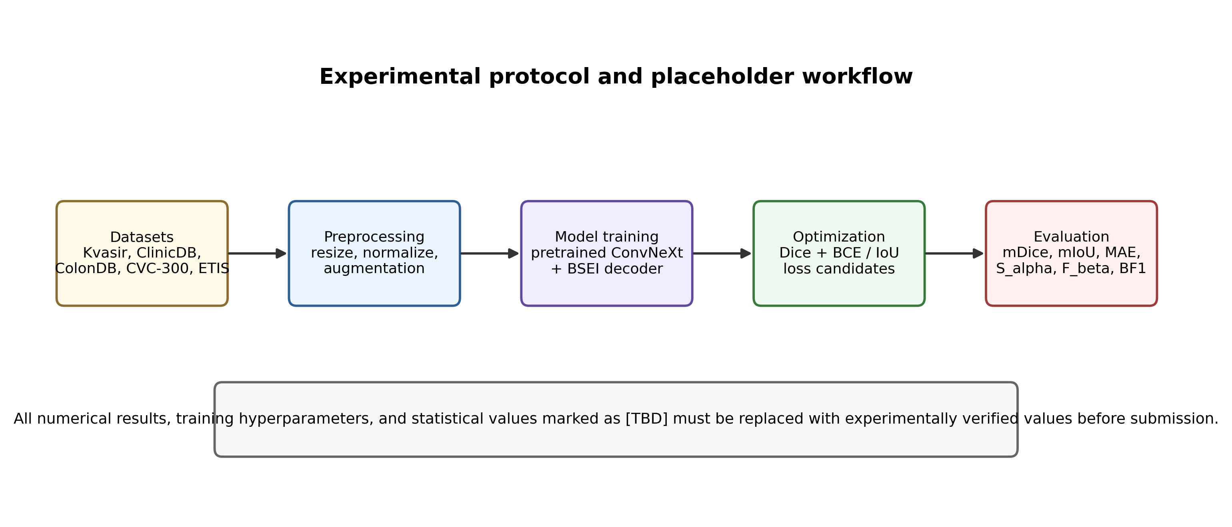
Figure 3. Experimental protocol. The workflow is structured to support reproducible training, cross-dataset testing, ablation, and efficiency evaluation.

4.1 Datasets
Experiments should follow the common protocol used in recent polyp segmentation literature: training on Kvasir-SEG and CVC-ClinicDB and evaluating both in-domain and cross-domain generalization on unseen datasets such as CVC-ColonDB, CVC-300, and ETIS-LaribPolypDB [5-9,10,14,20]. Dataset split details must be updated to match the final experimental implementation.
Table 2. Dataset summary and planned split. Values marked [TBD] should be replaced with the exact split used in the experiments.
Dataset | Images | Image size / input size | Training | Testing | Role
Kvasir-SEG | 1000 | Variable / 352 x 352 | 900 or [TBD] | 100 or [TBD] | Seen benchmark
CVC-ClinicDB | 612 | 384 x 288 / 352 x 352 | 551 or [TBD] | 61 or [TBD] | Seen benchmark
CVC-ColonDB | 380 | 574 x 500 / 352 x 352 | - | 380 or [TBD] | Unseen benchmark
CVC-300 | 60 | 574 x 500 / 352 x 352 | - | 60 or [TBD] | Unseen benchmark
ETIS-LaribPolypDB | 196 | 1225 x 966 / 352 x 352 | - | 196 or [TBD] | Unseen benchmark

4.2 Implementation details
The model is implemented in PyTorch. Unless otherwise stated, all images are resized to [TBD] x [TBD], normalized using [TBD] mean and standard deviation, and augmented with random horizontal/vertical flipping, random rotation, random scale/crop, and color perturbation. The optimizer, learning-rate schedule, batch size, epochs, warm-up strategy, mixed precision setting, and hardware must be replaced with the exact experimental values.
Table 3. Training and inference settings.
Item | Value
Framework | PyTorch [version TBD]
Input resolution | [352 x 352] or [TBD]
Optimizer | AdamW / Adam / SGD [TBD]
Initial learning rate | [TBD]
Weight decay | [TBD]
Batch size | [TBD]
Epochs | [TBD]
Learning-rate schedule | Cosine / polynomial / step [TBD]
Loss function | BCE + Dice + IoU or [TBD]
GPU | [TBD]
Evaluation threshold | 0.5 or [TBD]

4.3 Evaluation metrics
The model should be evaluated using overlap, structure, error, and boundary metrics. The main metrics are mean Dice coefficient (mDice), mean intersection-over-union (mIoU), weighted F-measure, structure measure, enhanced alignment measure, mean absolute error (MAE), and boundary F1. Efficiency should be reported using trainable parameters, GFLOPs, inference latency, and FPS.
Table 4. Evaluation metrics.
Metric | Purpose | Preferred direction
mDice | Measures overlap between predicted mask and ground truth | Higher is better
mIoU | Measures intersection-over-union between prediction and ground truth | Higher is better
F_beta^w | Measures weighted precision-recall balance | Higher is better
S_alpha | Measures object- and region-aware structural similarity | Higher is better
E_phi | Measures enhanced pixel/image-level alignment | Higher is better
MAE | Measures pixel-wise probability error | Lower is better
BF1 | Measures boundary alignment quality | Higher is better
Params / GFLOPs / FPS | Measures computational efficiency | Lower / lower / higher

5. Results

5.1 Quantitative comparison
Table 5 is prepared for comparison against representative CNN, transformer, hybrid, and lightweight polyp segmentation models. The final manuscript should report mean and standard deviation across repeated runs, if available. Values are intentionally left as placeholders until the final trained model is evaluated.
Table 5. Quantitative comparison on public polyp segmentation benchmarks. Replace all [TBD] values with verified results.
Method | Year | Type | Kvasir mDice | ClinicDB mDice | ColonDB mDice | ETIS mDice
U-Net [3] | 2015 | CNN | [TBD] | [TBD] | [TBD] | [TBD]
U-Net++ [TBD] | 2018 | CNN | [TBD] | [TBD] | [TBD] | [TBD]
PraNet [10] | 2020 | CNN/attention | [TBD] | [TBD] | [TBD] | [TBD]
CaraNet [11] | 2022 | CNN/attention | [TBD] | [TBD] | [TBD] | [TBD]
Polyp-PVT [14] | 2023 | Transformer | [TBD] | [TBD] | [TBD] | [TBD]
CAFE-Net [15] | 2024 | Transformer | [TBD] | [TBD] | [TBD] | [TBD]
CIFFormer [18] | 2025 | Transformer | [TBD] | [TBD] | [TBD] | [TBD]
HCA-Net [20] | 2026 | Attention/hybrid | [TBD] | [TBD] | [TBD] | [TBD]
BSEI-ConvNeXt U-Net (Ours) | - | ConvNeXt CNN | [TBD] | [TBD] | [TBD] | [TBD]

Table 6. Full metric table for the proposed method. Add one row per dataset after evaluation.
Dataset | mDice | mIoU | F_beta^w | S_alpha | E_phi | MAE | BF1
Kvasir-SEG | [TBD] | [TBD] | [TBD] | [TBD] | [TBD] | [TBD] | [TBD]
CVC-ClinicDB | [TBD] | [TBD] | [TBD] | [TBD] | [TBD] | [TBD] | [TBD]
CVC-ColonDB | [TBD] | [TBD] | [TBD] | [TBD] | [TBD] | [TBD] | [TBD]
CVC-300 | [TBD] | [TBD] | [TBD] | [TBD] | [TBD] | [TBD] | [TBD]
ETIS-LaribPolypDB | [TBD] | [TBD] | [TBD] | [TBD] | [TBD] | [TBD] | [TBD]

5.2 Qualitative comparison
Figure 4 provides a placeholder layout for qualitative comparison. The final version should include representative cases covering large polyps, small polyps, low-contrast polyps, boundary-ambiguous cases, and failure examples. Each row should contain the input image, ground truth, prediction, and error/boundary visualization.
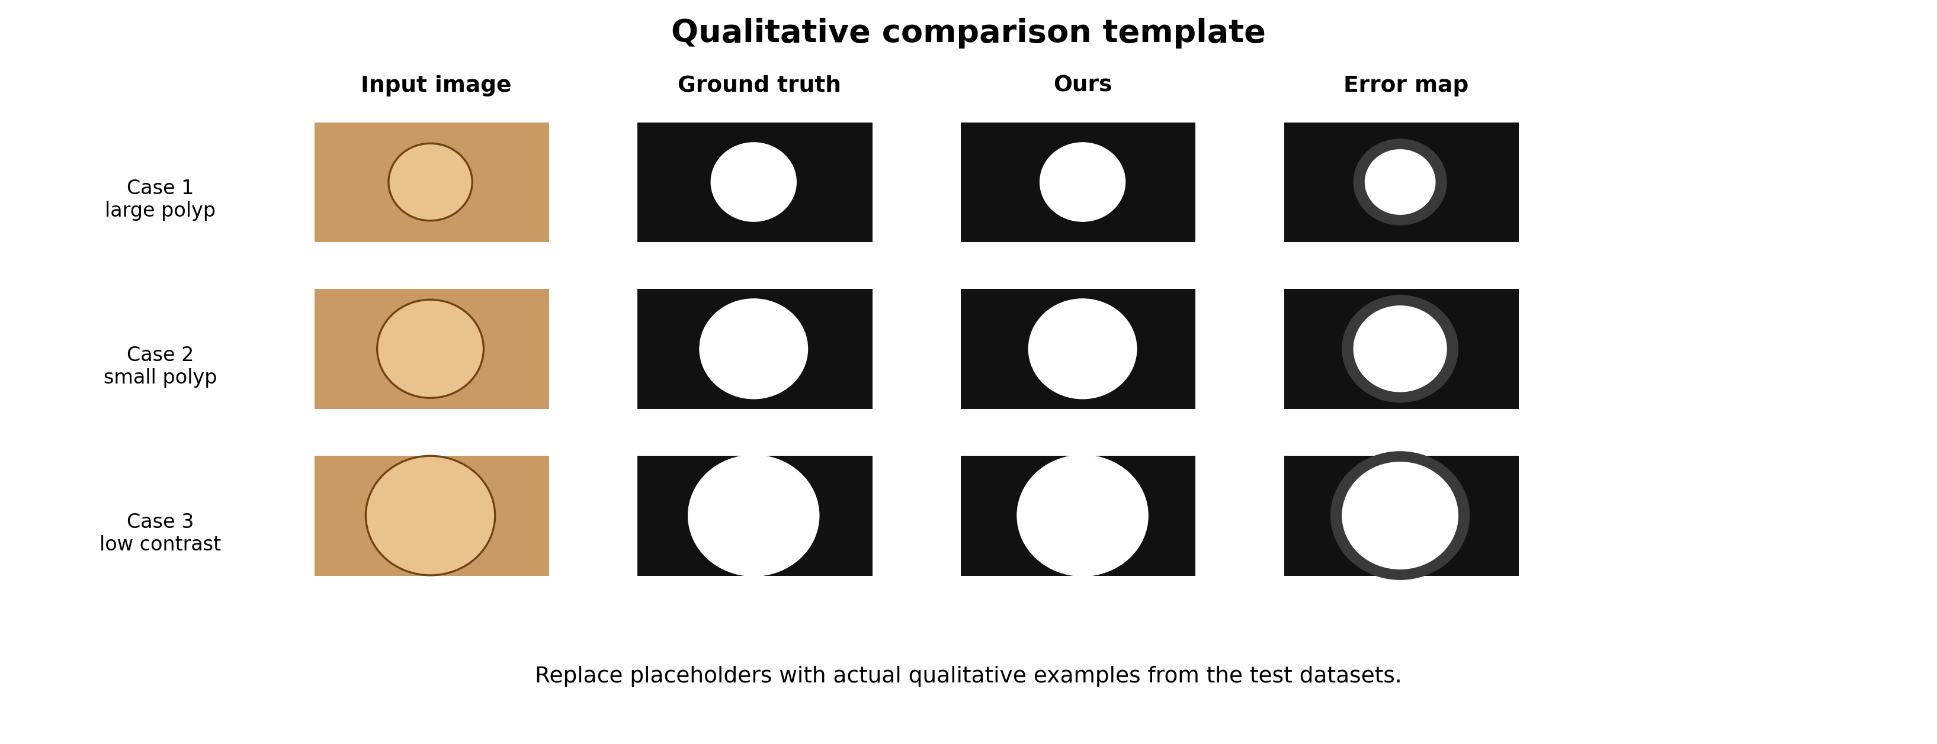
Figure 4. Qualitative comparison template. Replace synthetic placeholders with actual images, ground-truth masks, predictions, and error maps from the test sets.

5.3 Ablation study
The ablation study should isolate the contribution of each architectural decision. At minimum, compare a baseline ConvNeXt U-Net without BSEI, the full BSEI decoder, pretrained versus non-pretrained encoder initialization, frozen-warmup versus full fine-tuning, and different dropout/drop-path settings.
Table 7. Suggested ablation study on the proposed architecture.
Configuration | Pretrained encoder | BSEI | Dropout | mDice | mIoU | MAE
ConvNeXt U-Net baseline | Yes/No [TBD] | - | [TBD] | [TBD] | [TBD] | [TBD]
+ unified LayerNorm/GELU decoder | Yes/No [TBD] | - | [TBD] | [TBD] | [TBD] | [TBD]
+ BSEI at decoder levels 2-4 | Yes/No [TBD] | Partial | [TBD] | [TBD] | [TBD] | [TBD]
+ BSEI at all decoder levels | Yes/No [TBD] | Full | [TBD] | [TBD] | [TBD] | [TBD]
+ encoder warm-up then fine-tuning | Yes | Full | [TBD] | [TBD] | [TBD] | [TBD]
Full proposed model | Yes | Full | [TBD] | [TBD] | [TBD] | [TBD]

5.4 Computational efficiency
Efficiency should be reported at the same input size and hardware setting used by baseline methods. If comparisons are made from published values, clearly distinguish reproduced results from reported values. Inference speed should be measured with warm-up iterations, synchronized GPU timing, fixed batch size, and no data-loading overhead.
Table 8. Computational complexity and speed comparison.
Method | Params (M) | GFLOPs | Latency (ms) | FPS | Input size | Hardware
U-Net [3] | [TBD] | [TBD] | [TBD] | [TBD] | 352 x 352 | [TBD]
PraNet [10] | [TBD] | [TBD] | [TBD] | [TBD] | 352 x 352 | [TBD]
Polyp-PVT [14] | [TBD] | [TBD] | [TBD] | [TBD] | 352 x 352 | [TBD]
HCA-Net [20] | [TBD] | [TBD] | [TBD] | [TBD] | 352 x 352 | [TBD]
BSEI-ConvNeXt U-Net (Ours) | [TBD] | [TBD] | [TBD] | [TBD] | 352 x 352 | [TBD]

6. Discussion
The proposed model is motivated by the observation that polyp segmentation requires both high-level semantic discrimination and precise boundary recovery. The ConvNeXt encoder provides multi-scale hierarchical representations with modern convolutional design, while the BSEI decoder provides explicit edge-sensitive modulation during feature reconstruction. This combination is expected to be effective for low-contrast and boundary-ambiguous cases.
Compared with transformer-heavy designs, the proposed method maintains a convolutional representation throughout the network. This can simplify deployment and reduce implementation complexity, especially in settings where deterministic inference speed and compatibility with medical imaging systems are important. The final computational advantage must be confirmed by parameter, GFLOP, and latency measurements under controlled conditions.
A potential limitation is that BSEI currently derives its edge response from decoder features without direct boundary supervision. If final boundary metrics are weaker than expected, future work should evaluate explicit boundary targets, Sobel-derived weighting, contour losses, or auxiliary edge prediction. Another limitation is that the model is developed for 2D colonoscopy images; extension to video or volumetric medical data would require temporal or 3D context modeling.

7. Conclusion
This paper presents BSEI-ConvNeXt U-Net, a boundary-enhanced ConvNeXt encoder-decoder architecture for colorectal polyp segmentation. The model combines hierarchical ConvNeXt feature extraction with a BSEI decoder module that applies learned edge-response modulation to refine skip-fused feature maps. The manuscript provides a complete Elsevier-style structure, figures, methodology, experimental protocol, ablation plan, and placeholder tables for final quantitative results. Once the placeholders are replaced with verified experimental data, the paper can be adapted to the specific formatting and reference requirements of the selected Elsevier journal.

Declarations
Funding: [TBD].
Conflict of interest: The authors declare that they have no known competing financial interests or personal relationships that could have appeared to influence the work reported in this paper. Replace if needed.
Ethical approval: This study uses publicly available de-identified datasets. Institutional review board approval is [not required / TBD] depending on the final data source.
Data availability: Public datasets used in this study include Kvasir-SEG, CVC-ClinicDB, CVC-ColonDB, CVC-300, and ETIS-LaribPolypDB. Final download links and preprocessing scripts should be provided after release.
Code availability: The source code and trained weights will be made available at [TBD] upon acceptance/publication.
CRediT authorship contribution statement: [TBD].
Declaration of generative AI and AI-assisted technologies in the writing process: During preparation of this draft, AI-assisted writing support was used to structure and language-edit the manuscript. The authors must review, edit, and approve all content before submission, and the final declaration must follow the selected journal policy.

References
[1] Roshandel G, Ghasemi-Kebria F, Malekzadeh R. Colorectal cancer: epidemiology, risk factors, and prevention. Cancers. 2024;16(8):1530.
[2] Mei J, Zhou T, Huang K, Zhang Y, Zhou Y, Wu Y, Fu H. A survey on deep learning for polyp segmentation: techniques, challenges and future trends. Visual Intelligence. 2025;3(1):1. https://doi.org/10.1007/s44267-024-00071-w.
[3] Ronneberger O, Fischer P, Brox T. U-Net: Convolutional networks for biomedical image segmentation. In: Medical Image Computing and Computer-Assisted Intervention - MICCAI 2015. Springer; 2015. p. 234-241. https://doi.org/10.1007/978-3-319-24574-4_28.
[4] Liu Z, Mao H, Wu C-Y, Feichtenhofer C, Darrell T, Xie S. A ConvNet for the 2020s. In: Proceedings of the IEEE/CVF Conference on Computer Vision and Pattern Recognition. 2022. p. 11976-11986. https://doi.org/10.1109/CVPR52688.2022.01167.
[5] Jha D, Smedsrud PH, Riegler MA, Halvorsen P, de Lange T, Johansen D, Johansen HD. Kvasir-SEG: a segmented polyp dataset. In: MultiMedia Modeling. Springer; 2020. p. 451-462. https://doi.org/10.1007/978-3-030-37734-2_37.
[6] Bernal J, Sanchez FJ, Fernandez-Esparrach G, Gil D, Rodriguez C, Vilarino F. WM-DOVA maps for accurate polyp highlighting in colonoscopy: validation vs. saliency maps from physicians. Computerized Medical Imaging and Graphics. 2015;43:99-111. https://doi.org/10.1016/j.compmedimag.2015.02.007.
[7] Tajbakhsh N, Gurudu SR, Liang J. Automated polyp detection in colonoscopy videos using shape and context information. IEEE Transactions on Medical Imaging. 2016;35(2):630-644.
[8] Vazquez D, Bernal J, Sanchez FJ, Fernandez-Esparrach G, Lopez AM, Romero A, Drozdzal M, Courville A. A benchmark for endoluminal scene segmentation of colonoscopy images. Journal of Healthcare Engineering. 2017;2017:4037190.
[9] Silva J, Histace A, Romain O, Dray X, Granado B. Toward embedded detection of polyps in WCE images for early diagnosis of colorectal cancer. International Journal of Computer Assisted Radiology and Surgery. 2014;9(2):283-293.
[10] Fan D-P, Ji G-P, Zhou T, Chen G, Fu H, Shen J, Shao L. PraNet: parallel reverse attention network for polyp segmentation. In: MICCAI 2020. Springer; 2020. p. 263-273. https://doi.org/10.1007/978-3-030-59725-2_26.
[11] Lou A, Guan S, Ko H, Loew MH. CaraNet: context axial reverse attention network for segmentation of small medical objects. Medical Imaging 2022: Image Processing. SPIE; 2022.
[12] Jha D, Riegler MA, Johansen D, Halvorsen P, Johansen HD. DoubleU-Net: a deep convolutional neural network for medical image segmentation. In: CBMS 2020. IEEE; 2020.
[13] Chen J, Lu Y, Yu Q, Luo X, Adeli E, Wang Y, Lu L, Yuille AL, Zhou Y. TransUNet: transformers make strong encoders for medical image segmentation. arXiv:2102.04306; 2021.
[14] Dong B, Wang W, Fan D-P, Li J, Fu H, Shao L. Polyp-PVT: polyp segmentation with pyramid vision transformers. CAAI Artificial Intelligence Research. 2023;2:9150015.
[15] Liu G, Yao S, Liu D, Chang B, Chen Z, Wang J, Wei J. CAFE-Net: cross-attention and feature exploration network for polyp segmentation. Expert Systems with Applications. 2024;238:121754.
[16] Lin L, Lv G, Wang B, Xu C, Liu J. Polyp-LVT: polyp segmentation with lightweight vision transformers. Knowledge-Based Systems. 2024;300:112181.
[17] Wang S, Lin S, Sun F, Li X. Multi-feature fusion for accurate polyp segmentation using pyramid visual transformers. Expert Systems with Applications. 2025;280:127558.
[18] Xu C, Lin L, Wang B, Liu J. CIFFormer: a contextual information flow guided transformer for colorectal polyp segmentation. Neurocomputing. 2025;644:130413.
[19] Pan X-L, Ding J-R, Li X, Liu S, Wang J, Hua B, Tang G-Z, Zhong C-H. MSBP-Net: a multi-scale boundary prediction network for automated polyp segmentation. Pattern Recognition. 2026;170:112101.
[20] Li C, Xu H, Zhu X, Chen H, Liu X, Liu Y, Tang C, Chen Z, Li M, Lu S, Hu Y. HCA-Net: hierarchical contextual attention network for lightweight and accurate polyp segmentation. IEEE Journal of Biomedical and Health Informatics. 2026. https://doi.org/10.1109/JBHI.2026.3657790.
[21] Xu H, Wang J, Li Z, Teng S, Cheng X. Lite-PolypNet: a lightweight and efficient network for polyp segmentation in colonoscopy images. International Journal of Imaging Systems and Technology. 2025;35(5):e70215.
[22] Wang Z, Li T, Liu M, Jiang J, Liu X. DCATNet: polyp segmentation with deformable convolution and contextual-aware attention network. BMC Medical Imaging. 2025;25:120. https://doi.org/10.1186/s12880-025-01661-w.
[23] Zeng J, Santosh KC, Nayak DR, de Lange T, Varkey J, Berzin T, Jha D. FocusNet: transformer-enhanced polyp segmentation with local and pooling attention. arXiv:2504.13597; 2025.
[24] Islam MM, et al. QPolypNet: a quantum-inspired deep learning model for polyp segmentation. In: ICCV 2025 Workshop on Computer Vision for Automated Medical Diagnosis; 2025.
[25] Kirillov A, Mintun E, Ravi N, Mao H, Rolland C, Gustafson L, et al. Segment anything. In: Proceedings of the IEEE/CVF International Conference on Computer Vision. 2023. p. 4015-4026.
[26] Han K, Wang Y, Chen H, Chen X, Guo J, Liu Z, et al. A survey on vision transformer. IEEE Transactions on Pattern Analysis and Machine Intelligence. 2022;45(1):87-110.
[27] Rahman MM, Marculescu R. Medical image segmentation via cascaded attention decoding. In: Proceedings of the IEEE/CVF Winter Conference on Applications of Computer Vision. 2023. p. 6222-6231.

