**Natural Language Processing (NLP) Tasks: We will address few here using PDI.**

DB Diagram: <https://dbdiagram.io/d/ChatGpt_PDI-67c71518263d6cf9a030e12c>

#Testing to see SQL works!!

#Translation, Sentiment, NER, bigrams, PoS

#Sentence Similarity

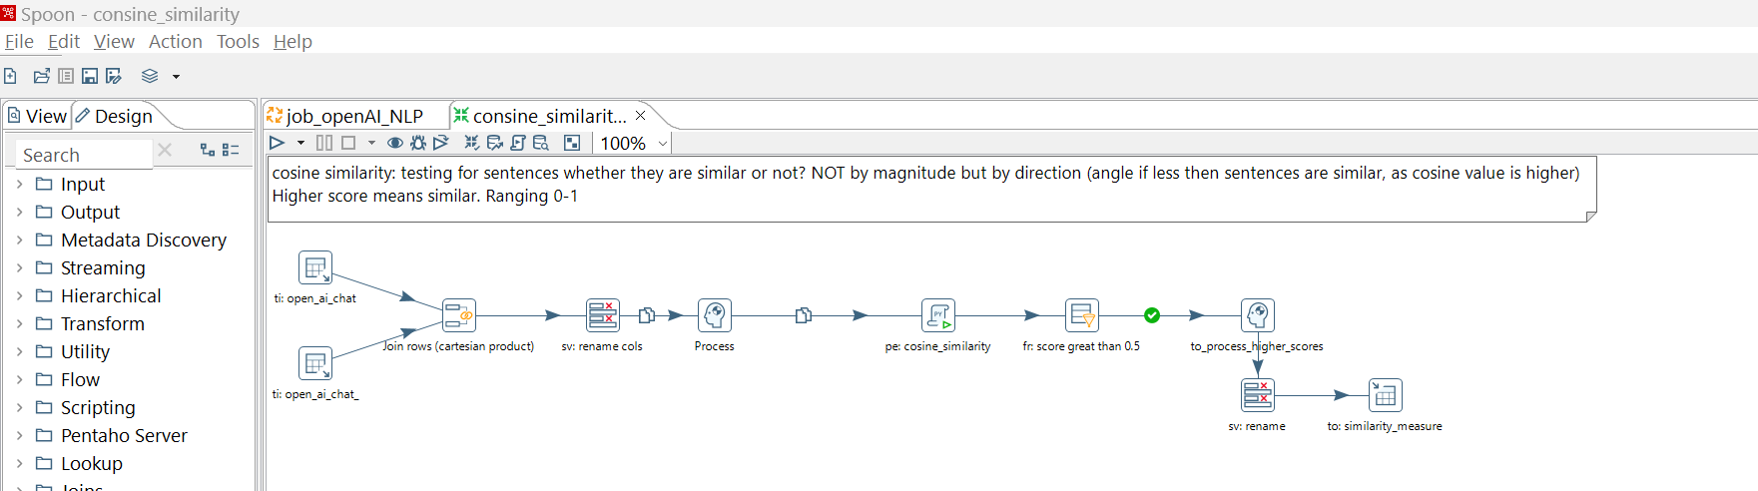

--Co-Reference

