**CHARITY-GLOBAL (CG)**



**Project Proposal**

For

Online Charity Management Software

**(Software Section)**

**Software Proposal**

**(P1.0 version 1.0)**

**For Project**

**Online Charity Management System Software**

**ID #CG-001.0-V.1**

**Version 1.0**

**Date of printing:**

**Responsible: 1. Fariya Tanjin**

**E-mail: 19320cse20030@gmail.com**

**Mobile:**

**Website: fariyatanjin.com**

**2. Zeesan Mahbub Chowdhury**

**E-mail: 19320cse20006@gmail.com**

**Mobile:**

**Website: zeesanmchowdhury.com**

**Company Website: https://shoto2020.github.io/oop-project/**

**Document History:**

June 2021 Visit the Charity-Global office (our customer)

19/06/2021 Create a proposal & present it in the internal meeting

26/06/2021 Prepare a Proposal and send it through e-mail.

**Responsible Persons:**

**Name Signature**

**Fariya Tanjin ………………………………………….. -------------------**

Email:19320cse20030@gmail.com mobile:

**Zeesan Mahbub Chowdhury………………………………….. -------------------**

Email: 19320cse20006@gmail.com mobile:

**Agreed Team members:**

**Name Signature**

**Md Abu Hurayra Uchchas …………..……………………….. -------------------------**

Email:19320cse20041@gmail.com mobile:

**Abul Kalam ………….……………………………………….. ---------------------------**

Email:19320cse20002@gmail.com mobile:

**Amira Mostafa Chowdhury……………..…………………….. --------------------------**

Email:19320cse20029@gmail.com mobile:

**Satodhru Das……………………….……..…………………….. --------------------------**

Email:17120cse20154@gmail.com mobile:

**CHAIRPERSON OF CG  
  
Name Signature**

**Shafkat Kibria……………..………………………..……. ---------------------------**

Email:shafkat80@gmail.com mobile:

**TABLE OF CONTENTS**

1 PROBLEM HISTORY 6

2 PROBLEM STATEMENT 7

2.1 Scope of the project 8

2.2 User of the Software 8

2.3 Proposed Software feature 9

3 Proposal 10

3.1 Technical Proposal 10

4 DIAGRAMS…………………………………………………………...11

4.1 Class Diagram……………………………………………………....11

4.2 Sequence Diagram………………………………………………….12

5 WORK PLAN.........................................................................................14

5.1 Work Divisions……………………………………………………14

6 PROJECT BOUNDARY AND DELIVERIES………………………..15

6.1 Project Boundary 15

6.2 Project Limitation 15

6.3 Project Delivery 15

7 Company’s experience 16

8 Glossary 17

1. **PROBLEM HISTORY**

Our customer, Charity-Global is currently managing the donations to coordinate the amount to be given as donations by using a manual system. To run the activities successfully, they are required to do the manual registration. The list of the philanthropists along with their donations are done manually using forms, logbooks and registers. This leads to numerous problems, as information sharing becomes slow, difficulties in making quick brief summary reports, difficulty to manage a large queue of volunteers, also having problems in applicants and members management etc. Our customer wants a software solution to this problem.

1. **PROBLEM STATEMENT**

The donation registration is a primary task for the Charity-Global. Here, the important issue is the applicant’s management and donation management process. It is a difficult task to manage and fill-up a form for applicants to donate and the donation amount manually. They are numerous ways to solve this issue using software system and applicants can register quickly rather than manual system.

In the manual applicant registration system, there are many redundant of works by keeping the same record in members or volunteers profile. By using software system, it is possible to reduce these redundant works and accelerate the activities.

They also found difficulties in member’s management task. A member management software system can easily these artifacts and all the members’ information properly.

At this charity organization, there are several activities where our customers are facing difficulties like how the volunteers can register themselves, how the applicants can register themselves, how the members can donate by logging into their id, how the donation amount is managed and how the admin works. These all tasks can be made easy for our customers using the software.

They also need proper guideline and suggestion about the hardware requirement and network architect as per software system requirement. Hardware requirement and network architecture will be suggested considering their existing hardware equipment and network architecture.

**2.1 Scope of the Project**

The scope of the project is mainly to focus on the organization’s applicant management and their donations along with volunteers, members and administration management.

**2.2 User of the Project**

The user of this software are the members, new applicants, volunteers and the administration.

*Fig 1: Users of the Software*

## Proposed Software feature

Database:

MySQL database Server –

OS: UNIX/ LINUX/WINDOWS etc.

Application Server:

MySQL database Server –

OS: WINDOWS for Application Server

Software use:

PHP 5.4.7

MySQL 5.6

Ajax

JavaScript

HTML, HTML5, CSS

Other features:

1. Web-based
2. User Friendly
3. Reduce Redundant Works
4. Faster & Efficient

# Proposal

## Technical Proposal:

|  |  |  |  |
| --- | --- | --- | --- |
| **Proposed Software** | **Project Duration** | **Total No. of System Analysts, Designers and Developers, web master, quality assurance involvement** | **Total Man-months** |
| *Online charity management software* | *1month* | *6* | *1 Man-months* |
| ***Total*** | ***1month*** | ***6*** | 1. ***Man-months*** |

***List of Professionals involvement in the project***

|  |  |  |
| --- | --- | --- |
| **List of Technical persons** | **Total No. persons involved** | **Experience in IT Field**  **(in years)** |
| *Project Manager & software developer* | *2 (Two)* | *2+ yrs.* |
| *System Designer* | *1 (One)* | *1+ yrs.* |
| *Web master* | *1 (One)* | *1+yrs* |
| *Tech.report writer* | *2 (Two)* | *1+yrs* |
| ***Total No. of Persons*** | ***6 (six)*** |  |

## DIAGRAMS

## 4.1 Class Diagram

1

to

1

t

1

o

1

1

to

1

1

to

1

1

to

1

t

1

o 1

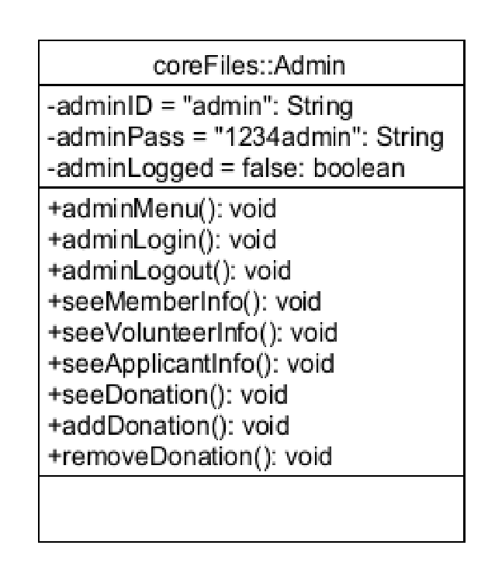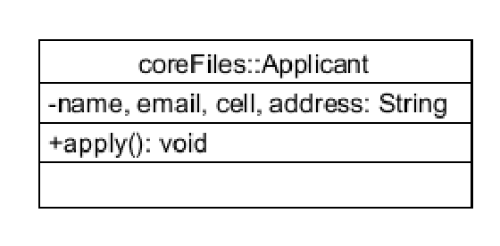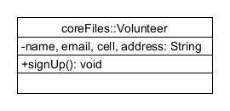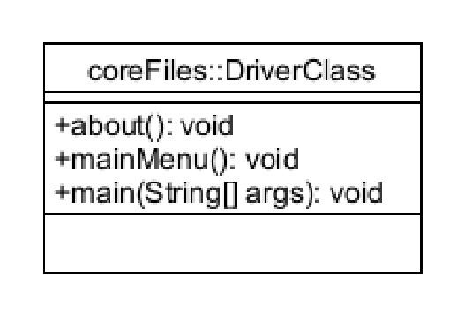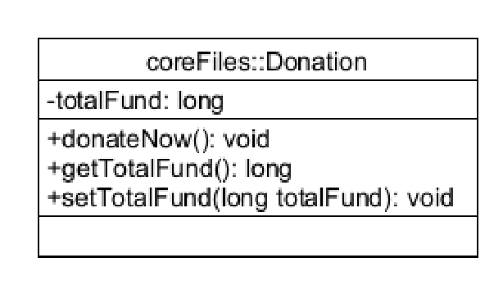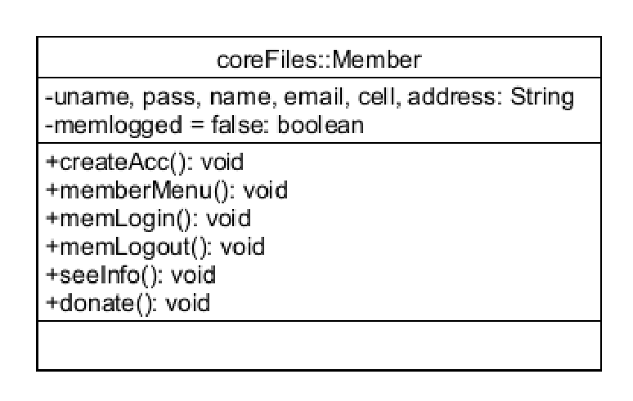

## Fig 2: Class diagram of the software

## 4.2 Sequence Diagram

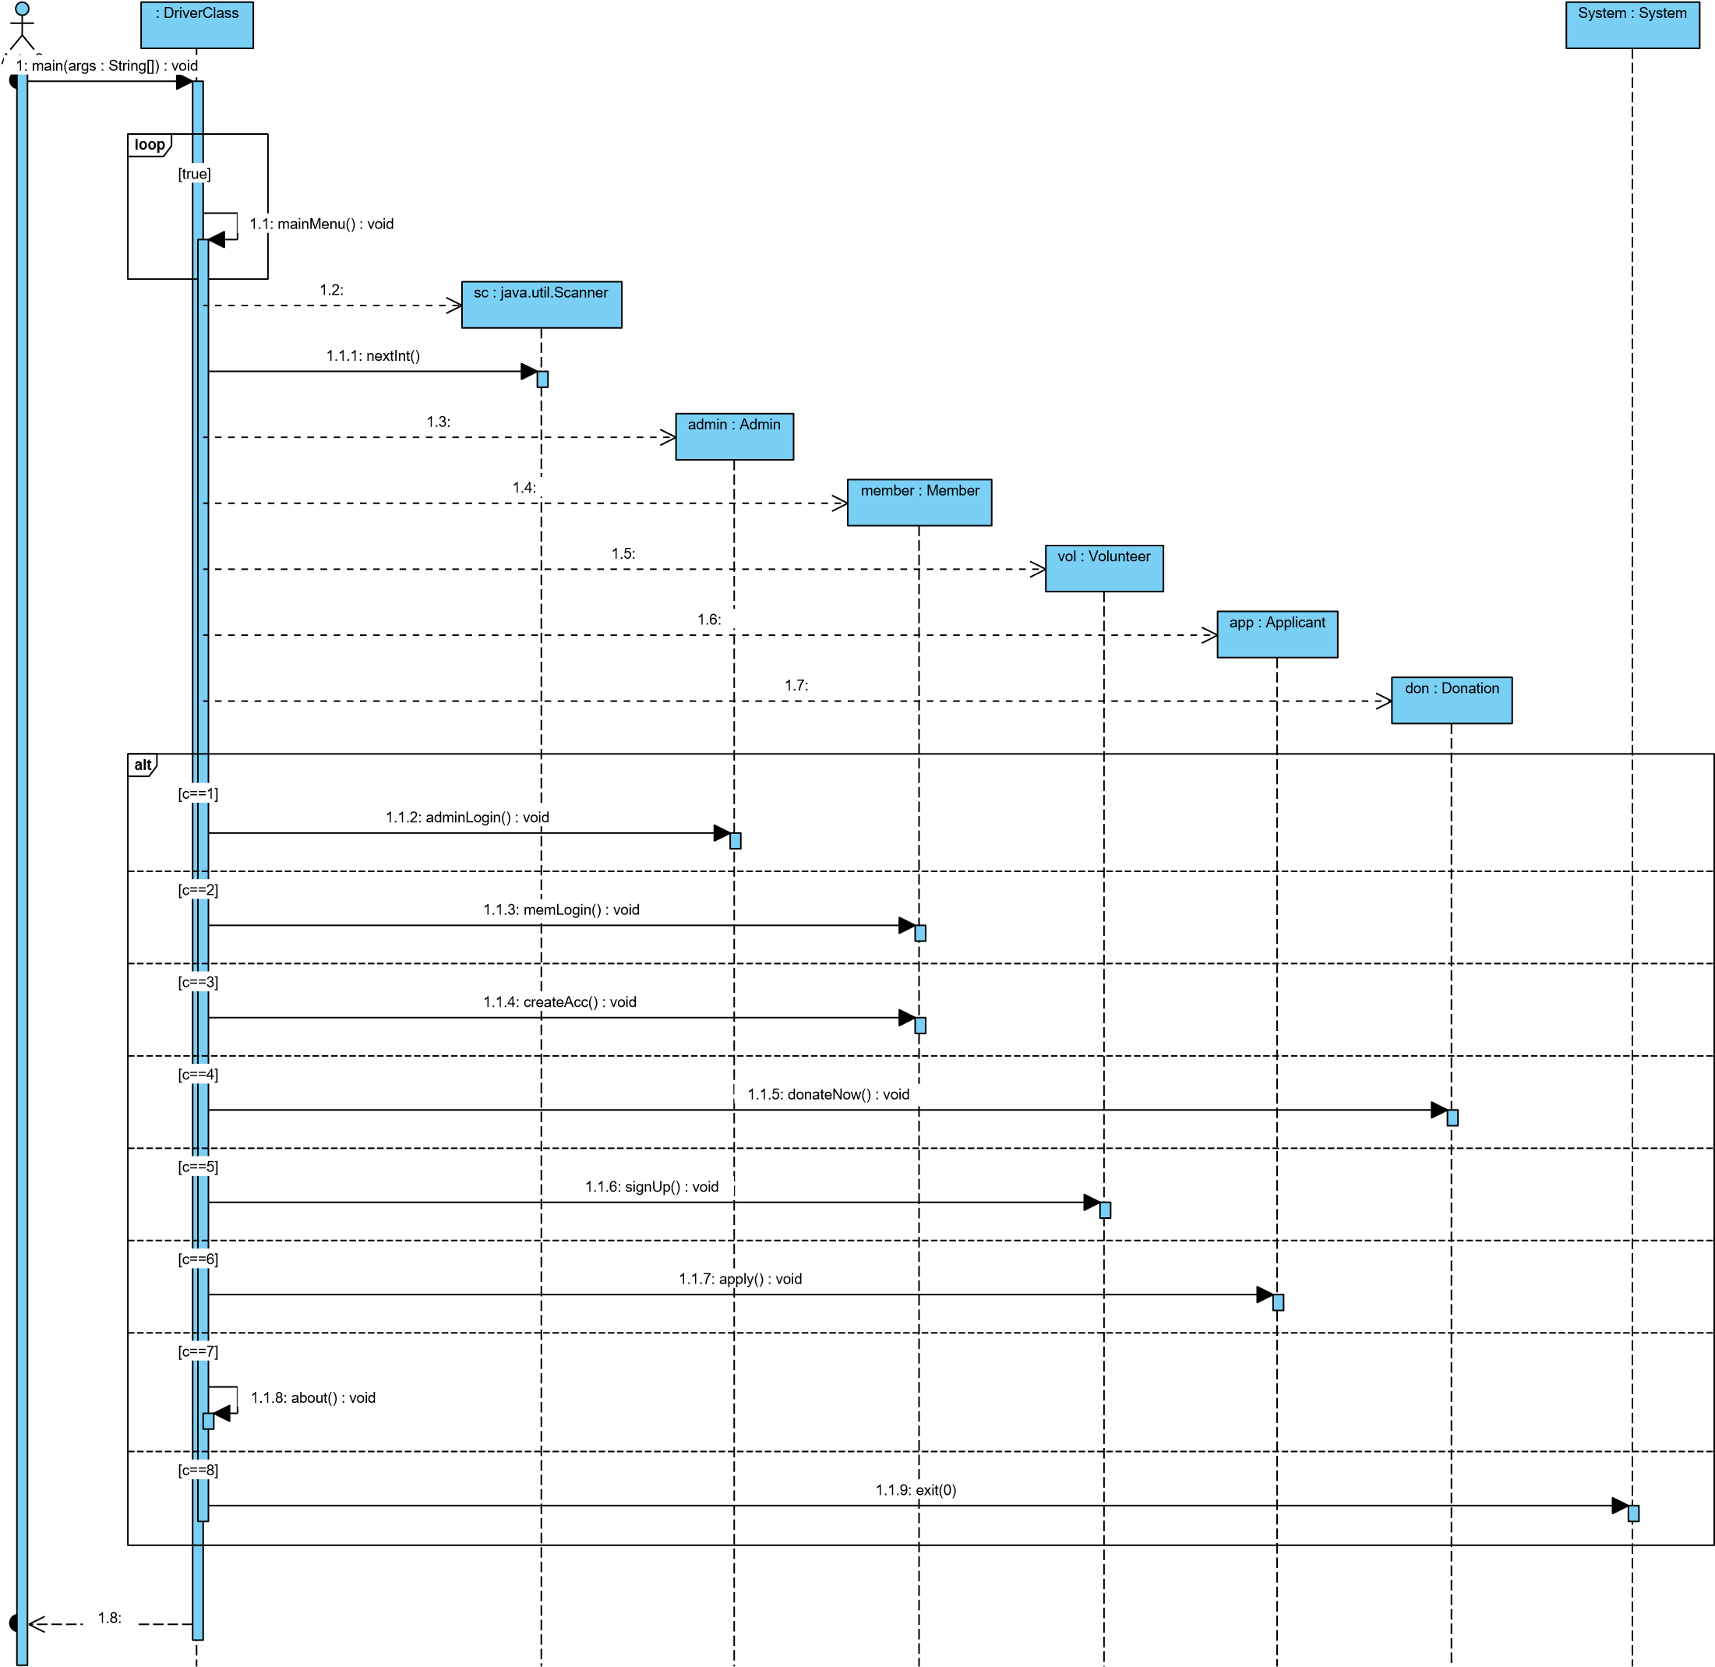

*Fig 3: Sequence Diagram (1) of the software*

## 

## Fig 4: Sequence Diagram (2) of the software

# 7. WORK PLAN

# Our team, which is full of experienced project workers, has made the planning and divided the tasks into individual fragments for faster and efficient result.

**7.1 Work Division**

* Project Leader and Core Programmer: Abu Hurayra Uchchas

His Main task is to manage the project work altogether and code for the same.

* Asisstant Programmer: Abul Kalam

His work is to assist the core programmer for coding the software.

* System Designer: Amira Mostafa Chowdhury

Her main job is to identify the problems occurring during the development of the software and finding an effective solution.

* Web Master: Satodhru Das

His job is to layout the webpage and updating it from time to time as the project progresses.

* Tech. Report Writer: Fariya Tanjin and Zeesan Mahbub Chowdhury

Both of them were assigned the task to give the project proposal.

**6. PROJECT BOUNDARIES AND DELIVERY**

## 6.1 Project Boundary

This project only enables registration of new applicants. It had fixed user id and password, which can be distributed, to the members after their membership. The organization can also donate after logging into their id. The volunteers are also registered into volunteers’ lists.

## Project Limitations

1. This project does not contain any realistic payments methods.
2. The members and volunteers do not have much profile details such as their photograph or identifications.
3. The user name and password are fixed.
4. The project needs more development for real life usage.
5. The use of basic security is done.

## Project Delivery

Online Charity Management System Project

Delivery Date: 27/06/2021

## COMPANY’S EXPERIENCE

**Company Information**

Our company is based on field. Here we work in web designing, web development and web related software.

OUR SERVICES:

1. Web designing in HTML CSS
2. Copy website
3. Word press website
4. University and school related software
5. Responsive website
6. Ecommerce and woo-commerce
7. CMS website

Our work base on:

1. PHP
2. HTML,HTML5
3. CSS,CSS3
4. J-query
5. MySQL database
6. PHP
7. JavaScript etc.

We have expert web developer, software engineer, system analyst please visit our website and know about us. Our Every member has experience in more than one year and working with IT field

# GLOSSARY

*Man-Month:* One person’s work in whole month.

*Fig:* Figure or an illustration*.*