Question 1：

a.

b. For the max delay situation. The reason is ai>ci-1. The previous job still processes at server. The next job has arrived. This situation indicates multiple jobs stack in the queue. When multiple jobs wait in the queue, this will be wait long time to process, and delay a lot.

c.

表格

This number is the service node jobs. Sum how much jobs int eh services node is equal to how long jobs process at service node.

d.

According to the experiment result. I can find that there are 723 of 1000 jobs. The proportion of jobs where delays is 72.30%.

The proportion of utilization:

表格

Question 2

a.

b.

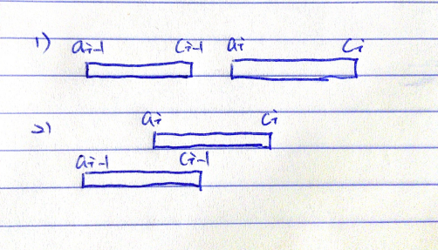

Question 3

a.







b.

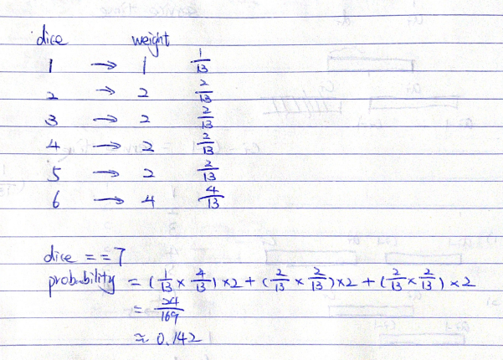

Question 4

a.





b.

The probability doesn’t depend on radium p. The probability only have relative with angle.

Option 1

手机屏幕截图

Option 2

