Samsung Electronics

Firm-Samsung Electronics
Vinay Krishna Patnana
Graduate DE Student
North Carolina State University
Unity Id: vkpatnan
Vinay Krishna Patnana
The document comprises my research proposal for the firm Samsung Electronics, to sustain its position as largest electronics manufacturer. The Knowledge Management Concepts used in this document are developed by Dr. Honeycutt over several years. My work comprises research about the firm, Samsung Electronics.

ACKNOWLEDGEMENT
I would like to acknowledge Dr. Honeycutt, the instructor for this course, for enlightening me on the concepts of business model and Knowledge warehousing and for providing invaluable knowledge in CSC546 course during the entire semester. Dr. Honeycutt gave us significant insights into the course in association with real world examples. His passion for the course and his way of explaining things kindled my enthusiasm for the subject.
I am indeed thankful to him for his valuable guidance in this course. As a Distance Education student, I really did not find any problem accessing the course or its material. The video lectures are quite informative. I sincerely thank Dr. Honeycutt for enlightening me with various Knowledge management concepts and techniques; it had been a great privilege having taken a course under his guidance.

SCOPE AND OBJECTIVES

This portfolio is prepared as a requirement for the course ― Management Decision and control Systems, during Summer 2011 under the guidance of Dr.Thomas L.Honeycutt.
The scope of this course was to learn how Knowledge Management is an integral part of today‘s world and how important it is in managing and controlling companies. The scope was also to provide precise characterizations of knowledge and skill in terms of detailed cognitive structures of knowledge and acquired cognitive processes that serve to generate the desired performance. It included study of the Knowledge Insight Model (KIM), the PDCA cycle and different processes which are essential for taking managerial decisions and to learn the concept of the Knowledge Creating Company.
The objectives of the course was teach the students about each of the model in depth, understand the models and the concept of the Knowledge Creating Company and apply the learning‘s by making a portfolio for a company applying these knowledge fundamentals.

Table of Contents
ACKNOWLEDGEMENT 2
SCOPE AND OBJECTIVES 3
Knowledge Management 7
References: 9
Section I – Assignment 1
Applying the Systems Model to the Business firm - Samsung Electronics 11
Abstract: 11
Samsung Electronics’ Environment: 11
Upstream Vendors: 12
Procurement Philosophy 12
Downstream Customers: 15
Input-Transformation-Output: 16
Quality-Cost-Delivery: 17
Quality-Cost-Delivery of vendors: 17
Quality-Cost-Delivery as viewed by customers: 19
Products, goods and services: 19
Key Products: 21
Section II– Assignment 2

Review of “Knowledge Enabled Organon” book: 27
Pattern: Knowledge Sharing with 2x2 Matrix 30
Inspirational Quotes: 30
Introduction: 30
Pattern Name: 32
Context: 32
Problem: 32
Forces: 33
Solution: 33
Examples: 34
Strategic frameworks: 34
Organizational Frameworks: 35
Individual Frameworks: 35
Resulting Context: 36
Rationale: 36
Known issues: 37
Related patterns: 37
References: 37
Section III – Paper 1- Company Prospectus……………………………………………………………………………… 38

Section IV – Inspirational Archetype………..……………………………………………………………………………… 65

Leonardo’s birth & childhood: [3] 67
The Last Supper:[4] 68
The Mona Lisa:[5] 69
The Vitruvian Man: The Proportions of the Human Figure [6] 69
Leonardo Da Vinci’s Inventions:[7] 70
Springs & Things: 71
References: 71
Section V – Paper II, Company proposal...……………………………………………………………………………… 74
Executive Summary 74
Business growth & Profits: 75
Current market share & outlook: 76
Innovative claims for the proposed research 77
Proposal Roadmap 79
Tangible benefits to end users: 80
Critical technical barriers: 80
Main elements of proposed research: 82
Rationale that the proposed approach will overcome the technical barriers: 83
Nature of expected results: 84
The Risk if the work is not done: 85
Criteria for scientific evaluation: 86
Cost of the proposed effort for each performance year: 87
Research Objectives: 89
Detailed Problem Description: 89
Research goals: 90
Extended Impact: 91
TECHNICAL APPROACH 92
Detailed Technical approach: PDCA cycle 92
Abstract Mandala Pattern & Knowledge Insight Model: 95
Application of 2x2 matrix for the current research proposal: 96
Comparison with the current technology: 100
Current Samsung’s smart TV frameworks: 100
Statement of Work 102
Future Goals and Objectives: 102
References: 103
Section VI – Humpty Dumpty Problem...……………………………………………………………………………… 105

Section I – Introduction

Knowledge Management

“Knowledge management will never work until corporations realize it's not about how you capture knowledge but how you create and leverage it."
~ Etienne Wenger

Knowledge Management (KM) comprises a range of strategies and practices used in an organization to identify, create, represent, distribute, and enable adoption of insights and experiences. Such insights and experiences comprise knowledge, either embodied in individuals or embedded in organizational processes and practice.
KM is rooted in many disciplines including business, economics, education, information management, psychology, and sociology among others. These areas have developed perspectives on the workings of individual and systemic knowledge. KM embraces these perspectives, but operates from the basic premise of the "sticky" nature of knowledge.


Different frameworks for distinguishing between different 'types of' knowledge exist. One proposed framework for categorizing the dimensions of knowledge distinguishes between tacit knowledge and explicit knowledge.
Tacit knowledge represents internalized knowledge that an individual may not be consciously aware of, such as how he or she accomplishes particular tasks.
At the opposite end of the spectrum, explicit knowledge represents knowledge that the individual holds consciously in mental focus, in a form that can easily be communicated to others.
Ikujiro Nonaka proposed a model (SECI for Socialization, Externalization, Combination, Internalization) which considers a spiraling knowledge process interaction between explicit knowledge and tacit knowledge. In this model, knowledge follows a cycle in which implicit knowledge is 'extracted' to become explicit knowledge, and explicit knowledge is 're-internalized' into implicit knowledge.
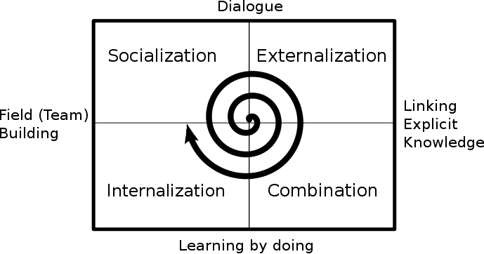
(Figure: The Knowledge Spiral as described by Nonaka & Takeuchi)

References:

- Knowledge Management Wikipedia: http://en.wikipedia.org/wiki/Knowledge_management
- About KM, Berkeley: http://www2.sims.berkeley.edu/courses/is213/s99/Projects/P9/web_site/about_km.html
- The SECI model of Knowledge creation: http://myweb.tiscali.co.uk/sngourlay/PDFs/Gourlay%202004%20SECI.pdf

ASSIGNMENT 1

Section II – Assignment I

Applying the Systems Model to the Business firm - Samsung Electronics

Abstract: The Systems Model of a Business Firm attempts to capture the dynamic process of information and resource flow for a firm, Samsung Electronics within the context of its surrounding environment.
The diagrammatic representation of the model of the business firm is below, and each of the components of the model as it applies to Samsung Electronics, will be explained in the ensuing sections.

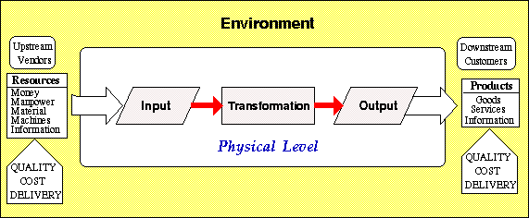
(Figure 1: Systems Model interaction with environment)
Source: Lecture Material CSC 546, http://courses.ncsu.edu/csc546/lec/651/systems_model_of_business_firm.html#III

Samsung Electronics’ Environment:

Upstream Vendors:

Source [1]: http://www.samsung.com/hk_en/aboutsamsung/companyprofile/majorstrategicalliances/CompanyProfile_MajorStrategicAlliances.html
Source [2]:
http://news.mk.co.kr/english/newsRead.php?rss=Y&sc=30800011&year=2010&no=410187
Source [3]:
http://www.koreaherald.com/national/Detail.jsp?newsMLId=20100816000846
Source [4]:
http://www.samsung.com/us/aboutsamsung/corpcitizenship/environmentsocialreport/environmentsocialreport_Partner.html
Source [5]:
http://www.samsung.com/us/aboutsamsung/sustainability/sustainabilityreports/download/2011/Samsung%20Electronics%202011%20Sustainability%20Report.pdf
Samsung Electronics pursues mutual interest in cooperative relationships with partner companies outsourced for material supplies, product part manufacturing, and services.
The partner companies Samsung Electronics referred to are those who supply materials, produce parts, or carry out services which the company outsourced.
Samsung Electronics calls its upstream vendors as Partners.

Procurement Philosophy

Open Sourcing

Samsung Electronics operates production plants in 14 countries overseas. The company maintains a purchasing policy of giving priority to competitive local suppliers, thereby contributing to the development of local communities.

Fair Trading

Samsung Electronics evaluate a company’s capabilities and their potential through objective assessments based on fair and effective selection criteria, and various efforts are made to prevent excessive competition among suppliers and violation of trade ethics. It strives for objective and rational purchasing based on adherence to local laws.

Win-Win Purchasing

Samsung Electronics pursue mutual advances with suppliers based on long-term partnerships. The company works together with partners for component quality improvement and cost savings. The company promotes an open and friendly environment in which its partners can freely express their views.
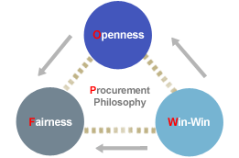
(Figure: Samsung Procurement philosophy)
There are many Japanese local companies the company relies on for its supplies, and the company reportedly has more than 800 primary suppliers of its raw materials.
The company is joining a growing number of conglomerates pursuing co-prosperity with smaller partners. The company reported that it would form a fund of USD 843.24 Million, which will be used to support supply facility investment, technology department and operation fund assistance.
Samsung Electronics has many Strategic partnership alliances with many world leading companies. Below, few are listed very briefly.

Partners | Date | Areas of Cooperation
Nokia | Apr. 2007 | Co-develop technology for handsets and DVB-H standardization solutions
Limo | Jan. 2007 | Establish a joint venture for developing a Linux platform (Samsung Electronics, Vodafone, DoCoMo, Motorola and NEC)
Alcatel | Oct. 2006 | Cooperate on satellite DVB-H
Sony (S-LCD) | Jul. 2006 | Jointly invest in 8th-generation LCD line (2200mm x 2500mm mother-glass)
IBM | Mar. 2006 | Co-develop and market technologies for industrial printer solutions
Intel & Microsoft | Mar. 2006 | Co-develop UMPCs
Discovery | Sept. 2005 | Cooperate on high-definition contents
Salvarani | Jul. 2005 | Co-develop new built-in products combining household electronics and furniture
Sun Microsystems | Jul. 2005 | Cooperation in solution business and next-generation business computing systems
Covad | Jul. 2005 | Supply access gateways
Lowe's | Jul. 2005 | Supply household electronics to 1,100 Lowe's stores
VDL | Feb. 2005 | Cooperate in commercialization of terrestrial DMB
Charter | Jan. 2005 | Co-develop cable broadcasting receiver and set-top box for digital TV Full-Duplex service
KDDI | Jan. 2005 | Supply CDMA2000 1xEV-DO network equipment in Eastern Japan
Bang & Olufsen | Nov. 2004 | Partner in home theater business
Kent State University | Oct. 2004 | Co-develop display technologies
Qualcomm | Jul. 2004 | Cooperation in MDDI (Mobile Display Data Interface) technology
Toshiba (TSST) | Apr. 2004 | Develop and market optical storage devices
Sony (S-LCD) | Mar. 2004 | Establish joint venture for 7th generation LCD (1870 x 2200 mm) line
IBM | Mar. 2004 | Co-develop nano-logic process technologies
Dell | Jan. 2004 | Supply multi-functional laser printers
Hewlett-Packard | Sept. 2003 | Share technology for ink-jet printers
Disney | Sept. 2003 | Supply "Movie Beam" set-top box for VOD
Napster | Sept. 2003 | Co-develop and market Samsung-Napster player
Sony | Aug. 2003 | Expand and consolidate memory stick business
NEC | Jul. 2003 | Cooperate in high-end business computer systems
Matsushita | Jan. 2003 | Standardize technology, co-produce and jointly market DVD recorders
Best Buy | Jul. 2002 | Sell side-by-side refrigerators through a network of more than 500 retailers
Microsoft | Nov. 2001 | Co-develop digital household electronics

Apart from this, for a wide range of collaboration and opportunities, including IP licensing and purchasing, VC investment, joint research and venture development, or M&A, the company has started an online portal called STSC (Samsung Technology Source Collaboration) to facilitate the potential partners to approach the company.
Few sample partners of Samsung via STSC are:







Source [6]: http://stsc.sisa.samsung.com/partners.html

Downstream Customers:

Samsung Electronics’ key customers are:

Samsung's key clients (Q1 2010)^{[45]}
Rank/company | Part description | Buying (trillion KRW) | Percent of total sales
1 Sony | DRAM, NAND flash, LCD panels, etc... | 1.28 | 3.7
2 Apple Inc | AP (mobile processor), DRAM, NAND flash, etc... | 0.9 | 2.6
3 Dell | DRAM, flat-panels, lithium-ion batteries, etc... | 0.87 | 2.5
4 HP | DRAM, flat-panels, lithium-ion batteries, etc... | 0.76 | 2.2
5 Verizon Communications | Handsets, etc... | 0.5 | 1.3
6 AT&T | Handsets, etc... | 0.5 | 1.3

Samsung Electronics is the world’s most popular consumer electronics brand, followed by Sony. Hence, the company’s huge customers are people across the world.
Source [7]: Global Interbrand Ranking
http://www.interbrand.com/en/best-global-brands/best-global-brands-2008/best-global-brands-2010.aspx

Input-Transformation-Output:

Source [8]: http://en.wikipedia.org/wiki/Samsung_Electronics
Source [9]: http://first.emeraldinsight.com/samples/samsung.pdf
Samsung Electronics is the world’s largest electronics company with 2010 revenue of 133.78 billion USD, headquartered in Samsung Town, Seoul, South Korea. It is the flagship subsidiary of the Samsung group. With assembly plants and sales networks in 65 countries across the world, Samsung has as many as 190,000 employees.
Samsung Electronics, being the world’s largest electronics company, the input is acquired in several ways, and it comes in various forms. The Samsung group of companies has large, complex, global supply chains in most of the products it manufactures and makes use of Supply Chain Management solutions and process innovations to support and improve its operations. Most notably, at Samsung Electronics, advanced planning and scheduling (APS) systems have been adopted since the 1990s and have brought the company many successes in terms of operational excellence. Recently, Samsung Electronics has ranked seventh in a respected analyst’s ranking of the global top 25 companies in supply chain excellence.
Given the huge number of businesses Samsung Electronics is involved in, the transformation methods very broadly include chip design & manufacturing, software design & development, embedded processor design, quality assurance, health and biological equipment manufacturing, TV panels manufacturing, digital appliances manufacturing, social awareness activities, sports activities sponsorship, R&D, marketing, sales and customer support etc.,
The output is achieved in the form of “Products, goods and services”. It is further elaborated in later sections.
Due to the vastness of its businesses and its global leadership in electronics industry, the company has partners in various stages of the input-transformation-output phases. The company has several customers who are also competitors, and also vendors.

Quality-Cost-Delivery:

Quality-Cost-Delivery of vendors:

Source [10]: http://www.samsung.com/us/aboutsamsung/corpcitizenship/environmentsocialreport/environmentsocialreport_Partner.html
Source [11]:
http://first.emeraldinsight.com/samples/samsung.pdf
At Samsung Electronics, Supply Chain Management (SCM) and six sigma have been two important enablers for the group's management innovation and growth. However, the company realized that there is significant room for improvement in its SCM operation. Thus, the effort has been synthesizing SCM and six sigma and developing a unique six-sigma based methodology to improve its SCM operation.
By continuously, optimizing its Supply chains and applying six sigma business processes, the company is able to sustain its growth and is able to world’s best products and services.
Once a year, Samsung Electronics conducts an overall evaluation of partner companies that the Company is dealing with. The partner companies’ continuance and management of their product quality and service after their acquisition of a supplier quality certificate, their contribution to the Company, cooperation, and the reliability management are reviewed in accordance with the Company’s evaluation policies and procedures. The Company delivers penalty or incentives based on the evaluation results.
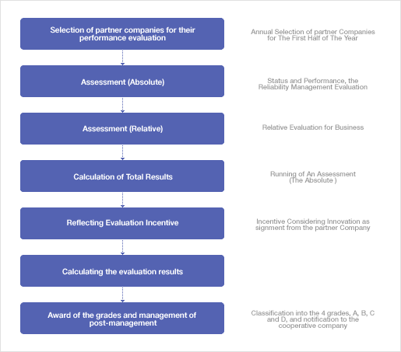

By, regularly monitoring the quality, cost and delivery of the resources from its vendors, the company maintains its complex supply chains and practices six sigma business processes.

Quality-Cost-Delivery as viewed by customers:

Through on going service innovations and service processes tailored according to regional requirements and needs, Samsung Electronics numerous customer satisfaction awards in the year 2010.

There are several service innovations, Samsung has come up with.

“The ceiling program, which is the first of its kind in the world, reflects our confidence in product quality. The customer pays for repairs up to the ceiling and the rest is covered by the company. It was launched to ease the repair fee burden which has increased along with the trend for premium home appliances.” – Samsung Electronics Sustainability Report 2011

Source [12]: Samsung Sustainability Report 2011,
http://www.samsung.com/us/aboutsamsung/sustainability/sustainabilityreports/download/2011/Samsung%20Electronics%202011%20Sustainability%20Report.pdf

Products, goods and services:

Samsung manufactures products in number of categories:

Source [13]: Samsung products & services, http://www.samsung.com/us/aboutsamsung/ourbusinesses/businessarea.html

The Semiconductor business consists of the Memory Division which enjoys a global number 1 position, the System LSI Division, which has experienced huge growth in the market and the Storage Systems Division. In a fast-paced electronic components industry, marked by intense competition and market volatility, clearly differentiated products from each of these divisions have helped spur continued growth.

Samsung's Memory Division designs and manufactures integrated circuits for storing digital information. It is the market leader in dynamic random access memory (DRAM), static random access memory (SRAM), NAND flash memory and Solid State Drives (SSDs). In addition, the Division has been setting an aggressive pace for developing new memory devices and multichip packages, as well as pioneering fusion memories and commercializing nanotechnology.

The System LSI Division designs and manufactures logic and analog integrated circuit devices. It is comprised of 3 major areas of business concentration - mobile solutions, home & media solutions, and ASIC & foundry services. The Division focuses its efforts in five strategic products areas - display driver IC (DDI), CMOS image sensor (CIS), mobile application processor (AP), smart card IC and media player SoC. System LSI holds the number one market share in DDI, Navigational AP and MP3 SoC.

The Storage Systems Division is a leading producer of high-capacity, high-performance hard disk drives for notebook and desktop PCs, as well as digital camcorders, MP4 players and a wide range of other consumer electronics and mobile devices. Just recently, it introduced a new line-up of ultra-compact, high-capacity external hard drives. It has made significant advances in hard disk drive technologies leading to lighter, quieter and more energy-efficient drives.

Samsung's LCD business produces panels for TVs, digital information displays (DIDs), notebook PCs and desktop monitors. It is the market leader in developing next-generation, premium products such as ultra-slim, edge-lit LED-backlit LCD panels, and is at the forefront of creating new markets with advancements in LED-backlit panel design and 240Hz LCD technology. The Division also is leading the LCD industry in its transition to the 16:9 widescreen aspect ratio, as well as in the introduction of high-value-added products such as 20-inch and larger slim-panel monitors and super-bright DID panels.

Key Products:

8M-pixel CIS
(CMOS Image Sensor)


800MHz Mobile AP
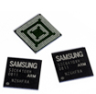

Mobile DDI


Smart Card IC
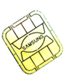

2Gb DDR3 SDRAM
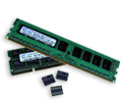

1Gb GDDR5 SDRAM
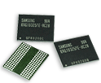

1Gb OneDRAM
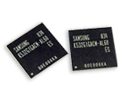

8Gb Flex-OneNAND
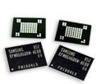

32Gb NAND
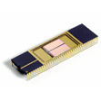

32Gb moviNAND
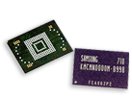

256Gb SSD (2.5")
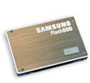

15.6" wide LCD panel for
notebook PCs
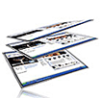

23" LCD panel for monitors
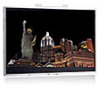

55" LCD panel for TVs
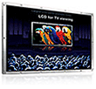

70" DID panel for Digital signage
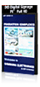

Samsung Electronics’ mobile phones, admired by customers around the world, enhance mobile lifestyles while meeting the diverse needs of the mobile marketplace. The company led the standardization of next- generation mobile phone technologies such as Mobile WiMAX and High-Speed Downlink Packet Access (HSDPA) to solidify their alliances with phone carriers around the world.

The business also comprises personal computers and MP3 players, creating synergies across platforms. The company merges the latest mobile technology with core computing technology for the PC business, while mobile technologies - also combine with our world-leading power efficiency and design to enhance MP3 player capabilities.

The TV business is a key driver in in the Samsung Set Business portfolio, along with the Mobile phone business. The TV business enjoys the top position in the current market. LED TVs, which have shown explosive growth in the latest market is a flagship product within the TV business. LCD TV and Monitors have also maintained top positions in their respective categories.

A premium brand image has powered Samsung's growth in the telecommunications category. The company lead the global telecommunication industry with the widest range of mobile phones on the market today - including 3G and multimedia phones - in addition to telecommunication systems.

The company’s printer and camera businesses are also receiving positive responses in the market and they continue to innovate in technology to increase their competitiveness in these segments.

ASSIGNMENT 2

Section III – Assignment 2

Review of “Knowledge Enabled Organon” book:

The content in this book aims to study the different ways to approach the concept of knowledge management, what it means in the context of a large commercial organization and describe frameworks for managing knowledge. The book is quite unique in its presentations of knowledge management concepts and theories.
The book starts with defining a pattern, and how patterns help the individuals or organizations to capture and record the knowledge. This captured knowledge is called “Knowledge nugget”. The entire book is organized as a collection of patterns, which provide solutions to various knowledge management problems in several contexts.
The book then goes on to defining various patterns like Magic Illusion, Knowledge Management Link and KM Magic, which explain the importance of knowledge, which is an asset that cannot be ignored and advantages of deploying Knowledge Management in enterprises, economies etc. The Magic Illusion pattern describes the illusion created due to lack of knowledge. This pattern is captured by Escher’s painting.
Figure: Escher’s waterfall
The next two patterns define the area of knowledge management, and describe how an illusion is created to those who lack of knowledge.
The book then provides a clear definition of the Plan-Do-Check-Act (PDCA) cycle as a pattern focusing on the framework for improvement and innovation process, which has to be followed to get from “problem-faced” to “problem-solved”. The PDCA cycle has four stages, Plan-Do-Check-Act, used to co-ordinate continuous improvement efforts. It explains the function of each of the phase of the PDCA cycle in great depth and also explains how it can be used to discover and refine solutions to related problems.

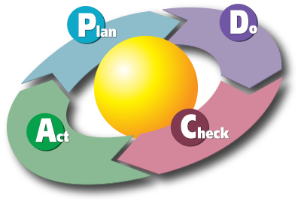
Figure: PDCA Cycle

It then goes on to provide an in-depth analysis of Knowledge Insight Model (KIM) which represents the generic organon or KM framework that provides its users with a set of related models (Framer, Sharer, Finder, Maker) that can help any organization manage its knowledge. Delving deeper into structure of this organon framework, problem-solving Plan-Do-Check-Act (PDCA) cycles can be applied to ensure the efficient and effective management of knowledge.

After clearly defining all the KIM related four models (Framer, Sharer, Finder, Maker), the book goes to the section KEO consulting, training and support. Even this information is explained in the form of pattern called Knowledge Enabling which provides solution to the problem, how KIM methodology can be applied to organization’s specific needs, enabling it to leverage its specific needs as rapidly, efficiently and effectively as possible. I sincerely appreciate Dr. Honeycutt’s and his team’s efforts (KEI) to actively progress and revive the knowledge concepts, and provide KEO training and support to various organizations.

It was quite an enlightening experience, to review the book. Providing all the information (knowledge) in the “pattern” format is quite unique and very appropriate, and shows off the validity of the argument that communicating in pattern language is very effective. I thoroughly enjoyed going through the examples, for each pattern, as they not only helped me understand the pattern well, but also showed the patterns’ applications.

Pattern: Knowledge Sharing with 2x2 Matrix

Inspirational Quotes:

“Knowledge in an organizational context stems from people; the concept of organizational knowledge is a metaphor because it is not the organization but the people in the organization who create knowledge”
~ Bhatt 2000; Grover & Davenport 2001.

“In today's environment, hoarding knowledge ultimately erodes your power. If you know something very important, the way to get power is by actually sharing it. “
~ Joseph Badaracco
"Innovation comes only from readily and seamlessly sharing information rather than hoarding it."
~ Tom Peters

Introduction:

  - What is a Pattern?
“Each pattern describes a problem which occurs over and over again in our
Environment, and then describes the core of the solution to that problem,
in such a way that you can use this solution a million times over, without
ever doing it the same way twice.” [1]
~ Christopher Alexander
A common definition of a pattern is that it is a solution to a problem in a context. Pattern is primarily a way to chunk up advice about a topic.
Chunking is important because there's such a huge amount of knowledge one needs to write software. As a result there needs be ways to divide knowledge up so one doesn’t need to remember it all - what one need is to be able to get at a particular chunk of knowledge when one needs it.
This chunking is what Dr. Honeycutt says, organizing knowledge in the form of “Knowledge nuggets”.
Patterns should have recurrence, which means the solution must be applicable in lots of different situations.
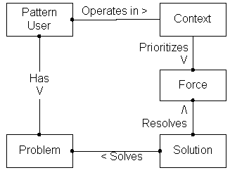
(Figure: Relationship between various Pattern elements)
  - Pattern Language
In practice, pattern languages arise from two very different needs: (a) as a way of understanding, and possibly controlling, a complex system; (b) as necessary design tools with which to build something that is functionally and structurally coherent. To visualize patterns and their interconnections, we use a graph representation. Patterns may be identified with nodes in a graph, and the graph is connected by edges of different lengths. A pattern is an encapsulation of forces; a general solution to a problem. The "language" combines the nodes together into an organizational framework. A loose collection of patterns is not a system, because it lacks connections.

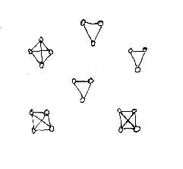
(Figure: Individual patterns group to form six higher level patterns having additional properties)

Pattern Name:

Knowledge sharing with a 2x2 matrix

Context:

It is often said that it is essential to create a "Knowledge Sharing Culture" as part of a Knowledge Management initiative. An isolated knowledge management programme looked after by a privileged few is a paradox in itself and will not survive for long. Only effective collaboration and communication which spans across the whole company structure will give knowledge management the boost it really needs. Every employee has a sphere of influence along with their own individual knowledge, and this is where he believes a knowledge sharing culture can begin.

Problem:

Despite the large volume of studies discussing the competitive advantages created by knowledge, creating an environment to generate and share knowledge remains poorly understood (Einsenhardt & Santos, 2002). The uncertain and competitive global business climate drives an increasing need for management to develop more effective strategies to share the knowledge within the organization and that flows from external sources into the organization.

Forces:

- A mere verbal communication of the solution to a problem is not sufficient, in effectively getting the team mates involved in the current situation, as the problem would not be simple enough without any conflicting interests.
- The adage “A picture is worth a thousand words” refers to the idea that a complex idea can be conveyed with just a single still image. It is essential that the organization employs a visual tool which aids them in effectively making it possible to absorb large amount of data quickly.
- Generally, a solution to a given problem is not a single solution. There can be more than one possible solution to a problem, and it is not necessary that the best solution is the right thing to do.
- Rather than prolonging the discussion, about several parameters individually, 2x2 thinking enables to put several conflicting parameters together, and find a viable solution.

Solution:

Knowledge sharing with 2x2 matrix is definitely a powerful and an efficient solution for this problem. 2x2 thinking enables us to seize the conflicting goals, making them useful markers to set the parameters for our search for the answer. In place of single right answer, a set of plausible options is created by considering high and low cases of two conflicting needs. Moreover, 2x2 matrix is not something like a black box which produces a solution for the problem, without a proper input.
The four options generated by the matrix, will be informative and provocative enough only if the two axes of the goals are well defined. For a detailed analysis of how 2x2 thinking can help in efficient knowledge sharing during crunch time within the organization, please refer Alex Lowy and Phil Hood’s “The Power of the 2x2 Matrix”. Employing 2x2 matrix techniques within the organization is not a tough job, as it only takes very little time to adapt and think in this direction. The organization will sure hugely benefit, if the managers who manage many people in their team, start using 2x2 matrix when they communicate with their team. It will surely be an indispensable aid to the managers to motivate their team, and lead their team mates in right direction, by pin-pointing the key focus points.
As always, the intangible element, the energy of processes, is ultimately more telling than structures, tools, and matrices. Just getting hung up on 2x2 form will surely not give great results. If we use it as a convenient medium and device to achieve important ends. 2 × 2 modeling brings focus and tension, often making issues clearer.
According to the breadth and width of the situational context the 2x2 modeling can be applied, there are 3 categories of 2x2 thinking:
- Strategic frameworks
- Organizational frameworks
- Individual frameworks

Examples:

Strategic frameworks:

Igor Ansoff introduced the Product-Market matrix, and with this, he helped to launch the modern practice of business strategy. Market penetration, which is lower left quadrant, is less risky according to Ansoff. He suggests that, businesses should choose “Market penetration” when a new product has been received warmly, and there is lot of untapped market potential. Strategy options defined in upper left and lower right quadrants are difficult ones to implement, as there should be favorable market conditions to do so. Diversification, according to Ansoff, businesses should employ great caution, as cost and risk tend to be higher as the product is unproven and the market is unknown.
(Figure: Product-Market matrix)

Organizational Frameworks:

According to Nonaka, knowledge management expert, the most crucial issue facing organizations is balancing between dilemma of Speed (succeeding today) and Scale and Scope (investing to succeed tomorrow) that leads to long-term competitive advantage. The following 2x2 matrix gives us the clear picture.
(Figure: Economies of Speed and Scale Matrix)

Individual Frameworks:

A 2x2 matrix that expresses a real and important tension in your life is a good example of this framework. The tension for an individual is captured in the 2x2 matrix, which is essentially striking a balance between spending time on activities that are meaningful and developmentally useful and the ability to do them reasonably well. This Alex’s core dialectic matrix is shown below.
(Figure: Alex’s Core Dialectic Matrix)
The star at the top of the matrix is what Alex aims for: working on rewarding projects that represent creative stretch yet are achievable.
There are few more examples like Employee typology matrix, Time management matrix etc.

Resulting Context:

- Clearer goals and options because of the well-defined 2x2 matrix, which captured the essence of the moment.
- Involves all the team members in the discussion, and improves rapport within the team.
- Saves a significant amount of time, as the matrix directly focuses on the crux of the crunch situation.
- The 2x2 matrix solution is reusable; hence don’t really have to rely on a new tool for future situations.
- Clear definition of their respective jobs for each of the team members, and the direction the team is heading is very clear.

Rationale:

Encapsulating knowledge acquired through time, 2x2 matrix can ensure efficient and effective transfer of this knowledge. A traditional approach can never instill confidence in handling the situation, and certainly there cannot be clarity about the situation. Since, “knowledge accumulates exponentially, with every innovation creating the opportunity for a greater number of innovations.” (Petzinger, 2000), use of 2x2 matrix to share knowledge could optimize the quality, speed and effectiveness of the communication.

Known issues:

As explained above, adapting 2x2 thinking by the organizations is very helpful and effective for their business processes. But, at the same time employing 2x2 framework in the organization will take quite some time to create a perfect 2x2 matrix. Employees in the organization should constantly try identifying the essential parameters in making the 2x2 matrix. At the organization level, 2x2 thinking will have significant impact, so it is essential that the employees perfect the art.

Related patterns:

- Solution Resolution Pattern
- Abstract Mandala Pattern.

References:

- A Pattern Language for Pattern Writing, Authors: Gerard Meszaros and Jim Doble: http://hillside.net/index.php/a-pattern-language-for-pattern-writing
- Picture is worth a thousand words wiki link: http://en.wikipedia.org/wiki/A_picture_is_worth_a_thousand_words
- Creating a Knowledge sharing culture, Author: David Gurteen: http://www.gurteen.com/gurteen/gurteen.nsf/id/ksculture
- Journal of Knowledge Management Practice, Vol. 10, No. 3, September 2009,NewKnowledge Creation As A Change Management Model:

http://www.tlainc.com/articl198.htm

COMPANY PROSPECTUS

Section IV - Prospectus of the firm Samsung Electronics

1) Who are the c omp any’s executives (C EO and board of di rectors),
list th eir profiles?

Source [1]: http://www.samsung.com/us/aboutsamsung/management/boardofdirectors.html

Source [2]: Samsung Annual Report 2011

http://www.samsung.com/us/aboutsamsung/ir/financialinformation/annualreport/downloads/
2010/SECAR2010_Eng_Final.pdf

SAMSUNG ELECTRONICS’ EXECUTIVE STAFF:

• Mr. Lee Kun-hee
Chairman, Samsung Electronics (2010 – Present)

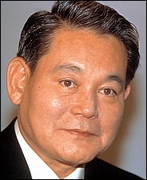

Mr. Lee served as Executive Chairman and Co- Chief Executive Officer of Samsung Electronics Co. Ltd., a subsidiary of Samsung C&T Corporation (Formerly Samsung Corp.) from 1997 to April 2008. He served as Chairman and Head of Overall Corporate Management of Samsung SDI Co. Ltd.

Mr. Lee received Honorable Doctoral Degree of Business Administration and Economics from Seoul National University in the year 2000. Mr. Lee received MBA from George Washington University in 1966 and, in 1965 his Economics Degree from Waseda University.

• Mr. Gee-Sung Choi
Chief Executive Officer & Vice Chairman, Samsung Electronics (2010 –
Present)



Gee-Sung Choi has been a member of the company's Board of Directors since
March 2009. Having served Samsung for more than three decades, Mr. Choi was
appointed President of the Digital Media & Communications Business in January 2009. He previously held the position of President of the Telecommunication Network Business from January 2007, helping Samsung to grow its market share to become the world's second-largest mobile phone maker.

Mr. Choi began his career at Samsung C&T's International Trade Division in
1977. He holds a degree in International Trade from Seoul National University.

• Mr. Lee Jae-Yong
Chief Operating Officer, Samsung Electronics (2010 – Present)

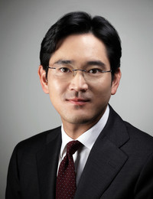

As Lee Kun-hee’s only son, Lee Jae-yong has long been considered the heir apparent at Samsung, a view solidified when he was appointed to the specially created role of chief customer officer of Samsung Electronics.

All his life he has been groomed to inherit the company, completing an MBA at
Keio University in Japan before entering Harvard Business School

Division heads
- Mr. Kwon Oh-hyun
Head of Semiconductor Division, President, Samsung Electronics
- Mr. Jang Won-ki
Head of LCD Division, President, Samsung Electronics
- Mr. Yoon Boo-keun
Head of Visual Display Division, President, Samsung Electronics
- Mr. Shin Jong-kyun
Head of Mobile Communications Division, President, Samsung Electronics
- Mr. Kim Young-ki
Head of Telecommunication System Division, Executive Vice- President, Samsung Electronics
- Mr. Nam Seong-woo
Head of IT Solutions Division, Executive Vice- President, Samsung Electronics
- Mr. Hong Chang-wan
Head of Digital Appliances Division, Executive Vice- President, Samsung Electronics
- Mr. Chung Hyun-ho
Head of Digital Imaging Division, Executive Vice- President, Samsung Electronics

Board of directors:

Yoon-Woo Lee

Vice Chairman, Samsung Electronics (2011 – Present)
Yoon-Woo Lee was named Samsung Electronics' Vice Chairman and Chief Executive Officer in 2008 and has been a member of Samsung's board of directors since 1988. Joining Samsung in 1968, Mr. Lee was appointed President of Samsung's Semiconductor Business in 1996.
In 2004, he was promoted to the position of Vice Chairman of the Samsung Advanced Institute of Technology, and assumed the additional role of Chief Technology Officer in 2005. Mr. Lee holds a bachelor's degree in Electrical Engineering from Seoul National University.

Ju-Hwa Yoon

Chief Finance Officer & President, Corporate Management Office, Samsung Electronics (2010 – Present)

Ju-Hwa Yoon has been Samsung Electronics' President and a member of the company's Board of Directors since 2009. He is currently CFO of the Corporate Management Office, moving from his previous position as the head of Corporate Auditing Team where his main responsibility was to audit and evaluate the business activities of Digital Media & communications and Digital Solutions.

As a member of the corporate staff, he was actively involved in the company's management support and innovation efforts from 1996 to 2004. From 2004 until 2009, he held the position of Vice President in the Management Support & Innovation Division while heading Global Enterprise Resource Planning Task Force Team. He has a bachelor's degree in Statistics from SungKyunKwan University.

Dong-Min Yoon

Independent Director, Attorney at Law, Kim & Chang Law Office (1999 – Present)

Dong-Min Yoon has been a member of Samsung's board of directors since 2006 and is an independent director with responsibilities in overall corporate management. He is an attorney at the Kim & Chang Law Office and also is an independent director of the Doosan Group, one of the oldest and largest conglomerates in Korea. Mr. Yoon previously served as director of the Social Protection and Rehabilitation Bureau at the Ministry of Justice; chief of the Planning Management department at the Ministry of Justice; and a public prosecutor at the Daejeon Supreme Public Prosecutor's Office. He received a law degree from Seoul National University.

Chaewoong Lee

Independent Director, Ombudsman, Financial Supervisory Service (2009 – Present)

Chae-Woong Lee has been a member of Samsung's board of directors since 2006 and is an independent director with responsibilities on the audit and related party transactions committee. He is a president of the Korean Economic Association and an independent director of Pusan Bank. Dr. Lee was a vice president of SungKyunKwan University from 1999 to 2003 and is an emeritus professor of Economics there. He also was a member of the Council for Financial Industry Development Review to the Ministry of Finance. He received his doctorate and master's degrees in Economics from Southern Methodist University, and his bachelor's degree from Seoul National University.

In-Ho Lee

Independent Director (2010 – Present)
In-Ho Lee has been elected as an independent director in 2010 with responsibilities on the Audit Committee and the Internal Transaction Committee. His profession in the financial industry continues more than four decades, including his career in Shinhan Bank which started as a foundation member in 1982 and continued to President & CEO from 1999 to 2003 and Vice Chairman from 2003 to 2005. After his directorship as a CEO in Shinhan Financial Group from 2005 to 2009, Mr. Lee is currently the Corporate Advisor to Shinhan Bank. He received a bachelor's degree in Economics from Yonsei University.

Oh-Soo Park

Independent Director (2010 – Present)

Oh-Soo Park has been a member of Samsung's board of directors since 2006 and is an independent director with responsibilities on the recommendation committee. He has been a business and academic leader for more than two decades, serving as Dean of the Business School at Seoul National University, Chairman of the Korean Human Resources Management Institute and as a visiting professor at Stanford University's Graduate School of Business.
Dr. Park is the independent director of Korean Air's board of directors and is a Business professor at Seoul National University. He received his doctorate in Business Administration from Pennsylvania State University, and his master's and bachelor's Business degrees from Seoul National University.

- What are Samsung Electronics’ target markets?
Source [2]: About Samsung,
http://www.samsung.com/us/aboutsamsung/ourbusinesses/businessarea.html
Source [3]: Samsung Electronics Wiki Page http://en.wikipedia.org/wiki/Samsung_Electronics
Source [4]: Samsung Electronics Annual report 2010 http://www.samsung.com/us/aboutsamsung/ir/financialinformation/annualreport/downloads/2010/SECAR2010_Eng_Final.pdf
Samsung Electronics focuses on eight target markets:
- Visual display
Samsung Electronics has achieved the world’s No. 1 market share in TVs for five years in a row since 2006. After establishing the new market for LED TVs in 2009, Samsung Electronics has extended their competitive lead with sales of 45.11 million TVs. That included 39.26 million flat panel TVs in 2010, as Full HD 3D LED TV became readily available. With sales of 2 million 3D TVs, Samsung Electronics is also leading the next-generation market. In 2011, Samsung Electronics launched smart TVs that feature Full HD picture quality, immersive viewing experience and Smart Hub options ( similar to iPhone Apps, Samsung has smart apps for Smart TV users ).

- IT Solutions

Samsung Electronics presents high end IT solutions for premium laptops and a full line of consumer and corporate printers. By implementing global marketing strategy for mobile PCs, Samsung Electronics realized rapid growth in 2010, reaching sales of 10 million units worldwide. It has launched a printer for consumers that supports mobile printing. Samsung Electronics provided business customers with a complete product line, including the first dual core CPU-equipped printer on the market, a multifunction printer and an A3 copier. Samsung Electronics secured second global market share in the A4 laser printer category.

- Digital Home Appliances
In 2009, the year of worldwide recession due to the 2008 global credit crisis, Samsung’s sales revenue rose 27 percent from the previous year, the biggest increase in the industry. In the North American, European, and Russian markets, it solidified its image as a premier home appliance maker by selling many refrigerators, washing machines, air-conditioners, as well as new steam microwave ovens and “robot” vacuum cleaners. In a market clearly split into two extremes of upmarket and budget categories, Samsung employs a two-pronged strategy to emphasize its premium image for affluent consumers while marketing lower-end items with fewer bells and whistles for emerging economies consumers.

- Mobile Communications
Samsung Electronics sold 235 million mobile handsets in the year 2009. At the end of Q3 2010 Samsung had surpassed the 70 million unit mark in shipped phones, giving it a global market share of 22% trailing Nokia by 12%. Overall, Samsung sold 280 million mobile phones in 2010, corresponding to a market share of 20.2%. Following the success of its “Anycall” brand mobile phones in Korea, the company introduced numerous mobile handset models including premium phones, full-touch screen phones, and environmentally friendly phones. Samsung’s flagship mobile handset line is the Galaxy S, which many consider a direct competitor of Apple's popular iPhone.

- Telecommunication Systems
Samsung Electronics is in Telecommunication Systems market by developing forward-looking products for two major 4G platforms, Long Term Evolution (LTE) and Mobile WiMAX (WiBRO). In 2010, the company established the first LTE commercial services network in the US and now the company is also expanding in North America, Asia and Europe.

- Digital Imaging

Samsung Electronics also focuses on developing trendsetting digital imaging devices, such as cameras and digital camcorders. Recently, the company released a mirror-less digital camera, the NX11, to secure a competitive lead over professional optical brands. The company is still growing in this segment of business.

- Semiconductor
For more than 20 years since 1993, Samsung has kept the title of the world’s largest memory chip maker. In 2009, it began a strategy of “Green Memory” by which it increased the global DRAM market share to 33 percent. It also started mass-producing 30 nm-class NAND flash memories in the same year whose world share rose as high as 42 percent. According to market research firm Gartner, during the second quarter of 2010 Samsung Electronics took the top position in the DRAM segment due to brisk sales of the item on the world market.
- LCD
Samsung Electronics has achieved the No. 1 market share for LCD panels for nine consecutive years owing to cutting-edge technology and product quality. Industry-first Active 3D technology supports True 240Hz for 3D TV, which has reinforced the company’s leadership. The company also sells displays as an LCD panel for the tablet PC.

Sony Corp and Apple are largest clients for Samsung Electronics. Samsung supplied semiconductor and LCD products to Apple, Dell and HP, the company said in a filing without elaborating or breaking down products for each client.
(Source [5]: http://finance.comcast.net/stocks/news_body.html?ID_OSI=86627&ID_NEWS=184186925 )

- What are Samsung Electronics’ core competencies?
Source [6]: http://www.quickmba.com/strategy/core-competencies/
In their 1990 article entitled, “The Core Competence of the Corporation”, C.K. Prahalad and Gary Hamel coined the term core competencies, or the collective learning and coordination skills behind the firm's product lines. They made the case that core competencies are the source of competitive advantage and enable the firm to introduce an array of new products and services.

According to Prahalad and Hamel, core competencies lead to the development of core products. “Core products are not directly sold to end users; rather, they are used to build a larger number of end-user products.”

Samsung Electronics’ core competencies are:

  - Hardware Manufacturing

Samsung’s key core competency is the company manufactures its own hardware. Samsung’s displays and chips go into its own large range of digital products. The company manufactures all the core components for its digital products, unlike any company in the electronics industry. They sell the

Source [7]:
http://www.businessweek.com/magazine/content/03_24/b3837001_mz001.htm

  - Product Diversification & Vertical Integration

Samsung Electronics creates synergy by vertical integration “More Convergence, More Synergy”. They manufacture a large range of digital products, which gives them a unique advantage over other competitors.

This gives the company with several key advantages:
- Cost competitiveness
- Time to market through a stable component supply
- Relatively fast technology adaption
Source [8]:
http://www.samsung.com/hk_en/aboutsamsung/ir/ireventpresentations/conferenceactivities/downloads/2004/CLSA_Chu_final_040915.pdf

- Who are the company’s customers?
Source [9]: http://en.wikipedia.org/wiki/Samsung
Samsung Electronics’ key customers are:

Samsung's key clients (Q1 2010)^{[45]}
Rank/company | Part description | Buying (trillion KRW) | Percent of total sales
1 Sony | DRAM, NAND flash, LCD panels, etc... | 1.28 | 3.7
2 Apple Inc | AP (mobile processor), DRAM, NAND flash, etc... | 0.9 | 2.6
3 Dell | DRAM, flat-panels, lithium-ion batteries, etc... | 0.87 | 2.5
4 HP | DRAM, flat-panels, lithium-ion batteries, etc... | 0.76 | 2.2
5 Verizon Communications | Handsets, etc... | 0.5 | 1.3
6 AT&T | Handsets, etc... | 0.5 | 1.3

Samsung Electronics is the world’s most popular consumer electronics brand, followed by Sony. Hence, the company’s huge customers are people across the world.
Source [10]: Global Interbrand Ranking
http://www.interbrand.com/en/best-global-brands/best-global-brands-2008/best-global-brands-2010.aspx
- What kind of research is the company engaged in, if any?
Source [11]: http://www.samsung.com/us/aboutsamsung/ourbusinesses/researchdevelopment.html
“More than a quarter of all Samsung employees—42,000 people—work every day in research and development, and we expect that number to surpass 50,000 by 2010.”—Samsung quotes in its website.
Samsung Electronics has 42 research facilities around the world, they collaborate on strategic technologies for the future and original technologies designed to forge new market trends.
The company’s research and development network spans six Samsung centers in Korea and 18 more in nine other countries, including the United States, the United Kingdom, Russia, Israel, India, Japan and China, as well as other research centers and universities.
Center Name | R&D Areas
Samsung Information Systems America, Inc. (SISA) | Strategic parts and components, core technologies
Dallas Telecom Laboratory (DTL) | Technologies and products for next-generation telecommunications systems
Samsung Electronics Research Institute (SERI) | Mobile phones and digital TV software
Moscow Samsung Research Center (SRC) | Optics, software algorithms and other new technologies
Samsung Electronics India Software Operations (SISO) | System software for digital products, protocols for wired/wireless networks and handsets
Samsung Telecom Research Israel (STRI) | Hebrew software for mobile phones
Beijing Samsung Telecommunication (BST) | Mobile telecommunications standardization and commercialization for China
Samsung Semiconductor China R&D (SSCR) | Semiconductor packages and solutions
Samsung Electronics (China)R&D Center (SCRC) | Software, digital TVs and MP3 players for China
Samsung Yokohama Research Institute | Core next-generation parts and components, digital technologies
Samsung Poland R&D Center (SPRC) | STB SW Platform Dev., EU STB/DTV commercialization
Samsung India Software Center (SISC) | S/W Platform and Application Design, Graphic design
- What is the current external market perception?
Source [12]: http://en.wikipedia.org/wiki/Samsung_Electronics#cite_note-75
Samsung Electronics is the world’s largest electronics company. It is the flagship subsidiary of the Samsung group. Its sales revenue in the areas of LCD and LED displays and computer chips is number one in the world.
In the TV segment, Samsung’s market position is dominant. For four years since 2006, the company has been in the top spot in terms of the number of TVs sold, which is expected to continue in 2011 and beyond. In the global LCD panel market, the company has kept the leading position for eight years in a row.
Product | Samsung's  global Market Share | Competitors | Competitor’s Market share | Year
DRAM | 40.4% | Hynix | 19.8% | Q3 2010
NAND Flash | 40.4% | Toshiba | 33.1% | Q2 2010
Large-size LCD Panel  (revenue) | 26.0% | LG Display | 25.9% | Q3 2010
Active-Matrix OLED | 97% | LG Display, AUO | 1~3% | 2010
Lithium-ion battery | 18.7% | Sanyo | 19.4% | Q1 2010
LCD Monitor | 18.0% | Dell | 12.8% | 2009
Hard disk drive | 9% | Seagate  Technology | 31% | Q4 2009
Television sets  (LDC, PDP, CRT, LED) | 17.2% | LG Electronics | 14.8% | Q3 2009
Mobile phone | 21.0% | Nokia | 32.4% | Q3 2010
Digital camera | 11.8% | Sony | 17.4% | 2010

In 2009, the company took the position of the world’s biggest IT maker by surpassing the previous leader Hewlett-Packard. The company is among the Top 50 world’s most admired companies.
Source [13]: http://money.cnn.com/magazines/fortune/mostadmired/2011/full_list/
- What is the company’s headcount?
According to recently released Sustainability report from Samsung Electronics, the total head count is 190,464.
Source [15]: http://www.samsung.com/us/aboutsamsung/sustainability/sustainabilityreports/download/2011/Samsung%20Electronics%202011%20Sustainability%20Report.pdf
- What are the companies’ hiring practices/trends/tendencies?
Source [16]: http://www.samsung.com/us/aboutsamsung/sustainability/sustainabilityreports/download/2011/Samsung%20Electronics%202011%20Sustainability%20Report.pdf
Samsung Electronics recognizes that attracting and retaining top talent is vital to building a competitive organization.
Attracting and retaining high-caliber people is crucial to staying competitive on the global stage and sustaining growth. Each year, Samsung Electronics recruits people across the world based on its annual business plan and mid- to long-term strategy. The number of new hires (domestic: 6,230, overseas: 21,188) decreased in 2009 compared to a year earlier in the aftermath of the global financial crisis.

New employees are recruited through a number of channels, one of which is our internship program. University students may choose from the college internship program, under which they work for nine weeks during the school term or vacation. Another option is the 16-week industry-academia program whereby students come to work during the school year.

The recruiting process differs according to region. Samsung Electronics holds on-campus recruiting events at major universities twice a year in the U.S. and Europe and organizes job fairs in emerging market such as China, India and Russia.

- What is the education profile of a typical employee?

According to company’s sustainability report 2011, company categorizes its employees into three categories.
Position Headcount
Executive 974
Manager 33,996
Staff 155,319
In 2010, Samsung Electronics invested KRW9.4 trillion, or 6.1% of consolidated sales in R&D. Currently, they employ 50,084 R&D personnel which is equivalent to 26% of its total workforce.

Due, to huge component manufacturing facilities, a considerable portion of the staff count would be production workers.

So, considering all these factors, a typical employee would be an R&D Engineer.

Education & Experience requirement of an R&D Engineer:

MS in Computer Science/Engineering or Electrical Engineering; PhD preferred
- Minimum of 4 years' related experience in mobile devices/services or software technologies. Mobile or web platform (e.g., Android, iOS, WebOs, etc.) related experience desirable.
- Past experience in creating novel concepts particularly in the mobile area
- Past experience with prototyping new ideas primarily in software but also mockup of hardware to support those ideas
- Past experience as a 'futurist' in creating concepts 'ahead of their time' is a plus
- Solid understanding in social sciences (e.g., social network, life log, eHealth), internet technologies (e.g., Cloud computing, mobile Internet, etc.), and user experience is key to this position. Also the ability to combine those into novel solutions.
- Expertise in java, C++, or high-level programming languages; additional expertise in scripting languages and Flash is preferred.

Source [17]: http://careers.us.samsung.com/RCPostInit.do

- Give a brief description of company business model.
Samsung Electronics is one company which does not have any history of sticking to one business model. The company kept on changing its model since its establishment.
This wonderful article, gives the exact details, as how the company reached the current enviable position, by continuously changing its business model.
Source [18]: http://manalac.com/samsung_model.pdf
“By making speed of new-product the center of its business model, Samsung also was able to move ahead of its major competitors”.
However, the company changed its business domain again in the year 2010.
“Our current business structure is centered on IT, telecom and AV (infotainment), with an orientation toward sets and components. We plan to make a transition with the addition of new business areas, namely medical/biotech, environment/energy, convenience/comfort (lifecare) with an emphasis on software and solutions.”

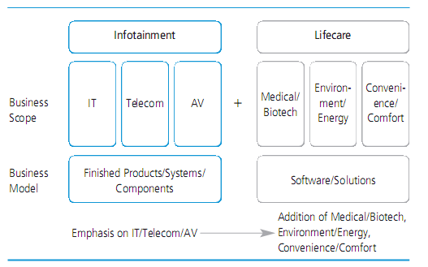

Source [19]: http://www.samsung.com/us/aboutsamsung/sustainability/sustainabilityreports/download/2010/2010Environmentalnsocialreport.pdf

- Who are the company’s chief competitors?
Source [20]: http://www.wikinvest.com/stock/Samsung_Electronics_(SEO:005930)#Competition
Samsung's technical leadership and cost-reduction efforts makes the company a competitive force in the industry. Major competitors to Samsung include:
- Hynix Semiconductor is among the world's top makers of DRAM and other memory chips. The company plans to diversify into other chip markets. The company is a primary competitor for Samsung in the Asia/Pacific region.
- Panasonic Corporation is a top consumer electronics manufacturer. Its Digital AVC Networks unit makes TVs, VCRs, CD and DVD players, PCs, cell phones, and fax machines.
- Sony manufactures high-revenue consumer electronics products and gaming systems, including digital and video cameras, Walkman stereos, and semiconductors. The company also owns entertainment divisions such as Sony Music Entertainment, Sony Pictures Entertainment and Sony Digital Production, Sony Pictures Home Entertainment, and Sony Pictures Television.
Other competitors in Samsung Electronics’ business segments include:
- Nokia is a manufacturer of mobile devices and is involved in the internet and communication industries.
- LG Electronics is a global leader in home entertainment products, mobile communications, home appliances, and business solutions.
- Toshiba is a leading competitor for Samsung in the electronics equipment industry, specifically semiconductors and digital products. Toshiba is also at the top of the Greenpeace Consumer Electronics Ranking along with Samsung.
- Dell is one of America's largest companies and a global manufacturer of personal computers.
- Seagate Technology Holdings is a primary competitor in the hard drives industry.
- Hewlett-Packard Company is a competitor to Samsung as a leading manufacturer of personal computers, commercial and consumer PCs, workstations, handheld devices, and digital entertainment systems.
- Canon is a competitor in the digital camera and printer segments.
- Motorola is a manufacturer of wireless telephone handsets.
- Koninklijke Philips Electronics a leading competitor for Samsung in consumer electronics, including mobile phones and entertainment solutions.

- How do competitors affect their business model?
Competitors have very significant effect on the company’s business model. As mentioned earlier, the company has changed its business model again and again, so as to beat its Japanese competitors in 2000s.
In 2004, Sony and Samsung announced a major agreement to share the costs of basic research into improving LCDs, which run into billions of dollars.
Source [21]: http://en.wikipedia.org/wiki/S-LCD
In the year 2009, the company has unveiled “Vision 2020”, to generate annual revenue of 400 billion USD, to become one of the world’s top 10 companies. Please refer question 10, for the new change of their business model.
Samsung electronics’ competitors, affect the company’s product pricing, product manufacturing & delivery process, R&D investment, Talent management, Recruitment process, Social responsibility Investment etc.,

- What are the financial projections over next 12 months and 60 months?
Source [22]: Reuters Analyst Predictions
http://www.reuters.com/finance/stocks/analyst?symbol=005930.KS
Sales and Profit Figures in Korea Won (KRW)
Earnings and Dividend Figures in Korea Won (KRW)
 | # of Estimates | Mean | High | Low | 1 Year  Ago
SALES (in millions)
Quarter Ending Jun-11 | 35 | 40,293.80 | 45,790.30 | 36,780.00 | 36,710.90
Quarter Ending Sep-11 | 35 | 43,724.50 | 49,973.10 | 40,484.00 | 39,500.00
Year Ending Dec-11 | 42 | 167,627.00 | 178,913.00 | 158,280.00 | 141,298.00
Year Ending Dec-12 | 39 | 183,031.00 | 202,516.00 | 169,610.00 | 150,893.00
Earnings (per share)
Quarter Ending Jun-11 | 10 | 21,191.30 | 23,934.10 | 18,365.60 | 22,987.40
Quarter Ending Sep-11 | 10 | 24,682.10 | 28,886.30 | 19,313.30 | 27,481.60
Year Ending Dec-11 | 39 | 93,448.30 | 123,113.00 | 75,040.00 | 98,298.80
Year Ending Dec-12 | 38 | 110,631.00 | 155,999.00 | 74,416.00 | 100,905.00
LT Growth Rate (%) | 5 | 13.62 | 18.30 | 7.00 | 11.79

From all the estimates, the mean growth rate is 13.62% per share, so the company has a positive business outlook for the next year.
“Samsung could take over from Intel as the world’s No.1 semiconductor company in four years’ time, according to Arizona analysts IC Insights. Samsung’s semiconductor revenues rose at a CAGR of 13.5% from 1999-2009, while Intel’s sales have increased at a CAGR of just 3.4% in the same period. Extrapolating these growth rates, Samsung would pass Intel in semiconductor sales in 2014.”
Source [23]: http://www.electronicsweekly.com/Articles/2010/08/26/49337/samsung-to-overtake-intel-as-no.1-chip-company-in-2014.htm
Samsung Electronics unveiled “Vision 2020”, to generate annual revenue of 400 billion USD, by the year 2020.
But, the exact forecast within 5 years was not provided by the company or analysts.

- Any imminent inflection points the company will certainly face in short- term?
The following are the inflection points the company faces as they go ahead in their business:
  - Samsung Electronics plans to invest approximately $20.6 billion in clean-tech over the next 10 years to boost its sales and turn a corporate corner. The move would create 45,000 jobs and result in approx. $44 billion in additional revenue by 2020.

Source [24]: http://www.smartplanet.com/blog/smart-takes/samsung-invests-20-billion-in-cleantech-solar-led-pharma-healthcare-hybrid-batteries/6790

  - Samsung Electronics faces a challenging outlook after reporting its third consecutive fall in quarterly profit as it struggles to make ground on Apple and deal with a tepid recovery in its TV and flat screens business.

"Although the memory chip business is reviving, other operations such as telecommunications and displays are facing tough times ahead," said Han Se-woong, a fund manager at AssetPlus Investment Management, which owns Samsung shares.
Source [25]: http://www.irishtimes.com/newspaper/breaking/2011/0429/breaking10.html

  - Apple has filed a lawsuit against Samsung in South Korea, claiming the company has infringed on its smartphone and tablet-related patents. The latest lawsuit comes after a string of suits between Apple and Samsung. Although these two consumer electronic giants are closely working with each other, Apple claims Samsung copied its iPhone and iPad. Samsung responded by filing several countersuits of its own.

Source [26]: http://mashable.com/2011/06/24/apple-samsung-lawsuit-south-korea/
15) Any other factors t hat could provide parameters describing an organizational mod el .
Source [27]:
http://www.samsung.com/us/aboutsamsung/sustainability/sustainablemanagement/do
wnload/SamsungValueCode_ofConduct.pdf

Samsung Electronics endeavors to become a world leading company by following its management philosophy of “Devoting its talent and technology to creating superior products and services that contribute to a better global society.” Samsung Electronics’ value chain of “Management Philosophy, Core Values and Management Principles” is rooted in this management philosophy and constitutes the spiritual guidelines for all its employees in their effort to realize the corporate vision of being a world leader.

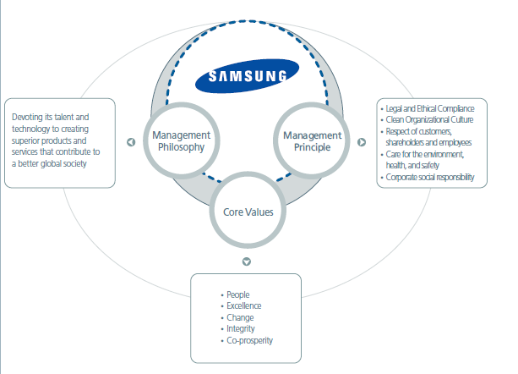

16) Risk factors the c o mpany faces in the introduction of a new product, service, o r good (bey o nd th e typical risk of market non - acceptance) .

The following are risk factors which Samsung Electronics faces in the release of a new product, service or a good:

• Global consumer demand and its outlook has been soured by the debt crisis in Europe and sluggish U.S. job and housing markets.

• Apple which is one of the largest customers for Samsung electronics’ memory components, has filed lawsuits against the company, for patent infringement. Due to this legal wrangling, a Samsung spokesman said Apple may be trying to lower its dependence on Samsung. So, Samsung is now investing 10 trillion won, in non- memory components, like Application Processor.
• Sales of flat-panel TVs edged up 5% from a year ago but tumbled 31% from the previous quarter to 8.8 million units. Samsung’s LCD business reported an operating loss of 230 billion won versus a 490 billion won profit a year ago. TV makers are struggling with fierce competition from cheaper brands and fragile consumer spending.

Source [28]: http://m.mydigitalfc.com/companies/samsung-q1- profit-2-year-low-435
Source [29]: http://stockmarket- predictions.blogspot.com/2011/06/samsung-other-asian-tech-shares-tumble.html
Source [30]:
http://www.koreatimes.co.kr/www/news/nation/2011/05/129_866
54.html

PAPER II-Prospectus

Section V- INSPIRATIONAL ARCHETYPE: LEONARDO DA VINCI – RENAISSANCE MAN


There are three classes of people: those who see, those who see when they are shown, those who do not see.
It had long since come to my attention that people of accomplishment rarely sat back and let things happen to them. They went out and happened to things.
"The heavens often rain down the richest gifts on human beings, but sometimes they bestow with lavish abundance upon a single individual beauty, grace and ability, so that whatever he does, every action is so divine that he distances all other men, and clearly displays how his greatness is a gift of God and not an acquirement of human art. Men saw this in Leonardo."
~ Georgio Vasari
(Author of ‘The Lives of the Artists’)
Leonardo di ser Piero da Vinci was an Italian Renaissance polymath: painter, sculptor, architect, musician, scientist, mathematician, engineer, inventor, anatomist, geologist, cartographer, botanist and writer. Leonardo has often been described as the archetype of the Renaissance man, a man of “unquenchable curiosity” and “feverishly inventive imagination”.[1]
He is widely considered to be one of the greatest painters of all time and perhaps the most diversely talented person ever to have lived.
Da Vinci's fascination with science and his in-depth study of human anatomy aided him in mastering the realist art form. While Leonardo's counterparts were known to create static figures in their works, Leonardo always tried to incorporate movement and expression into his own paintings. All the personages in his works are painted with great accuracy and detail that it is sometimes said that Da Vinci painted from the bones outward.[2]
Having lived until the age of 67, Leonardo experienced a very long career that was filled with times during which the painter was celebrated, but at times he was also humiliated and cast away. His life experiences all influenced his works and often, his paintings never left the sketchpad, or were only partially completed, as Leonardo often abandoned his commissions in order to flee from social situations.[2]
Da Vinci is revered for his technological ingenuity. He conceptualized a helicopter, a tank, concentrated solar power, a calculator, the double hull and outlined a rudimentary theory of plate tectonics. Relatively few of his designs were constructed or were even feasible during his lifetime.[1]

Leonardo’s birth & childhood: [3]
The location of Leonardo's birth is questionable. Some say Vinci (about 50km west of Florence), others believe Anchiano (near Vinci). He was the illegitimate son of Ser Piero da Vinci, a Florentine notary, and Caterina, a peasant woman. It is unknown as to whether he spent the first years of his life with his mother or father. Records show, however, that by the time he was five years old he was living with his father and stepmother, Albiera who was at that stage childless.
Leonardo's early education was probably handled by Albiera and her mother-in-law, Monna Lucia who was fifty-nine when Leonardo was born. He demonstrated a talent for drawing and design early in the piece. Then, between the ages of fifteen and eighteen, after he moved with his family to Florence, was apprenticed to one of the leading artists in the city - Andrea di Cione, called Verrocchio ('True Eye').
It was in Verrocchio's studio, according to the art historian Giorgio Vasari, that Leonardo gave the first great demonstration of his ability. He assisted in painting Verrocchio's Baptism of Christ. His contribution, the left-hand angel, made the other figures look prosaic. Vasari asserted that Verrocchio was so affected by his pupil's success that he never wanted to paint again.
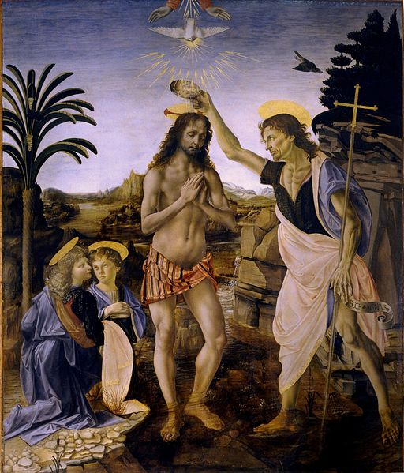
(Figure: The Baptism of Christ, by Verrocchio and Leonardo [1])
His most famous paintings, and the most popular Da Vinci posters around, are those of The Last Supper, The Mona Lisa and Vitruvian man: The proportions of the Human Figure. These works displayed in Milan and Paris respectively, are the most influential works ever created.[4]

The Last Supper:[4]

Leonardo Da Vinci’s “The Last Supper” remains one of the greatest masterpieces of all time. Even over 500 years after the painting was completed, this piece remains one of the most studied painting in history.
In 1495 Leonardo Da Vinci was commissioned by Ludovico il Moro to paint a wall in the refectory of the Santa Maria delle Grazie in Milan. Leonardo was asked to create a portrait of Christ's last supper with his disciples, but more importantly, Leonardo chose to paint the very moment in which Christ announces that among the disciples lies a traitor.
His 12 disciples, whom Leonardo has cleverly divided into groups of 3, surround Christ, figured in the center of the painting. Alone in the center, Christ's arms lay open, encompassing him into a triangular shape, expressive of the Divine Trinity, while the four groups around him are each boxed within their areas of the painting. Like most of Leonardo's other works, geometric shapes form the painting and aid in creating the painting's dialogue.
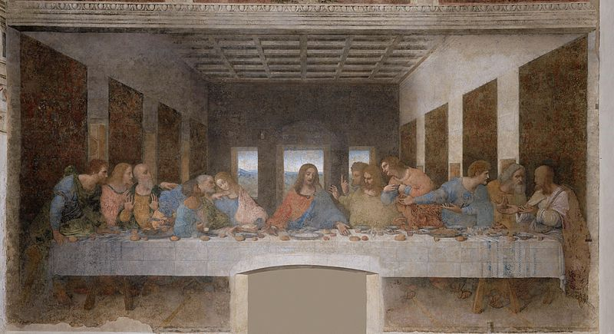
(Figure: The Last Supper[1])

The Mona Lisa:[5]

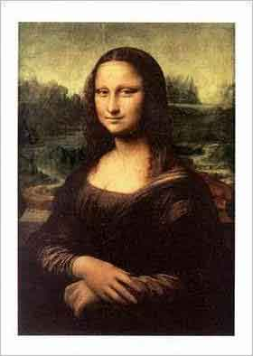
(Figure: The Mona Lisa)
Leonardo Da Vinci's Mona Lisa is one of the most famous and most celebrated works of all time. The mastery of the painting lies in its subtle detail, including the faint smile, and Mona Lisa's distinctive gaze. The work is said to have been commissioned by a gentleman named Francesco del Giocondo, who hired Leonardo to paint a portrait of his wife, and this is why The Mona Lisa is sometimes referred to as La Gioconda. While this is a theory on the origination of the painting,scholars have disagreed throughout the ages about how factual this story really
is.
The Mona Lisa, aside from being one of the most recognized works in the history of art, is also one of the most widely reproduced works ever.

The Vitruvian Man: The Proportions of the Human Figure [6]

In this work, Leonardo used both image and text to express the ideas and theories of Vitruvius, a first century Roman architect and author of 'De Architectura libri X'. The Vitruvian ideas, presented by Leonardo, formed the basis of Renaissance proportion theories in art and architecture. In his treatise, Vitruvius discussed proper symmetry and proportion as related to the building of temples. The architect believed that the proportions and measurements of the human body, which was divinely created, were perfect and correct. He therefore proposed that a properly constructed temple should reflect and relate to the parts of the human body. He noted that a human body can be symmetrically inscribed within both a circle and a square; this idea influenced his architectural practice.
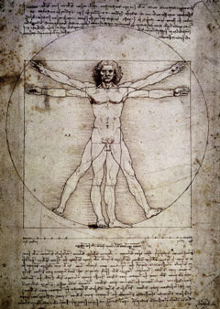
(Figure: The Vitruvian Man)

Leonardo Da Vinci’s Inventions:[7]

Aside from his masterful, artistic talent, Da Vinci also possessed an acute scientific mind that he put to good use by inventing and re-inventing dozens of contraptions. However, Leonardo Da Vinci inventions have been somewhat overlooked and one might be pleasantly surprised to discover some of the ideas that have sprung from this artist’s mind.
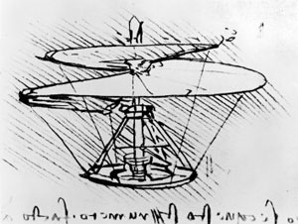
(Figure: Flying Invention)
His earliest sketches depict the inner workings of various machines from his era. Eventually, his creativity led to the outlines of flying machines, weapons and musical instruments. Leonardo first became enamored with the idea of flight in the 1480s. He designed what is called the ornithopter flying machine. Although the invention never came to fruition during his time, many believe that the helicopter was indeed inspired by Da Vinci. His creations may also have given rise to today’s hand glider and parachute.

Springs & Things:

Da Vinci inventions were diverse. He is credited with creating one of the first primitive alarm clocks, a contraption based on the flow of water. A thin stream of water would drip from one container to another until the second container was full, at which time the legs of the sleeping Da Vinci would be lifted by a combination of pulleys and gears, hence rousing him awake.
Although never actually constructed, Da Vinci designed a crane capable of moving large boulders effortlessly and efficiently, most likely intended for gathering stones from a quarry.

References:

- Leonardo Da Vinci: http://en.wikipedia.org/wiki/Leonardo_da_Vinci
- Da Vinci’s Life: http://www.davincilife.com/index.html
- Great Artists in History: http://www.theartgallery.com.au/arteducation/greatartists/davinci/about/
- The Last Supper: http://www.davincilife.com/lastsupper.html
- The Mona Lisa: http://www.davincilife.com/monalisa.html
- The Vitruvian Man: http://www.davincilife.com/vitruvianman.html
- Leonardo Da Vinci’s Inventions: http://www.davincilife.com/inventions.html

PAPER II – Company Proposal

Section VI – Company Proposal, Samsung Electronics

Executive Summary

Samsung Electronics is the world leader in consumer electronics and it is a household name in many parts of the world. Samsung was founded in 1939 by the family of the present Chairman Lee-Kun Hee family who for generations has run this company. The company is a classic example of a family run conglomerate or chaebol (refers to South Korean form of business conglomerate) that is an integral part of the South Korean business landscape. The company is headquartered in Seoul and operates in over 100 countries across the world. With assembly plants and sales networks in 68 countries across the world, Samsung has as many as 200,000 employees. The Samsung group of companies forms the world’s largest conglomerate in terms of revenues and the fact that Samsung accounts for 20% of South Korea’s exports gives an idea about its size and breadth of operation. (Samsung.com, 2010, 1)
The company has a powerful influence on the South Korea’s economic development, politics, media and culture, being a major driving force behind the Miracle of Han River. Many businesses today use Samsung's international success as a role model. Its revenue as large as some countries' total GDP. In 2006, Samsung Group would have been the 35th largest economy in the world if ranked, larger than that of Argentina.
Samsung electronics’ mainstay business is semiconductor and visual display. For more than 20 years since 1993, Samsung has kept the title of the world’s largest memory chip maker. According to DisplaySearch, the U.S. market research and consulting firm, Samsung is forecast to take a 27-percent share for the global TV market in the second quarter of 2010. The market researcher predicted that Samsung’s leadership would continue in 2011. The company is pro-actively competing with Mobile phone manufacturers Apple and Nokia. The recent Galaxy line of products which include smart phones and tablets, are proving to be world’s best Android based devices to date, and is significantly helping Samsung electronics capture global market share.
Samsung had emphasized innovation in its management strategy since the early 2000s and it again highlighted innovation as part of core strategies when it announced the Vision 2020 in which the company set an ambitious goal of reaching the $400-billion sales revenue within 10 years. In order to cement its leadership in the areas of memory chip and TV production, Samsung has invested aggressively in research and development. The company currently has 24 R&D centers around the world.
Samsung Electronics vice chairman once said:
"We don't predict the future and wait, as we expect our people to be committed to product innovation with the belief that this can only be achieved through constant creating."
This has been the key mantra for Samsung’s success for years. Samsung electronics strives heavily upon its core competencies such as Complex Global Supply chain excellence, Six sigma business practices, Own Hardware Manufacturing and Fabrication Plants and Technology, to aggressively expand into new business domains and become a world leader in several electronics’ businesses it has.

Business growth & Profits:
Samsung reported earnings for the 2nd quarter 2011 and came in as expected, but were down. Revenues were up 4% year-over-year to 39.44 trillion won ($37.63 billion), but its consolidated net income declined by 18% to 3.51 trillion won ($3.35 billion).
Here are the highlights of the Samsung Electronics 2nd quarter earnings report:
- Telecommunications showed the most growth as revenues rose 45% to 11.69 trillion won ($11.15 billion) and profit came in at 1.67 trillion won ($1.59 billion). The semiconductor business showed higher profits at 1.79 trillion won ($1.71 billion), but down big time year-over year from 2.94 trillion won ($2.80 billion).
- Samsung’s Semiconductor businesses recorded a consolidated operating profit of 1.79 trillion won in the second quarter, improving from the 1.64 billion achieved in the first quarter but declining from the 2.94 billion won registered the previous year.
- Samsung’s Mobile Communications Business saw revenues rise 45 percent year-on-year to 11.69 trillion won. Shipments of mobile handsets increased in the high-single-digit range quarter-on-quarter driven by brisk sales of smart phones including the flagship GALAXY SII, which began to be rolled out globally during the quarter. The average sales price of handsets increased by more than 10 percent.
- The Digital Media & Appliances businesses – including Visual Display, IT Solutions and Digital Appliances – posted revenues of 14.07 trillion won for second quarter. The operating profit of 510 billion won represented an improvement on the 100 billion won registered the same period last year.
Overall the company reported a 25 percent drop in quarterly profit, hit by losses in its flat screen business, overshadowing strong profit growth from mobile phone sales.
Samsung warned of a challenging business outlook and said uncertain economic prospects may keep demand for TVs and memory chips depressed. The company's biggest drain on earnings remains its loss making Liquid Crystal Display business.
Sony Corp and Panasonic Corp also warned of weak TV sales, especially in the United States and Europe, following Philips and Corning Inc in highlighting anemic demand.

Current market share & outlook:
Samsung Electronics is the world largest Electronics Company by revenue. The company is facing fierce competition in TV business and mobile business. The company is doing extremely well in mobile business, with its recent string of Galaxy product releases. Samsung Galaxy S II has passed the 5 million global sales milestone, within 85 days from its launch, even before the product’s debut in North America and China. The product’s sales are set to accelerate as it has been recently launched in China.
According to the market research firm's Advanced Quarterly Global TV Shipment and Forecast Report, Samsung was the No. 1 brand in North American and worldwide on a revenue basis, with a 21.2 percent share of total global TV revenues and a 21.4 percent share of global flat-panel TV revenues.
DisplaySearch reported – “As for worldwide 3DTV shipments during the quarter, Sony was the top 3D LCD TV brand on a unit basis, and Panasonic was the top 3D PDP TV brand. However, in total combined 3DTV shipments across all technologies, Samsung was the leader in the U.S. and worldwide.”
For the full year 2010, Samsung remained No. 1 in total flat-panel TV, although its global share fell by a point from 2009 on growth from LG Electronics as well as increases by Japanese brands due to the strong home market.

Q4 10 Worldwide Flat Panel TV Brand Rankings by Revenue Share
Rank | Brand | Q3'10 | Q4'10 | Q/Q | Y/Y
Rank | Brand | Share | Share | Growth | Growth
1 | Samsung | 21.60% | 21.40% | 27% | 2%
2 | Sony | 11.80% | 14.20% | 54% | 34%
3 | LGE | 13.50% | 12.70% | 20% | 18%
4 | Panasonic | 9.10% | 8.30% | 15% | 13%
5 | Sharp | 8.00% | 8.10% | 29% | 67%
 | Other | 36% | 35.30% | 25% | 8%
 | Total | 100.00% | 100.00% | 28% | 15%
Source: DisplaySearch Advanced Quarterly Global TV Shipment and Forecast Report
So, it is inevitable that the company has to take necessary steps so as to sustain its position as global No. 1 TV manufacturer. As for the LCD TV business, the market simply shows that this segment has reached a “good enough” point. Many users don’t care enough about the potential design or image quality improvements (which are real) to pay a huge premium on a high-end television. This is the reason why LCD business is under price pressure, as the prices keep plummeting, due to slipping demand and oversupply.

Innovative claims for the proposed research

As explained above, with profit percentages and market research results, it is evident that for the company to sustain its position as global No.1 TV brand by market share, and improve its profits in TV global business, it has to create distinct value in its products, which should bear tangible benefits to its customers. The company could create distinct value for its TVs, by decreasing its focus on improving the image quality of LCD/LED displays and should increase it focus on manufacturing smart LED TVs and High quality, hassle free viewing experience technology for 3D TVs, for which the consumers will be willing to pay a huge premium.
Samsung smart TVs are web-connected entertainment systems, which apart from typical TV watching, will enable the consumers to easily search for movies, TV shows, browse the web, explore Samsung apps, chat with friends and find many other types of new interactive TV content. The current Samsung smart TV which is running on Embedded Linux Operating system, with applications running on Javascript based framework on the browser of the TV, reportedly has software defects even for basic applications like “Netflix”. Moreover, with only 500 odd applications, the consumer has a very less freedom in his application choice.
This paper proposes a new line of Samsung smart TVs based on Android operating system, an open-source operating system for smart phones and tablets, which will enable the company to expose its smart TV application store, to the existing huge number of Android freelancers and Android application development based firms. Moreover, this will also let Samsung integrate existing “Android market” applications (similar to Apple App store) for TVs. With Android being stable and defect free compared to existing Samsung’s application framework, there wouldn’t be any basic software defects, which will enhance the consumer’s satisfaction with the product. Customizing Android operating system which is actually for mobiles is not something new for Samsung Electronics, as they have done the same thing for Samsung Galaxy Tab launch, except that it is a different business division. The company should only just let the knowledge flow across business divisions. Providing the customers with huge number of smart TV applications, and with more and more developers making applications for TV, this would generate a lot of revenue for the company, both in the form of applications and TVs.

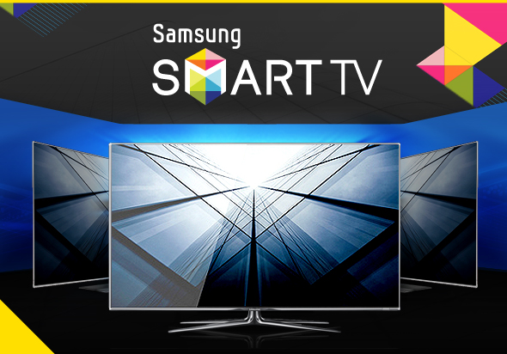

I will be using Knowledge Insight Model along with 2x2 approach to aid this research. I am sure after the implementation of this proposal; Samsung Electronics will be able to create distinct value for its TVs, exponentially improve its profits and sustain its position as global No.1 TV brand name.

Proposal Roadmap

Goals of the Proposed Research:
- Improve the profit percentages; as the LCD business continues to be in losses for second quarter due to weak demand for PCs, TVs in developed economies like US and Europe, it is essential for the company to improve the revenue in countries with strong economy outlook and create revenue in other forms.(by selling Android based smart LED TVs and Android applications)
- Efficient use of existing technology (Android) and tacit knowledge within the organization (Knowledge lying within the Samsung Galaxy Tab development team in the company).
- Stay ahead of the competitors to sustain the company’s global position.
- Winning customers’ confidence and satisfaction by delivering seamless products and services.
- Save costs for the company by utilizing the existing manpower efficiently.

By extensive use of knowledge dynamics and knowledge management concepts, all the above goals can be accomplished easily, if the churnings out of this research are put to proper use. By making use of the PDCA cycles, the product development process can be properly streamlined and efficiently carried out.
The above goals are in best interest of the company, which won’t require the company to make high investments for implementing this proposal. After all, the proposal’s main objective is to boost the company’s profits. The research will help the company to streamline its knowledge management practices, and will help them go in a direction which will only help them create more revenue in a situation of weak market outlook.

Tangible benefits to end users:

The benefits of starting an Android OS based smart TVs are many to the end users. Following are the benefits the consumers get if the proposal is implemented:
- Diverse choice of applications on TV, just like in smartphone.
- Stable and seamless software, enhancing the customer experience and satisfaction.
- Effortlessly provide ongoing support for existing user’s favorite Android applications.
- Applications custom-made for TV based on Android provide better viewing experience compared to smart phones.
- Applications once bought for Samsung Android smart phone, can also be seamlessly used on TV, with the use of same account Id.
- Users don’t have to buy the same application twice, for his smart phone and TV, so will be able to save money.

Critical technical barriers:

- Customizing the Android Operating system for High Definition LED TVs can be quite challenging, as all the output has to be scaled to very high resolutions, unlike for tablets, but a similar approach can be followed. Having an experienced team which already customized Android operating system for tablets, the company has right people in hand. With Samsung trying to customize operating system for tablets, led Google to release further versions of Android OS which support tablets. Similarly, if Samsung is successful in tapping huge TV markets with Android, this might lead Google to support Android OS for TVs too. This is very beneficial to the company in the long run.

- The development of this product has to be very fast, so as to have competitive edge over its competitors. Google, Sony and Logitech as an alliance, launched Google TV, and is one of the competitors to the Samsung smart TV. Though Google TV is not doing well, as Android is maintained by Google, it is quite possible that Google may start integrating Android market into their TV framework. So, in order to gain differentiation, it is better if Samsung rolls out Android based TVs as soon as possible.

- With global economic outlook very weak, it is necessary that the cost of the resulting Android TVs is not too high. Rather than creating TVs with lots of premium features which will increase the cost of the product, the company should focus on TVs with optimal features, so as to have differentiation in terms of cost and quality of the product.

- Localizing the product according to each region it gets launched. It is necessary that in order to tap several regional markets, the company needs to tailor the product specific to each region’s needs. This might lead to adding few features or customizing the existing features in the Android operating system software.

- Ready launch of critical and popular applications along with the TV. Popular applications like Youtube, Netflix, Facebook, Twitter, AngryBirds etc., should be readily available with the TV; else this would irk the consumers. Moreover, the company should facilitate a smooth and efficient framework, for the developers to rapidly create applications for the TV.

- The implementation cost involved. Though, there is already a good level of tacit knowledge about the project within the organization, there will be an extra burden on the employees as they have to work for development of this product in addition to their existing projects. This is because, Samsung is still not totally moving out of their currently existing TV frameworks. So, it might be mandatory to hire Android engineers and experts so as to progress with the proposed product development.

Main elements of proposed research:

Samsung Electronics makes smart TVs, which are based on Embedded Linux Operating system, with all their applications based on a browser like framework, and applications are using technologies like Javascript, with the help of some of the libraries the company has built to make the framework robust and fast. The company exposes the framework APIs to the developers of the applications for TVs, and gives significant margin of the revenue generated by selling the application, to encourage the developers.
The current proposal suggests that the company starts manufacturing smart TVs based on Android Operating system, as that will lure huge Android developer base to make applications for TVs, which will further provide quite a lot of application choices for the consumers, and will also boost the revenue the company gets with the sales of Android applications.
To introduce a new line of smart TVs based on Android operating system has the following benefits:
- Robust and reliable software compared to existing smart TV frameworks
- Increase the popularity of Samsung smart TVs, as they are based on most popular among all the Mobile operating systems, Android
- Boost the revenue that comes from the sale of applications
- Consumers now have access to much popular “Android Market”
- Increase the customer base for Samsung smart TVs
- Improve the profits for the company
- Provide a cost effective solution and reduce maintenance cost of the software systems.
To improve the synergy between several business divisions in Samsung Electronics, and to facilitate knowledge sharing between these business units. Though, Samsung Electronics is virtually integrated, the company’s various business units work in isolation. The company’s knowledge flow shouldn’t be constrained within their specific business units.
The research proposal uses the Knowledge Insight Model (KIM) as presented in the KEO book and with the help of the Marker, Sharer, Finder & Framer provides a design cycle for the new product. Thus, the target of this research proposal is to combine the already existing ideas with the concepts of Knowledge Management, knowledge sharing with 2x2 thinking and provide a complete feasible solution to Samsung Electronics which will help it achieve the research goals.

Rationale that the proposed approach will overcome the technical barriers:

Capturing an unknown market and sustaining its leadership stance in several consumer electronics businesses across the world is not something new for Samsung Electronics. The company has a very strong Research & Development department, with unique technologies in the works, a lot of which trickle down in its huge array of products the company sells.
Under the leadership of Leonardo Da Vinci, Samsung Electronics will once again prove its unique way of doing things, and doing right things at right time. As Leonardo Da Vinci once said,
“It had long since come to my attention that people of accomplishment rarely sat back and let things happen to them. They went out and happened to things.”
“I have been impressed with the urgency of doing. Knowing is not enough; we must apply. Being willing is not enough; we must do.”
Moreover, Android’s rising popularity is just showing how well the software is engineered, and a recent survey gives me an impression that, Android can be base for several future products.
Not only Android based products are robust, but also they are cost-effective and extremely flexible.
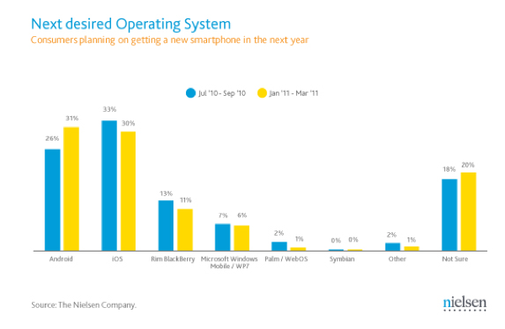
So, all these factors put together, gives a great amount of confidence in the proposed research.

Nature of expected results:

The expected results after this transformation would mean the following benefits:

- Production of cost-effective smart TVs, which would revolutionize the way the consumers use TVs.
- Expansion in Samsung Electronics’ market share and further sustaining its leadership in TV industry with the introduction of innovative products that meets the market needs.
- Samsung Electronics will improve its brand value, by developing products which are reliable, robust, user-friendly and cost-effective. The consumers should find pride in owning Samsung’s product.
- The Android based smart TVs will become benchmark for its competitors, in terms of product quality and services (in terms of Android applications).
Only if the company makes such product innovations, the company will be able to realize its vision 2020, to become among the world's top 10 respected companies, and transform to become a top-tier environment-friendly enterprise by then.


The Risk if the work is not done:

“The first step in the risk management process is to acknowledge the reality of risk. Denial is a common tactic that substitutes deliberate ignorance for thoughtful planning”

~ Charles Tremper
“Risk varies inversely with knowledge”
~ Anonymous

- If there is no innovation by Samsung Electronics on its current smart TV frameworks which suffers from large number of basic software defects, and very few applications available for the consumer, there is a huge risk involved. There might be a stage where Google TV can get strong by integrating Android market into its Android based TV frameworks. If Google does this first, Samsung will have no other option than to bow to Google and start making TVs based on Google’s TV frameworks just like Sony Corp.

- If the smart TV’s frameworks are not developed, then there can be a risk where customers will not be interested in the product anymore, due to growing number of woes about very primitive software defects in the TV with respect to applications like Netflix.
- Samsung electronics’ LCD business is running in losses for second quarter consecutively. The company’s LCD business is becoming a big drain of its earnings due to weak demand for Personal computers, TVs in developed economies like US and Europe. In order to cover up for losses in this business, the company has to come up with distinct ways of generating revenue, which will boost the investors’ confidence in the company. The company lost 12% share price in last 6 months.

Criteria for scientific evaluation:
“A Stage-Gate Process is a conceptual and operational roadmap for moving a new-product project from idea to launch. Stage-Gate divides the effort into distinct stages separated by management decision gates. Cross-functional teams must successfully complete a prescribed set of related cross-functional tasks in each stage prior to obtaining management approval to proceed to the next stage of product development.”
~ Stage Gate International

A through testing is done by engineers following the Stage-Gate process
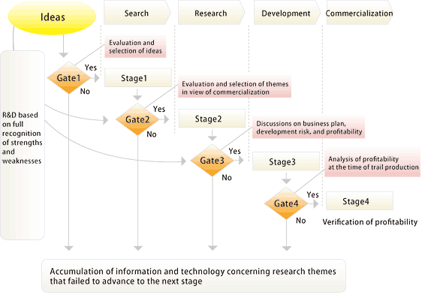
Before launching the final product in to the market, the developed product from the stage-gate process is released only to few of the company’s customers, feedbacks will be collected from the customers and any issues on the prime functional areas will be addressed and released in the market.

The annual review at the end of each fiscal year will provide an overview of the sustainability of the product and the company can account for the cost it invests in the research and development and the returns from the product sales.

Cost of the proposed effort for each performance year:

The cost of the proposed research from my analysis is not really high. And, I don’t think there should be a separate budget allocation in the company’s finance planning, for the proposed effort.
The main idea behind choosing Android operating system is that not only it is robust and flexible, but also very much cost-effective. The Android operating system is open-source, and hence there is no extra cost incurred in deploying it in Samsung smart TVs. As the company already has the required expertise for the proposal, the number of new Android recruits to reduce the burden on the current employees will not be too many, and certainly not a big concern for a world’s largest electronics company.
If we look at the cost of the proposed effort year-on-year, the cost is expected to only come down, as man power is only required for customizing the operating system before the launch. For maintaining the developed systems each year, the man power is only set to come down.

The proposal’s main aim is only to enable the company to get higher returns, with considerably less investments.

Research Objectives:

Detailed Problem Description:

The term Long Tail has gained popularity in recent times as describing the retailing strategy of selling a large number of unique items in relatively small quantities – usually in addition to selling fewer popular items in large quantities. The Long Tail was popularized by Chris Anderson in an October 2004 Wired magazine article, in which he mentioned Amazon and Netflix as examples of businesses applying this strategy.
The distribution and inventory costs of businesses successfully applying this strategy allow them to realize significant profit out of selling small volumes of hard-to-find items to many customers instead of only selling large volumes of a reduced number of popular items. The total sales of this large number of "non-hit items" is called the Long Tail.
One such distribution is power law. The below graph shows that even though most customers frequently buy products (shaded in green), there is still large market untouched ,i.e. these are the products where only few customers buy( shaded in yellow). If you closely observe both areas are equal which means equal number of customers exists in both the areas (green and yellow as depicted in the figure). Using this power law distribution, the company can change the target area.
(Figure: Power law distribution)

Samsung Electronics will portray into selling Android applications for smart TVs (new market), and with the help of KM concepts and knowledge sharing patterns of this research, will be able to get the new market segment in the tail portion. The company’s focus has always been to sell large number of popular products to the customers (green portion), and never delved into selling small number of less popular products to large customer base (yellow portion). So, rather than focusing only on green portion, it is time with the help of this research and the above power law, the company start focusing on selling Android applications, which are small number of less popular products, intended for a large consumer base.
This strategy will enable the company to maximize their profits.

Research goals:



The major goals of this research are:
- Creating a new source of revenue, with no significant amount of investments.
- Improve the profit percentages, so as to aid its ailing business units.
- Help the company to adapt 2x2 thinking.
- Enable the company to let knowledge flow across its business divisions.
- Stay ahead of its competitors, by delivering products with cutting-edge technology, thereby sustaining its position.
- Help the company to improve its knowledge management practices.

Extended Impact:

The company is already global No.1 TV manufacturer in terms of market share. It has been No.1 for last 6 years all over the world. But, the company is recently facing neck-to-neck competition from LG electronics, in regions like China, India, US, South Korea etc.,
My research proposal enables the company to sustain its position, by simply making use of its large R&D capabilities and existing knowledge repository, combined with existing state-of-the-art existing open-source technology. Since, my research proposal also makes use of KM practice and 2x2 thinking, it will extend a significant impact on the company’s business practices.
The proposal also enables knowledge sharing across business divisions, as generally this is not the case with Samsung Electronics.

TECHNICAL APPROACH

Detailed Technical approach: PDCA cycle

The plan–do–check–act (PDCA) cycle is a checklist of the four stages, which you must go through to get from “problem-faced” to “problem-solved”. The PDCA cycle should be repeated again and again for continuous improvement. This model should be used whenever you are developing a new or improved design, process or implementing any change.
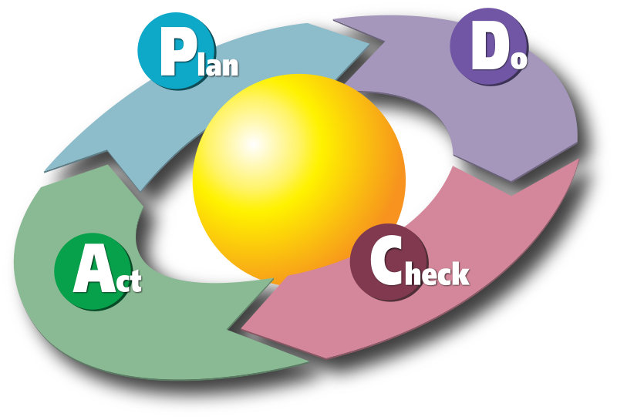
(Figure: PDCA Cycle)
The four stages of this cycle which are denoted by the picture above are described as follows:
- Plan: Recognize an opportunity and plan a change. The first step is to identify the problems that are being faced by the company and then make a plan to solve the problems.

- Do: Test the change. This has to be performed on a small-scale, mainly because of the risk factor involved, if the idea fails. On the event of the failure of the test the Plan phase is executed again with an alternate or a different plan.

- Check: Review the test that has been performed on a small-scale; analyze the results to see whether they match to what was desired. Also, keep looking at the output to be able to face any new problems, if they occur.
- Act: If the check is successful on a small scale, go ahead and implement the same on a wider scale. It is equally important to ask the people (e.g. customers) who will be affected by these changes as to what other things are required to implement the same on a wider scale.
The above points are represented pictorially in the following way:
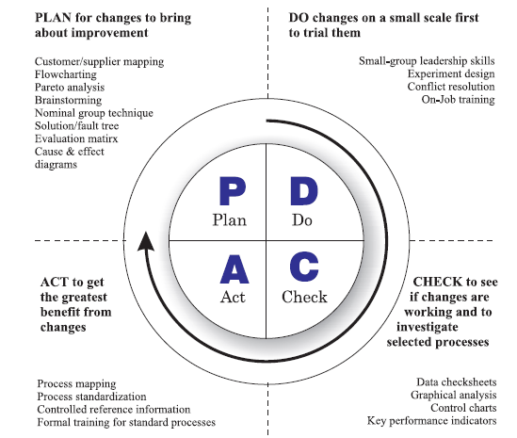

PDCA approach in implementing my proposal is described below:

Plan:
In the “plan” phase analysis is done to identify the root cause of the problem, in this case the market of smart TV products. In this phase, we analyzed what we intend in improving and sustaining Samsung’s global TV market share. Understanding the strategies of the competitors, and gathering data relevant to our product from competitors’ releases and market surveys will enable us to defining clear objectives for the product development. GATE process as explained above which involves constant feedback and involves higher management in decision making, is applied on our ideas to get the optimal problem that is impacting our business.

Do:
In the “do” phase, the product with all the changes implemented until now will be subject to an internal release, to the team mates and sister teams who have relevant knowledge about the product, and will collect the feedback after they using the product for a specified amount of time. On a positive response from the users i.e., if the product development is viable with the current progress and technology, the developers will go ahead. The changes suggested from the feedback will be integrated easily into the current existing product, without much difficulty, as the product is still in incipient stages.

Check:
The experimental smart TV products based on Android OS will first go through a series of unit tests by the developers of the product. Then product will be put through a series of integration tests. The experimental product will be going through a series of tests from specialist test teams at Samsung Head Quarters. Both the reports from Internal Testing and Specialist test teams are then consolidated.

Act:
If the results from both the reports are satisfactory then, the experimental product will be scaled to real-time commercial product. If the results are not satisfactory, and there is a significant deviation from original plan then, it is necessary to go back to the “plan” phase, rethink the design and run the PDCA cycle again.

Abstract Mandala Pattern & Knowledge Insight Model:

Processes depend on systems evolving in the organization’s internal environment as well as its external environments. Processes start off from a discover stage, move on to a refinement stage and iterate back and forth between these two stages to gradually advance, solve problems and achieve results. By crossing the external/internal dimensions of the organization’s processes with their discover/refine dimensions, the Organon can be articulated around a four-quadrant matrix presented below
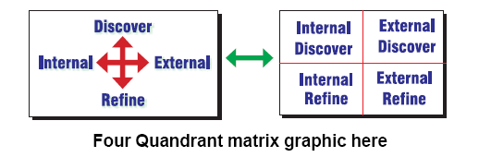
(Figure: Four quadrant matrix showing internal, external, discover and refine)
In this matrix, the transitions from discover to refinement represent a further step in the process, while the transitions back to the discover stage involve the consolidation of what has been refined in order to move forward in the creative. Similarly, the transitions from external to internal and back depend on the level of creative achievement that has been reached.
Delving deeper into the center of the Mandala, the PDCA cycle is applied to each of the problem solving phases.

(Figure: PDCA And Problem Solving states)

Application of 2x2 matrix for the current research proposal:

- Idea to manufacture Samsung smart TVs based on Android Operating system – External Discovery
- A proposal to develop the product is made to the higher management – Internal Discovery
- Tests performed by Internal Quality Assurance team, which is part of the development team – Internal Refinement
- Tests performed by External Specialist Testing teams from Samsung Head Quarters – External Refinement
- Knowledge and research ideas are brought into the organization from knowledge centers like Universities, Alliance Research Labs etc. – External Discovery
- Discovered ideas are integrated and changes are made by product development team – Internal Discovery
- Tests are performed by Quality Assurance teams within the company – Internal Refinement
- Market survey and constant feedback from the users of the product and changes are implemented – External Refinement
These cycles of discovery and refinement is carried until the product is satisfactory.
The Knowledge Insight Model (KIM) chiefly comprises of four major functions. These functions are labeled as the Framer, Maker, Finder and the Sharer. With respect to a particular problem for which a solution has to be proposed and developed and implemented, the four functions handle the various tasks required to come up with the solution.
FRAMER:
The Framer allows its users to “zoom out” and “see the big picture” in order to make the necessary plans to correctly frame the Knowledge Insight Model and its other three related models. The Framer is the function responsible for understanding the problem, and designing a framework (hence the name Framer) within which a solution can be developed. The Framer identifies the requirements of a problem, and is also responsible in guiding the process of developing a solution. The Framer proposes a design for the solution.
The framer focuses on the Plan phase of the PDCA cycle. Higher management generally focuses on the Framer model to develop short to long term plans.
The framer consists of the components shown below. Apart from these components it also contains its own PDCA cycle.
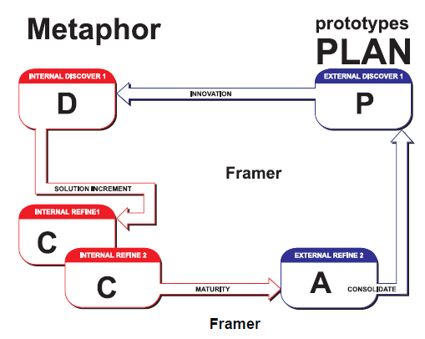
MAKER:
Once the framework has been established, the Maker function is responsible for developing the solution, or application based on the design put forth by the Framer. The Maker functions at an implementation level wherein it puts together the working modules and components as required by the design developed by the Framer.
The Maker is a cycle which has components: External Discover 1, Innovation, Internal Discover 1, Solution Increment, Internal Refine 1, Internal Discover 2.
The diagrammatical representation of the Maker is given as follows:
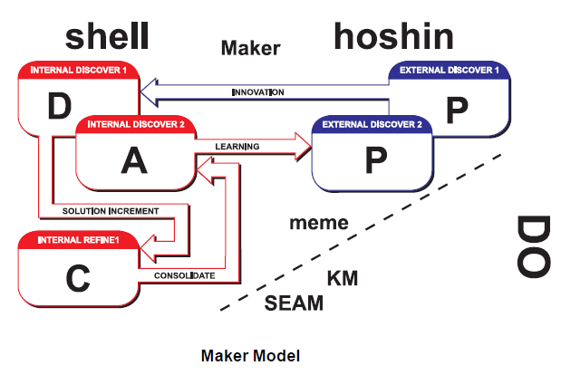
FINDER:
The Finder allows its users to find/match external needs with internal Maker creations and Framer plans. Finder is a function responsible for finding resources to supplement the Maker’s efforts. In cases where there exists a technique or application that performs the required operation, the Finder procures this solution for the Maker, thereby saving time since the application need not be developed from scratch. Another important task of the finder is to test the solution that has been proposed by the maker for all possible test cases. If there is a failure then the Finder gets back to the Maker with the changes to be made in the solution. In Finder, the knowledge flows from Explicit to Tacit. After continuously analyzing the data, explicit knowledge gets transformed into implicit knowledge.
This interaction between the Finder and the Maker at this stage is equivalent to the Discover – Refine transitions to attain the desired result. If the Finder and Maker are not able to solve the problem, the Framer will have to design the solution again.
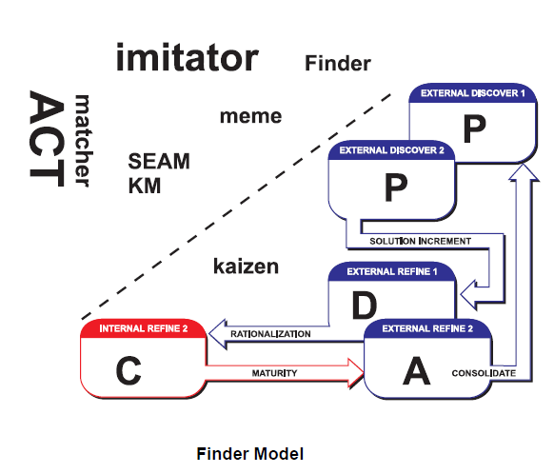

SHARER:
The Sharer allows its users to share between Maker and Finder within the Framer. The Sharer function, as the name suggests, is responsible for ensuring that all other functions can work effectively by sharing their information freely, and that knowledge flows freely between all modules. The Sharing function is instrumental in refining the model and the application being developed, particularly in situations where the application does not perform satisfactorily. Once a satisfactory solution is developed, the Sharer applies the solution to the problem area. We can compare the Sharer with the Integration Testing phase of the SDLC, wherein the modules may not be tested but care is taken to make sure that the knowledge flow is consistent throughout.
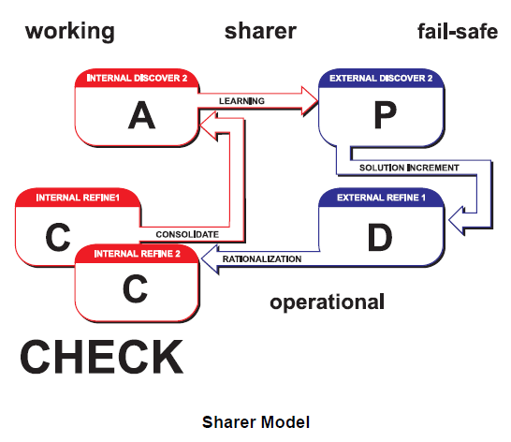
The Sharer is a guide, who understands the framework put together by the Framer, and this function works so that knowledge is managed effectively, and that all functions are working towards a solution.
Thus, Sharer (Project Manager) ensures that the Framer (Designers), Finder (Troubleshooters and Support team) and Maker (Software Developers and Programmers) work together by sharing information.

“Blinding ignorance does mislead us. O! Wretched mortals, open your eyes! ” – Leonardo Da Vinci

Hence I would like my Archetype: Leonardo Da Vinci to be the Sharer since he should have all the knowledge acquired by the Framer, Finder and Maker, make them work in harmony with each other and be able to work in place of anyone if need be.

So I would like Leonardo Da Vinci to be the Sharer (Think deep as well as have Broad Vision).

Comparison with the current technology:

There are a few famous key players in the area of smart TVs. Apart from Samsung Electronics, which dominates the majority of the global TV market share; there are companies like LG Electronics, Sony Corp, Google and Apple.
LG Electronics uses their own custom framework, whereas Sony Corp, Google and Logitech as an alliance launched Google TV which is the world’s first smart TV.
Google TV is based on Android like framework, but the TV’s sales are very poor, forcing Google to revamp its smart TV frameworks.
Apart from all this, there is an interesting small company based in Sweden, called “People of Lava”, which is the first company to launch world’s first Android based smart TV. But, the company based its framework based on Android 1.5, which is considered to be very obsolete. The latest Android OS is Honeycomb. The company does not have strong global market, hence it is quite un-noticeable.
So, overall Samsung and LG have best technology in-place as of now, but Google has a great potential to take off from its current situation. My proposal will this way help Samsung in order to stay ahead of the competition.

Current Samsung’s smart TV frameworks:

Current Samsung’s smart TV deploys Embedded Linux Operating systems in their TV chip. All the applications are based on a web browser, using Javascript language and some of the libraries Samsung has built. Samsung’s current TV frameworks are widely appreciated and hence fetched Samsung top position in smart TV market. But, the current TV frameworks lack robustness, and contain several software defects.
Drawbacks of the current Samsung’s smart TV technology:
- Contains a lot of software defects, which do not provide a glitch-less experience to the users, when compared to the experience the users have on their personal laptops.
- Users are given a very narrow choice of applications to install on their smart TVs. The number of applications is about 500, which is infinitesimally small compared to the volume of apps available for a smart phone.
- Due to the software defects, the current system is not robust, and gives rise to crash of the web browser on the TV.
The main technical improvement of my proposal is making the product robust, with minimal software defects, and providing consumers a large choice of applications, just like a smart phone. If same is achieved besides carrying all the benefits of Android operating system, I am sure that Samsung Electronics will sustain its position as market leader.

Statement of Work

Estimating the amount of time required to complete the product development successfully depends on how aggressively the company undertakes the proposed project. As Samsung Electronics is an hierarchical company, it is necessary that the proposal first gets approved by the higher management. Generally, the time taken for the approval is more than we expect, as it is a strategic decision. But, once the approval is successful, the product development will be quite fast, as Samsung is quite aggressive when it undertakes the project. Typically, the product development will comprise of more than one Plan-Do-Check-Act (PDCA) cycles, before the successful launch of the product. The proposal will be sent to Chief Financial Officer (CFO) to approve the budgetary allocation. But, as explained budgetary allocation for the current proposal won’t be significant. One of the requirements would be to hire a new set of Android experts & engineers, to ease the burden on the existing employees. Going ahead with the product development, Samsung Electronics will be able to sustain its market position and boost its profits. The company’s Knowledge Management practices will improve and knowledge sharing with the aid of 2x2 thinking will be adapted. Upon successful completion of the project, the expected returns from the product will be high, due to much popular Android applications and Android Market integration into the Samsung’s smart TV frameworks.

Future Goals and Objectives:


After careful observation of the company’s business model and closely relating it with the PDCA cycle and the Knowledge Insight Model that I have learnt in the class I was able to find some problems existing in the company and with knowledge of KIM I was able to propose solution to the company. Samsung Electronics being world’s largest electronics manufacturer company, the company has several business divisions and verticals all across the globe. The next approach would be to identify any problems within other verticals of the company by applying the KIM and Knowledge Dynamics and trying to compare it with the PDCA cycle that I have learnt in the class.
Having done analysis with Knowledge Management concepts about one firm, I have learned what aspects of the firm I need to target when I review. I would like to continue to my work in these Knowledge Management concepts and review several other firms, and become a Knowledge management expert one day.

References:

  - Wonder of Samsung smart TVs, http://www.samsung.com/us/article/the-wonder-of-samsung-smart-tvs

  - DisplaySearch Market Share analysis, http://www.twice.com/article/464284-Samsung_Leads_In_Global_TV_Market_Share_DisplaySearch.php

  - Samsung Profits decline, smart phones sales boost, http://www.talkandroid.com/49942-samsung-profits-decline-will-stop-reporting-shipments-of-smartphones-and-tablets/

  - Koreatimes Samsung smart TV News, http://www.koreatimes.co.kr/www/news/opinon/2009/11/202_54800.html

  - Samsung Electronics Wikipedia, http://en.wikipedia.org/wiki/Samsung_Electronics

  - Google TV forum, http://www.googletvforum.org/forum/more-news-your-google-tv-news-team/1503-samsung-aims-30-smart-tv-market.html

  - Samsung smart TV targets 2011, http://www.ubergizmo.com/2011/08/samsung-quarterly-results-2011-august/

  - UCLA International Journal excerpt, http://www.international.ucla.edu/article.asp?parentid=56837

  - Normal distribution and Power law distribution, http://www5.cao.go.jp/seikatsu/whitepaper/h20/06_eng/chapter2-column.pdf

  - The first step in Risk management processes, http://thinkexist.com/quotation/the_first_step_in_the_risk_management_process_is/202055.html

  - Innovation Playground, http://mootee.typepad.com/innovation_playground/2008/03/the-problem-wit.html

  - Stage Gate official website, http://www.stage-gate.com/knowledge_pipwhat.php

  - Long Tail Wikipedia, http://en.wikipedia.org/wiki/Long_Tail

  - Leonardo Da Vinci quotes, http://www.goodreads.com/author/quotes/13560.Leonardo_da_Vinci

  - Growing Android Popularity and Nielsen survey results, http://www.wired.com/gadgetlab/2011/04/android-popularity-growing/

  - Apple-Samsung Lawsuit battle, http://www.phonearena.com/news/Apple-Samsung-lawsuit-a-battle-over-Samsung-Galaxy-S3-and-the-iPhone-5-both-slated-for-fall-release_id18446

  - The New Market Place, http://chuchscoop.wordpress.com/category/media/page/2/

  - Google TV forum – Samsung smart TV news, http://www.googletvforum.org/forum/more-news-your-google-tv-news-team/922-smart-tv-center-global-lcd-tv-market.html

  - Google TV forum – Samsung competitors trends and plans, http://www.googletvforum.org/forum/more-news-your-google-tv-news-team/1503-samsung-aims-30-smart-tv-market.html

  - Smart TV market in South Korea, http://www.advancedtechnologykorea.com/?p=4864

  - SECI framework by Nonaka, http://myweb.tiscali.co.uk/sngourlay/PDFs/Gourlay%202004%20SECI.pdf

Section VI – Humpty Dumpty Problem & Alexander’s pattern language

Let us look at Alexander’s processes and his pattern structure first:
“Each pattern describes a problem that occurs over and over again in our environment and then describes the core of the solution to that problem in such a way that you can use this solution a million times over without ever doing it the same way twice.”
~ Alexander, 1977
Alexander in 1999 is quoted to say as follows:
“Pattern languages are more than just collections of design patterns. In one sense, a pattern language is a design vocabulary, from which patterns can be selected and sequenced into solutions to meet larger-scale design problems and goals. A Pattern Language is a collection of 253 patterns identified by Alexander and his associates over several years of research and study of modern and traditional buildings and communities. These patterns range in scale from geographic regions and cities down to the addition of ornamentation and personalization of individual homes. While buildings and communities built using these patterns were improvements over those that did not use them, Alexander noted that there were still deficiencies: a lack of wholeness and profoundness.”
Grabow in his book wrote as follows:
A pattern language may also be thought of as a narrative describing the life and living structure of a sustainable built system. In this sense, the narrative explains how the system works and its internal and external relationships. Alexander's A Pattern Language is part design language and part design narrative, but was still missing a critical aspect: while it described a well-designed community from the geographical scale to the smallest ornaments within rooms, it did not address the process of creating these built systems, nor was it clear that patterns are not simply templates but are intended to be interpreted locally. Take away the underlying process of growth and adaptation and the interpretive nature of design patterns, and the things you build using them are ordinary and lacking the living structure and character that makes them timeless.
Now, let us look at the article about Humpty-Dumpty problem:
The first embraced reductionism as a way of knowing: Descartes committed himself to “divide each of the difficulties under examination into as many parts as possible, and as might be necessary for its adequate solution,” and to “conduct my thoughts in such order that, beginning with those objects that are simplest and most readily understood, I might ascend little by little, and, as it were, step by step, to the knowledge of the more complex.” Later in the same work, he deployed one of the most durable metaphors of Western intellectual thought: He argued that the body was best thought of as a machine.
By coupling those two ideas—that complex machines could be understood by taking them apart, and that living beings are essentially machines—Descartes set the stage for the age of science. He argued persuasively that living systems emerge as the physical consequences of material forces.
Both Alexander and Descartes are trying to address same concern essentially. Their point is “inorder to understand and model complex systems, we should learn about simple elements of the complex system first, which will then lead to developing complex systems such as machines or pattern languages which model software systems”
Descartes says, to understand the anatomy of human body, we need to understand individual interacting elements which complete the human complex body system. Similarly, Alexander says in order to model large complicated systems, we need to make use of 253 patterns which model simple situations, which are quite reusable, and a meaningful collection of these patterns will then help understanding complex systems.
There is clearly a high frequency matching of their direction of thought process, and both of them are essentially trying to address same concern, but just in different contexts.
References:
- American Scientist, Humpty-Dumpty problem, http://www.americanscientist.org/issues/pub/the-humpty-dumpty-problem/1
- Patterns and Pattern Languages, http://www4.ncsu.edu/~drwrigh3/p3f/patt-lang.html

