Gyan Ganga College of Technology

Jabalpur Madhya Pradesh



NOTICE CSE Department (Minor Project Report)

INSTRUCTIONS FOR MINOR PROJECT REPORT SUBMISSION BY B. E (CSE 5th SEM)

All students of B.E. 5th sem are required to submit their Minor Project reports (N+2 Hard bindings and 1 Spiral binding) by 17/Oct /19 to Prof. Saurabh Shama. The seminar and internal viva of the Minor Project report will be held on 17/Oct /19 – 19/Oct /19 where the student have to present their project with a presentation and one Spiral bind report. Before that they have to give viva of their projects to their guides on 15/Oct /19 – 17/Oct /19 and get the spiral bind report signed after verification. Students are advised to follow a prescribed sequential format for writing Minor project reports given below:

1. The sequence in which the Minor Project report material should be arranged and bound should be as follows:
2. Cover page (sample copy attached as annexure-A).
3. Title page (sample copy attached as annexure-B).
4. Preface (sample copy attached as annexure-C)
5. Acknowledgment (sample copy attached as annexure-D)
6. Declaration (sample copy attached as annexure-E)
7. Contents with title & subtitle, page no. (Breakup of sections according to explanation is advised).
8. List of Figures
9. List of Tables
10. Notations/nomenclature (if any)
11. Executive summary (with Chapters & sections)
12. 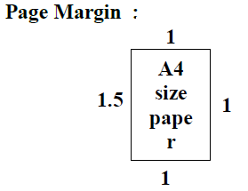Appendix / Annexure/Data sheets( if any)
13. For text in the of the report a proper format must be followed i.e.

Chapter heading : 16 font-Times New Roman-Bold

Section heading :14 font-Times New Roman-Bold

Rest of the text :12 font-Times New Roman

Line spacing : 1.5

1. There should be Separator sheets between the chapters mentioning chapter no. & the title & should also carry one transparency with each separator sheet.
2. The report must consist of following chapters

* Chapter 1- Introduction
* Chapter 2- Project work (It can span in two or three subchapters depending on type & volume of work. This contains the text & related to hardware & software implementation. This section should follow the software engineering approach)
* Chapter 3- Results and Discussion
* Chapter 4  Conclusions and future scope

1. Minimum No. of pages in report should be 50 (excluding starting pages and annexure)
2. Numbering of pages upto List of tables should be in (ROMAN -8 font) and the text, beginning with the Introduction, or of Chapter 1, should be numbered consecutively with Arabic numerals. Page numbers must be placed 1.5cm from the bottom center of each page.
3. Numbering of Tables, Figures and Illustrations must be done sequentially, including the Chapter number in which it is placed (for example, Figure 2.1, 3.2, etc).
4. Captions for Figures, Tables and Illustrations must be placed at the bottom of each, and centered.
5. Two sets of reports per student need to be submitted. one hard bound & one spiral bounded
6. Cover of Hard bound should be with Black colour & engraved text in silver colour & Cover of Spiral bounded should be with Front Page transparent and back blue colored
7. Students are advised to prepare a 8 minutes power point presentation
8. All the students who had made the project in group should prepare the presentation completely. The students have to give their presentation separately or any student from the group may be asked to present any portion of the presentation. This decision will be taken by the experts sitting during the presentation.
9. A CD inculcating soft copy of the report and power point presentation along with the project needs to be submitted as well at the time of viva.

Details of CD:

CD of the project work is required to be pasted on the back cover of the project report in clear packet, which should include the following folders and contents:

1. Presentation (should include a PPT about project in not more than 40-50 slides)
2. Documentation (should include a word file of the project report)
3. SourceCode (full source code of the project with libraries used)
4. Program (final running copy of the project executable)
5. Support (any third party tools used or runtime environment setups that are required to run the project)
6. Help (user manual on how to run the project)

NOTE: CD must be checked for any harmful viruses before submission. Source Code and Program folders can be combined into single folder Project if it’s a web project etc.

1. Minor Project viva will be awarded as per the following criterion
2. Synopsis – 15%
3. Regular Dairy Maintained and signed by Guide – 10%
4. Innovation and timely submission of report in proper format - 25%
5. Ability to express / Knowledge – 25%
6. Presentation and Viva - 25%

Dr. Ajay Lala

( HOD, CSE)

(Annexure A) Cover Page

MINOR PROJECT REPORT

*(16 Normal Arial)*

On

*(14 Arial)*

SMART NOTES

*(20 Arial)*

B.TECH

*(18 Arial)*

in

*(14 Arial)*

COMPUTER SCIENCE AND ENGINEERING

*(16 Arial)*

Submitted By

SIDDHARTH JAIN

Roll. No. 0208CS171121

*(16 Arial)*



DEPTT. OF COMPUTER SCIENCE & ENGINEERING

*(14 Times New Roman)*

Gyan Ganga College of Technology

Jabalpur, Madhya Pradesh

*( 1st letter 20, rest 14 Times New Roman)-Bold*

Nov 2019

(Annexure B) Title Page

MINOR PROJECT REPORT

*(16 Normal Arial)*

On

*(14 Arial)*

SMART NOTES

*(20 Arial)*

B.TECH

*(18 Arial)*

in

*(14 Arial)*

COMPUTER SCIENCE & ENGINEERING

*(16 Arial)*

Submitted By

SIDDHARTH JAIN

Roll. No.0208CS171121

*(16 Arial)*



DEPTT. OF COMPUTER SCIENCE & ENGINEERING

*(14 Times New Roman)*

Gyan Ganga College of Technology

Jabalpur, Madhya Pradesh

*( 1st letter 20, rest 14 Times New Roman)-Bold*

Nov 2019

(Annexure -C)

PREFACE

Minor Project is an integral part of B.E and each and every student has to create the Minor Project in the 6th Semester while studying in Institute.

This record is concerned about our practical Minor Project during 5th Semester i.e. final year of B.E. course. We have taken our Practical Minor Project in “SMART NOTES” During this Minor Project, we got to learn many new things about the technology and its practical implementation. This Minor Project proved to be a milestone in our knowledge of present environment. Every say and every moment was an experience in itself, an experience which theoretical study can’t provide.

(Annexure -D )

ACKNOWLEDGEMENT

It is my pleasure to be indebted to various people, who directly or indirectly contributed in the development of this work and who influenced my thinking , behavior and acts during the course of study.

I express my sincere gratitude to *Dr. Neeraj Shukla* worthy Principal for providing me an opportunity to undergo Minor Project in 5 th Semester

I am thankful to *Prof.Saurabh Sharma* for his support, cooperation, and motivation provided to me during the Minor Project for constant inspiration, presence and blessings.

I also extend my sincere appreciation to *Prof. Sandeep Rao* who provided his valuable suggestions and precious time in accomplishing my Minor Project report.

Lastly, I would like to thank the almighty and my parents for their moral support and my friends with whom I shared my day-to day experience and received lots of suggestions that my quality of work.

SIDDHARTH JAIN

(Annexure –E )

DECLARATION

I, SIDDHARTH JAIN, 0208CS171121, B.TECH (Semester- V) of the Gyan Ganga College of Technology, Jabalpur hereby declare that the Minor Project Report entitled “SMART NOTES” is an original work and data provided in the study is authentic to the best of my knowledge. This report has not been submitted to any other Institute for the award of any other degree.

SIDDHARTH JAIN

(0208CS171121)

Place: Jabalpur

Date:

This is to certify that above statement made by the candidate is correct to the best of our knowledge.

Approved by:

|  |  |  |
| --- | --- | --- |
| Prof. Saurabh Sharma,  Project Coordinator,  Assitant Professor,  Department of CSE,  GGCT,JABALPUR | Prof.Sandeep Rao,  Assitant Professor,  Department of CSE,  GGCT,JABALPUR | Dr. Ajay Lala,  Hod (CSE),  Department of CSE,  GGCT,JABALPUR |

(Annexure –F )

GYAN GANGA COLLEGE OF TECHNOLOGY

JABALPUR (MP)



Approved by AICTE New Delhi & Govt. of M.P.

(Affiliated to Rajiv Gandhi Prodyougiki Vishwavidhyalaya, Bhopal)

Certificate

Certificate This is to certify that the Minor Project report entitled “Smart notes” is submitted by Siddharth jain for the partial fulfillment of the requirement for the award of degree of Bachelor of Engineering in Department of Computer Science & Engineering from Rajiv Gandhi Proudyogiki Vishwavidyalaya, Bhopal (M.P).

(Internal Examiner) (External Examiner)

ABSTRACT

Smart Notes is web based Application in which we will make the user get learned.

Imagine that you have left only few hours for your exam you don’t have any types

Of notes and books and also not more slot of time is left. Then you have to give the

Exam for getting passed.

So here we will provide the platform that will provide the useful and relevant data

In very less time .Today world we all are dependent on the electronic media .

In this platform user will get the data by scraping the data from the other website

Learning Management System is the use of technology to enable people to learn any

-where and anytime. Simply put , learning accomplished with the use of electronic

media is LMS. However ,it is not as simple as it may seem. The information provided

00 by subject-matter experts is made learner-friendly.

LMS aims at replacing old-fashioned time/place/content predetermined learning

with a just-in-time/artwork-place/customized/on-demand process of learning.

The purpose of this website is to allow people to learn , without physically attending a traditional university or academic setting This makes the website to be free of files, printed matter, which takes up space and time. It will even make the data secured so as to any type of data loss won’t be seen if it is stored in a computer of the website which is designed for the same.

Online education in simple words is an education on te internet. It means one does not need to go for a physical School or College. Due to the growth in internet usage , online education courses have come up. But the gro/th of online education is not as much as expected. But still the scope of online learning of present day has broadened beyond classical teaching . This is due to easy of application of the educational technology in teaching than in classical mode.further the scope of online education is not just limited

To online tution alone it has many other features like helping the student for exams ,after

School tution ,technology exposure , research etc.

Annexure-G

(A typical specimen of table of contents)

* includes full content from Project Synopsis as per the format given separately.

Table of Contents

|  |  |  |
| --- | --- | --- |
|  |  |  |
|  | Title Page | i |
|  | Declaration of the Student | ii |
|  | Certificate of the Guide | Iii |
|  | Abstract | Iv |
|  | Acknowledgement | V |
|  | List of Figures | Vi |
|  | List of Tables (optional) | Vii |
|  | Timeline / Gantt Chart | Viii |
|  |  |  |
| 1. | INTRODUCTION* | 1 |
|  | * 1. Problem Definition   2. Project Overview/Specifications* (page-1 and 3)   3. Hardware Specification   4. Software Specification   1.3.1  1.3.2  … | 1  2  3  4  4 |
|  |  |  |
| 2. | LITERATURE SURVEY | 5 |
|  | 2.1 Existing System  2.2 Proposed System  2.3 Feasibility Study* (page-4) | 5  6  7 |
|  |  |  |
| 3. | SYSTEM ANALYSIS & DESIGN |  |
|  | 3.1 Requirement Specification* (page-2)  3.2 Flowcharts / DFDs / ERDs  3.3 Design and Test Steps / Criteria  3.4 Algorithms and Pseudo Code  3.3.1  3.3.2  3.4 Testing Process  … | 9  10  12  16  18  19  22  27 |
|  |  |  |
| 4. | RESULTS / OUTPUTS | 40 |
| 5. | CONCLUSIONS / RECOMMENDATIONS | 47 |
| 6. | REFERENCES | 49 |
| 7. | APPENDICES | 50 |
|  |  |  |

INTRODUCTION*

* Learning Management System is the use of technology to enable people to learn anywhere and anytime. Simply put, learning accomplished with the use of electronic media is LMS. However, it is not as simple as it may seem. The information provided by subject-matter experts is made learner-friendly.
* LMS aims at replacing old-fashioned time/place/content predetermined learning with a just-in-time/artwork- place/ customized /on-demand process of learning.

Problem Definition

* The purpose of website is to allow people to learn, without physically attending a traditional university or academic setting.This makes the website to be free of files, printed matter, which takes up space and time. It will even make the data secured so as to any type of data loss won’t be seen if it is stored in a computer of the website which is designed for the same.

1. As now a days global pandemic is increasing day by day.
2. During examinations time students are facing a lot of problem for getting the right study material according to curriculum.
3. Need to waste a lot of time to search the study material.
4. Sometimes we need to learn and understand the topic by visual mediums without wasting any time.
5. The need of question bank is their.
6. The process which may consume less time.
7. They want to get all the necessary staff in single platform all together.

Project Overview/Specifications*

LMS stands short for Learning Management System.

Learning, because you use it to deliver education courses or training programs.

Management, because it helps you organize these courses (create them, change them, assign them to students, grade them, etc).

System, last but not least, is just a fancy word that translates to "software". An LMS is a computer program.

Just like Word helps you write documents and Gmail helps you manage your emails, an LMS is a software program that helps you create, manage and deliver eLearning courses.

An LMS is the "engine" that powers eLearning, and in the most common form it consists of two separate parts:

- A server component that performs the core functionality (creating, managing and delivering courses, authenticating users, serving data and notifications, etc.)

- A user interface that runs inside your browser as a web (like Gmail or Facebook), that is used by administrators, instructors and students.

An LMS handles the management and delivery of eLearning courses.

Well, an LMS lets you create eLearning content (lessons), organize it into courses, deliver the content (either internally to your business or to a wider internet audience), enroll students to said courses, and, finally, monitor and assess their performance (attendance, grades, etc.).

Project overview and specifications-

The project focuses on the field of the education specially meant for the students we are really interested in the learning and always ready for some good knowledge.

We want our students not to only score good marks in the examinations but also have the sound knowledge of the subject.

Our website will reduce the problems being faced by the students in the form of saving time and giving them on point topic education.

Here they will get all the study material and all curriculum in a single plateform.

All notes will be according to their respective fields and the subjects.

Subject wise notes will be according to the unit wise.

Our website will take you to the most appropriate content containing the right content.

Hardware Specification

* **DESKTOP**
* **LAPTOP**
* **MOBILE PHONES**

Software Specification

* **FRONTEND GUI - HTML, CSS,**
* **BACKEND - NODE JS**
* **DATABASE- MySQL**

**LITERATURE SURVEY 2.1**

Existing System 2.2

There is no as such system in the real world scenario as we are giving something to society.

This is a online learning website.

The role of a Learning Management System varies depending on the organization’s objectives, online training strategy, and desired outcomes. However, the most common use for LMS software is to deploy and track online training initiatives. Typically, assets are uploaded to the Learning Management System, which makes them easily accessible for remote learners.

Proposed System 2.3

Think of a Learning Management System as a vast repository where you can store and track information. Anyone with a login and password can access these online training resources whenever and wherever. For self-hosted Learning Management Systems, users must also have the LMS software installed on their hard drive or access to the company’s server. Whatever the installation option, the thing to bear in mind is that LMS users fall into two categories: First, online learners who use the Learning Management System to participate in online training courses; second, your eLearning team who relies on the LMS platform to disburse information and update the online training content.

Feasibility Study

**SYSTEM ANALYSIS & DESIGN 3.1**

**Requirement Specification* (page-2)**

So as the idea arised in our mind that we we were in our previous semesters and it was the time our semester examinations it was really difficult to pick and choose the content and pass the the examinations without having the sound knowledge of the subject notes .

So we were having a lot of problems for finding and searching the study material online for study.

So at this time the idea arises that the to develop such kind of the website where everything is easily available from different platforms.

TARGET AUDIENCE-

All the students pursuing their studies in any field cangather knowledge from this particular website.

Services-

Our website will be considering of the pfd files, video lecture, various links from different plateforms.

**Testing**

Usability testing: - all the features can be understood easily.

Functional testing: - all the function we had mentioned in the documents are perfectly running.

Compatibility testing: - it is perfectly compatible with the hardware and software which we had mentioned

Database testing: -

Security testing: -this website is completely secure.

Performance testing: - the performance is good the website can handle moderate amount of traffic.

3.2 Flowcharts / DFDs / ERDs

Flowcharts / DFDs / ERDs

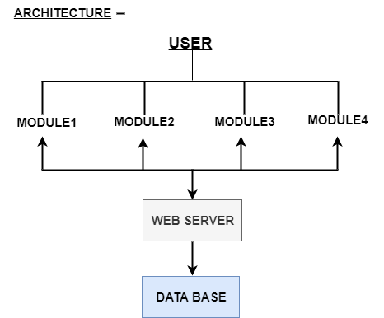

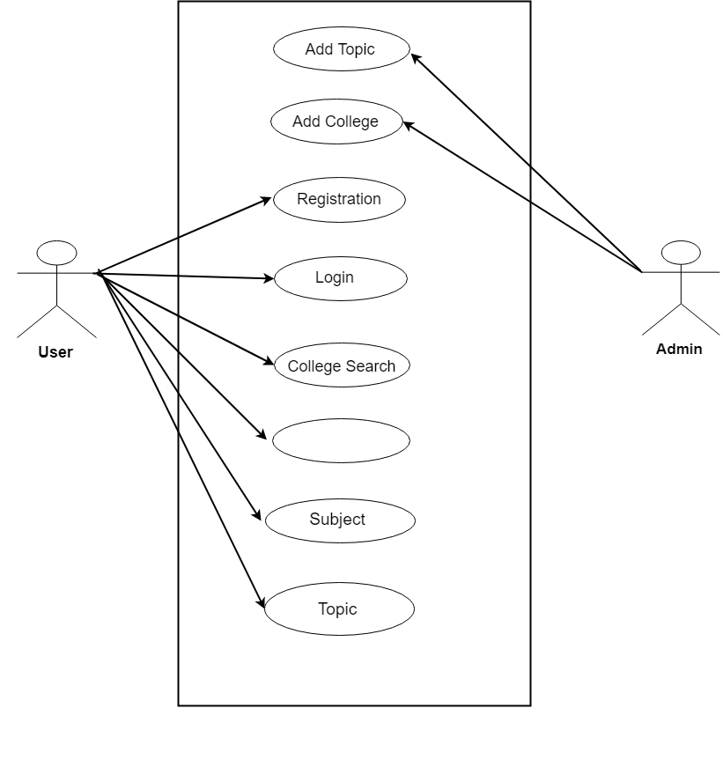

Branch

# 1 (1).jpg3.jpg

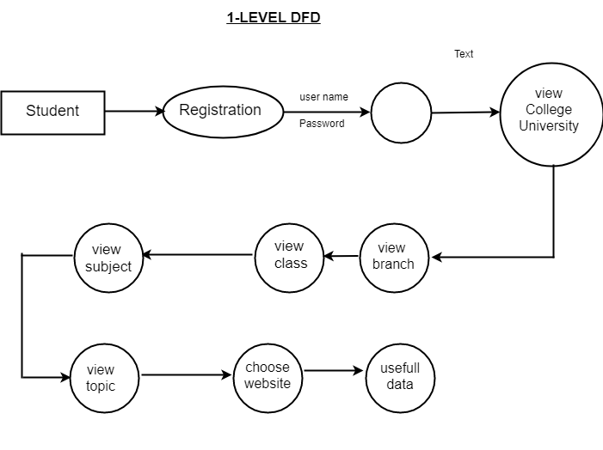

Login

**2nd Used case**

Design and Test Steps / Criteria

Algorithms and Pseudo Code

Testing Process …

RESULTS / OUTPUTS CONCLUSIONS / RECOMMENDATIONS

REFERENCES

APPENDICES