## **AMHF-TP**

An Multifunctional Therapeutic Peptides Prediction Based on Attention Mechanisms and Multi-granularity Hierarchical Features

## **Introduction**

This paper proposes AMHF-TP, a multifunctional therapeutic peptide recognition method based on attention mechanisms and multi-granularity hierarchical features. This method integrates biological features, sequence information, and interaction networks to enhance accurate prediction of multifunctional peptides. The key contributions are:

1. Extracting amino acid atomic composition features of multifunctional peptides using transfer learning, leveraging previously acquired knowledge to perceive potential relationships in peptide sequences.

2. Combining convolutional neural networks with self-attention mechanisms for feature extraction from amino acid sequences and their secondary structures, enhancing local feature extraction and diversifying feature representation.

3. Building hypergraphs to extract relational features between peptide sequences, adding complex similarity features.

4. Extracting peptide sequence features on three levels (atomic, amino acid sequence, and multi-sequence relation), constructing a multi-granularity hierarchical feature extraction algorithm for multifunctional peptides, fully capturing their potential features.

The framework of the AMHF-TP method for MFTP prediction is described as follows:

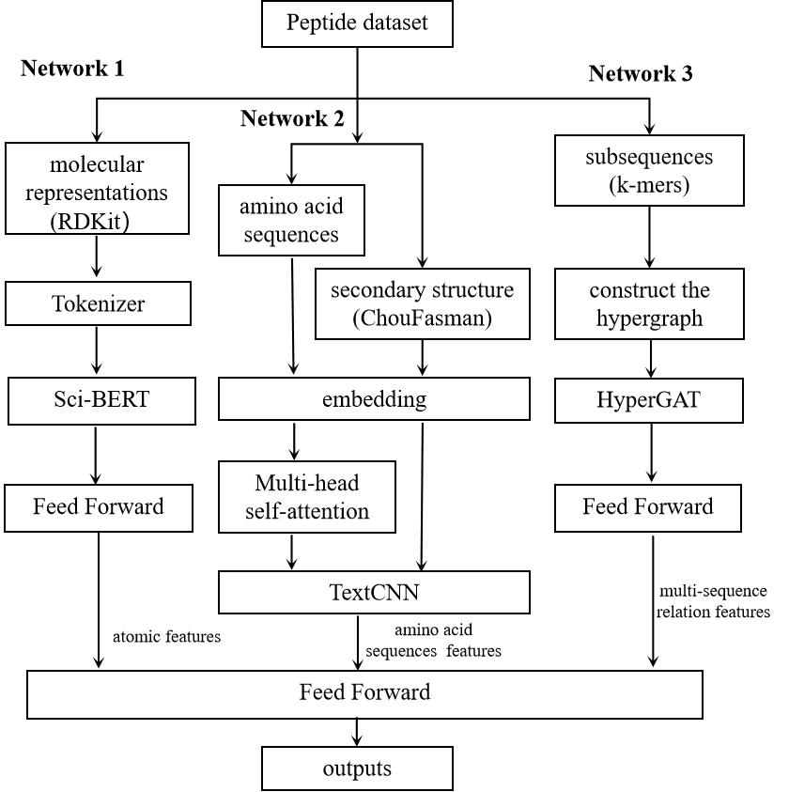

## **Related Files**

#### **AMHF-TP**

| **FILE NAME** | **DESCRIPTION** |
| --- | --- |
| AMHF-TP_1 | Contains all files about network 1, in which run_sicbert.py contains training and testing, and the finetune_save directory contains the saved trained models. |
| dataset | The dataset used. |
| result | The saved trained models. |
| main.py | The main file of network 2 predictor (include data reading,training and testing) |
| HyG_main.py | The main file of network 3 predictor (include data reading,training and testing) |
| ChouFasman.py | Used to calculate the secondary structure of peptides. |
| evaluation.py | Evaluation metrics (for evaluating prediction results) |
| model.py | Model construction about network 2. |
| HyGmodel.py | Model construction about network 3. |
| AM12_main.py | Training and testing of combined models (network 1 and network 2),similar to AM13_main.py,AM23_main.py and AM123_main.py. |
| AM12_model.py | Model construction about network 1 and network 2,similar to AM13_model.py,AM23_model.py and AM123_model.py. |

## **Installation**

open the dir and install requirement.txt with pip:

cd "./AMHF-TP"

pip install -r requirement.txt

## **Training and test AMHF-TP model**

cd "./AMHF-TP"

python AM123_main.py