Lokomo
OneCMDB™

Product description
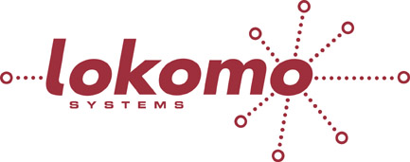

www.lokomo.com

Configuration Control is Crucial
Today, IT-departments and data centers are struggling with a work environment that is difficult to manage for several reasons:
- Increasing software complexity
Larger and more complicated application suites, more integration between various software packages, new multi-tiered architectures, etc.
- Increasing infrastructure complexity
The computing environment is getting more and more complex. More servers, larger networks and more storage components. SAN and NAS concepts, portable computers, mobile terminals. Wireless networks etc.
A crucial component for managing the computing environment is a CMDB (Configuration Management Database) and a CMS (Configuration Management System). OneCMDB is an Open Source Configuration Management concept.
OneCMDB is aimed at small and medium sized businesses. It is easy to install and to populate with data. All imported data is inserted into a user-defined data model, which specifies how Configuration Items shall be structured and how they relate to each other. The data model can be changed and expanded from the One CMDB Graphical User Interface.
OneCMDB allows you to easily:
- Create your own CMDB data model, without writing a single line of code
- Populate the CMDB, through auto-discovery and powerful import functions
- Federate data from other data sources (MDR:s, Management Data Resources)
- Validate imported data and decide how it shall be treated in the CMDB.
- Visualize your data in dynamic graphs, trees and tables
- Export data to other applications

Using Lokomo OneCMDB
Lokomo OneCMDB has three cornerstones: Import/federation, Visualization and Export

Import/federation
The starting point is to import a suitable Data Model and if necessary, adapt it to the user’s specific needs. Once the Data Model is set it is time to set up the different data sources from which data shall be imported or federated.
OneCMDB can import files of different formats, for instance XML files and CSV files. It can also read and interpret configuration files from Network Management Systems like Nagios and Netcool The auto-discovery tool NMAP can also be used to scan the user’s network.
The import functions can be set up to either run once, or repeatedly at predefined intervals. New data that enters the system is presented in the OneCMDB GUI so that the user can decide if it shall be imported and how it shall be inserted in the database. This validation step is crucial in order to keep the CMDB current.

Visualization
The content of the CMDB can be explored in the OneCMDB GUI using graphs, tree hierarchies and tables. The presentation is dynamic and it is easy to change what CI:s, attributes and relations that shall be shown. This way it is possible to view various aspects of the data in the CMDB in order to find errors and bottlenecks, create inventory lists, management reports, network maps, etc.
User defined views (graphs, tree hierarchies and tables) can be named and stored for later usage and other users’ can access them and benefit from them. Views are also machine readable and can thus be called from other applications. Alternatively, a user defined view can be saved as a file (for instance XML or CSV) and opened in another application.

Export
Export rules can be defined in order to send selected information to other applications. OneCMDB can for instance export data to the Nagios Network Management System by creating Nagios Configuration Files.

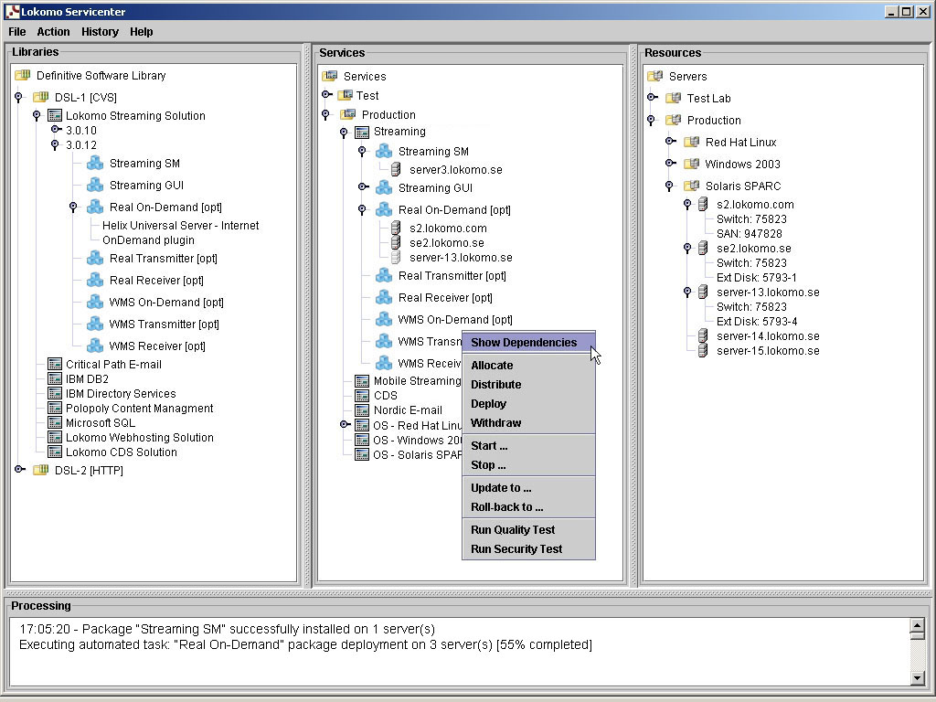
Figure 1: The Lokomo OneCMDB GUI

OneCMDB key features

Flexible Data Model
Lokomo Servicenter features a unique XML based Data Model, which defines the structure of the CMDB. It defines the templates for all kind of CI:s and relations. All templates are object-oriented and characteristics are inherited from parent CI:s to its childrens. This makes it easier to maintain and develop the database model. The model can be adapted and customized on the fly and without programming.

Object-oriented database
The data model is used to create the structure of the object-oriented CMDB. OneCMDB then stores all data in a backend standard SQL database.

Automatic change log
OneCMDB automatically stores all changes that occur in the database, CI by CI.

Multi-user system
OneCMDB is a client-server system and the backend database server has a multi-user design. Users and applications have to login before they can access the system.

RBAC - Role Based Access Control
As users log in they are assigned to predefined Roles. Each Role is mapped to different functions and privileges in the system.

Open API:s
OneCMDB has a Java Application Programming Interface and a Webservices interface, with which other application software can access the CMDB.

System Requirements
Supported/interfaced products
Hardware platforms: | Intel, Sparc
Operating systems: | Linux, Windows
Auto discovery systems: | NMAP
Network & systems management systems: | Nagios, Netcool
Relational databases: | HSQL, MySQL, MS-SQL, Oracle
Please contact Lokomo Systems for a complete list.

www.lokomo.com • Phone +46 8 5490 4380 • Sweden
2008-09-02
Any third-party trademarks, or registered trademarks, referenced are the property of their respective owners.

