NATIONAL UNIVERSITY OF COMPUTER AND EMERGING SCIENCES ISLAMABAD



Data Base Systems

Project – Café Management System
Group Members: Shoukat Khan_22i-8784,
Hashim Ahmad_22i-2478
Submitted to: Sir Bilal Khalid Dar
Contents
• Functional Requirements: 4
1. Login/Signup Module: 4
2. Administrator Module: 5
• Customer Module: 6
3. Seller Panel: 7
• User Documentation and help: 8
1. Introduction: 8
2. About the system: 8
3. Getting Started: 8
4. Usage: 8
5. Features and functionality: 8
• Entity Relationship Diagram: 10
• Enhanced Entity Relationship diagram: 11
• Relational Schema: 12
• Screenshots of the system: 15
1. Login page: 15
2. Signup page: 16
3. Administrator Dashboard: 16
4. Add new employee: 17
5. Edit Employee details: 18
6. View Stock: 18
7. Add Items: 20
8. View Employees: 21
9. Seller Dashboard: 22
10. View Seller profile: 23
11. Edit Profile: 24
12. View orders: 24
13. View Table reservations: 25
14. Customer Dashboard: 26
15. Reserve table: 27
16. Place Order: 28
17. Order History: 29
18. Feedback: 30

Functional Requirements:
Our café management system comprises of 4 modules that are:
- Login/Signup module
- Administrator Module
- Seller Module
- Customer Module
Each module has its own set of functionalities.

Login/Signup Module:
The Signup module is made specifically for the customers to create their accounts and start using the café management system. The customers can create their account by first providing a unique username and a unique 8-digit password. Then the customer provides his personal details like first name, last name, gender, phone number, email. The system only registers the user if all the required fields are filled and the user provides unique 8-digit password and a unique username.
To Login to a account the user enters his registered username and password for his account and the system checks for the entered username and password in the database and then logs in the user.

Administrator Module:
The system already has registered users. The registered administrator logs in to his account and it is then he is redirected to the administrator portal. The administrator portal has the options given below:
- Add new Seller
- Add new Product
- Delete Product
- Edit Profile
- Edit Seller Details
- View Stock reports
- View Employee details
Only administrator has the ability to add new products to the system along with the information of ingredients used to make them additionally the administrator has the ability to add new sellers to the system. The administrator is given different insights into the stock information in addition with the employee details. To edit the details of the sellers the administrator first enters the id of the seller then all the information of the seller fills in and then the administrator updates the information of the seller.

Customer Module:
The customer can perform the following functionalities:
- Reserve table
- Edit profile
- Place orders
- View order history
The customer can only reserve one table from the café at a time. The café has total of 9 tables and the customer can reserve one of them at a time. If a table is unreserved, it is displayed green as soon as the customer reserves a table by clicking the table it turns red.
The customer is displayed a list of items which are available in the café and the user adds to cart by clicking the item and adding its quantity. When the user clicks on place order the items in the order are moved to the order and the order is placed.
Similarly, the customer can view his previous orders history and can sort them on the bases of month week and day.

Seller Panel:
The seller is provided with the options to view/edit his profile, view orders, view table reservations.
The seller can have different insights into the orders for example he can view the orders placed by each customer, the customers who placed maximum number of orders etc.
Similarly, the seller can also have different insights into the table reservations.
All these details are only viewed to the seller and no one else can view these details.

User Documentation and help:

Introduction:
Welcome to the documentation and guide for the H.S Café Management System. This section provides you the details and guides to use this café management system.

About the system:
This system is a comprehensive café management system made specifically to cater problem of order placements, table reservations etc. at the cafes. This system will provide you efficient order and inventory tracking options along with the employee management.

Getting Started:
To start using the system the user first has to create his account by providing the details required and if the account is already created the user then simply logs in to the system by providing his username and password.
When you log in to the system you will be taken to your respective dashboard for example the admin will be redirected to the admin portal etc.

Usage:
The usage of the application is super easy and user friendly. Each functionality in the system can be accessed by pressing the buttons. Each button clearly explains the functionality.

Features and functionality:
The customer can perform the following functionalities:
- Reserve table: reserve a table by just clicking on the table.
- Edit profile: edit the profile by entering new details in.
- Place orders: First add the items to the cart then click on place order to place the order.
- View order history: Access the order history by clicking the order history button.

The administrator portal has the options given below:
- Add new Seller: Add new sellers by creating their account and providing their necessary details.
- Add new Product: Add stock by providing the stock information and ingredients information.
- Delete Product: Provide the id of the product to delete it.
- Edit Profile: edit the profile by entering new details in.
- Edit Seller Details: edit the profile by entering new details in.
- View Stock reports: Access the stock reports by clicking the stock reports button.
- View Employee details: Access the employee details by clicking the employee details button.

Entity Relationship Diagram:
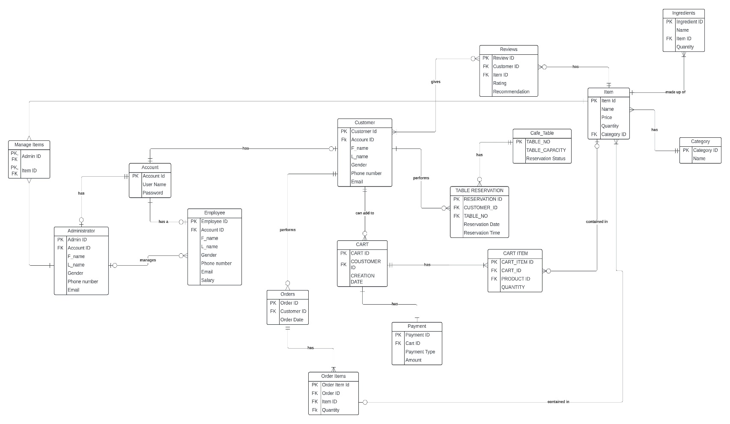
Entity relationship diagram of café management system made using LUCID chart

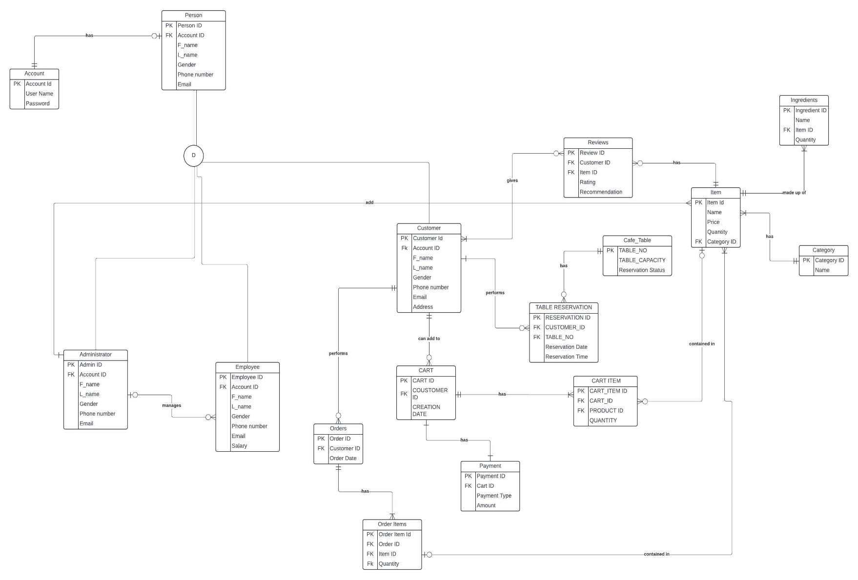
Enhanced Entity Relationship diagram:

Relational Schema:
Already in normalized Form
Account
PK
Account ID | User Name | Password

Administrator
PK FK
Admin ID | Account ID | F_name | L_name | Gender | Phone Number | Email

Employee
PK FK
Employee ID | Account ID | F_name | L_name | Gender | Phone Number | Email | Salary

Customer
PK FK
Customer ID | Account ID | F_name | L_name | Gender | Phone Number | Email

Category
PK
Category Id | Category Name

Item
PK FK
Item ID | Category ID | Name | Price | Quantity

Ingredients
PK FK
Ingredient ID | Name | Item Id | Quantity

Reviews
PK FK FK
Review ID | Customer ID | Item ID | Rating | Recommendation

Café Table
PK
Table number | Capacity | Reservation status

Table Reservations
PK FK FK
Reservation ID | Customer ID | Table Number | Date | Time

Cart
PK FK
Cart ID | Customer ID | Creation Date

Cart Items
PK FK FK
Cart Item ID | Cart ID | Item ID | Quantity

Order
PK FK
Order ID | Customer ID | Order Date

Order Items
PK FK FK
Order Item ID | Order ID | Item ID | Quantity

Screenshots of the system:

Login page:
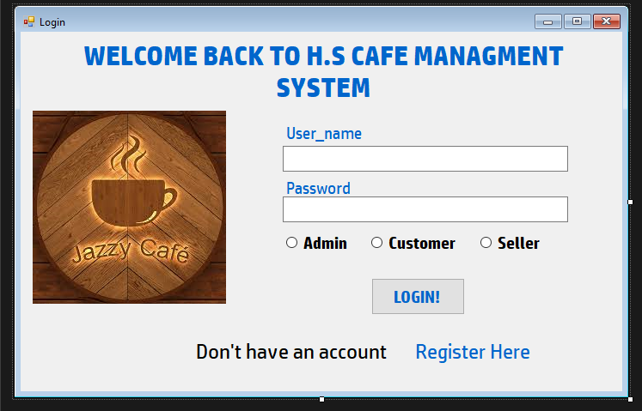

Signup page:
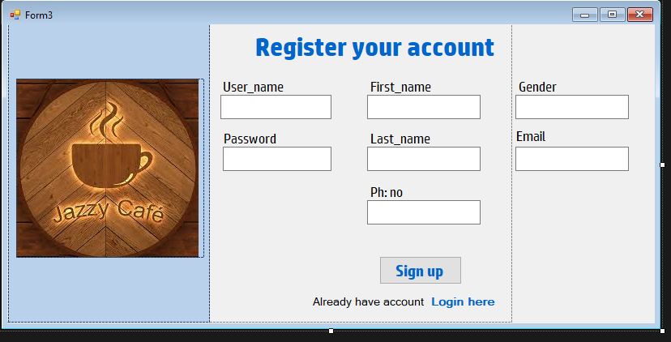

Administrator Dashboard:
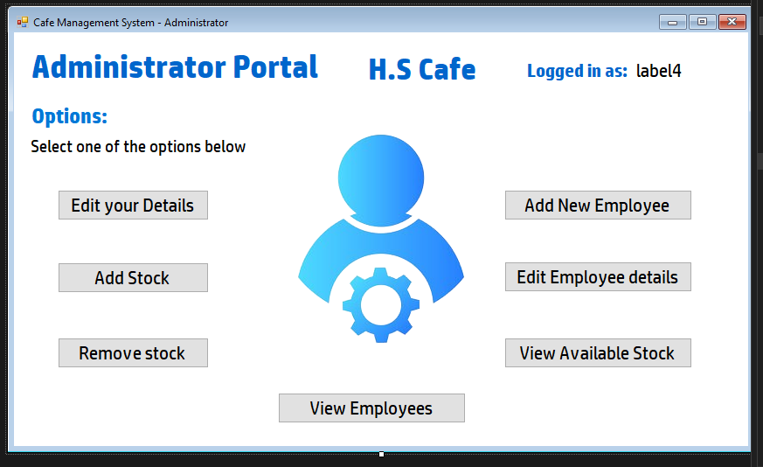

Add new employee:
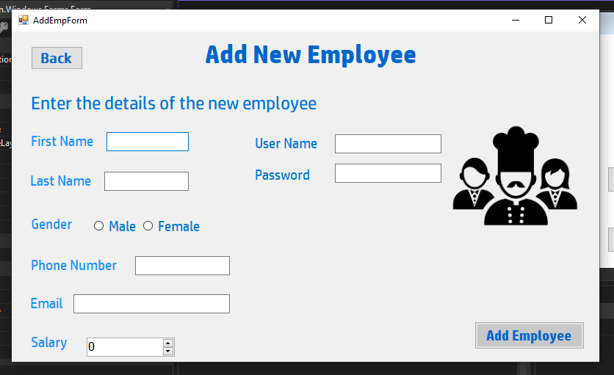

Edit Employee details:
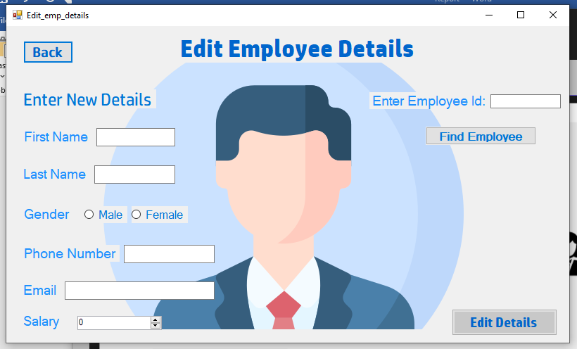

View Stock:
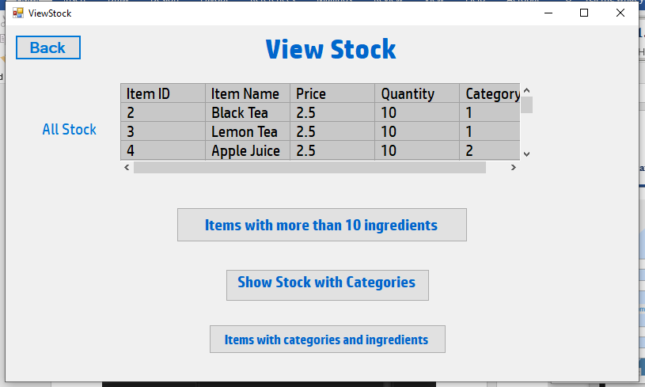
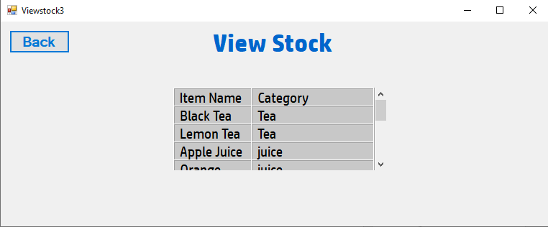
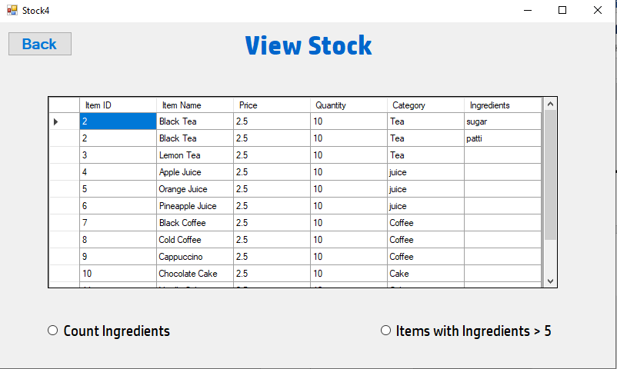

Add Items:
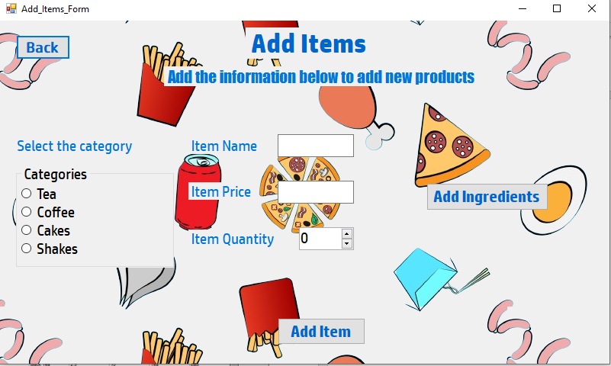
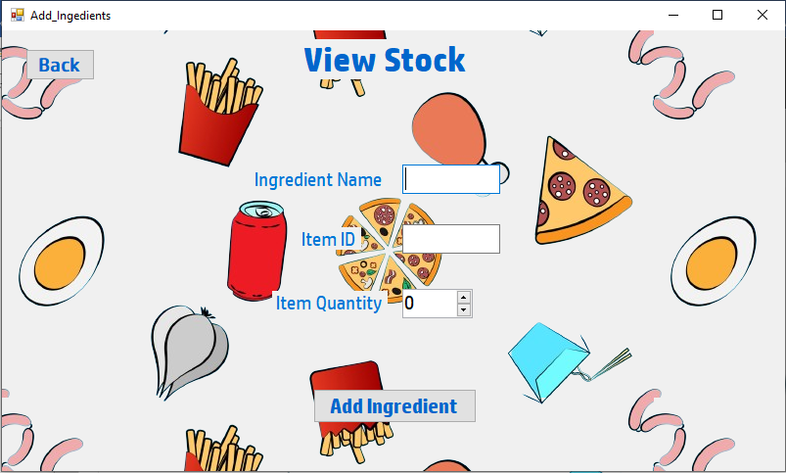

View Employees:
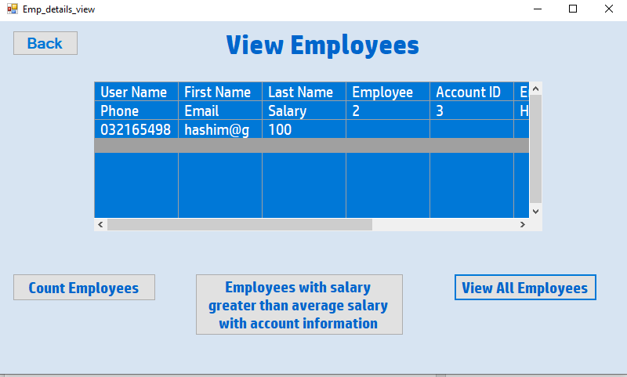

Seller Dashboard:
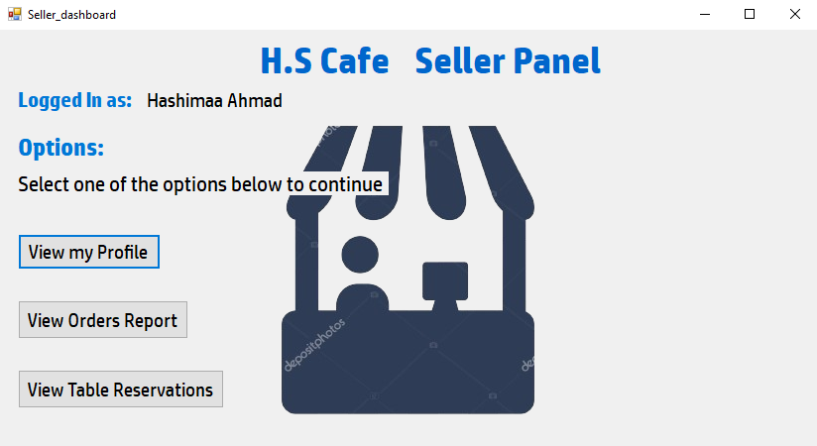

View Seller profile:
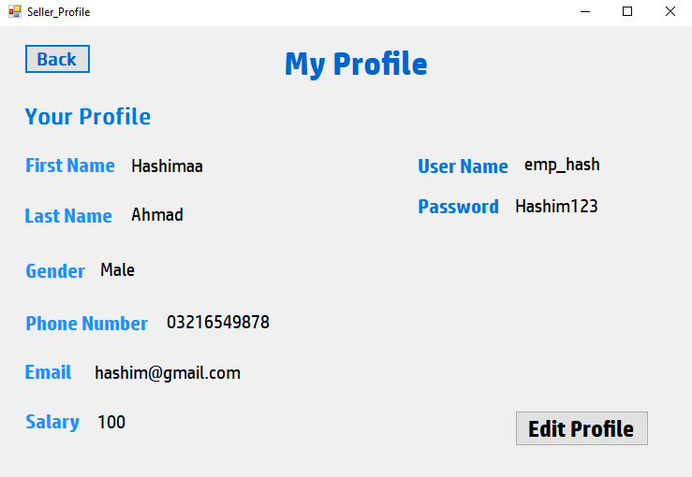

Edit Profile:
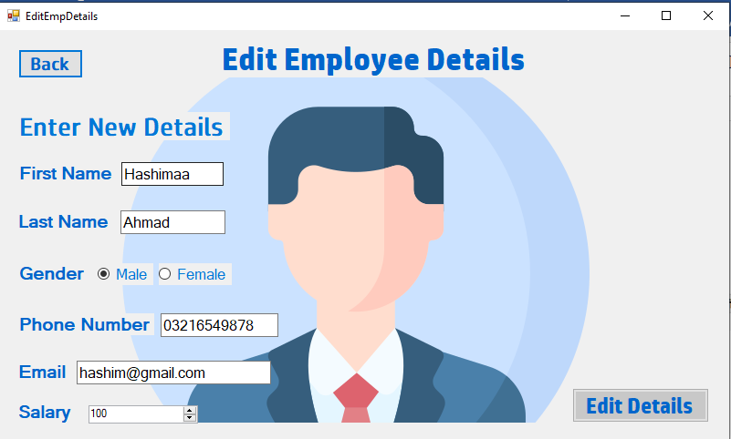

View orders:
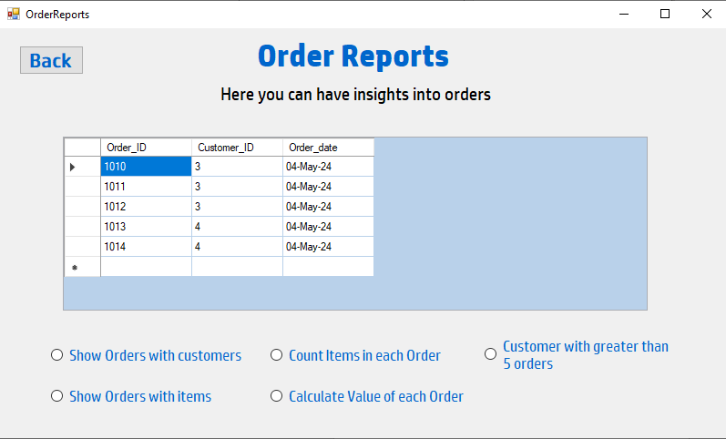

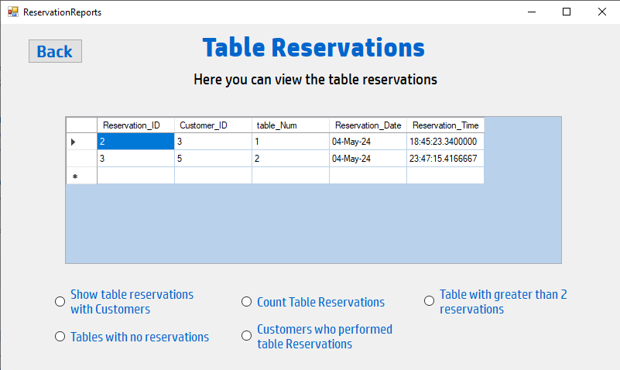
View Table reservations:

Customer Dashboard:
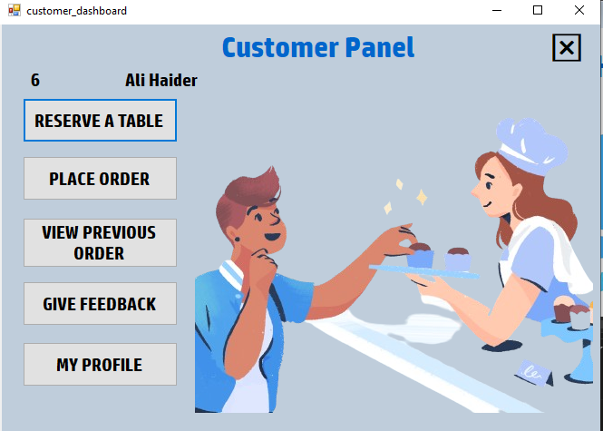

Reserve table:
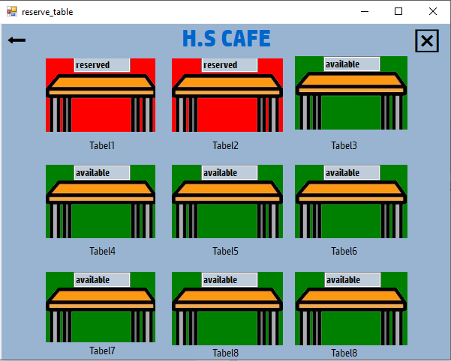

Place Order:
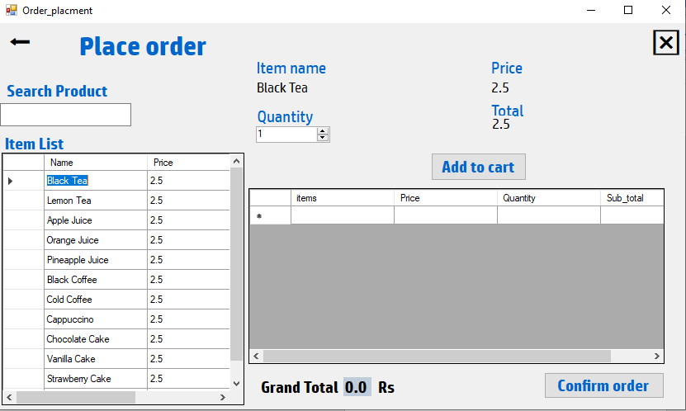

Order History:
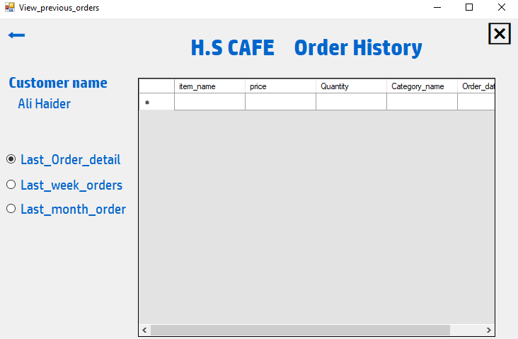

Feedback:
