NATIONAL UNIVERSITY OF COMPUTER AND EMERGING SCIENCES ISLAMABAD



Data Base Systems
Scope Document
Project – Café Management System
Group Members: Shoukat Khan_22i-8784,
Hashim Ahmad_22i-2478
Submitted to: Sir Bilal Khalid Dar
Table of Contents
• Project Description: 3
• Problem Statement: 3
• Problem Solution: 3
• Advantages/Benefits of proposed system: 3
• Scope: 4
1. Users: 4
2. Modules: 4
1. Admin panel: 4
2. Seller panel: 4
3. Customer panel 4
3. Functional Requirements: 5
1. Administrator: 5
2. Seller: 5
3. Customer: 5
• Planning Approach: 6
• Link to google form: 11

Project Description:
The domain of the café management system is the industry of point-of-sale systems. University cafes, coffee shops and other local cafes come under this domain. Things related to tracking orders, managing items, managing sellers and employees, customer management and many other aspects come under the domain of the café management system.

Problem Statement:
Currently there is a lack of easy to use and effective café management system to effectively perform tasks related to managing inventory, managing orders etc. Currently the manual processes of selling items at university cafes lead to poor customer experiences and errors in tracking sales etc. and customers also face difficulties in buying items from cafes.

Problem Solution:
Our development of a comprehensive café management system will minimize these problems related to management of inventory items, buying of items and will provide a user-friendly environment to all the users of the platform to perform their related tasks easily and efficiently. Our café management system will allow the café owners to improve their café experience.

Advantages/Benefits of proposed system:
- User-friendly system
- Enhanced customer experience
- Effective management of inventory items
- Accuracy in sales
- Insights into sales and orders
- Simplified tasks for all users

Scope:

Users:
- Administrators
- Sellers
- Customers

Modules:

Admin panel:
- Employee management
- Items management

Seller panel:
- Order Management
- Inventory Management
- Feedback management
- Sales analytics

Customer panel
- View Menu Items
- Order Placement
- reviews

Functional Requirements:

Administrator:
- Add items to café
- Remove items from café
- Add sellers
- Edit items from café

Seller:
- View past orders
- Update inventory
- View reviews
- Order Management
- Inventory Details

Customer:
- Reserve tables
- View unreserved tables
- Place orders
- Give feedback
- View menu items

Planning Approach:
We have performed an online survey through questionnaire to gather the requirements from the users of café management system. The questionnaire was the easiest approach and it helped us gain good insights into the requirements and problems faced by the café owners and customers.
Here are the few responses we got from the stakeholders of café management system.
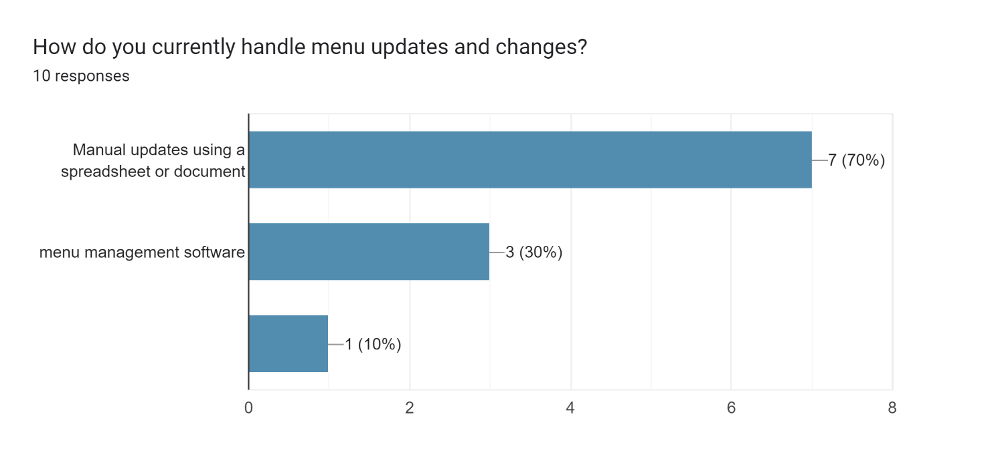
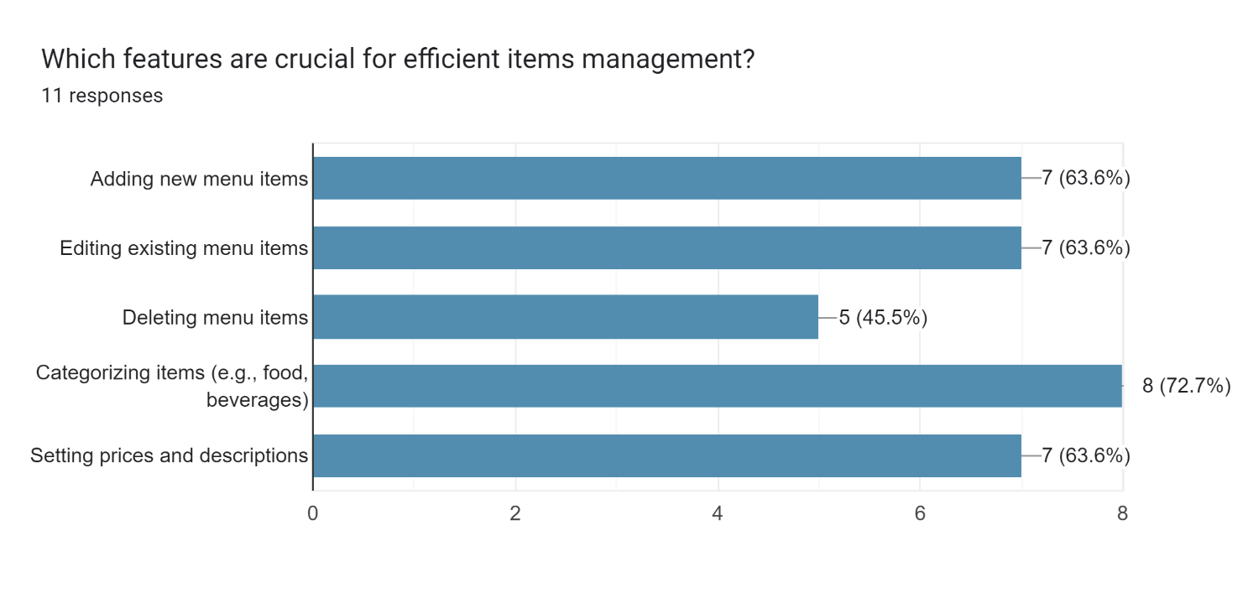
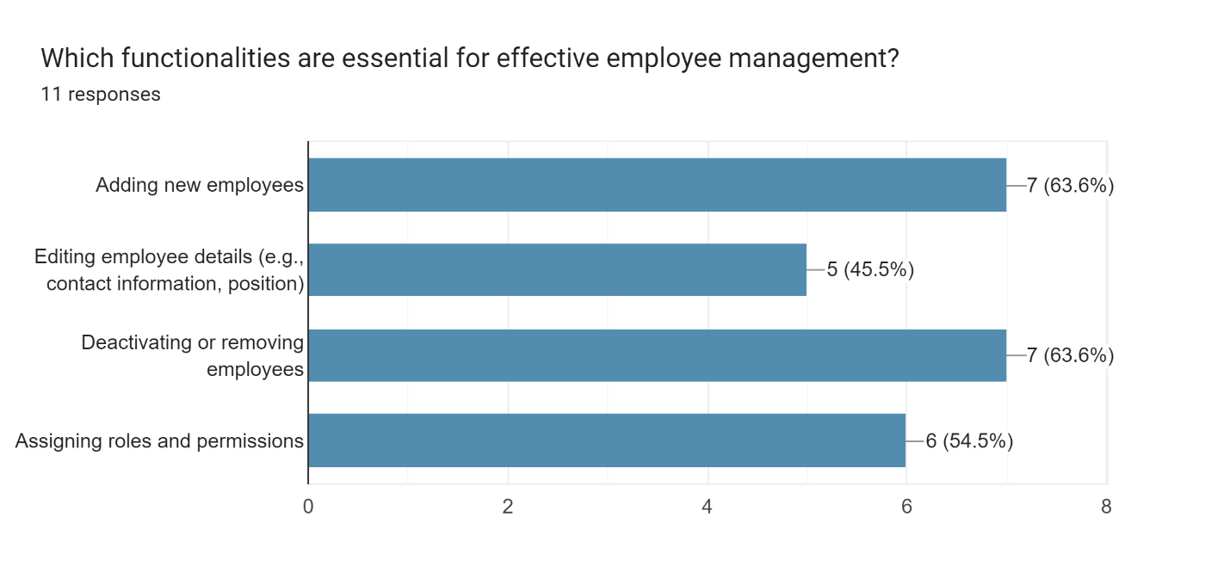
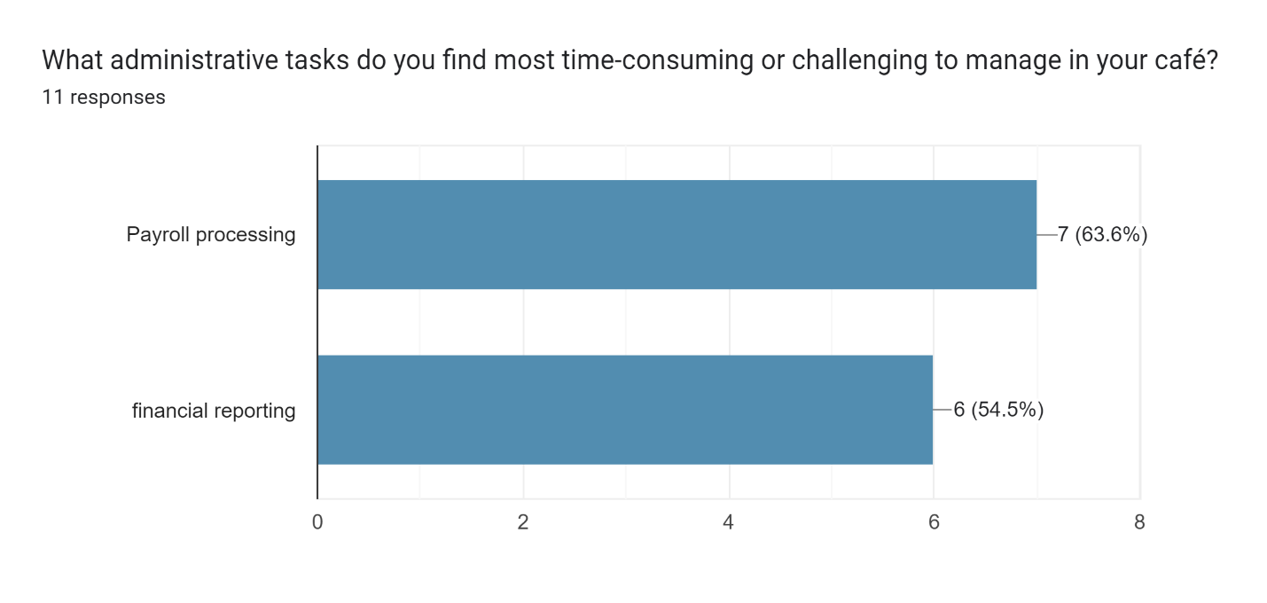
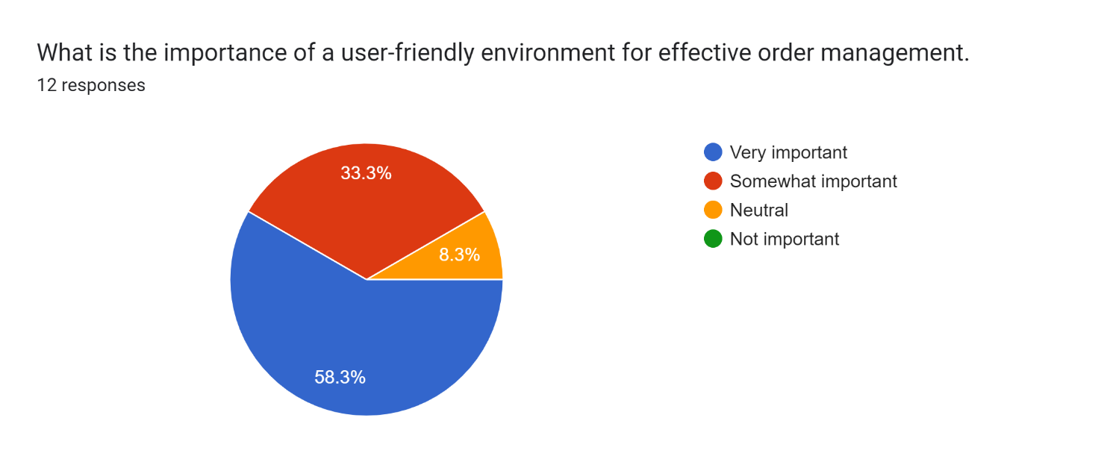
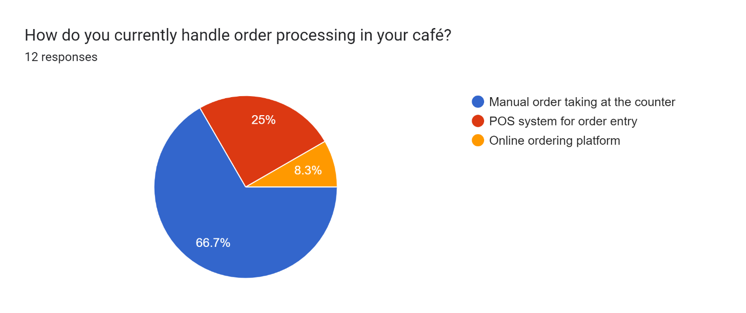
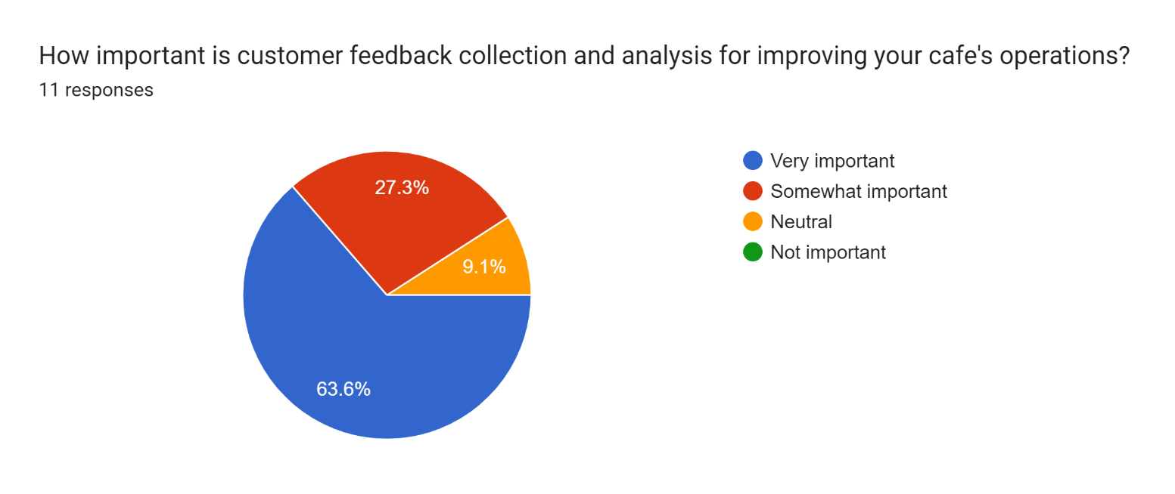
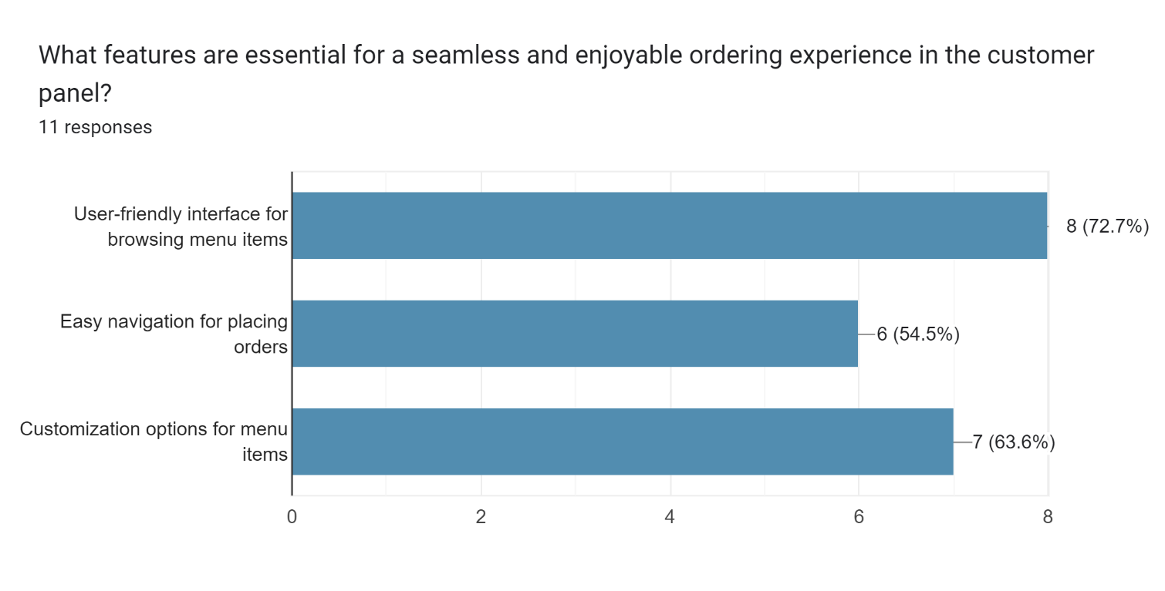
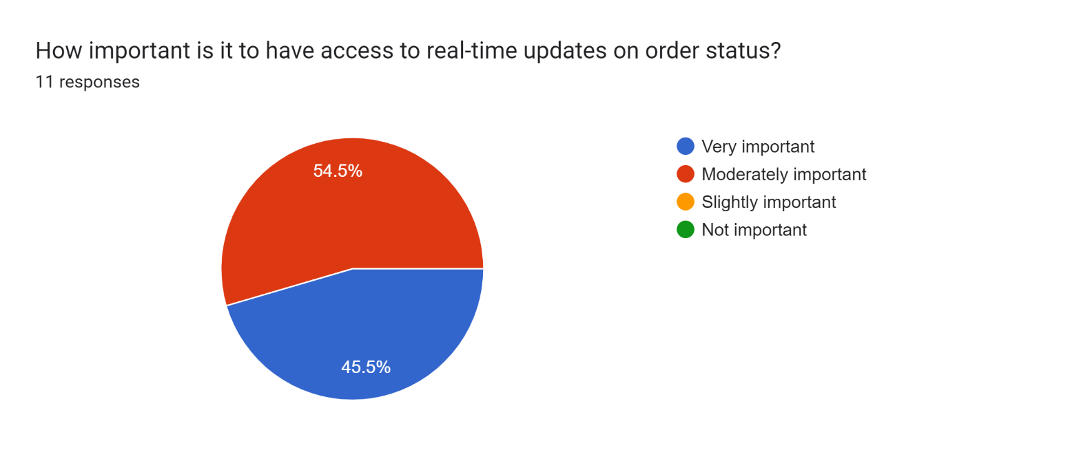
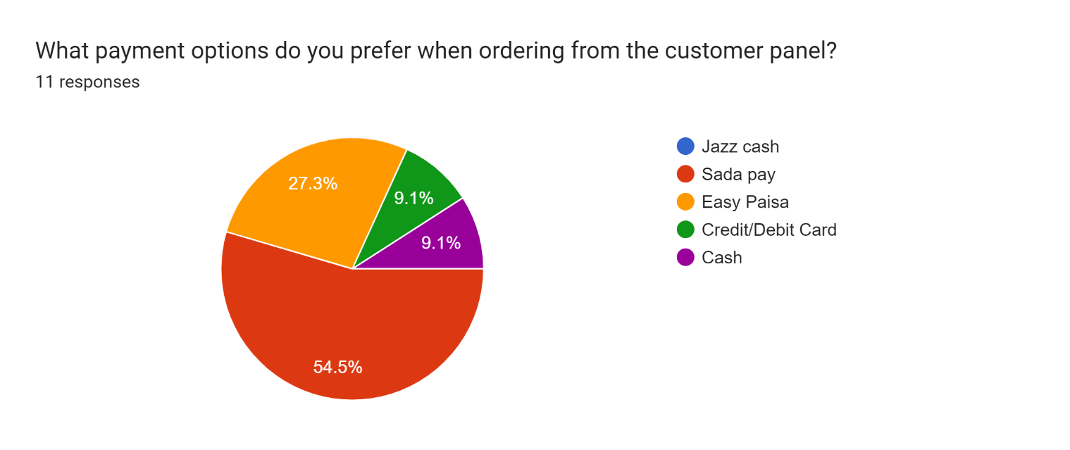
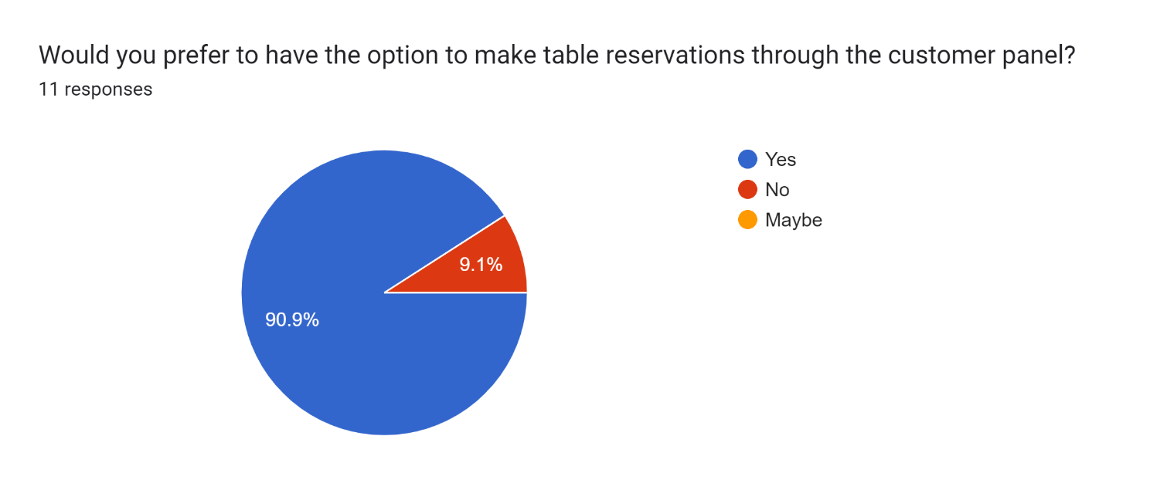

Link to google form:
https://docs.google.com/forms/d/e/1FAIpQLSckX4JWNQBuPCLF445KiJB4nwzXTIcVFcrqdT5p6mPGOFjDNg/viewform?usp=sf_link

