Coursework on nuclear transport
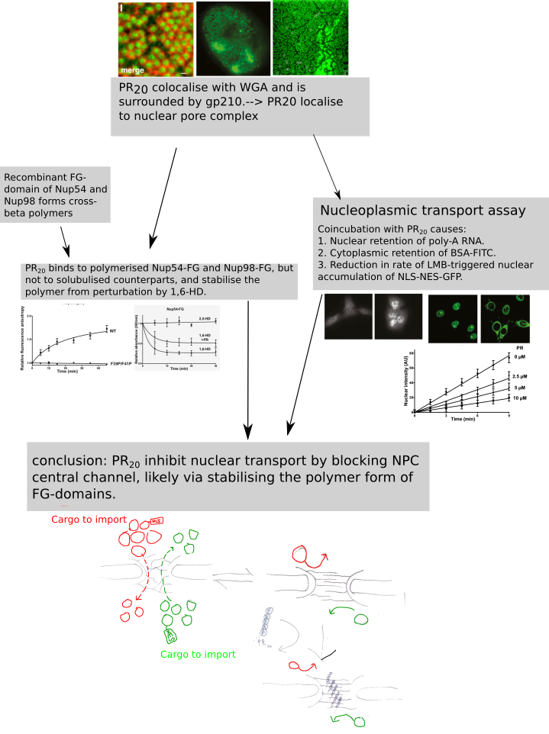
The major conclusion of the paper (Shi et al., 2016)⁠ is that cellular toxicity of PR20 is partially mediated by its blockage of NPC complex and resultant dysfunction of nucleocytoplasmic transport, which in turn is mediated by its affinity for polymerised low-complexity FG-domains. This is supported through some major findings. PR20 peptide is found to localise to nuclear pore complex, likely binding to FG domain of NUP proteins. PR20 also binds to recombinant FG-domain of NUP54/98 in a polymer-dependent manner. Disruption of polymerisation, either by mutagenesis or with aliphatic alcohol (1,6-HD), reduces the binding. Mobility assays confirmed retention of both cytoplasmic proteins with NLS (in HeLa cells) and nuclear mRNA with poly-A tail (in U2OS cells) upon co-incubation with PR20. Moreover PR20 is shown to reduce nuclear import rate in a dosage-dependent manner. Further, 1,6-HD previously known to permeabilise NPC is shown to recover nuclear import in HeLa cells upon coincubation with PR20 but not with WGA.

Two of experiments are of significant importance. The first is mobility assay demonstrating dosage-dependent inhibition of GFP-NLS-NES import into U2OS cells. The experiment did not use RanGTP and conducted in vivo as compared with the BSA assay, thus less biased. Moreover, it employs LMB to inhibit export receptor CRM1 to trigger a net import flux to allow quantification, presenting the most reliable and precise information about PR20's inhibition on nuclear import, allowing for further comparisons between alternative hypotheses. Import rate decrease as more PR₂₀ is added, but the maximum cumulative import amount is seemingly reachable. If PR₂₀ really shut down the channel irreversibly, there should be a cutoff concentration where import rate vanishes quickly. The observed nearly-linear inhibition suggests PR₂₀ might compete with other cargo for import flux (provided with importin) and cause an apparent slowdown.

The second is in vitro polymerisation assay showing PR20 stabilising the NUP54-FG polymer against perturbation with hexanediol gives result consistent with the hypothesis prediction. Addition of PR₂₀ is shown to increase residual polymerisation, raising the possibility that PR20 binds to FG-polymers in a non-reversible manner and inhibit disassembly. Moreover, this stabilisation effect may be readily generalised to other low-complexity domains (Lin et al., 2016)⁠.

The paper is strong in it organise a well focused set of experiments to test the candidate hypothesis that PR₂₀ inhibit transport by stabilising the FG-domains in polymer configuration. Indeed, the observations are roughly consistent with this hypothesis. However, the authors allegedly ignore other properties of PR_{20,} such as its localisation to nucleolus and possible interaction with importin machinery given their positive charges (Kwon et al., 2014)⁠, making a biased interpretation. They also employ RanGTP and its non-hyrolyzable mutants in some experiments without providig the “clean” version, undermining its reliability. As to methodology, the authors take good use of some factors, like 1,6-HD and 2,5-HD, while missing important controls for polymer-stabilising and nuclear blocking. That is, no known polymer-stabilising agent, nor known import blocking agent (except for WGA in last mobility assay) is employed to contrast PR20. The blocking by PR20 also appear less robust than that by WGA. The paper also lacks a connection between in vitro polymer assay and in vivo mobility assay. i.e.:they should at least show some interaction in vivo, either by rescuing the phenotype or enhancing it -- mere co-localisation does not mean any binding! Overall, the paper reports a mixture of reliable and questionable facts, and lack discriminative power between alternative hypotheses, but serve a good basis for further testing.

We suggest two further experiments here. The first aims to test whether PR20 is a “clog” or just a “cargo” or both. A group of candidate peptides are selected either from literature or from an unbiased screen of peptide library, containing known nucleolus-localising signal (NoLS), known beta-fibre stabilising agents, and some feature both if possible. These properties will be confirmed by nuclear localisation studies, polymer-binding assays and monomer-binding assays. These three categories of peptides are then subject to LMB-triggered nuclear accumulation assay to see which of the property correlates most with reduced nuclear import. If the inhibition is indeed clog-specific, overflowing an “cargo” peptide should show no inhibition.

The other experiment employs single-molecule tracking to characterise the dynamics of PR20 in NPC. If PR20 indeed bind to FG polymer in vivo, it should get trapped inside the NPC for a longer period than expected for a neutral peptide of the same size. We will label the PR20 and PA20 with small fluorophores and apply STED microscopy to track trajectory of multiple molecules and compare the mean traversal time. If PR20 does not appear to stay longer in NPC than PA20, then there seems to be no interaction between PR20 and NPC20. Note the experiments should not involve use of RanGTP.

References:
Kwon, I., Xiang, S., Kato, M., Wu, L., Theodoropoulos, P., Wang, T., … McKnight, S. L. (2014). Poly-dipeptides encoded by the C9orf72 repeats bind nucleoli, impede RNA biogenesis, and kill cells. Science, 345(6201), 1139–1145. https://doi.org/10.1126/science.1254917
Lin, Y., Mori, E., Kato, M., Xiang, S., Wu, L., Kwon, I., & McKnight, S. L. (2016). Toxic PR Poly-Dipeptides Encoded by the C9orf72 Repeat Expansion Target LC Domain Polymers. Cell, 167(3), 789–802.e12. https://doi.org/10.1016/j.cell.2016.10.003
Shi, K. Y., Mori, E., Nizami, Z. F., Lin, Y., Kato, M., Xiang, S., … Ding, M. (2016). Toxic PR n poly-dipeptides encoded by the C9orf72 repeat expansion block nuclear import and export. https://doi.org/10.1073/pnas.1620293114

