Mycoplasma testing Report

Brief
We tested anomalously numbered cell suspensions for mycoplasma infection. Supernatant was taken from the cell culture and PCR-amplified for a 300bp mycoplasma marker. Several positives were detected among the samples. Researchers are advised to cross-validate the results and to discard the infected samples.

Results
Most PCR reactions are successful (with a 500bp control band present). Some reactions failed (no 500bp control band present). Negative controls show there is no mycoplasma in PCR master mix. Positive control show this PCR is capable to detect mycoplasma marker. Thus the test results are of high confidence.(Table 1and figure 1, Table 2 for a detailed log).

Sample 5,6,7,16 were tested positive for mycoplasma contamination. Sample 9,10,11,12,17,18,20,21,22 were tested negative for mycoplasma contamination. Sample 2,3,4,13,14,15,19 give ambiguous result and possibly associate with marginal mycoplasma contamination. No result was obtained for sample 1 due to unsuccessful PCR amplification.
Table 1:Test Results
Sample | 1 | 2 | 3 | 4 | 5 | 6 | 7 | 8 | 9 | 10 | 11 | 12 | 13 | 14 | 15 | 16
Result | / | ? | ? | ? | + | + | + | - | - | - | - | - | ? | ? | ? | +
Sample | 17 | 18 | 19 | 20 | 21 | 22
Result | - | - | ? | - | - | -
Results notation, ‘+’: The sample is tested positive for Mycoplasma infection. ‘-’: the sample is tested negative for Mycoplasma infection. ‘/’:The sample was not amplified successfully. ‘?’: The sample was amplified, but the result was ambiguous.
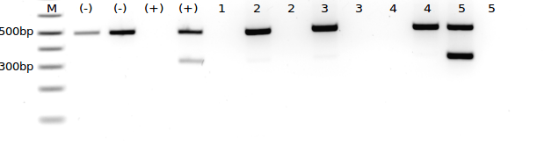
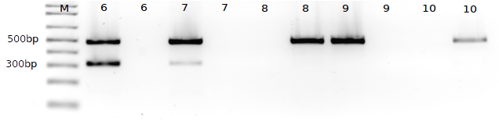
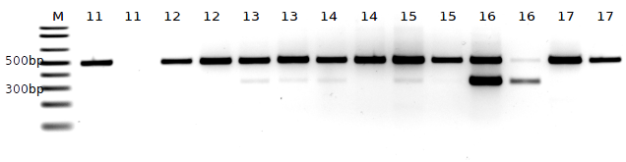
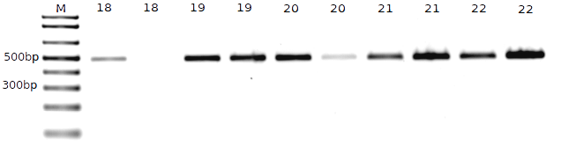
figure 1: Invert-coloured Gel Photo. Gel 1a, Gel 1b, Gel 2a, Gel 2b (from top to bottom). Sample no is indicated at top, (+) for positive control (mycoplasma DNA), (-) for negative control,(PBS solution). Presence of 500bp band is indicative of successful PCR amplification; presence of 300bp band is indicative of mycoplasma contamination.
Table 2 : Detailed Test Results
Gel1a
Well | 1 | 2 | 3 | 4 | 5 | 6 | 7 | 8 | 9 | 10 | 11 | 12 | 13 | 14 | 15
Sample | M | (-) | (-) | (+) | (+) | 1 | 2 | 2 | 3 | 3 | 4 | 4 | 5 | 5 | /
Results |  | - | - | / | + | / | ? | / | ? | / | / | ? | + | /
Gel 1b
Well | 1 | 2 | 3 | 4 | 5 | 6 | 7 | 8 | 9 | 10 | 11 | 12
Sample | M | 6 | 6 | 7 | 7 | 8 | 8 | 9 | 9 | 10 | 10 | /
Results |  | + | / | + | / | / | - | - | / | / | -
Gel 2a
Well. | 1 | 2 | 3 | 4 | 5 | 6 | 7 | 8 | 9 | 10 | 11 | 12 | 13 | 14 | 15 | 16
Sample | M | 11 | 11 | 12 | 12 | 13 | 13 | 14 | 14 | 15 | 15 | 16 | 16 | 17 | 17 | n/a
Results* |  | - | / | - | - | ? | ? | ? | - | ? | - | + | + | - | -
Gel2b
Well | 1 | 2 | 3 | 4 | 5 | 6 | 7 | 8 | 9 | 10 | 11 | 12 | 13 | 14 | 15 | 16
Sample | M | 18 | 18 | 19 | 19 | 20 | 20 | 21 | 21 | 22 | 22 | / | / | / | / | /
Results |  | - | / | ? | - | - | - | - | - | - | ?
* Results notation, ‘+’: The sample is tested positive for Mycoplasma infection. ‘-’: the sample is tested negative for Mycoplasma infection. ‘/’:The sample was not amplified successfully. ‘?’: The sample was amplified, but the result was ambiguous.
Sample notation: (-):negative control, i.e. ddH2O (+):positive control, i.e. PBS solution.
Method
- Sample cell culture is sub-cultured in antibiotic-free PBS solution and grown to 100% confluency.
- Supernatant(~3mL) is taken from the sub cell-culture, anomalously numbered and stored at -80ºC.
- On the day of test, supernatant is thawed by hand.
- 100uL of supernatant boiled to 95°C for 5mins, spun down for 45 secs.
- 10uL of vortexed(~30s) StrataClean resin was added to supernatant and mixed well.
- The mixture is spun down for 1 min and supernatant was transferred to a fresh tube to be PCRed.
- PCR reaction mixtures were made using BioMix solution. Mg2+ was adjusted to a final concentration of 3.5mM. 5uL of sample supernatant was added in a final volume of 50uL.
- A 35-cycle PCR is runned, each cycle spends:
  - 30s at 94°C
  - 60s at 55°C
  - 60s at 72°C
  - The final product is held at 4°C.
- PCRed product is then run on a 2% EtBr-TAE-agarose gel soaked in 1xTAE buffer at 145V for 30 mins.
- The runned gel is visualised in a UV chamber.

Discussion and Recommendation
- Researchers with contaminated samples are advised to discard their cell culture ASAP to avoid cross-contamination or abrupt data.
- Researchers with negative samples are encouraged to continue their cell culture and obtain data.
- Researchers with ambiguous results are advised to test at higher sensitivity, which can be obtained by modifying the supernatant-based PCR test to include more sample in the PCR reaction mixture, or to perform a longer PCR cycle. Or one can run a cell extraction-based PCR test, that provides a more sensitive detection limit.
- Researchers with lacked results are advised to carry out a standard supernatant-based PCR test.

