Mycoplasma testing Report
sampled on 13/02/2017, Result on 17/02/2017
Brief:
We tested 23 anonymously numbered cell suspensions (No.23-No.45) in 8 batches (a-h) for Mycoplasma contamination with MycoSensor PCR Assay Kit (Agilent Cat#302109). Samples include supernatant from cell subculture without antibiotics, taken by Dr. Mina Edwards. Cleaned samples are PCR-amplified for a 315bp Mycoplasma marker. Each batch is prepared with an individual PCR master mix to reduce cross-contamination. Two samples (25 & 38) are tested positive with high confidence and their owners are advised to cross-validate the results and to disinfect or discard the regarding samples.

Figure 1: Invert-coloured Gel Photo. Sample no and batch index is indicated at top of each lane. For example, 23a reads sample 23, batch a.
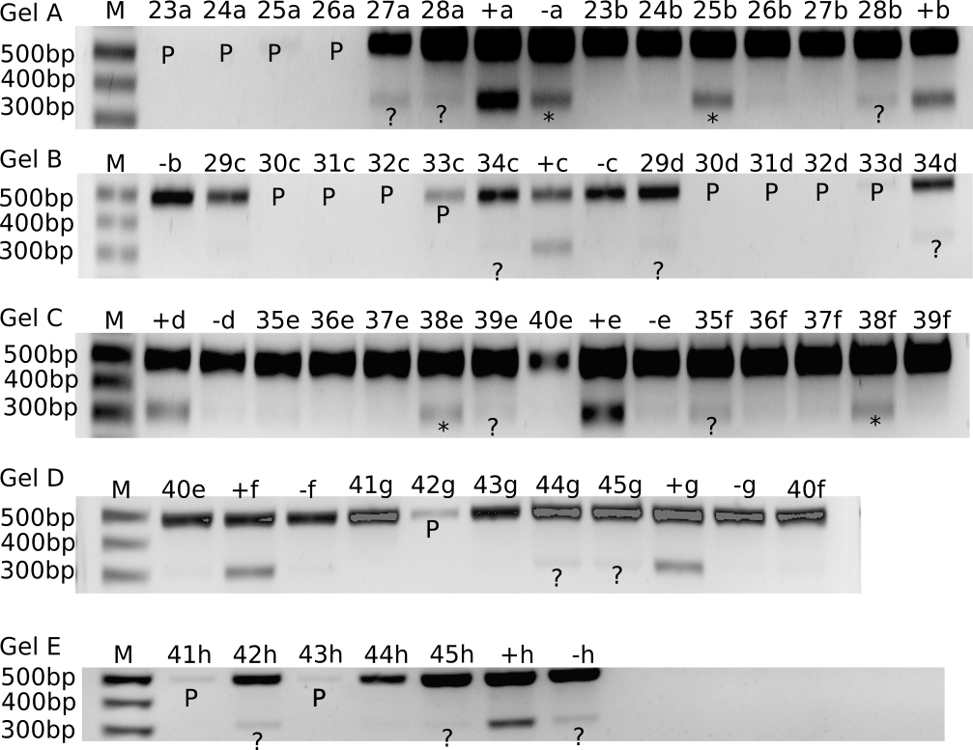Notations: “+”:positive control with Mycoplasma DNA, “-”:negative control with PBS solution, “M” : DNA size maker. “P”: a missing/weak 500bp band indicative of failed/reduced PCR. “*”: a strong 315bp band indicative of Mycoplasma contamination that is not in positive control. “?”: a weak 315bp band with ambiguous status.
Method:
We followed the manufacture protocol (Agilent Cat#302109) [1] for test with cell supernatant.
Result:
PCR reactions:
Out of 63 PCR reactions, 51 were successful and 12 failed, where a 500bp band is missing (see “P” in figure 1). One-off PCR failure is observed for 23a-26a, 33d, 41h, 42g , 43h, whereas 30-33 suffer failures in both batches. All of 8 batches have successful positive 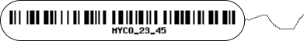controls. Two of 8 batches, a & h, have negative controls contaminated with Mycoplasma, and deemed unreliable for subsequent analysis.

Mycoplasma Contamination:
Only successful PCR reactions with a successful negative control is included in the analysis (27 valid reactions in total). Sample 25 and 38 are tested positive for Mycoplasma contamination (“*” in figure 1). Sample 27,28,29,34,39,35,44,45 are tested ambiguous with low confidence for contamination (“?” in figure 1), possibly with marginal Mycoplasma contamination. The rest 13 samples are tested negative.
Discussion and Recommendation:
PCR reactions:
Whereas one-off PCR failure may represent technical failure in testing, double PCR failure is indicative of PCR-inhibiting substance in the cell culture. Indeed, coagulation in some of the samples were reported during cleaning with StrataClean resin. Researchers with failed PCR runs are advised to check their cell-culture for non-standard constituents and known PCR inhibitors, such as EDTA and magnesium ions, especially for the samples with double failures. Any suspected compound should be informed in future testing requests to assure successful testing.

Mycoplasma Contamination:
Researchers with contaminated samples are advised to discard their cell culture ASAP to avoid cross-contamination and look for replacement. Alternatively they may isolate and disinfect the culture with antibiotics or Plasmocin and conduct further tests to confirm successful disinfection.
Researchers with ambiguous results are advised to test at higher sensitivity, by either concentrating the test sample, or performing a longer PCR cycle, or running a cell extraction-based PCR test with a lower detection limit.
Both researchers above are advised to disinfect their working surfaces and more regularly with formaldehyde or 70% EtOH to disinfect Mycoplasma.
Researchers with clean samples are advised to keep clean samples free from ambiguous/contaminated samples.
Reference:
[1]: MycoSensor PCR Assay Kit: Instruction Manual, Revision D.0 , Agilent catalog #302109

