humanized RK35 antibody light chain
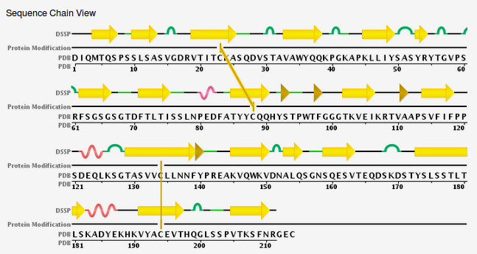
humanized RK35 antibody heavy chain
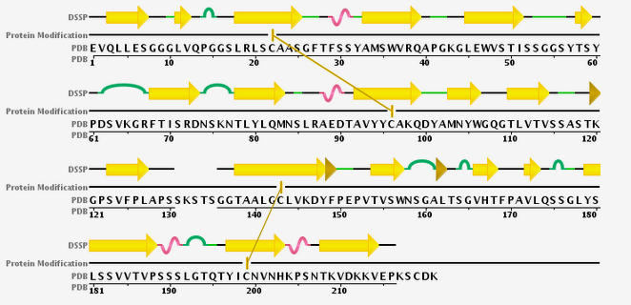
RK35 antibody light chain

humanized Length: 214 Type: P Check: 8659 ..

1 DIQMTQSPSS LSASVGDRVT ITCKASQDVS TAVAWYQQKP GKAPKLLIYS

51 ASYRYTGVPS RFSGSGSGTD FTLTISSLNP EDFATYYCQQ HYSTPWTFGG

101 GTKVEIKRTV AAPSVFIFPP SDEQLKSGTA SVVCLLNNFY PREAKVQWKV

151 DNALQSGNSQ ESVTEQDSKD STYSLSSTLT LSKADYEKHK VYACEVTHQG

201 LSSPVTKSFN RGEC

>>RK35 antibody heavy chain
humanized Length: 221 Type: P Check: 5681 ..

1 EVQLLESGGG LVQPGGSLRL SCAASGFTFS SYAMSWVRQA PGKGLEWVST

51 ISSGGSYTSY PDSVKGRFTI SRDNSKNTLY LQMNSLRAED TAVYYCAKQD

101 YAMNYWGQGT LVTVSSASTK GPSVFPLAPS SKSTSGGTAA LGCLVKDYFP

151 EPVTVSWNSG ALTSGVHTFP AVLQSSGLYS LSSVVTVPSS SLGTQTYICN

201 VNHKPSNTKV DKKVEPKSCD K

Claims:
- A humanised immunoglobulin having complementarity determining regions (CDRs) from a donor immunoglobulin and heavy and light chain variable region frameworks from human acceptor immunoglobulin heavy and light chains, which humanised immunoglobulin sepcifcally binds to an antigen with an affinity constant of at least 10^7 M^-1 and no greater than about four-fold that of the donor immunoglobulin, wherein said humanized immunoglobulin comprises amino acids from the donor immunoglobulin framework outside the Kabat and Chothia CDRs, wherein the donor aminoacids replace corresponding amino acids in the

----
*Figure out how to produce model Sd. done
*Figure out an alternative to produce the distance set. done
*Figure out an alternative to produce SA. done
*Is Kabat Scheme a definite scheme or content addressable? Assumed definite
