Comments on “Storage of 7±2 short-term memories in oscillatory sub-cycles, Lisman and Idiart”

This paper presents a hypothetical model for short-term working memory employing afterdepolarisation to perpetuate high-frequency oscillation between low-frequency oscillations. Additionally, the model introduce inhibitory feedback to avoid synchronised firing and to separate individual spikes. While the model gives compelling performance, further tests is required to validate its effectiveness. Importantly, the paper focuses on the mechanism of perpetuating short-term memory through time, and does not elaborate the practical significance between neuronal activity and memory, such as the retrieval of short-term memory or the scanning. Such feature, however, is inevitable given the highly hypothetical nature of the model.

This model employ several elements to reconstruct some properties of the working memory. To understand how this model works, we firstly examine its tractable features. The first is the emergence oscillations at a particular high frequency , as a result of global negative feedback. The waveform of the inhibitory hyper-polarisation directly determines this global refractory period after each spike, inducing a corresponding frequency. To be consistent with experiment-derived 60-80Hz high-freq oscillation, the timescale of inhibition need to be on order of 10ms, which can be validated by measuring the electrical activity of interneuron. This high-freq oscillation also directly induces its second feature, which is the sequential nature of the learned spike sequence. The third is the memory capacity, that can be approximated with the ratio between the excitable period and the high-freq inhibition time-scale (100ms/10ms~=10). The mechanistic insight it provide however goes beyond the experimental evidence, which we will remark later in numerical simulations.

From a mechanistic perspective, the model employs a background sinusoidal wave (6Hz) to partition time domain into excitable and refractory periods. Information contained in spikes from last excitable period is perpetuated in the form of a slowly rising ramp via ADP. Furthermore, partitioning into sub-cycles is maintained by inhibitory feedback, which forces a globally refractory phase after each firing. With these features established, one can adjust parameters to fit experimental data.

Bearing those explanatory powers, the model does fall short in some other aspects. Firstly, the rising of ADP ramp is so slow that once a neuron fire in the cycle, it does not have a chance to fire again, i.e. each neuron can only be activated exactly once in the same alpha cycle. This feature is incompatible with real application. For example, if one want to store a telephone no. 0767486… , the number “6” will occur 2 times. Such memory can not be explicitly mapped to a temporal spiking sequence. Thus, one need to carefully interpret the learned temporal firing sequence.

We can review experimental significance to seek a resolution. Using list-match test, Sternberg measured reaction time for testee to decide whether the given object is part of the list or not to reflect the retrieval of working-memory. Every additional object on the list incurs a 38ms increase in reaction time, for confirming both the presence of the test object and the absence of the test object, implying that both tasks employ an exhaustive scanning search. Thus, in Sternberg’s test, we would only be required to decide whether number “6” is present in the learned number, which is within capability of such model. While such tests do not concern any order present in the memorised object, the model stores memory explicitly as a temporal sequence, making this additional feature a testable prediction.

The paper also briefly talks about how memory can be formed and removed. Memory can be formed by presenting activity spike through informational input to a neuron, which then fits itself to the firing sequence, depending the ADP status of all other neurons. Two removal approaches are provided. First is by overflow, where new inserted spike re-phase the firing pattern and take the place of old perpetuated spike. The second is by relieving interneuron inhibition, where all phase information is lost and all spikes simultaneously begin to fire where the first spike was firing.

In the first approach, the insertion of new spike depends on where it is presented first in the cycle. One natural choice is to spike just before any existing spike, shifting all later spikes to later. Consequently if the new spike is presented during the descending phase, it is effective before the earliest spike, thus will become the new first spike and shifting all existing spikes to later, which cause the last spike to drop out of the excitable window. The authors have also suggested alternative parameter to shift phases to earlier. Overall, the insertion works by inhibiting other spikes, at one point or another. In the scene that sequential nature do not play a specific function, the orientation of insertion seems irrelevant.

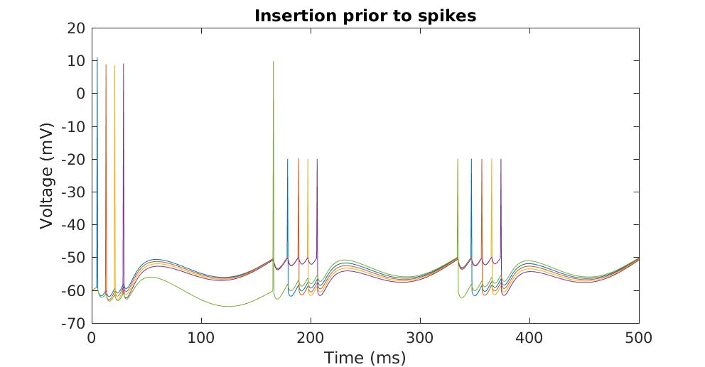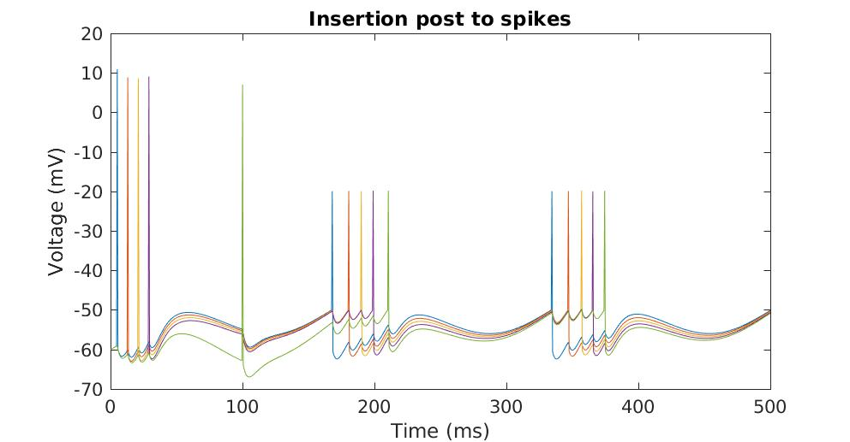

In the second approach, one can still access the presence/absence of any specific object by looking at the activity of its corresponding neuron. This echoes the unnecessary ordered feature in the original model – if one only wants to know whether a particular object is present, the non-phasic memory is still adequate for the job.
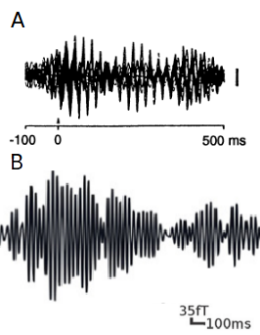
figure 1: Profiles of MEG-deteceed gamma claimed to reflect short-term memory. A: adapted from Llinas and R ; B: Adapted from Roux et al. .

While these hypothetical ways of modifying working memory serve an adequate proof of concept, their practical relevance cannot be tested without a functional framework link the model to real working memory. It’s also not clear how such network should be trained to perform a specific function. Rather, it is constructed only to explain the experimental observables. In this sense this model is explanatory rather than mechanistic.

Some disadvantages of the model:

1. The nesting process can not be iterated to construct longer nested oscillations, highlighting the explanatory nature of the nesting process. The fact that only the excitable part of the waveform is nested also contradicts evidence from electroencephalographic study (Llinas and R) of human cortical responses, where nesting is spread evenly throughout the waveform without apparent affinity, This shape of brainwave is also confirmed in recent MEG analysis (Roux et al.).

2. As authors have mentioned, the removal of memory upon overflow is rapid. Once a neuron drop off, it never comes back, i.e. all-to-none decay without a transient. This contradicts psychological notion where working-memory decays slowly away.

We go on to make some rough estimation and numerical simulations:

The model employed by the authors has the form:

r*dV/dt=-Vi+Vrest+Vosc+Vadp+Vinh;

Assuming small value of r (a.k.a. long timescale of leakage) givesThe paper hypothesize that several informational elements stored in high-frequency oscillation are nested to give a low-freq oscillation.
on the basis that a synchronised central oscillatory signal is distributed throughout the neuron population.

Vi=Vrest+Vosc+Vadp+Vinh.

Set Vrest to -60mV. Set spike only if Vi exceeds -50mV, which implies

Vosc+Vadp+Vinh>10mV.

If we assume a fast decay for Vinh to decay fast. Then the firing condition reduce to

Vosc+Vadp>10mV.

If we further assume Vosc to be zero to focus on the effect of Vadp, we obtain

Vadp>10mV.

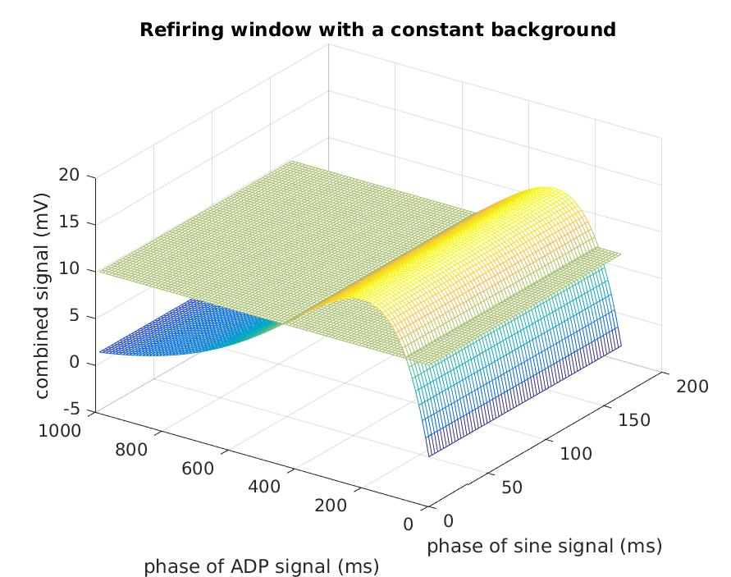
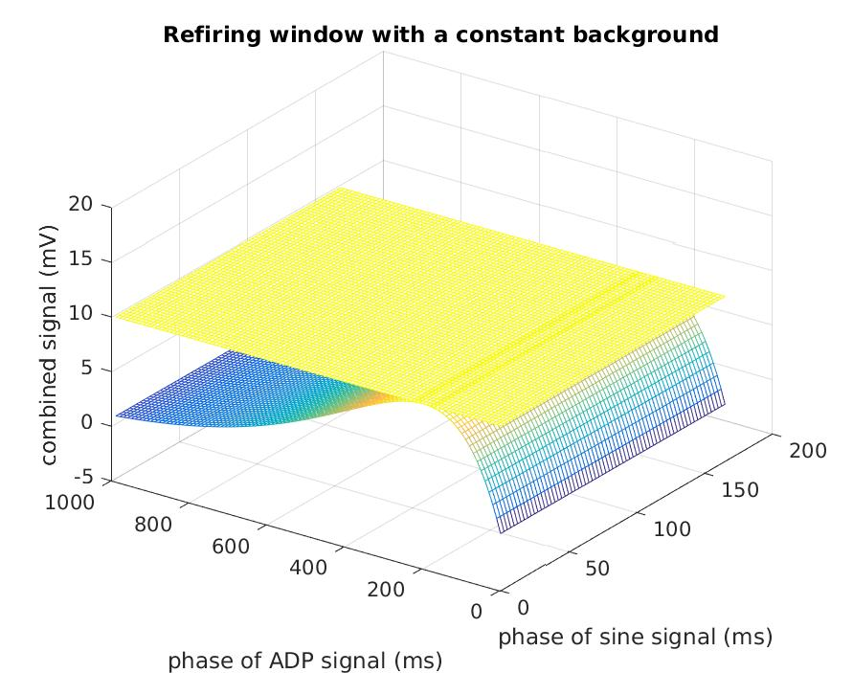
figure 2

The time window where this condition is met is referred to as a “refiring window.” Depending on the precise shape of the wave form, the refiring window size varies. The paper assumes an alpha function with amplitude 10mV and time constant of 200ms. Thus the refiring window is only a single point where the ADP curve touches 10mV. (see figure 1a). By increasing the amplitude of ADP signal to 15mV, an extended refireing window emerged (70ms to 430ms, figure 1b). Correspondingly, presented spikes are repeated even in absence of the sinusoidal background. (figure 2)

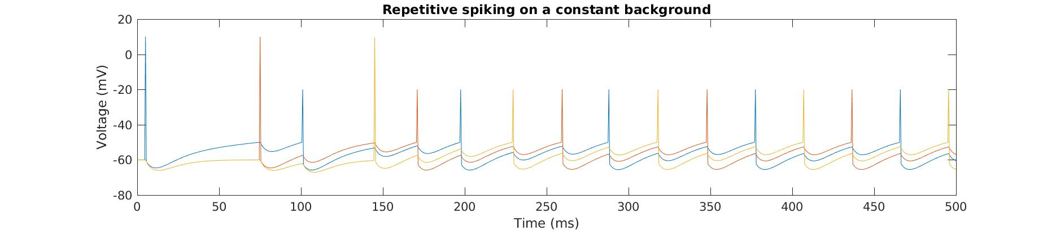
figure 3
Now let’s reconsider the author’s model, where they introduce an oscillating Vosc of amplitude 5mV and frequency 6kHz (a.k.a. period of 166ms). Where ADP signal is reinforced, a refiring window emerge as a oval shape 50-510ms through ADP phase, 0-82ms through alpha signal. (figure 2a,2b). Notice this means the same neuron cannot be reactivated until 50ms post-discharge, which prevent its reactivation in the same alpha cycle. Even the neuron is activated early as 0ms, its trajectory still does not touch the refiring zone of the first cycle (figure 2b). Given that the first activation is bound to take place at 0-82ms, same-cycle reactivation is prohibited.
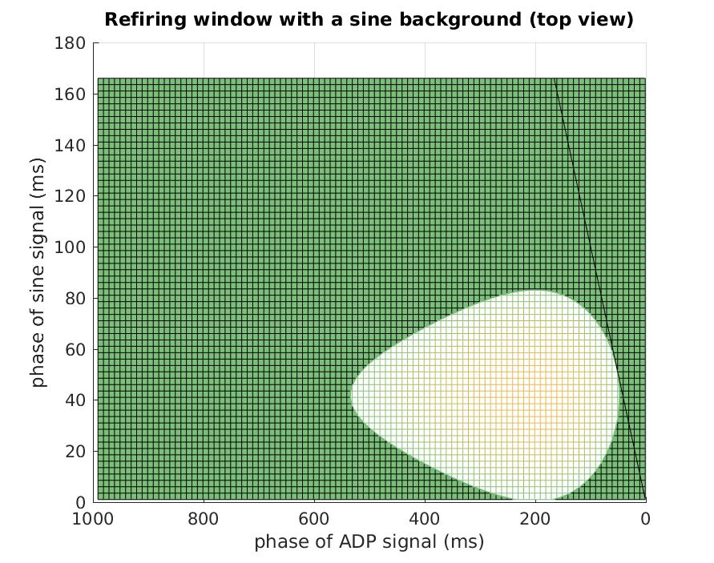
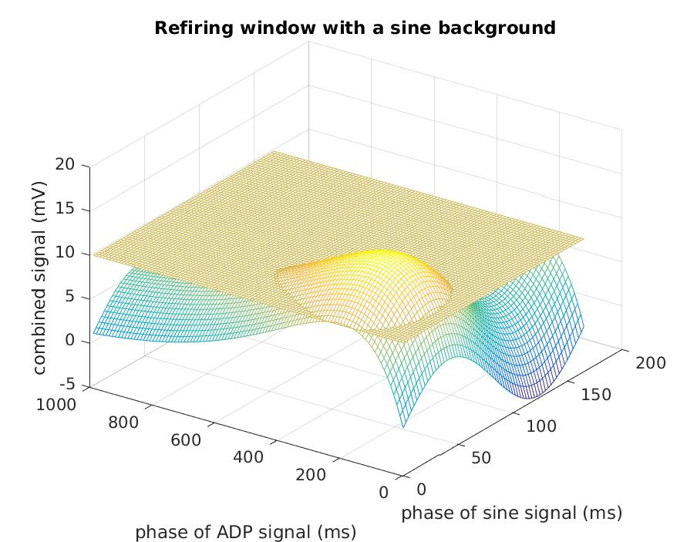
figure 4

With a central oscillatory input, it

Agreement of timescale:38ms.

The fate of the temporal sequence:

The paper hypothesize that several informational elements stored in high-frequency oscillation are nested to give a low-freq oscillation.
on the basis that a synchronised central oscillatory signal is distributed throughout the neuron population.

