Explain the dynamics of measles with the SIR model
Brief:
Measles is a highly contagious disease most common in children. The non-lethal nature allows easy data collection and relatively simple dynamic, making measles outbreaks an excellent example for epidemiological study. Here we conduct several SIR-model-based simulations and discuss its predictive power and shortcomings.

Introduction:
Measles is a contagious disease caused by viral infection. The infected typically shows 4-day fevers and the 3 C’s including cough, corzya and conjunctivitis, along with the rashes over the body. The disease is highly infectious due to its air-borne nature and transmit through air droplets emitted during the coughing or sneezing of the infected. Any contact with infected in terms of saliva, sex, or mucus also mediates infection. In 2016, measles is reported to have been eliminated from the Americas, meaning there is no local infections except for the ones caused by the external population.

An infected person normally becomes infectious from 4 days before to 4 days after the rashes develop. Thus the mean infectious period of an infectious individual can be consider to be 8 days. The disease is non-lethal and a person usually recovers after 3 weeks of symptoms, after which he/she acquires life-long immunity towards the virus, except for rare cases (1)⁠. Bartlett first recognised (2) ⁠the outbreak of measles is dependent on the population of susceptible hosts which are mainly newborns, with estimates that 95% of population needs to be vaccinated to achieve herd immunity. Though lacking effective treatments, vaccination has been very effective in preventing measles. One dose of vaccine delivers a 93% efficacy, whereas a 2 doses of vaccines deliver a 97% efficacy.

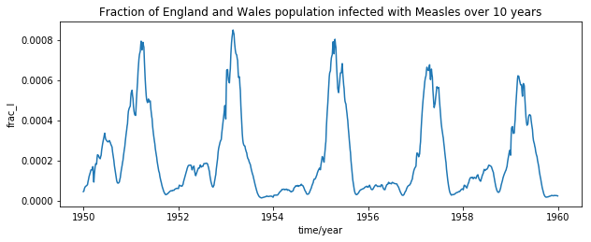
Figure 1: Historical measles outbreaks
Measles outbreaks is well-documented given its non-lethality. From the 1950-1959 data (see Appendix) it is clear that the outbreaks follow a periodic fashion at a ~2 year interval. We have normalised the infected population into a fraction by dividing it with the England/Wales population during that period to ease the modelling.

The SIR (susceptible, infectious, resistant) model represents the classical approach to model outbreak. It makes several assumptions: Firstly, the spatial dimension is ignored, and only absolute number of each states is of interest (and not the spatial density of states). Secondly, the principle of mass action is assumed, that is, the flux of any transformation events (such as infection, recovery, figure 2) is estimated by ordinary reaction kinetics, second order at most. The resultant model appears to be 3 coupled ODE’s, of which 2 are linear, 1 is non-linear, with 2 degrees of freedom in total. Overall, the model predicts the time-dependent trajectory of an idealised spatially homogeneous population during the outbreak of an infectious disease.

Though simple in nature, the SIR model captures some important features of the dynamics. Firstly, it predicts a critical resistance level, above which there is no outbreak, phenomena known as herd immunity. Secondly, it relate the outbreak size to the initial infectious population. With appropriate modification, it may even give periodic limit cycle, which can be employed to explain historical data.
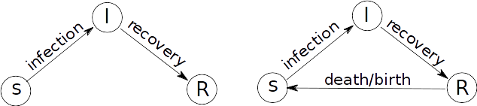
Figure 2: Topology of Simple SIR model

Simple SIR model:
We present the ODE’s for the time-evolution of S,I,R variables:
(infection flux)

(recovery flux)
Here S,I,R, represents the dimensionless fraction of population that is susceptible, infectious and resistant respectively, hence they are constrained with S+I+R=1, allowing for projection of the phase-space onto a 2D plane (of S and I). Here t represents the time in unit of day. There are 2 processes at action here: 1) the infection flux, as shown by dS/dt, which is proportional to both “I” and “S”, whose product indicating the collision rate between “I” and “S”. 2) the recovery flux, as shown by dR/dt, which is dependent on “I” only with a constant. dI/dt can be obtained by combining the two flux.

Parameters:
The model also permits 2 free parameters: and . From recovery flux it is seen specify how fast the infectious becomes resistant, with units in day^1. This flux makes the assumption that every infectious case has the same probability to recover within a given period (p= within), effectively resulting in a poisson distribution for recovery time. (), with (mean recovery time =).

In contrast, it is not straightforward to interpret the meaning of from the ODE’s. Instead, we interpret the quotient first. From infection flux it is seen that specifying rate of effective collision between S and I converting S into I, in unit of day^-1. It can be intuitively interpreted as follows: out of cases of collisions made by each infection case I every day, only is susceptible and contribute towards the infection flux. Thus we can view to specify as product of effective collision/infection rate with mean recovery/infectious time, thus indicating the average effective infections contributed by each infectious case over the course of its infection.

We estimate our initial parameters from daily experience. An infected person typically closely contacts 10-50 person during the infectious period of 8 days. Here we take the reported value of = 16 from wikipedia (3)⁠. The average infectious period is taken to be 8 days (= 8 days). To characterise the disease dynamics, we start the simulation with a small infected population (I=0.0001), corresponding to the fact that infected input population only constitutes a small amount of the total population, and run until the system stabilises (I→0). In different runs, fraction of susceptible (S) is varied to observe its impact on the outbreak.

Before proceeding to simulation, we calculate nullclines and steady states for the model.

The non-trivial nullcline is . There is no non-trivial steady state besides the axis I=0.
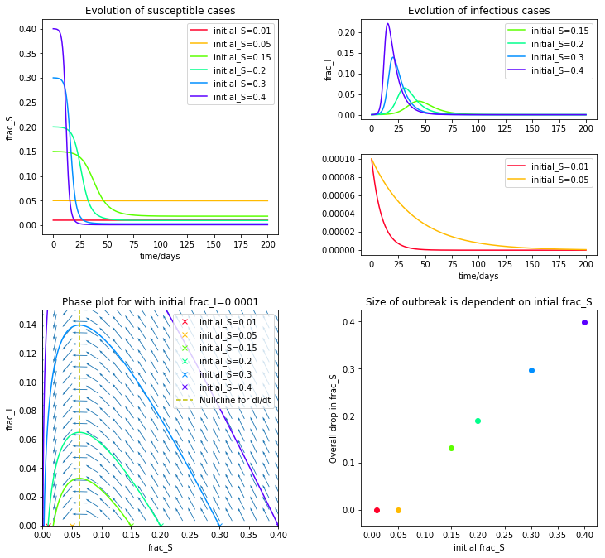
Figure 3: Result of simple SIR model, with= 16 and = 8 days.

This simple model has several implications. Firstly, there exists a critical value for initial S (S=0.0625), as outlined with nullcline for dI/dt. The positivity of determine whether there will be an outbreak or not. Especially if <0 (for initial_S=0.01, 0.05), the infection cases follow an exponential decay with little reduction in susceptible (upper-left panel of figure 3), whereas if , an outbreak takes place and drastically reduces the number of susceptible. Secondly, the overall reduction in susceptible cases is approximately proportional to the initial susceptible cases in an outbreak (lower-right panel of figure 3).

It is useful to consider these results in terms of initial immune/resistant fraction. Since “I” is small at the start of simulation we have R=1-S. If the population is well immunised (R>0.9375, aka 93.75%), either by vaccination or due to earlier outbreak, the infection population will just decay and no outbreak is seen. However, if the immunisation level is low (R<0.9375), then all susceptible people will catch the diseases (and die if it is lethal). The reported critical immunity level of 93.75% is close to the well-known 95% cut-off for herd immunity in measles.

It is noticed the system lacks a stable limit cycle, owing to the linear topology in its transition diagram incapable of sustaining a flow (figure 4). This is, however, contradictory to the historical data of measles outbreak (figure 1), which exhibits strong periodic behaviour.
Figure 4: Topology of system. Left: The simple SIR, there is no cycle in the graph. Right: The modified SIR, with a 3-cycle present.

Circularised SIR model:
To overcome this problem, we introduce an R→S flux to circularise the simple SIR model, under the rationale that, in a non-vaccinated population, most people catch measles at a young age and remain resistant for the rest of their life. Given that people mostly die at an older age, it’s reasonable to suggest more deaths took place in the resistant phase, whereas new births are susceptible to measles by default, since the resistance towards measles is not inheritable. This death-birth flux (who knows what’s in between, paradise maybe?) is so introduced that the size of the population does not change, that is, S+I+R=1 should not be violated. Thus, we modify the model by adding a constant flux of k from R to I, yielding:

Parameters:
The extra parameter k denotes the average birth/death rate per capita, in units of (day)^-1. Its value is estimated by taking average total fertility rate (TFR) of England and Wales from 1950~1959 (see Appendix). We take k=15.67/1000/365=4.29E-5. Again, we calculate nullclines and steady states to guide the simulation.

It is seen that the nullcline of dS/dt has a hyperbolic shape, whereas that of dI/dt has two straight lines. Their intersection give up to a single non-trivial steady state at . aka (3.29E-4, 0.0625). Simulation confirms this is indeed the steady state.
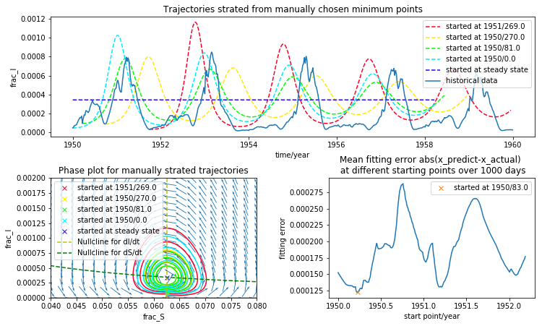
Figure 5: Manually started trajectories and fitting errors.
We then keep “S” fixed and vary initial “I” according to the historical data to fit the trend of measles outbreak in 1950~1959 in England and Wales (see appendix for data). Initially, we start the simulation at various minima according to the number of infections with the assumption that they are close to steady state. But this makes the trajectories too messy to interpret (figure 5). We then develop a criterion to describe the goodness of the fitting, and identified the best starting point where this goodness is maximised (1950yr 83days).

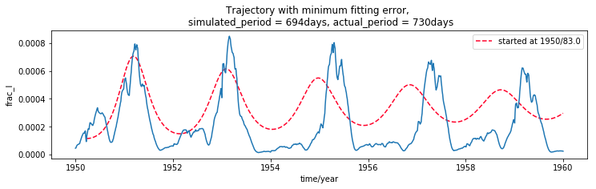
Figure 6: Trajectory with minimal fitting error

This simulation (figure 6) captures the periodic behaviour of measles outbreaks, with a comparable period. However the simulated period is slightly shorter than the actual period, and the simulation drifts away in the long run. The damping of the simulation is also greater than the observed damping of the measles outbreaks. The simulation also disagree with the historical data in fine details. For example, actual big outbreaks are often preceded with small outbreaks, which is not reflected in the simulation. Additionally, peak in actual outbreak is often split into several individual peaks indicating periodic behaviour on a shorter time scale.

Empirically fitting:
If we pay more attention towards the actual measles outbreaks, it is evident the outbreak is seasonal. Most outbreaks decay off towards the end of a year. On reaching the minima, the next outbreak is started so on and so force. The sizes of outbreaks also alternate between the years. A major outbreak is followed with a minor one, and a minor outbreak is followed with a major one. Thus to improve the simulation, we must seek to incorporate this alternating behaviour into a yearly period. Whereas the currently model well captures the 2-year period, it does not reflect the one-year period of the outbreak.

To improve the fitting result, we make 2 modifications. Firstly, we adjust the original parameters to so that the simulated period and damping are as close as possible to real measles breaks (period of 730 days). Secondly, we inject a 1-year periodic behaviour (period of 365 days) into one of the parameter to account for the observation.

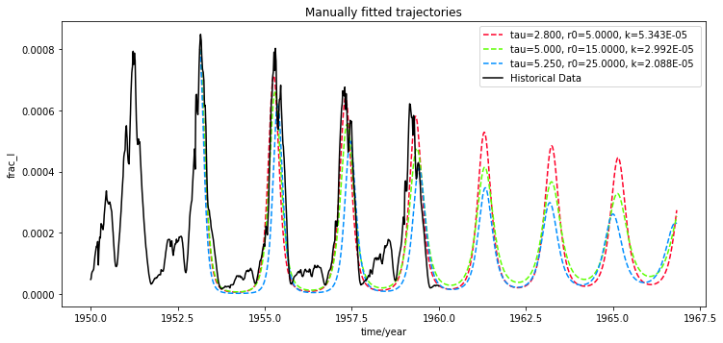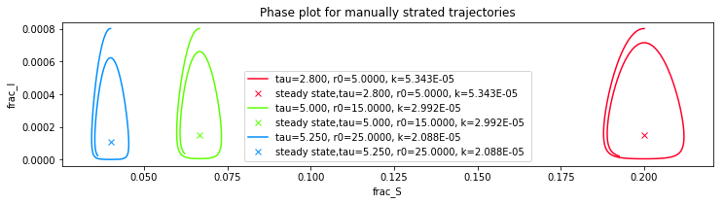
Figure 7: Effect of on residual infection level. A higher permits a higher residual infection.

When manually adjusting the parameters, we made several observations. First, the residual infection level between outbreaks is related to the “I” coordinate of the steady state, since the trajectory is forced to go between the axis and the steady state. Since the data has a low residual infection, we are forced to keep low (figure 7). With this constraint we have 2 degrees of freedom left, one for , another for . The other constraint comes from the periodicity observed in the data, which is collectively determined by all 3 parameters. We then varyand adjust to keep the period invariant to meet both constraints. The observation is that, the higher the , the lower the outbreak peaks in subsequent cycles, corresponding to a greater amount of decay between cycles (figure 8). Since the 1951 outbreak does not quite follow the exponential decay pattern, we start out fitting from the 1953 outbreak peak.

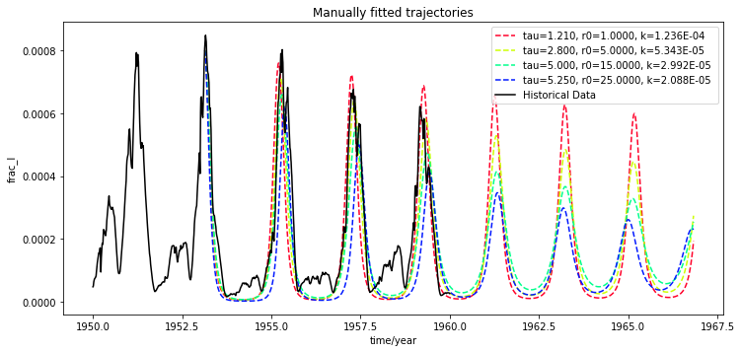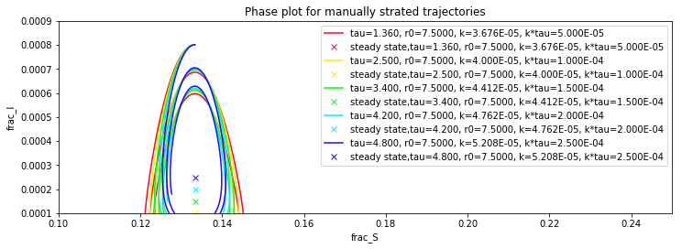
Figure 8: Effect of on peak height, note the decaying constant is different between trajectories

It is seen that an around 5.0~10.0 best reflect the decay rate, though more data is required to support this assertion. We then specify and adjust other parameters to fit the data (figure 9). The resultant simulation accurately reflect the periodic spike outbreak, but failed at predicting minor outbreaks. We now proceed to the second modification: injecting a periodic parameter to adjust the detail of a 2-year cycle to introduce the minor outbreak. Given that the limit cycle is dominated by the steady state, we suggest to adjust the “I” coordinate alternatively.

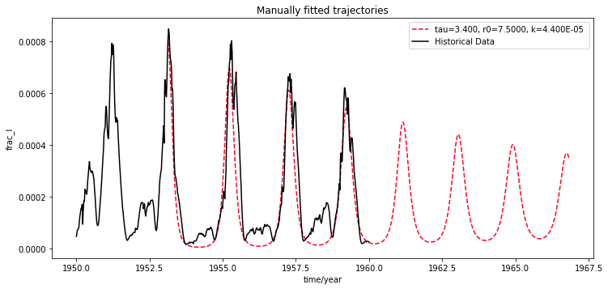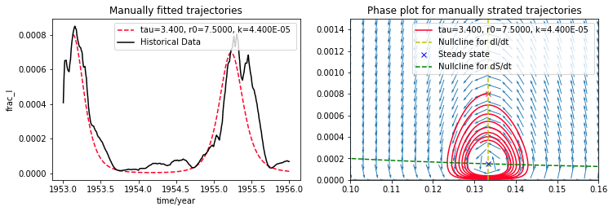
Figure 9: Manually optimised trajectory fitted to give low residual infection and a 2-year period.

Given that the peak height is determined by the parameter , it seems logical to inject the periodicity into . However the result is not satisfactory so is not presented here.

Discussion and Future Investigation:
Overall, the modified SIR can reproduce the historical trend of repeated measles outbreak in an exponential-decaying fashion.

It is important to notice the empirical nature of the model in the sense that it has been deliberately adjusted to reproduce the trend observed in historical data. Thus one needs to treat its predictive power carefully, and evaluate its implication critically, in order to avoid the pitfall of empirical fitting. The aforementioned observations imply that the residual infection level is a function of both the lifespan of a single infection and the birth/death rate k, whereas the infection cycle is a complicated function of all three parameters.

Realistically, the observed yearly outbreak would stem from the seasonal periodic change of , and should not be fitted by changing the other parameters, since the seasonal change is an external input. The limiting cycle behaviour of SIR, in contrast, is a result of periodically reduction and replenishment of the susceptible population, which is completely unrelated to the seasonal changes.

Another shortcoming of the modified SIR model is its incapability of capturing the sub-cycle behaviour, namely to display separate major/minor outbreaks in a 2-year cycle, which should stem from the fact that susceptible population is small immediately after a major outbreak and unable to sustain another major outbreak, resulting in a minor outbreak instead. This phenomenon again supports the hypothesis that measles outbreak is triggered with a seasonal cue and not an increase in susceptible population, otherwise a minor outbreak is not possible. We suggest to inject a periodic to promote measles outbreaks at observed seasons, and adjust the remaining parameter to fit the data.

References:
1. Measles-Wikipedia [Internet]. Available from: https://en.wikipedia.org/wiki/Measles
2. Bartlett MS. Measles Periodicity and Community Size. J R Stat Soc Ser A. 1957;120(1):48–70.
3. Basic reproduction number-Wikipedia [Internet]. Available from: https://en.wikipedia.org/wiki/Basic_reproduction_number

