RK4 is an ODE solver similar to euler's method, with the iterator taking the form:

RK-family method relies on finding k_n iteratively, in RK4 the iteration reads

However, these relations are only useful to derive k2, not from k1 directly, but proxyed through a complicated y. We now seek to eliminate this proxy. We wonder what happened to the coefficients of k1 to k4. Thus, we should taylor-expand k1 to k4, exploiting the aforementioned preserved relation. Note this expansion has a 2D form if partial derivative is taken. However we can exploit the principle of total derivative to simplify the notation.(This is essentially dropping the dependency of "f" on "y" to achieve a simpler notation).

By the principle of total derivative:

Take derivative wrt t:

Exchange LHS with RHS, time both sides by gives:

substitue ( II ) into ( I ) gives:

Note ,in other words:

Compare (III) against well-known Taylor expansion of y( t+h ):

We obtain

*According to Wikipedia, the full expansion of (III) looks like
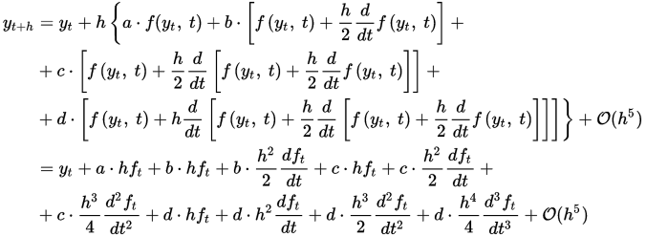

Giving up to:
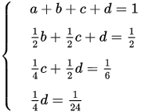
and thus

