3.

The minimum free energy for fhla is -43.50 kcal/mol. The structure is:

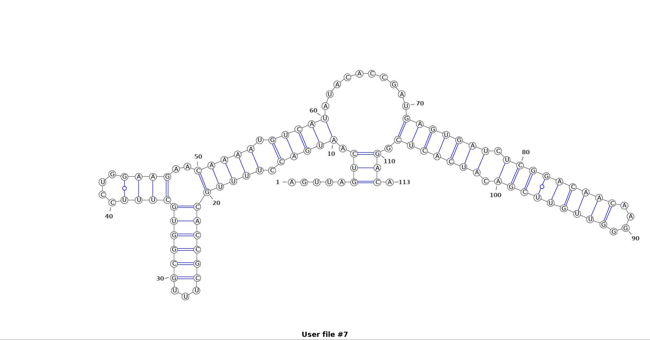

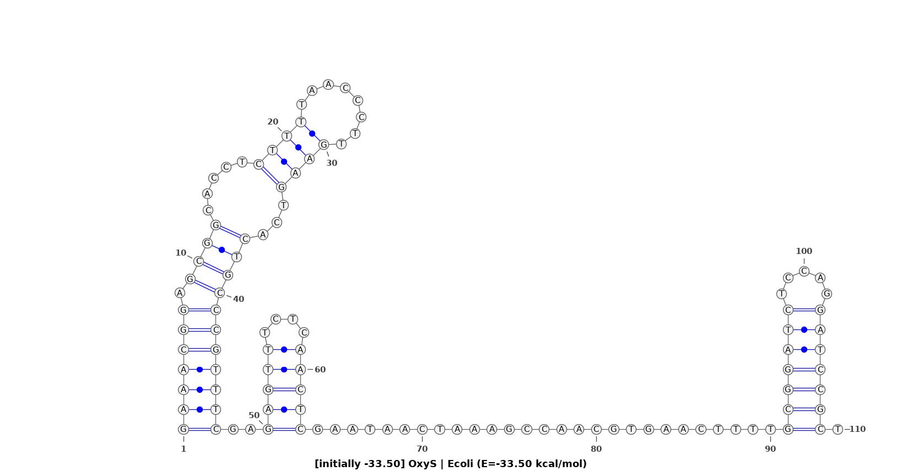The minimum free energy for oxys is -33.50 kcal/mol. The structure is: