Game Design Document

Fill up the Following document

1. Write the title of your project.

Shooting hero

1. What is the goal of the game?

To earn the more point

1. Write a brief story of your game?

In my game there are two player :

1: hero

2: enemy

3:enemy2

We will play the game using mouse and keyboard

we will shoot the enemy by clicking right button

and move the hero by moving the mouse

once the level increase the speed increase as the enemy comes faster and faster

we will also add sound to our game at different point

the game becomes interactive as the player and enemy moves faster and faster

1. Which are the playing characters of this game?

* Playing characters are the ones which respond to the user based on the input from the user
* Cars, monkeys, dinos, wizards etc, are the playing characters in the game.

|  |  |  |
| --- | --- | --- |
| Number | Character Name | What can this character do? |
| 1 | Hero | Shoot the enemy |

Which are the Non Playing Characters of this game?

* Non Playing characters are the ones which don't have an action or a behaviour when the user interacts with the game.
* Hurdles, stones, bananas, coins, etc are non playing characters in the game.

|  |  |  |
| --- | --- | --- |
| Number | Character Name | What can this character do? |
| 1 | Enemy | Kill the hero |
| 2 | Enemy 2 | Kill the hero |

Draw your imagination of this game. What does this game look like?

* Draw the game either on your computer or on paper,
* Add images of scenes of the game to show each of the playing and non-playing characters at least once.

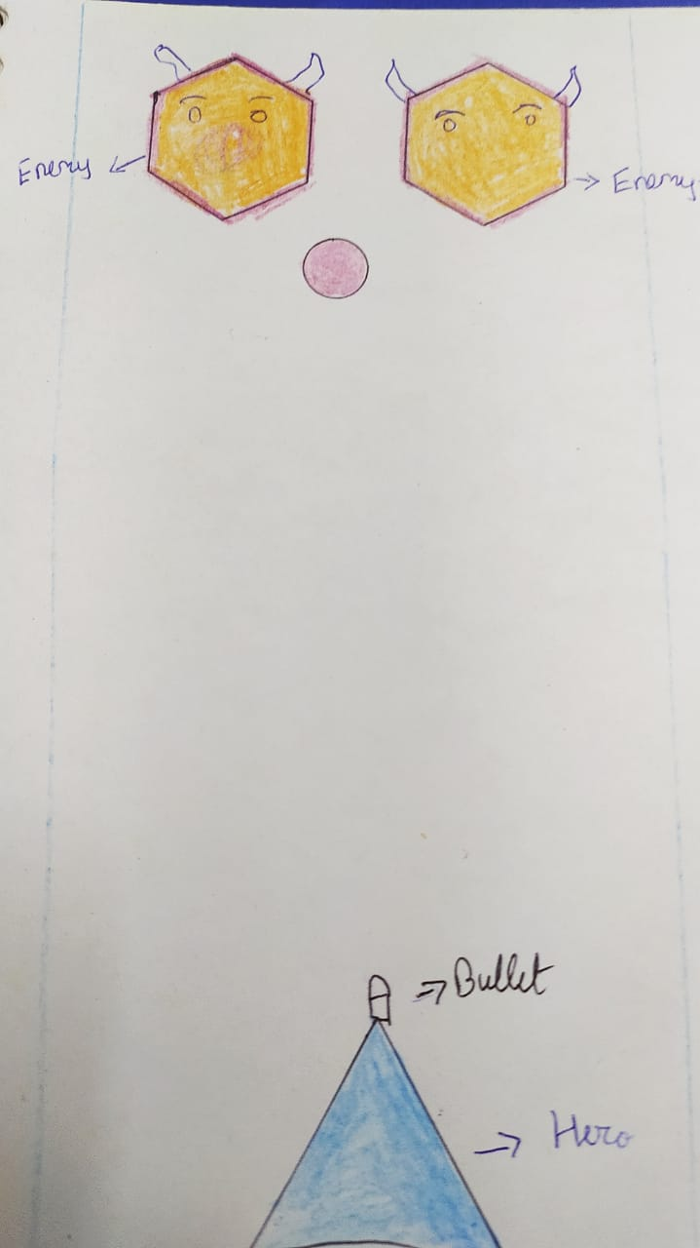

How do you plan to make your game engaging?

By adding sound

By adding level

By adding score

By making harder