For this question I tried lots of neuralnetwork models , I was also planning to use randomforest regressor but I couldn’t find a way to include both strings and values in python. I included a custom activation function for the last layer prediction as the values had to be between 0 to 5(sigmoid(x) * 5).

I excluded the version columns from features and made two seperate feature sets:
1)In one I didnt take dates
2)In second I seperated date into three columns Date, Month and Year.

I trained different models by making changes to the same file and storing the progress of each in a different log file.

I found that adding more than 3 dense layers tends to overfit the model and having 128 hidden units per layers does ok.

I trained without custom activation also but the loss was much higher.

At first , when i used the features with date the model was performing much worse but later I used l2 reguralization for the weights of the second layer and the model performed slightly better than without dates.

////
from __future__ import absolute_import, division, print_function
import tensorflow as tf
import pickle
import pathlib
import numpy as np
from tensorflow import keras
from keras.layers import Activation
from keras import backend as K
from keras.utils.generic_utils import get_custom_objects
import pandas as pd
import numpy as np
from tensorflow.keras.callbacks import TensorBoard
import time
from keras import regularizers

NAME='playstore_neural_network(l2reg)(with_date)-128*3(50)-{}'.format(int(time.time()))
tensorboard=TensorBoard(log_dir='logs/{}'.format(NAME))

def custom_activation(x):
return (K.sigmoid(x) * 5)

get_custom_objects().update({'custom_activation': Activation(custom_activation)})

pickle_in=open('features_with_date.pickle','rb')
train_x,train_y=pickle.load(pickle_in)
model=tf.keras.models.Sequential()
# model.add(Activation(custom_activation))
tx=[]

for arr in train_x:
tx.append(np.array(arr))
ty=np.array(train_y)
tx=np.array(tx)

model.add(tf.keras.layers.Dense(128,activation=tf.nn.relu))
model.add(tf.keras.layers.Dense(128,kernel_regularizer=regularizers.l2(0.01),activation=tf.nn.relu))

model.add(tf.keras.layers.Dense(1,activation=custom_activation))
# model.add(tf.keras.layers.Dense(1))
optimiser=keras.optimizers.RMSprop(lr=0.001, rho=0.9, epsilon=None, decay=0.0)
model.compile(loss='mse',optimizer=optimiser,metrics=['mae','mse'])
history=model.fit(tx,ty,epochs=50,validation_split=0.3,verbose=0,callbacks=[tensorboard])
hist=pd.DataFrame(history.history)
hist['epoch']=history.epoch
print(hist)

/////

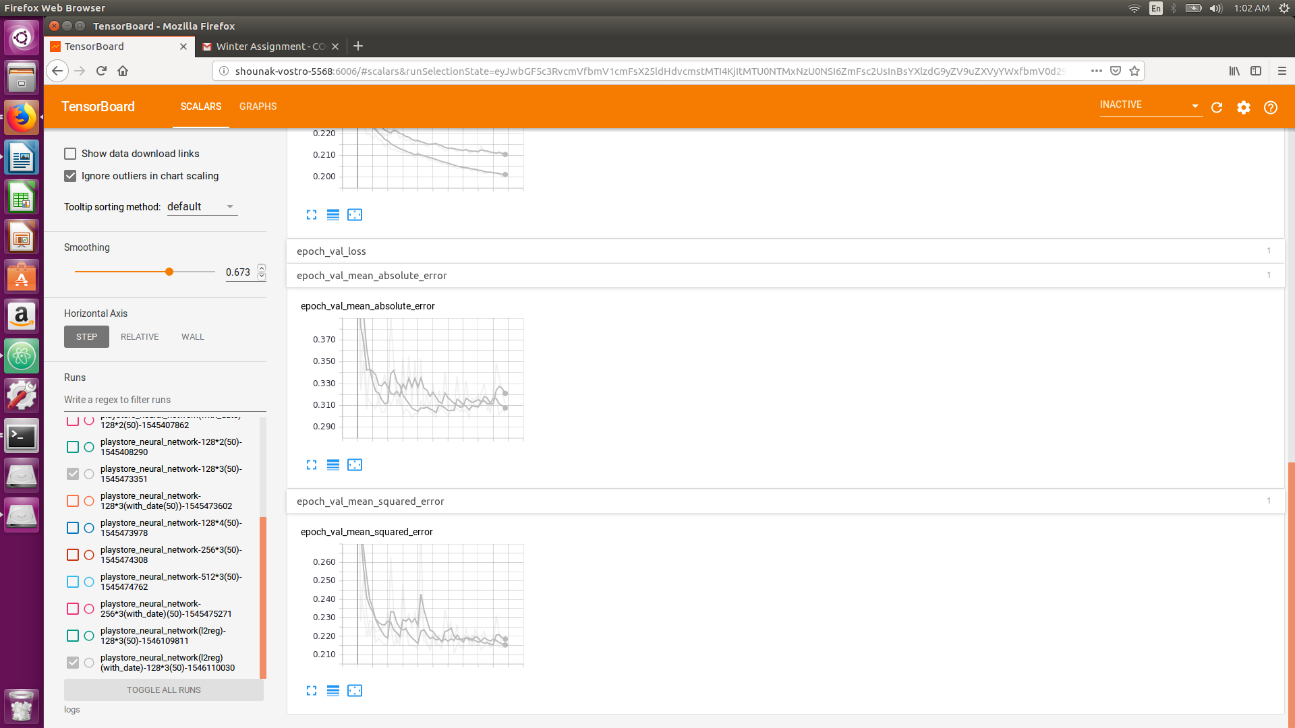

This is the training of the two best models I got so far, the one with dates is slightly better.

//// Code for creating features

import pickle
import numpy as np
import pandas as pd
from collections import Counter
df=pd.read_csv('googleplaystore.csv')
index=list(df['Category']).index('1.9')
df=df.drop(df.index[index])
print('index:',index)
# category=Counter(df['Category'])
df=df.reset_index(drop=True)
sum=n=i=0
for row in df['Rating']:
if(row==row):
sum=sum+float(row)
n=n+1

avg=sum/n
print('avg:',avg)
i=0
for row in df['Rating']:
if(row!=row):
df.loc[i,'Rating']=str(avg)
i=i+1
i=0
for row in df['Reviews']:
try:
float(row)
except:
print(df['Reviews'][i])
df=df.drop(df.index[i])

finally:
i=i+1
df=df.reset_index(drop=True)
# float(df['Reviews'][index])
i=0
n=sum=0
for row in df['Size']:
size=str(row)
if(size[-1]=='M'):
size=str(1000*(float(size.replace('M',''))))
size=size.replace('k','')
df.loc[i,'Size']=size
try:
float(size)

except:
df.loc[i,'Size']='0'
else:
sum=sum+float(size)
n=n+1
finally:
i=i+1

avg=sum/n
print('avg:',avg)
i=0
for row in df['Size']:
if(row=='0'):
df.loc[i,'Size']=str(avg)
i=i+1

i=0
for row in df['Installs']:
installs=str(row)
installs=installs.replace('+','')
installs=installs.replace(',','')
df.loc[i,'Installs']=installs
try:
float(installs)
if(row!=row):
df=df.drop(df.index[i])

except:
df=df.drop(df.index[i])
finally:
i=i+1
df=df.reset_index(drop=True)
i=0
for row in df['Price']:
price=str(row)
price=price.replace('$','')
df.loc[i,'Price']=price
try:
float(price)
if(row!=row):
df=df.drop(df.index[i])

except:
df=df.drop(df.index[i])
finally:
i=i+1
df=df.reset_index(drop=True)

i=0
for row in df['Content Rating']:
if(row!=row):
df=df.drop(df.index[i])
i=i+1
df=df.reset_index(drop=True)

# shuffling
df=df.sample(frac=1).reset_index(drop=True)

df=df.reset_index(drop=True)
df['Day']=''
df['Month']=''
df['Year']=''
i=0
for row in df['Last Updated']:
date=str(row)
date=date.replace('January','01')
date=date.replace('February','02')
date=date.replace('March','03')
date=date.replace('April','04')
date=date.replace('May','05')
date=date.replace('June','06')
date=date.replace('July','07')
date=date.replace('August','08')
date=date.replace('September','09')
date=date.replace('October','10')
date=date.replace('November','11')
date=date.replace('December','12')
date=date.replace(',','')
df['Month'][i]= date[:2]
df['Day'][i]=date[3:-5]
df['Year'][i]=date[-4:]
i+=1
# content_rating=Counter(df['Content Rating'])
# print(content_rating)

# From here creating onehot lists
category=Counter(df['Category'])
# print(category)
i=0
feat_cat=[]
for row in df['Category']:
i=0
feat=np.zeros(len(category))
for cat in category:
if(row==cat):
feat[i]=1
i=i+1
feat_cat.append(feat)

i=0
content_rating=Counter(df['Content Rating'])
feat_con=[]
for row in df['Content Rating']:
i=0
feat=np.zeros(len(content_rating))
for con in content_rating:
if(row==con):
feat[i]=1
i=i+1
feat_con.append(feat)
i=0
features=[]
for cat in feat_cat:
features.append(list(cat)+list(feat_con[i]))
i=i+1

labels=[]
for row in df['Rating']:
labels.append(float(row))

# Normalizing
df=df.drop(df.columns[[0,1,6,8,9,10,11,12]],axis=1)
df = df.apply(pd.to_numeric)
df=(df-df.mean())/df.std()

# Normalizing

i=0
for row in df['Reviews']:
features[i].append(row)
i+=1
# df=df.drop(df.index[10839])
i=0
for row in df['Size']:
features[i].append(row)
i+=1
i=0
for row in df['Installs']:
features[i].append(row)
i+=1
i=0
for row in df['Price']:
features[i].append(row)
i+=1

# print(df.loc[[10839]])

# print(features)
i=0
for row in df['Day']:
features[i].append(row)
i+=1
i=0
for row in df['Month']:
features[i].append(row)
i+=1
i=0
for row in df['Year']:
features[i].append(row)
i+=1

# x_train=features[:1084*9]
# x_test=features[1084*9:10840]
# y_train=labels[:1084*9]
# y_test=labels[1084*9:10840]

print(len(labels))
print(len(features))

with open('features_with_date.pickle','wb') as f:
pickle.dump([features,labels],f)

//////

