I studied a little timeseries analysis but as I havent learnt it properly I used LSTM units for this question. I had to try some things as the model was not learning well at first, as this is a many to many with different inputand output sequence lengths.

I didnot do any data cleaning in this question as there was no distinction between unavailable data and 0, and too many rows were blank to drop .I just think that 0 multiplied by weights will give zero and adding the bias will hopefully yield a small output close to zero so my model will lern to predict zero when all previous values are zero.

In my model the first 490 days go as input to the lstm layers and final output is a sequence to 60 values corresponding to the next 60 days that I have to predict.

//////

import pickle
import tensorflow as tf
from tensorflow import keras
from keras import backend as K
from keras.models import Sequential
from keras.layers import Dense
from keras.layers import LSTM
from keras.layers import Activation

from keras.layers import RepeatVector
import numpy as np
import time
from keras.layers import TimeDistributed

from keras.callbacks import ModelCheckpoint
from tensorflow.keras.callbacks import TensorBoard

NAME='LSTM_web-lfr60ltd1arelu(50)-{}'.format(int(time.time()))
tensorboard=TensorBoard(log_dir='logs/{}'.format(NAME))

pickle_in=open('features(ret_seq=T).pickle','rb')
x_train,y_train,x_test,y_test=pickle.load(pickle_in)
print(y_train.shape)
model=Sequential()
model.add(LSTM((60),batch_input_shape=(None,x_train.shape[1],1),return_sequences=False))
model.add(RepeatVector(60))
model.add(LSTM((60),batch_input_shape=(None,60,1),return_sequences=True))
model.add(TimeDistributed(Dense(1)))
model.add(Activation('relu'))
# model.add(LSTM((60),batch_input_shape=(None,x_train.shape[1],1),return_sequences=False))
# model.add(Dense(60))
model.compile(loss='mean_absolute_error',optimizer='adam',metrics=['mae'])
model.summary()

print(y_train.shape)
filepath="models(lfr60ltd1arelu)/weights-improvement-{epoch:02d}-{val_loss:.2f}.hdf5"
checkpoint = ModelCheckpoint(filepath, monitor='val_loss', verbose=1, save_best_only=False,save_weights_only=False,period=1)
callbacks_list = [checkpoint,tensorboard]
history=model.fit(x_train,y_train,epochs=50,validation_data=(x_test,y_test),callbacks=callbacks_list)

///////

I saved the progress per epoch as this took a lot of time to train.

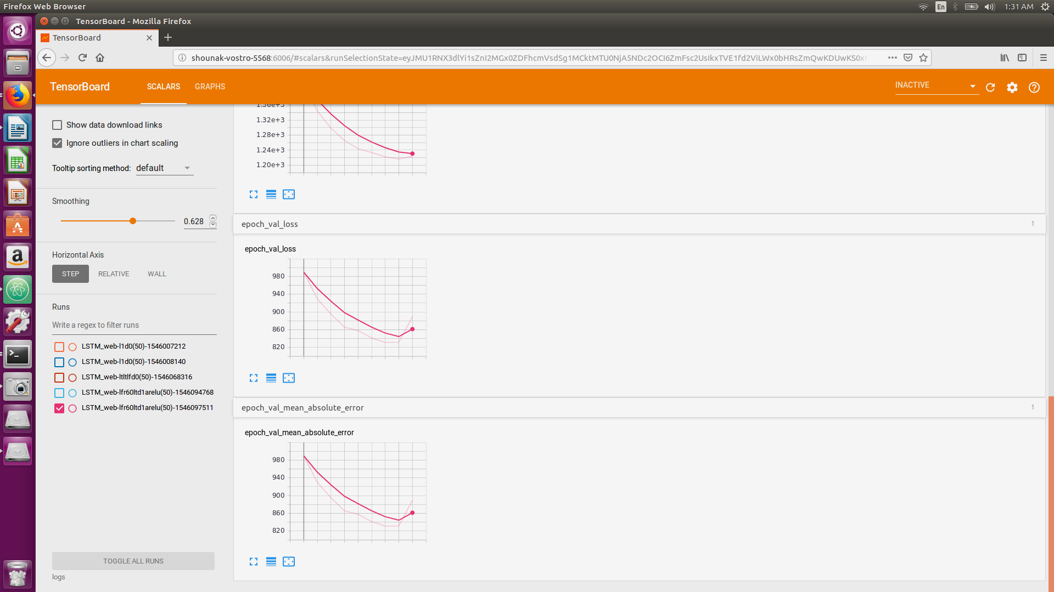

////code for features

import numpy as np
import pandas as pd
import pickle

df=pd.read_csv('train_1.csv')
df=df.drop(df.columns[[0]],axis=1)
df=df.sample(frac=1).reset_index(drop=True)
df=df.fillna(0)
data=np.array(df.values)
data=data.reshape(df.shape[0],df.shape[1],1)
y=data[:,-60:,:]
print(y)
x=data[:,:-60,:]

x_train=x[:int(x.shape[0]*0.9),:,:]
x_test=x[int(x.shape[0]*0.9):,:,:]
y_train=y[:int(y.shape[0]*0.9),:,:]
y_test=y[int(y.shape[0]*0.9):,:,:]

with open('features(ret_seq=T).pickle','wb') as f:
pickle.dump([x_train,y_train,x_test,y_test],f)

//////

