**The Visual Microphone**

**Objectives:**

* Recovering Sound from a muted Video

**Description:**

The main idea of this project will be to recover sound from a video. When sound hits an object, it causes small vibrations of the object’s surface. We show how, using only high-speed video of the object, we can extract those minute vibrations and partially recover the sound that produced them, allowing us to turn everyday objects—a glass of water, a potted plant, a box of tissues, or a bag of chips—into visual microphones.

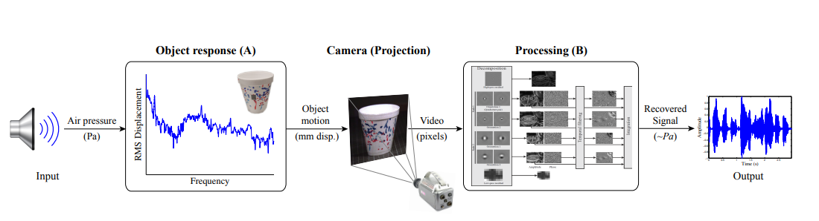

**References:** <http://people.csail.mit.edu/mrub/papers/VisualMic_SIGGRAPH2014.pdf>

**Automatic Symptom-Based Disease Detection from Patient's Voice(Bengali)**

**Description:** Most of the times the patients don’t know which type of doctor they should consult with which might lead to wrong treatment or loss of crucial time. So,the main idea of this project is to suggest the correct specialist doctor by analyzing the symptoms. So, the patient will tell his/her symptoms in Bengali and our system will predict the specialist doctor for the patient by analyzing the speech signal through Deep Neural Networks.

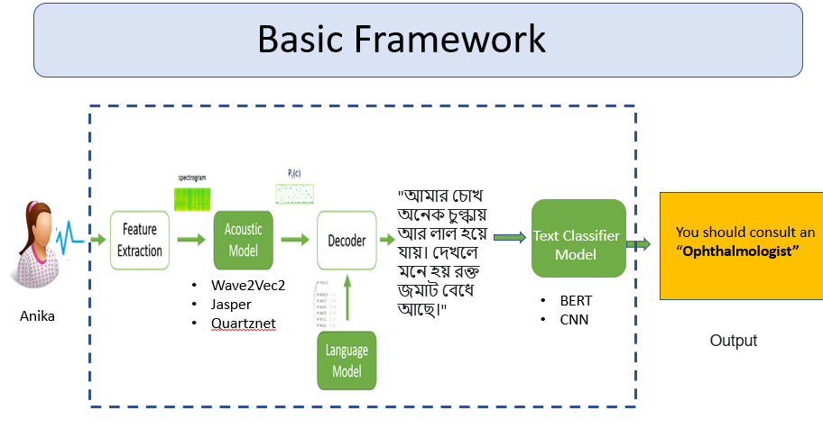

In this project we will use Automatic Speech Recognition for Bengali and the Bangla text classifier. The datasets for both of these tasks are available on the internet.

**References:**

* [**https://www.kaggle.com/datasets/shashwatwork/bengali-medical-dataset**](https://www.kaggle.com/datasets/shashwatwork/bengali-medical-dataset) **(Dataset for Bengali Medical symptom detection)**
* [**https://www.kaggle.com/competitions/dlsprint/data**](https://www.kaggle.com/competitions/dlsprint/data) **(Dataset for Bengali ASR)**