A Report on Inference on Population Means

10/16/2021

# 1 Abstract

Statistical inference is the process of making reasonable guesses about a population’s distribution as well as its parameters on the basis of observations which may be drawn using some forms of sampling. Inference for mean of a population are made using a sample mean when population mean cannot be known.

# 2 Chapter 1: Introduction

# 3 Chapter 2: Methodology

# 4 Chapter 3: Practical Application

# 5 Chapter 4: Conclusion

This is an R Markdown document. Markdown is a simple formatting syntax for authoring HTML, PDF, and MS Word documents. For more details on using R Markdown see <http://rmarkdown.rstudio.com>.

When you click the **Knit** button a document will be generated that includes both content as well as the output of any embedded R code chunks within the document. You can embed an R code chunk like this:

summary(cars)

## speed dist   
## Min. : 4.0 Min. : 2.00   
## 1st Qu.:12.0 1st Qu.: 26.00   
## Median :15.0 Median : 36.00   
## Mean :15.4 Mean : 42.98   
## 3rd Qu.:19.0 3rd Qu.: 56.00   
## Max. :25.0 Max. :120.00

## 5.1 Including Plots

You can also embed plots R Core Team (2021), for example:

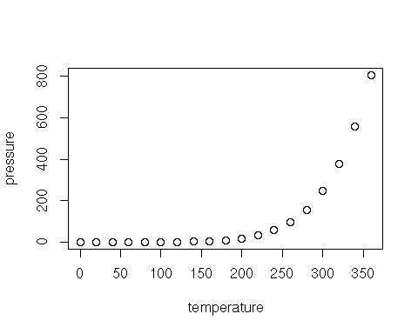

Note that the echo = FALSE parameter was added to the code chunk to prevent printing of the R code that generated the plot.

R Core Team. 2021. *R: A Language and Environment for Statistical Computing*. Vienna, Austria: R Foundation for Statistical Computing. <https://www.R-project.org/>.