Document Scanner + OCR Pipeline
A Computer Vision Project Report
Course: CSE3010 – Computer Vision
Assignment: Build Your Own Project (VITyarthi)
Institution: VIT Bhopal University, School of Computing Science and Engineering
Submitted by: Shourya gupta
Registration Number : 24BAI10801

1. Introduction

Images of physical documents captured using a mobile phone are often affected by problems such as incorrect alignment, perspective distortion, and uneven lighting. This project develops a command-line based pipeline that takes a document photograph and converts it into a clean, flattened, high-contrast image. It then extracts the written content using Optical Character Recognition (OCR). The complete pipeline is divided into three separate and testable modules based on the image-processing and geometric-transformation concepts included in the CSE3010 syllabus, such as image enhancement, homography-based perspective correction, and feature/contour-based document detection.

2. Problem Statement

A lightweight and GUI-independent solution is required to transform a raw document photograph into two useful outputs: (a) a properly flattened and readable scanned image and (b) structured machine-readable text. The system should perform these operations locally without depending on mobile applications or cloud-based services. The proposed project provides a simple, scriptable pipeline that can be executed directly from a terminal.

3. Functional Requirements
The system implements three major functional modules, as required by the assignment brief:
- Module 1 – Document Detection & Perspective Correction: locates the document boundary in the input photo (Canny edge detection + contour approximation) and applies a homography-based perspective warp to produce a top-down view.
- Module 2 – Image Enhancement & Binarization: converts the warped image to grayscale, applies CLAHE contrast equalization and denoising, then adaptive thresholding to produce a clean, scanner-quality black-and-white page.
- Module 3 – OCR Text Extraction & Structured Output: runs Tesseract OCR on the enhanced image and emits both plain text and a structured JSON file containing per-word text, confidence score, and bounding box.
Input/output structure: the CLI accepts a single image path (--input) and an output directory (--output-dir); it writes the intermediate warped image, the enhanced/binarized image, the extracted text file, and a structured JSON result.
Workflow: read image → detect & warp → enhance & binarize → OCR extract → write outputs → print summary. See the Process Flow diagram in Section 6.

4. Non-Functional Requirements
Requirement | How it is addressed
Performance | Image is resized before contour search (fixed 800px height) to bound processing cost; full pipeline runs in well under a second for typical inputs.
Reliability | A DocumentNotFoundError fallback path uses the full frame if no 4-point contour is found, so the pipeline degrades gracefully instead of crashing.
Usability | Single CLI entry point with argparse, clear --help text, sensible defaults, and a printed run summary (word count, confidence, elapsed time).
Maintainability | Each module (detector, enhancer, OCR) is a separate file with a narrow, documented public API, so any module can be modified or swapped independently.
Error handling | Every module validates its inputs (empty/invalid images) and raises specific exceptions; main.py catches and logs these without a raw stack trace reaching the user.
Logging / monitoring | Centralized logging (utils.setup_logging) writes timestamped, leveled logs to both the console and scanner.log.
Resource efficiency | Uses OpenCV's headless build (no GUI dependencies) and releases all intermediate arrays automatically via Python's garbage collector; no persistent state between runs.

5. System Architecture
The CLI (main.py) orchestrates three independent modules, each with a single responsibility, plus a shared utilities module for logging and I/O helpers.
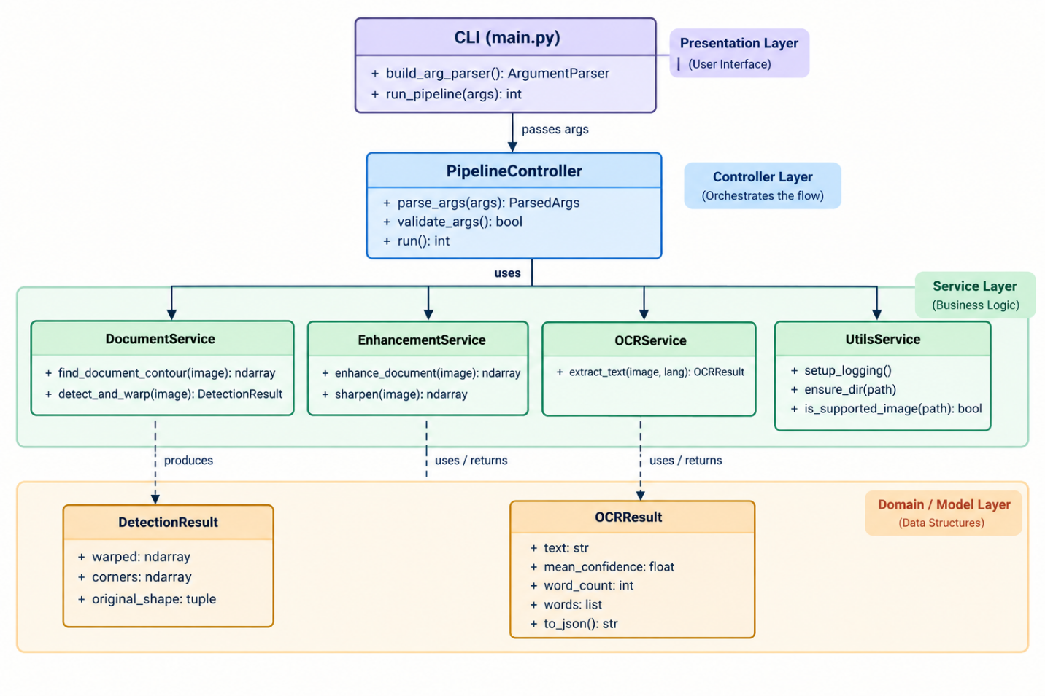

Figure 1: System architecture — module responsibilities and data handed between them.

6. Design Diagrams

6.1 Process Flow / Workflow Diagram
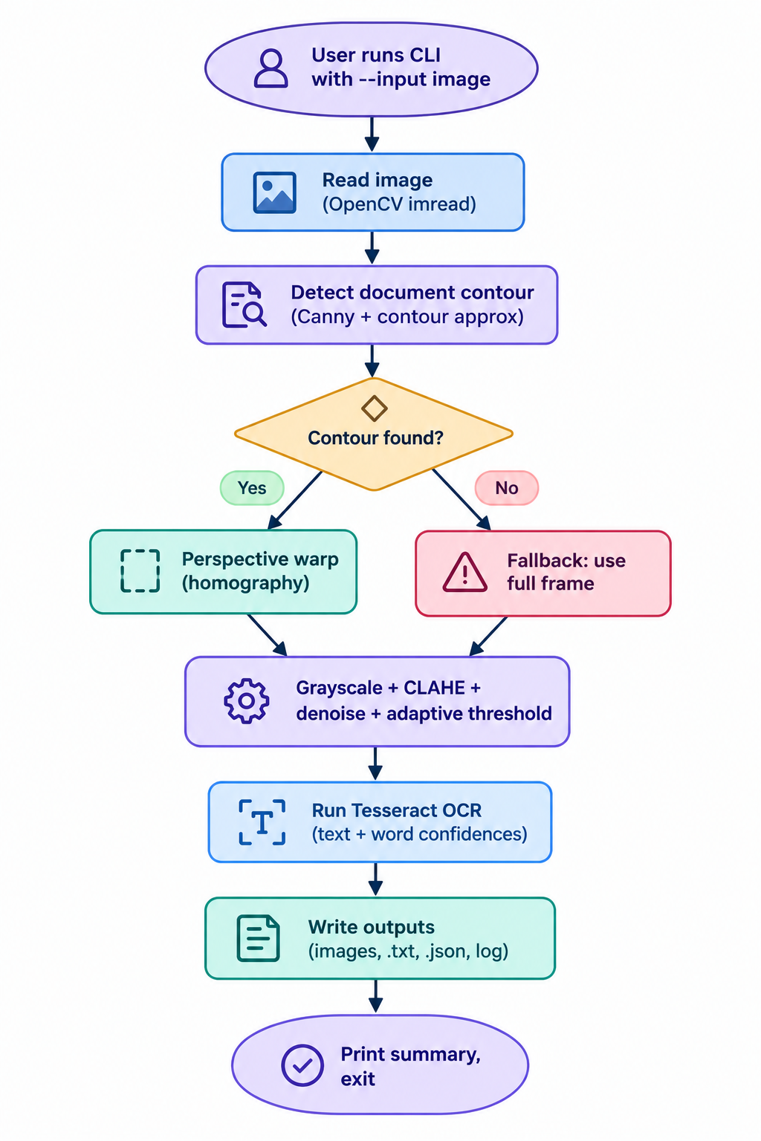

Figure 2: End-to-end processing workflow, including the contour-not-found fallback path.

6.2 Use Case Diagram
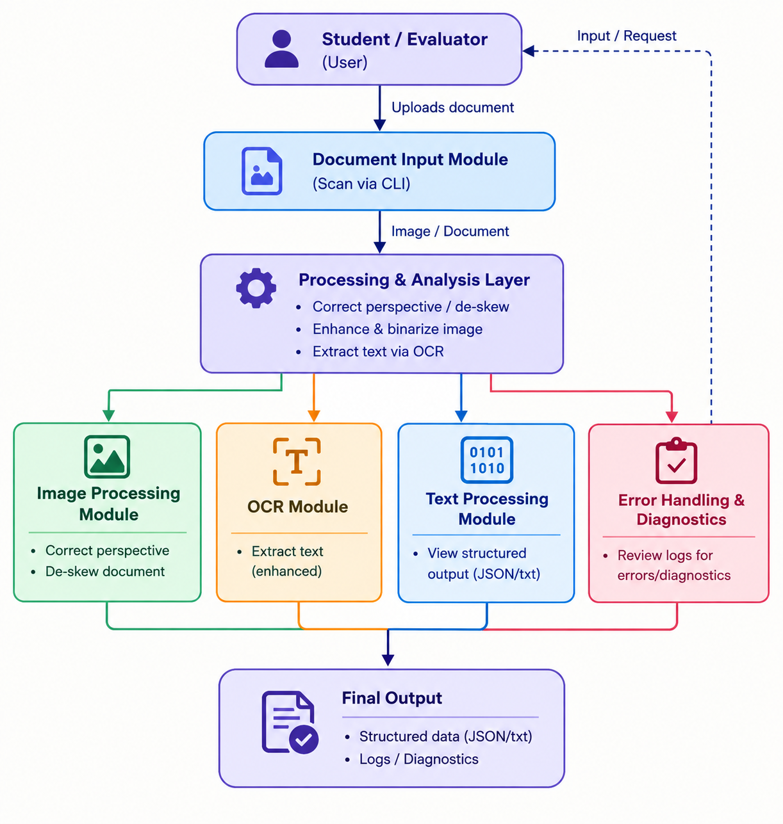

Figure 3: Use cases available to the student/evaluator running the CLI.

6.3 Class / Component Diagram

Figure 4: Module-level components, their public methods, and the data classes they produce.

6.4 Sequence Diagram
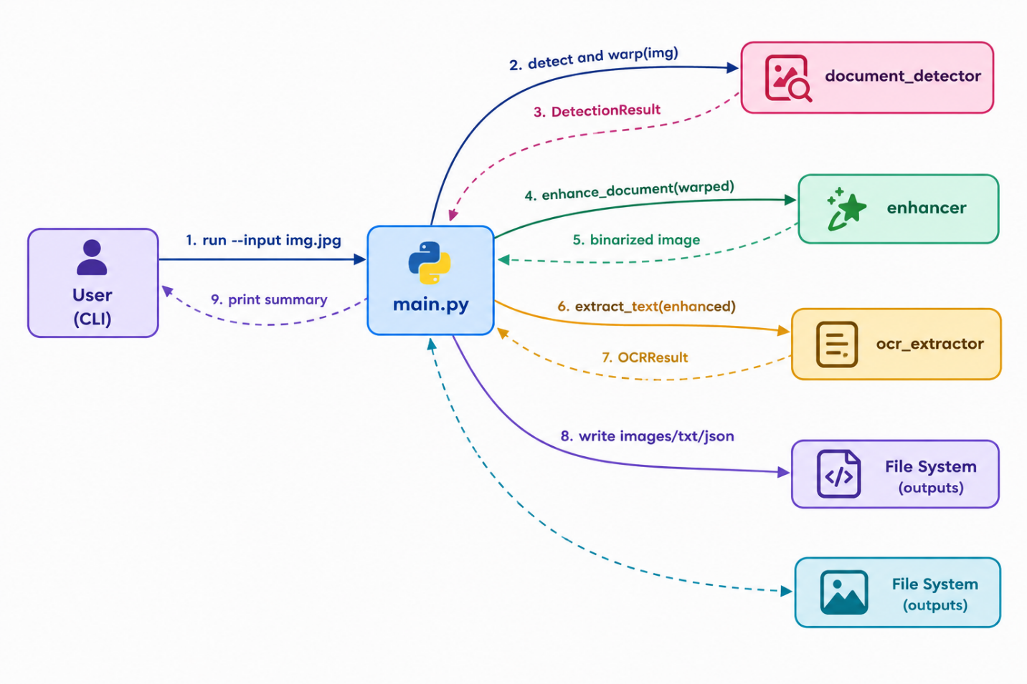

Figure 5: Call sequence for a single CLI invocation, from input image to written outputs.

6.5 Database / Storage Design
Not applicable — this project is a stateless, file-in/file-out CLI pipeline and does not use a database. Outputs are written directly to the filesystem as image, text, and JSON files (see Section 3).

7. Design Decisions & Rationale
- Three separate modules instead of one script: keeps each concept (geometry, image processing, OCR) independently testable and replaceable — e.g. Module 3 could be swapped for a cloud OCR API without touching Modules 1–2.
- Fallback-to-full-frame on failed detection: chosen over hard-failing so the pipeline is robust to photos where the document fills the whole frame or has low-contrast edges.
- Adaptive thresholding over a global threshold: documents photographed under uneven lighting have local brightness gradients that a single global threshold cannot handle well.
- JSON structured output alongside plain text: enables downstream automation (e.g. filtering by confidence, locating specific words) rather than only a human-readable transcript.
- CLI-only (argparse), no GUI: satisfies the assignment's command-line-executable requirement and keeps the tool scriptable/automatable.

8. Implementation Details
Language & libraries: Python 3, OpenCV (opencv-python-headless) for all image processing and geometric transforms, NumPy for array operations, and pytesseract as a thin wrapper around the Tesseract OCR engine.

8.1 Module 1 — document_detector.py
Resizes the input for fast contour search, applies Gaussian blur + Canny edge detection, finds the largest contours, and keeps the first one that approximates to a 4-point polygon (cv2.approxPolyDP). Corners are ordered (top-left, top-right, bottom-right, bottom-left) and a perspective transform matrix is computed with cv2.getPerspectiveTransform, then applied with cv2.warpPerspective.

8.2 Module 2 — enhancer.py
Converts to grayscale, optionally applies CLAHE (contrast-limited adaptive histogram equalization) to correct uneven lighting, denoises with cv2.fastNlMeansDenoising, and binarizes with cv2.adaptiveThreshold (Gaussian-weighted, block size 25).

8.3 Module 3 — ocr_extractor.py
Calls pytesseract.image_to_string for the plain-text transcript and pytesseract.image_to_data for per-word bounding boxes and confidence scores, aggregating them into an OCRResult dataclass with a to_json() serializer.

8.4 CLI — main.py
Wires the three modules together behind an argparse interface, writes all intermediate and final artifacts to the chosen output directory, and prints a run summary.

9. Screenshots / Results
The pipeline was validated on a synthetically generated test document (a skewed page with printed text on a dark background, generated in tests/test_pipeline.py) to provide a deterministic, reproducible demonstration.
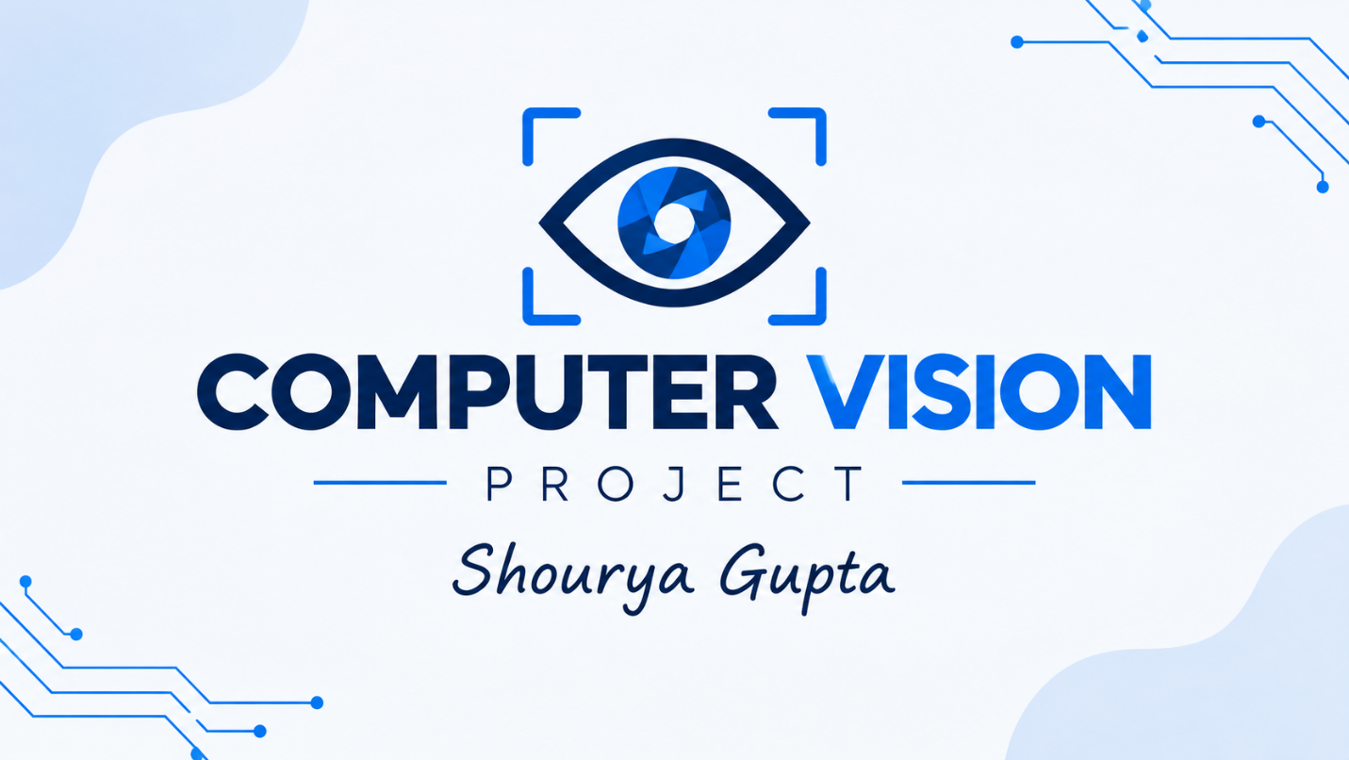
Figure 6: Module 1 output — perspective-corrected, de-skewed document.
Figure 7: Module 2 output — enhanced, binarized scan ready for OCR.
Module 3 (OCR) output on this sample:
{ "text": "HELLO WORLD\n\nComputer Vision Test", "mean_confidence": 96.0, "word_count": 5, "words": [ { "text": "HELLO", "confidence": 96.0, "bbox": {...} }, ... ] }
Run summary printed by the CLI:
Words extracted: 5 Mean OCR confidence: 96.0% Time elapsed: 0.59s

10. Testing Approach
Automated unit tests (tests/test_pipeline.py, run via pytest) cover all three modules:
- Document Detector: verifies a valid DetectionResult is returned for a normal image, that an empty image raises DocumentNotFoundError, and that a blank/featureless image correctly falls back to using the full frame.
- Enhancer: verifies output is strictly binary (0/255 pixel values only) and that an empty image raises ValueError.
- OCR Extractor: verifies text is extracted from a synthetic page, mean_confidence is a float, an empty image raises ValueError, and JSON serialization includes expected fields.
All 8 tests pass. Synthetic test images are generated on the fly (no external fixture files needed), keeping the test suite fully self-contained and deterministic. The pipeline was additionally validated end-to-end via the CLI itself (Section 9).

11. Challenges Faced
- Robust corner ordering: perspective warps break if the four detected corners aren't consistently ordered (TL/TR/BR/BL); solved using the sum/difference-of-coordinates trick.
- Handling failed contour detection gracefully: rather than letting the pipeline crash on low-contrast or edge-filling images, a full-frame fallback path was added and unit-tested explicitly.
- Uneven lighting in photographed documents: a plain global threshold produced patchy results; switching to adaptive Gaussian thresholding (with CLAHE beforehand) fixed this.
- Deterministic testing without real photos: building a synthetic-document generator (skewed page + printed text) so tests don't depend on external image fixtures or manual photography.

12. Learnings & Key Takeaways
- Practical experience applying homography/perspective-transform theory (Module 2 of the syllabus) to a real image, not just synthetic point sets.
- Adaptive, locally-aware image processing (CLAHE, adaptive thresholding) matters far more than global operations once inputs come from uncontrolled, real-world conditions like phone photography.
- Designing for graceful degradation (fallback paths, input validation) is as important as the 'happy path' algorithm for a tool meant to be run by someone else.
- A clean module boundary (detector → enhancer → OCR) made independent unit testing straightforward and would make it easy to later swap any one stage (e.g. a different OCR engine) without touching the rest.

13. Future Enhancements
- Multi-page / batch processing: accept a directory of images or a PDF and process all pages in one run.
- Automatic rotation correction: detect and correct 90°/180° rotated documents in addition to perspective skew.
- Layout-aware OCR: group extracted words into lines/paragraphs/table cells instead of a flat word list.
- Configurable OCR backend: abstract Module 3 behind an interface so a cloud OCR API can be swapped in for higher accuracy on handwriting.

14. References
- R. Szeliski, Computer Vision: Algorithms and Applications, Springer-Verlag London Limited, 2011.
- R. Hartley and A. Zisserman, Multiple View Geometry in Computer Vision, 2nd Edition, Cambridge University Press, 2004.
- OpenCV Documentation: https://docs.opencv.org/
- Tesseract OCR / pytesseract Documentation: https://github.com/tesseract-ocr/tesseract , https://github.com/madmaze/pytesseract
- CSE3010 Computer Vision course syllabus, VIT Bhopal.

15. Project Objectives
The main objectives of the proposed Document Scanner and OCR Pipeline are:
- To develop a lightweight computer vision application for processing document photographs.
- To automatically identify the document boundary from an input image.
- To correct perspective distortion and convert the photographed document into a top-down view.
- To improve document readability using grayscale conversion, contrast enhancement, denoising, and thresholding.
- To extract printed text automatically using Optical Character Recognition.
- To generate both human-readable text and structured JSON output.
- To provide a command-line interface that can be executed without requiring a graphical user interface.
- To design the system using independent modules so that individual components can be tested and modified separately.

16. Scope of the Project

The project focuses on processing photographs of physical documents captured using a camera or mobile device. The system accepts an image as input and performs a sequence of computer vision operations before extracting its textual content.
The scope of the project includes:
- Document Detection – identifying the document region from the background.
- Perspective Correction – removing skew and perspective distortion.
- Image Enhancement – improving contrast and reducing unwanted noise.
- Binarization – converting the enhanced image into a scanner-like black-and-white representation.
- OCR Processing – recognizing printed text from the processed document.
- Structured Output – storing extracted text, confidence information, and bounding-box data.
- File-Based Processing – saving intermediate and final results to the output directory.
The current implementation is primarily designed for printed documents and does not specifically target handwriting recognition.

17. Proposed Methodology
The proposed system follows a sequential image-processing methodology. Each stage receives the output of the previous stage and performs a specific operation.
Step 1 – Input Image
The user provides the document image through the command-line interface using the --input argument.
Step 2 – Document Detection
The input image is analyzed to locate the document boundary. Edge detection and contour approximation are used to identify a suitable four-corner polygon.
Step 3 – Perspective Transformation
After obtaining the four corners of the document, a homography transformation is calculated. The transformation converts the distorted document into a properly aligned rectangular image.
Step 4 – Image Enhancement
The corrected image is converted into grayscale. CLAHE can be applied to improve local contrast, while denoising helps remove unwanted image noise.
Step 5 – Binarization
Adaptive thresholding converts the enhanced image into a binary representation. This helps separate text from the background even when lighting is not uniform.
Step 6 – OCR
The processed image is passed to the Tesseract OCR engine. The system extracts the text along with confidence values and word-level positional information.
Step 7 – Output Generation
The final results are stored as:
- Warped document image
- Enhanced/binarized image
- Extracted .txt file
- Structured .json file
- Log information
Step 8 – Summary
Finally, the CLI displays useful information such as extracted word count, average OCR confidence, and processing time.

18. Algorithms Used
A. Canny Edge Detection
Canny edge detection is used to identify strong edges in the document image. These edges help locate the boundary of the document.
The basic stages include:
- Noise reduction
- Gradient calculation
- Non-maximum suppression
- Double thresholding
- Edge tracking
The detected edges are then used for contour detection.
B. Contour Approximation
Contours are detected from the edge image. The system searches for a contour that can be approximated to a four-point polygon.
A four-point contour is useful because a rectangular document normally has four major corners.
The implementation uses cv2.approxPolyDP() for polygon approximation.
C. Homography Transformation
Homography is used to correct the perspective of the detected document.
If a document is photographed at an angle, its rectangular shape appears distorted. Homography maps the four detected corners to the corners of a new rectangular image.
The project uses:
- cv2.getPerspectiveTransform()
- cv2.warpPerspective()
to perform this operation.
D. CLAHE
CLAHE stands for Contrast Limited Adaptive Histogram Equalization.
It improves local contrast rather than applying one global contrast operation to the entire image. This is useful when different areas of a document have different lighting conditions.
E. Adaptive Thresholding
Adaptive thresholding determines the threshold locally instead of using one threshold for the entire image.
This is useful for photographed documents because lighting may vary across different parts of the page.
F. Optical Character Recognition
Tesseract OCR is used to convert the visual characters in the processed image into machine-readable text.
The project uses pytesseract to communicate with the Tesseract OCR engine and obtains both plain text and word-level information.

19. Technologies and Tools Used
Technology | Purpose
Python 3 | Main programming language
OpenCV | Image processing and computer vision
NumPy | Image-array and numerical operations
Tesseract OCR | Text recognition
Pytesseract | Python interface for Tesseract
Argparse | Command-line argument handling
Pytest | Automated testing
JSON | Structured OCR output
File System | Storage of generated results
The existing implementation already identifies Python, OpenCV, NumPy and pytesseract as the main technologies.

20. Conclusion

The Document Scanner and OCR Pipeline demonstrates how fundamental computer vision techniques can be combined to solve a practical document-processing problem. The system begins with a raw photograph and performs document detection, perspective correction, image enhancement, binarization, and OCR-based text extraction.
The modular architecture makes the system easier to understand, test, maintain, and extend. The use of OpenCV provides the required image-processing capabilities, while Tesseract enables conversion of the processed document into machine-readable text.
The project also demonstrates the practical application of concepts such as Canny edge detection, contour approximation, homography, CLAHE, adaptive thresholding, and OCR. Testing with synthetic documents showed that the complete pipeline can successfully generate corrected images and structured OCR results. The existing test suite covers all three major modules and reports all 8 tests passing.
Overall, the project provides a foundation for a more advanced document digitization system that could later support batch processing, automatic rotation correction, layout-aware OCR, and alternative OCR engines.

