OR Gate
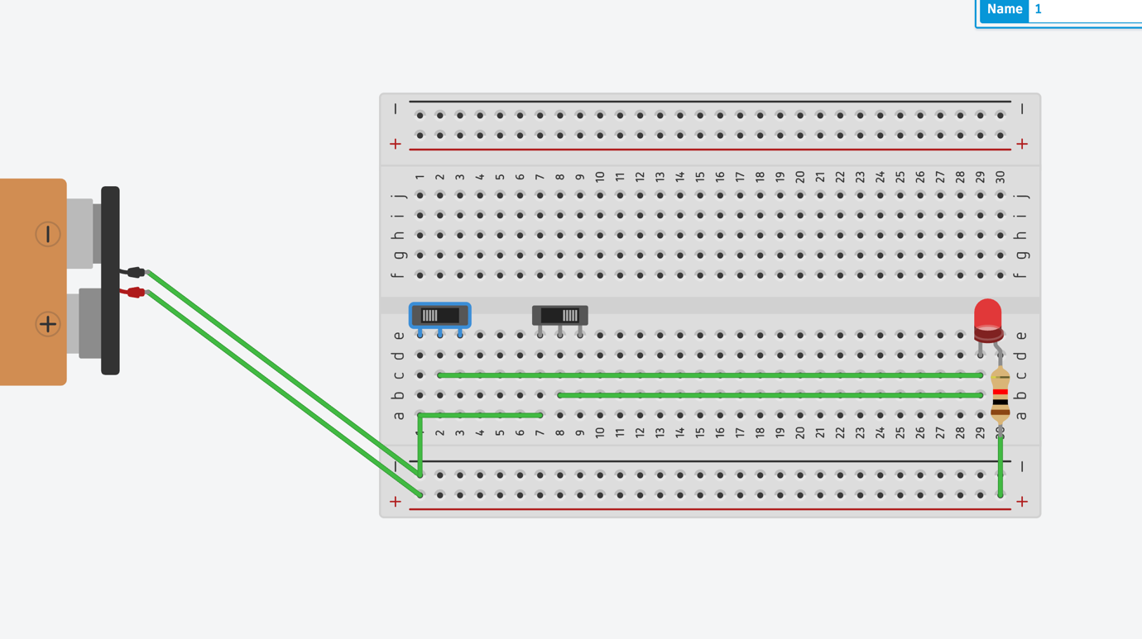

AND Gate
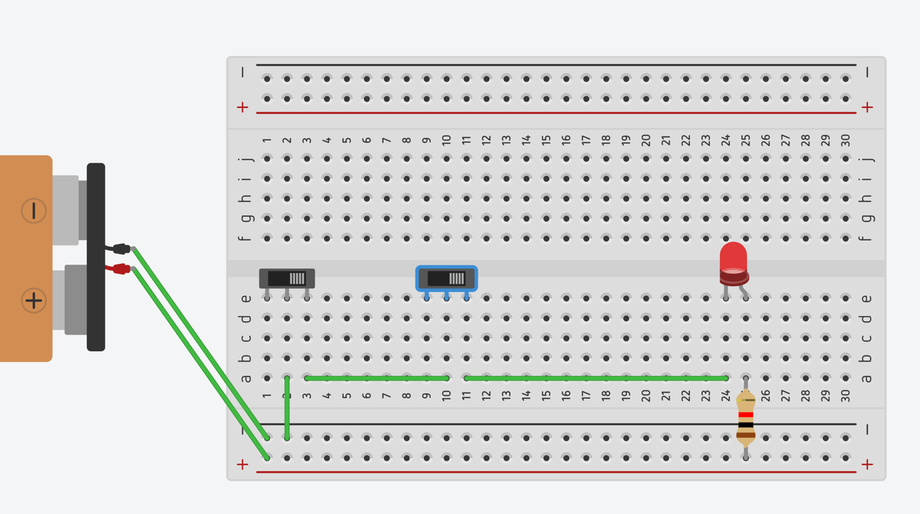

NOT Gate

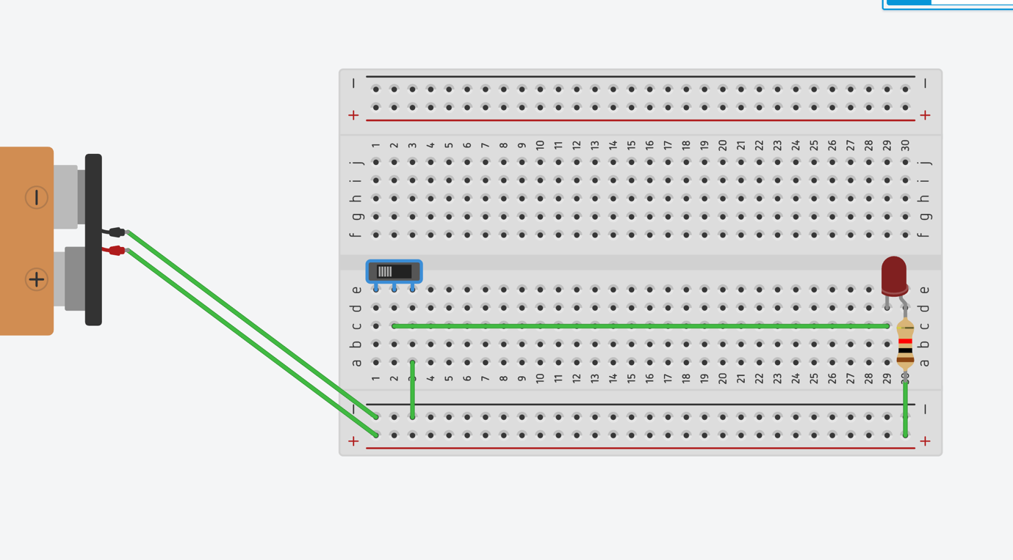

XNOR Gate
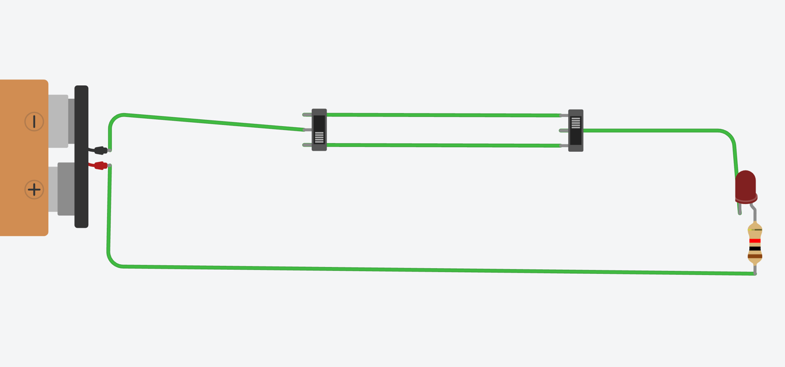

XOR Gate
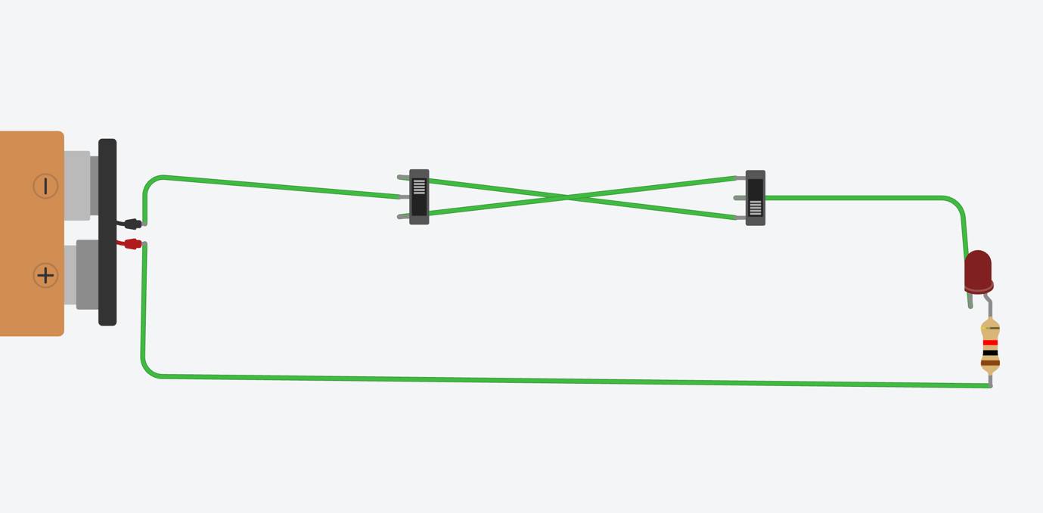

Traffic Signal
https://www.tinkercad.com/things/kO4B5sq2mAZ-traffic?sharecode=i_HPbJLIfzKu8Yaoi1VmzSLGQp7TZutHFrBtQlpaPJk
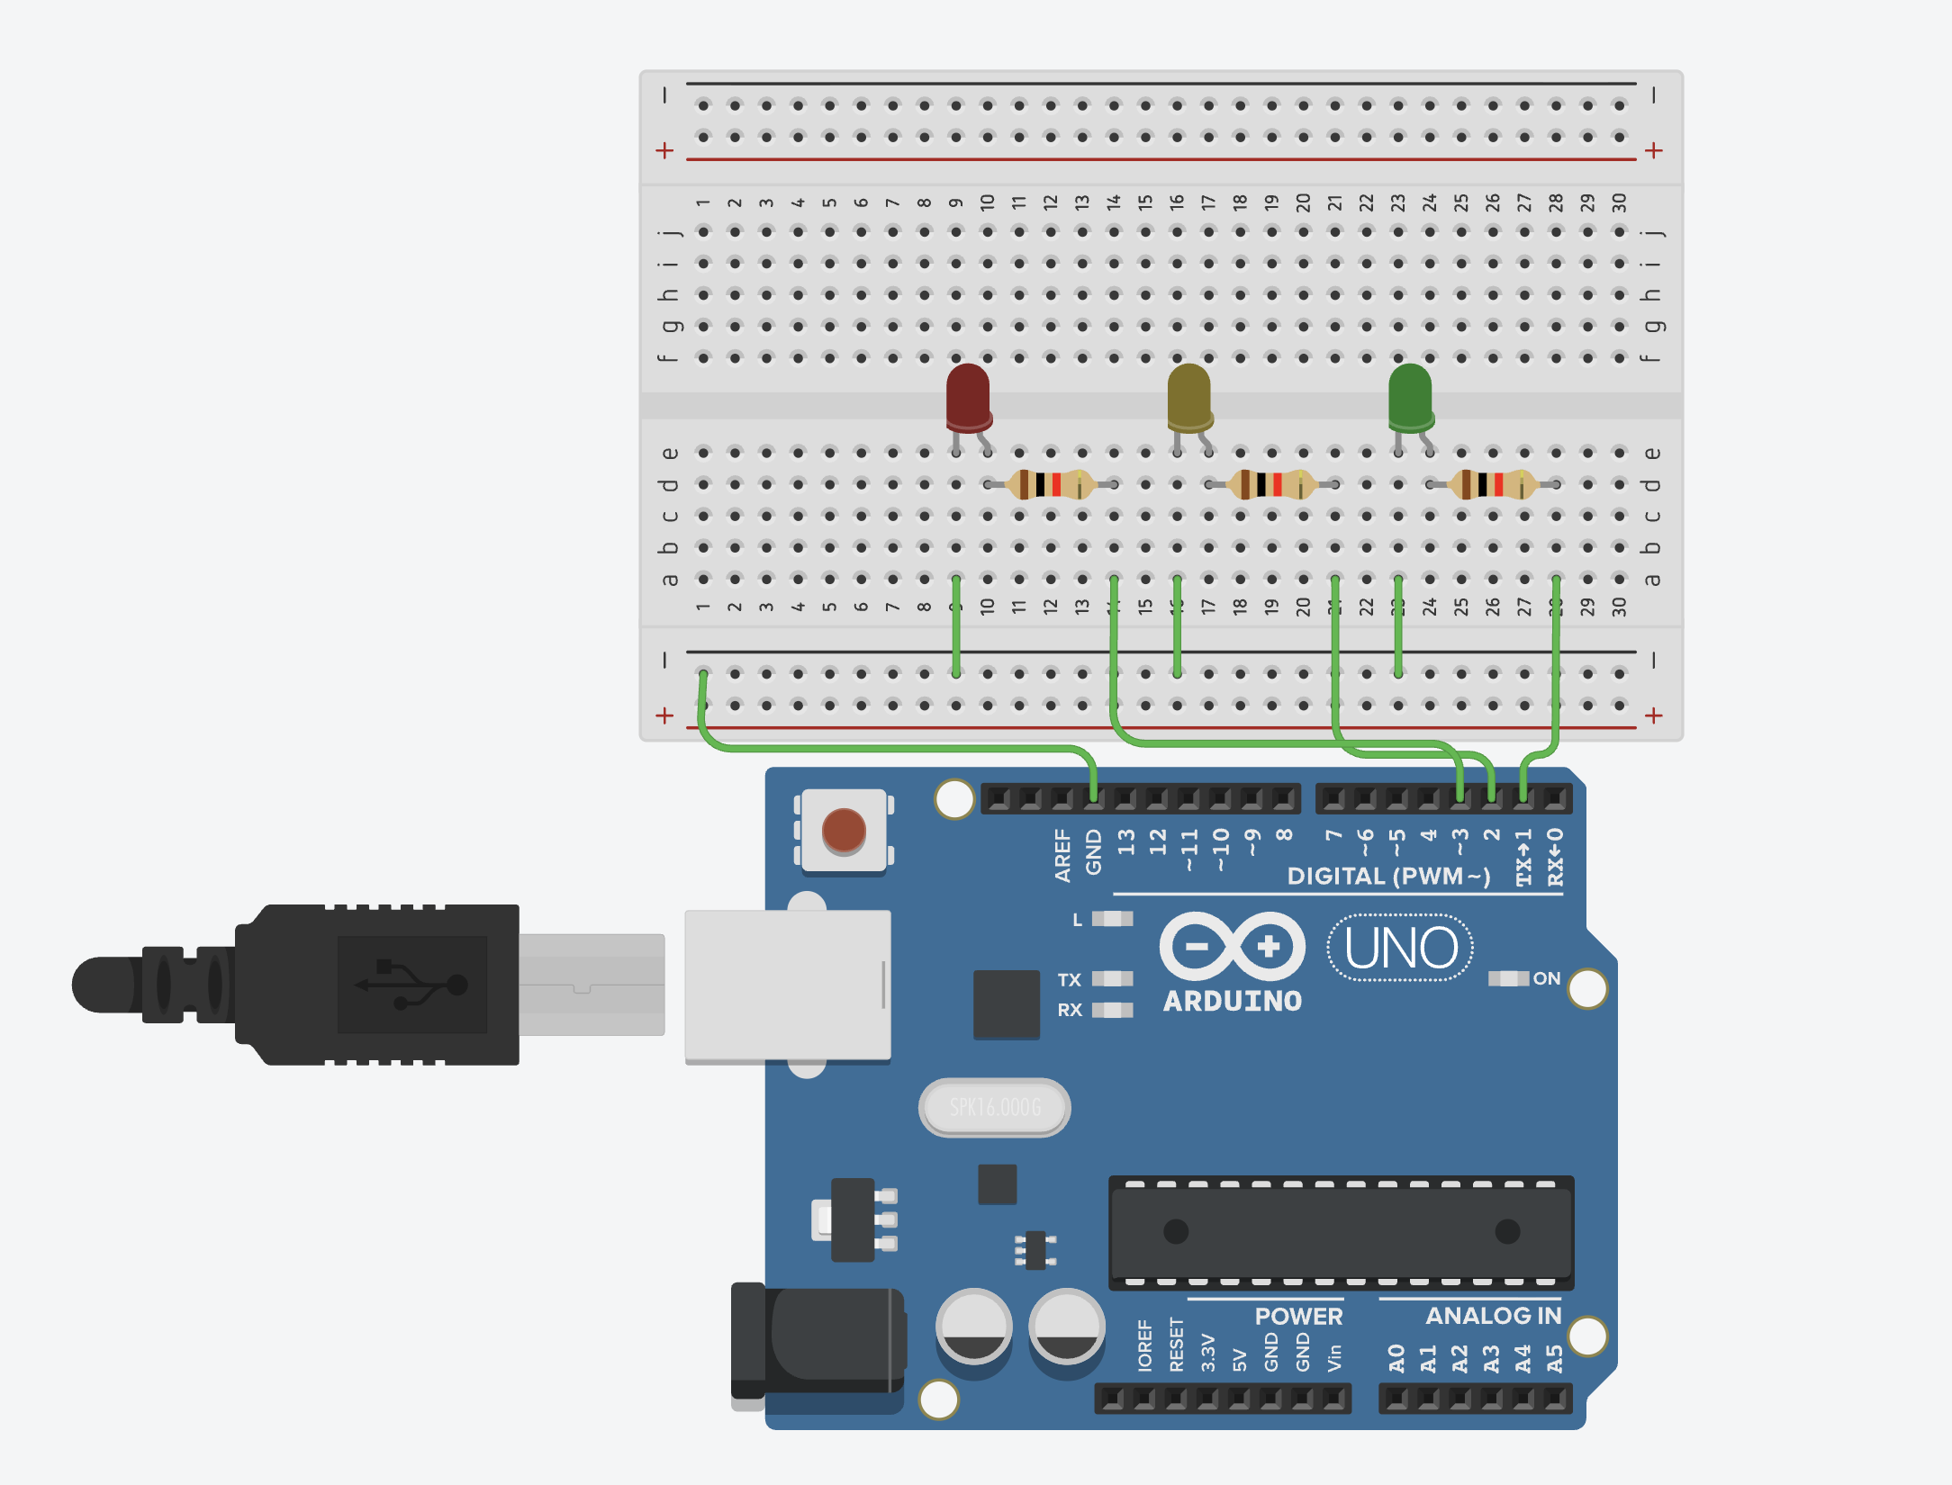
Ultrasound Sensor
https://www.tinkercad.com/things/0qkynZJPdtk-ultrasound?sharecode=HD8BuSp3Y7Capi2C2Vob3zD2gd-O6qrdpsozoual-mg
