**Experiment 04**

**Aim:** Learn use of chmod command and vi text editor.

**The "chmod" command modifies the read, write, and execute permissions of specified files. The octal digits used for assigning permissions are as follows:**

**Octal Digit Permissions Symbolic Display**

**7**  read, write, execute  **rwx**

**6**  read, write **rw-**

**5**  read, execute **r-x**

**4**  read **r--**

**3**  write, execute **-WX**

**2**  write **-W-**

**1**  execute **--X**

**0**  no permissions  **---**

**• Owner is denoted by 'u'.**

**• Group is denoted by 'g'.**

**• Others is denoted by 'o'.**

**Examples**

1. **Using octal notation:**

**• chmod 711 test.sh**

1. **Using symbolic notation:**

**• chmod u+rwx test.sh**

**• chmod go+--x test.sh**

**The "vi text editor" is a powerful text editor available in Unix and Linux systems. It is widely used for editing configuration files and scripts.**

**Basic Modes in vi**

**1. Insert Mode (For writing text)**

• **Press i to enter insert mode.**

**• Start typing the content.**

**2. Command Mode (Default mode)**

**• Used for navigation and executing commands**.

**• Press Esc to return to this mode.**

**3. Last Line Mode (For saving and exiting)**

• **Press Esc, then type: to enter last line mode.**

•**:wq→ Save and exit.**

**Program Case 1:** Creating hello.sh file in a directory with your name and giving permission to user only using chmod command.

**ls**

**mkdir Shourya**

**cd Shourya**

**cat > hello.sh**

**#!/bin/bash**

**echo "Hello World"**

**chmod u+rwx hello.sh**

**./hello.sh**

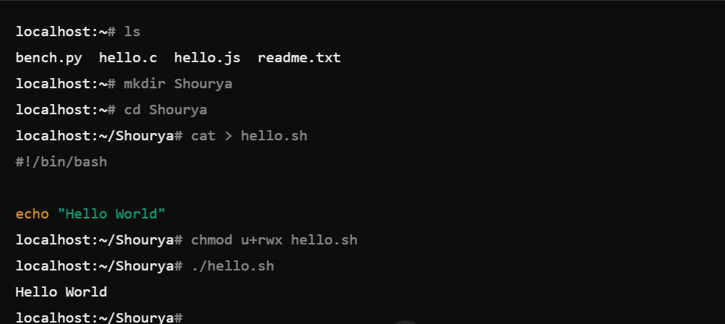

**Program Case 2:** Creating vi text editor file namely test.sh

**vi test.sh**

**i (for start inserting text)**

**#!/bin/bash**

**var1="hello"**

**var2="shourya"**

**echo $varl $var2**

**esc (for escaping insert mode and come back to command mode)**

**:wq(for save and exit)**

**chmod u+rwx test.sh**

**./test.sh**

