QUESTION 1.Write a program to rotate an object by 90 degree in clockwise direction

**ANSWER 1**

#include<graphics.h>

#include<stdio.h>

#include<conio.h>

#include<math.h>

void main()

{

int gd=DETECT,gm;

int pivot_x,pivot_y,x,y;

double degree,radian;

int rotated_point_x,rotated_point_y;

initgraph(&gd,&gm,"C://TURBOC3//BGI");

cleardevice();

printf("\t\t*** ROTATION *** \n");

printf("\n Enter an initial coordinates of the line = ");

scanf("%d %d",&pivot_x,&pivot_y);

printf("\n Enter a final coordinates of the line = ");

scanf("%d %d",&x,&y);

line(pivot_x,pivot_y,x,y);

printf("\n\n Now, Enter a degree = ");

scanf("%lf",&degree);

radian=degree*0.01745;

rotated_point_x=(int)(pivot_x +((x-pivot_x)*cos(radian)-(y-pivot_y)*sin(radian)));

rotated_point_y=(int)(pivot_y +((x-pivot_x)*sin(radian)+(y-pivot_y)*cos(radian)));

setcolor(RED);

line(pivot_x,pivot_y,rotated_point_x,rotated_point_y);

getch();

closegraph();

}

**OUTPUT**

**BEFORE ROTATION**

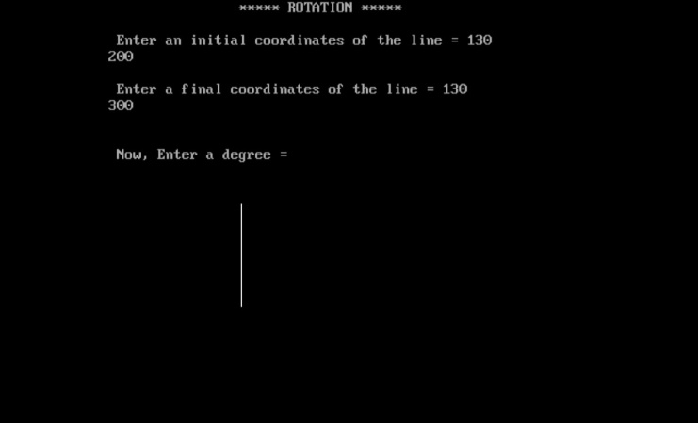

**AFTER ROTATION**

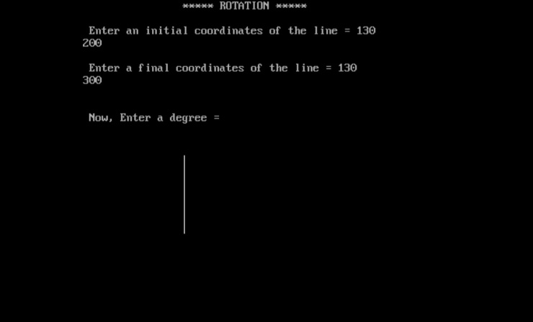

Question 2.Write a program to draw a line using Bresenham’s line generation algorithm.

**ANSWER 2**

#include<stdio.h>

#include<conio.h>

#include<graphics.h>

int main()

{

int gd = DETECT, gm;

int dx, dy, p, end;

float x1, x2, y1, y2, x, y;

initgraph(&gd, &gm, "c:\tc\bgi");

printf("Enter Value of X1: ");

scanf("%f", &x1);

printf("Enter Value of Y1: ");

scanf("%f", &y1);

printf("Enter Value of X2: ");

scanf("%f", &x2);

printf("Enter Value of Y2: ");

scanf("%f", &y2);

dx = abs(x1 - x2);

dy = abs(y1 - y2);

p = 2 * dy - dx;

if(x1 > x2)

{

x = x2;

y = y2;

end = x1;

}

else

{

x = x1;

y = y1;

end = x2;

}

putpixel(x, y, 10);

while(x < end)

{

x = x + 1;

if(p < 0)

{

p = p + 2 * dy;

}

else

{

y = y + 1;

p = p + 2 * (dy - dx);

}

putpixel(x, y, 10);

}

getch();

closegraph();

return 0;

}

**OUTPUT**

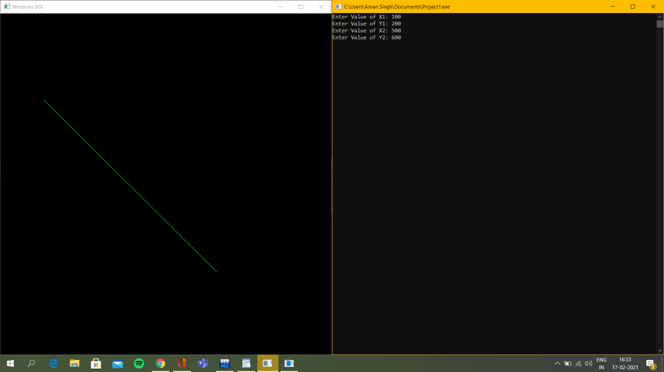

QUESTION 3. Write a program to implement Boundary-fill algorithm.

**ANSWER 3**

#include<graphics.h>

#include<stdio.h>

void boundary_fill(int x, int y, int fill_color, int bound_color)

{

if(getpixel(x,y) != fill_color && getpixel(x,y) != bound_color)

{

putpixel(x,y,fill_color);

delay(1);

boundary_fill(x+1,y,fill_color,bound_color);

boundary_fill(x,y-1,fill_color,bound_color);

boundary_fill(x-1,y,fill_color,bound_color);

boundary_fill(x,y+1,fill_color,bound_color);

boundary_fill(x-1,y-1,fill_color,bound_color);

boundary_fill(x+1,y-1,fill_color,bound_color);

boundary_fill(x-1,y+1,fill_color,bound_color);

boundary_fill(x+1,y+1,fill_color,bound_color);

}

}

int main( )

{

int gd=DETECT,gm;

initgraph(&gd,&gm,"");

line(100,100,250,100);

line(250,100,250,250);

line(250,250,400,250);

line(400,250,400,400);

line(248,400,400,400);

line(248,250,248,400);

line(100,100,100,250);

line(100,250,248,250);

boundary_fill(150,150,RED,WHITE);

getch( );

closegraph( );

}

**OUTPUT**

