Question 2.Write a program to draw a line using Bresenham’s line generation algorithm.

**ANSWER 2**

#include<stdio.h>

#include<conio.h>

#include<graphics.h>

int main()

{

int gd = DETECT, gm;

int dx, dy, p, end;

float x1, x2, y1, y2, x, y;

initgraph(&gd, &gm, "c:\tc\bgi");

printf("Enter Value of X1: ");

scanf("%f", &x1);

printf("Enter Value of Y1: ");

scanf("%f", &y1);

printf("Enter Value of X2: ");

scanf("%f", &x2);

printf("Enter Value of Y2: ");

scanf("%f", &y2);

dx = abs(x1 - x2);

dy = abs(y1 - y2);

p = 2 * dy - dx;

if(x1 > x2)

{

x = x2;

y = y2;

end = x1;

}

else

{

x = x1;

y = y1;

end = x2;

}

putpixel(x, y, 10);

while(x < end)

{

x = x + 1;

if(p < 0)

{

p = p + 2 * dy;

}

else

{

y = y + 1;

p = p + 2 * (dy - dx);

}

putpixel(x, y, 10);

}

getch();

closegraph();

return 0;

}

**OUTPUT**

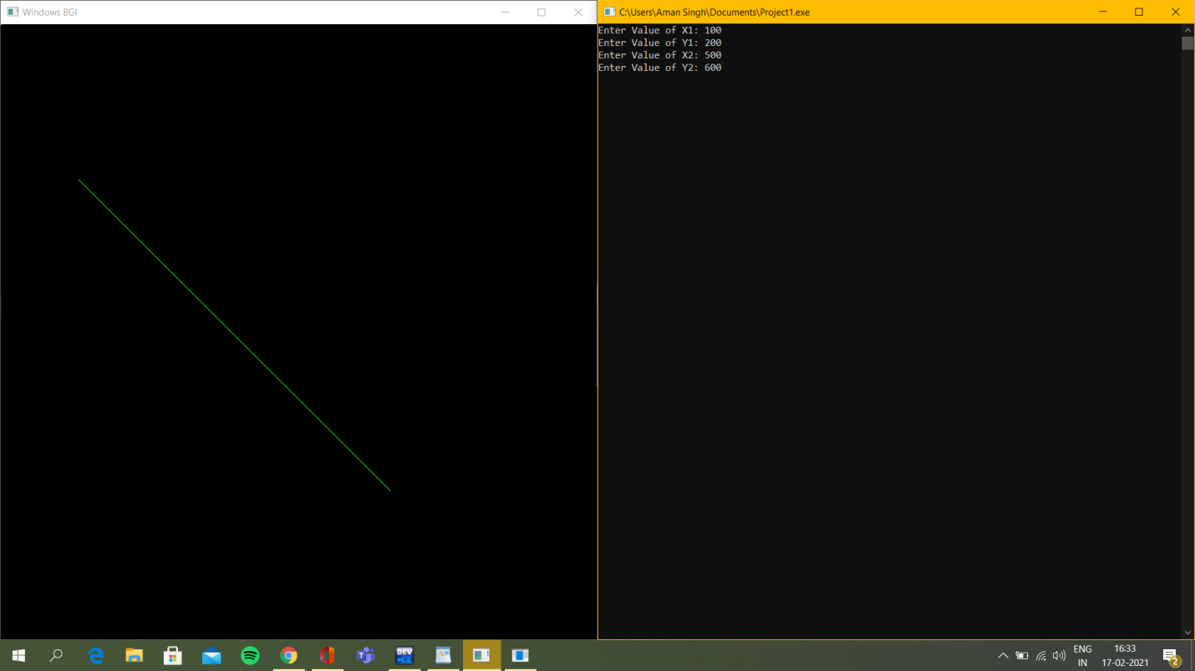

QUESTION 3. Write a program to implement Boundary-fill algorithm.

**ANSWER 3**

#include<graphics.h>

#include<stdio.h>

void boundary_fill(int x, int y, int fill_color, int bound_color)

{

if(getpixel(x,y) != fill_color && getpixel(x,y) != bound_color)

{

putpixel(x,y,fill_color);

delay(1);

boundary_fill(x+1,y,fill_color,bound_color);

boundary_fill(x,y-1,fill_color,bound_color);

boundary_fill(x-1,y,fill_color,bound_color);

boundary_fill(x,y+1,fill_color,bound_color);

boundary_fill(x-1,y-1,fill_color,bound_color);

boundary_fill(x+1,y-1,fill_color,bound_color);

boundary_fill(x-1,y+1,fill_color,bound_color);

boundary_fill(x+1,y+1,fill_color,bound_color);

}

}

int main( )

{

int gd=DETECT,gm;

initgraph(&gd,&gm,"");

line(100,100,250,100);

line(250,100,250,250);

line(250,250,400,250);

line(400,250,400,400);

line(248,400,400,400);

line(248,250,248,400);

line(100,100,100,250);

line(100,250,248,250);

boundary_fill(150,150,RED,WHITE);

getch( );

closegraph( );

}

**OUTPUT**

