Program Structure and Algorithm

Assignment 1 Random Walk

Shouting Lyu

001822094

Following the instruction of the lecture, I designed my experiments and implemented it in my code. First, after many tries, I found that the final positions of the program vacillate unstably (Figure 1). Hence, from my perspective, it is more reasonable to use the average distance calculated from the whole test for a certain n while analyzing the results. Generally, I did several tests for different n and L. In details, to optimize the results, I run 5 times for each certain value of n (10, 20, 40, 80, 160, 320, 640, 1280, 2560, 5120)In addition, I repeated running the program with different L(1, 2, 4, 8, 16).

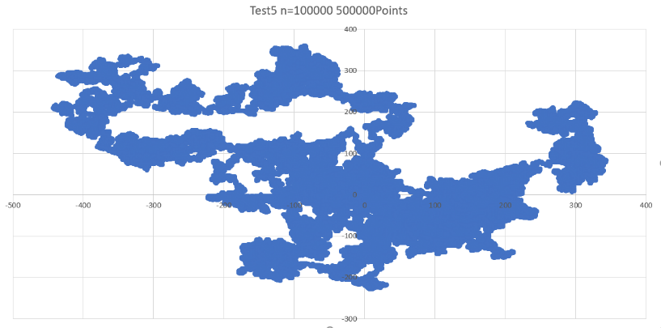

Figure

|  |  |  |  |  |  |
| --- | --- | --- | --- | --- | --- |
| L | 1 | 2 | 4 | 8 | 16 |
| Slope | 0.55 | 0.448 | 0.493 | 0.494 | 0.455 |
| Intersection | -1.288 | 0.726 | 1.415 | 2.185 | 3.517 |
| R-square | 0.978 | 0.941 | 0.989 | 0.982 | 0.933 |
| 2intersection | 0.712 | 1.654 | 2.666 | 4.547 | 11.447 |

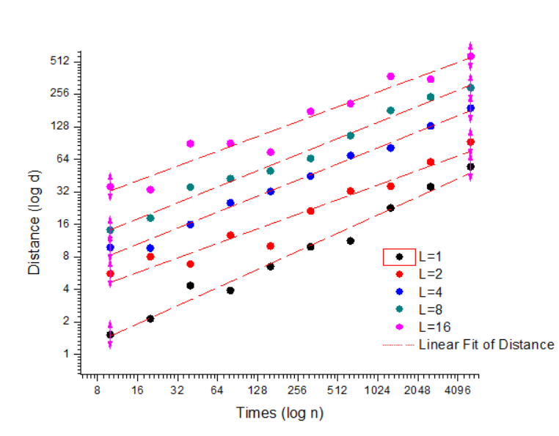Then, the graphs below clearly show the relationships between n, L and distance. As shown in the Figure 2, the x axis represents times which means the value of n, and the y axis represents the average distance between the current place to the (0,0) and they are both under by logarithm transformation.

Figure Table

Since the average slope is 0.488 and the intersection of the linear fit increases when L increases, the relationship should be d = f(L) * N0.488. Then, calculating the 2intersection, we could get the f(L)=0.697L - 0.121. Because the intersection of linear fit of f(L) is small, we could make a theory that f(L) approximately monotonically increase with L.

In conclusion, the final relationship should be d = (0.697L-0.121) * N0.488, if we make an approximation of it, then the relationship is d = 0.7L * N0.5.

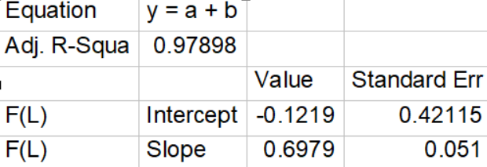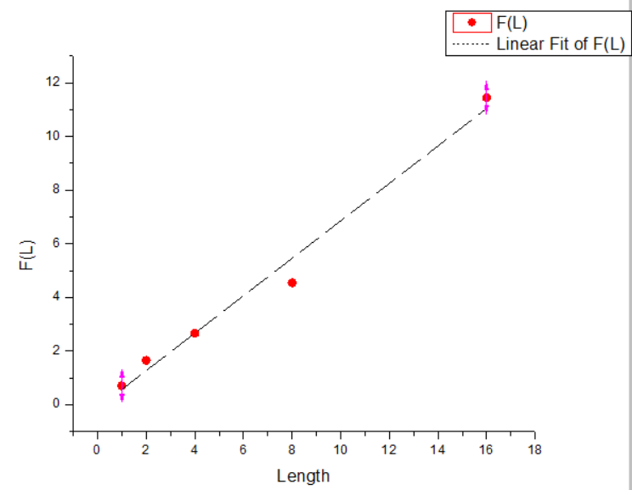

Table 2

Figure 3

Finally, there are some evidence of passing the Junit tests shown below.

