**Introduction**

My project is a short podcast made by myself and some friends. Over the summer, a few of my friends and I picked up cycling. I interview two friends on a couple of cycling related experiences. The format of the interview is a quick question and answer. This paper may be best read as a pdf given the images following.

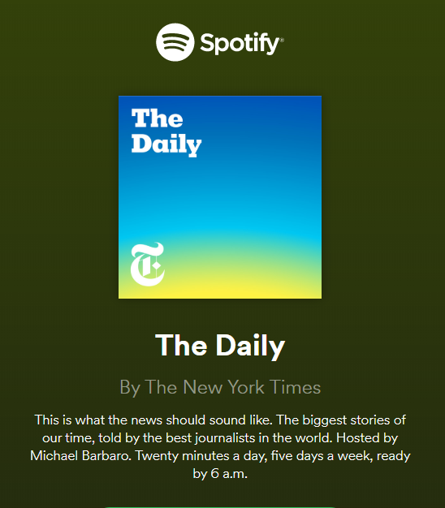

I was inspired to make a podcast because I listen to podcasts and because of my experiences making “Let’s Play” videos. My primary inspiration is “The Daily” from The New York Times, hosted by Michael Barbaro, a current events podcast. From a technical perspective, Michael’s podcast is quite complex. He brings in many guests on his podcast, there are intros & outros, he’ll bring on snippets from press releases / news channels. Most importantly, must have been quite a challenge for Michael’s team to create a balanced and crisp mix.

**Motivation**

I felt that making a podcast would generate a practical and immediate takeaway. In the past I ran a YouTube channel making video game “Let’s Play” videos, an edited commentary video of sorts. Creating a podcast addresses some useful elements such as proper mixing, creating audio mixes, transitioning between pieces and creating intro/outro or other minor sound effects. While I don’t make videos anymore, I’d like to in the future. In the past, I never had good audio quality, but I am also just making videos casually. I’d like to get into two things, making more formal videos, and making some simple “retrowave” music and I believe this project touches upon both.

**Goals**

I want to make a concise podcast that focuses on clarity of the speakers and accentuates the subject matter via sound effects and the intro and outro segments.

Creating a clear and balanced recording mix is my primary goal. I consider this a non-trivial task since I must consider how to first, construct good recording spaces with what I have and how-to post-process what I have. I am recording in various places on campus each of which have certain ambient dynamics that I must consider. In post processing, I must consider how to normalize the various recordings I have. In practice, I would be satisfied with a mix that never detracts from the content. Given the nature of the recording environment, and my limited access to quality recording equipment.

My second and third goals would be to create complementary sound pieces and an ambient soundscape to immerse the audience. Firstly, a small intro and outro piece MIDI instrument piece would be a good exercise. There is an immediate takeaway in making transitions or branding for my YouTube projects. I am a computing sciences student, my expectations for creating a musically complex track are a bit limited. I would be happy with a short catchy track. Secondly, I thought of making an ambient soundscape in some parts of the podcast to help set the mood. In assignment two I made a biking soundscape, the sound of biking through the city. From “The Daily” I noticed their use of ambiance, how it can be great by to set the mood to subjects and that background sounds to the discussion can be immersive. This poses an audio editing task and an exercise on creating a balanced mix with the actual discussion.

**Development**

My overall workflow consisted of three main components, recording, structuring and processing, and enhancement. I decided to record things upfront since my project required some participants. I decided not to limit the discussion timewise, I wanted to capture as much as possible and edit away if necessary.

**Recording**

The two participants had similar schedules so I could book a single one-time period for rehearsal and recording, having two participants offered some risk mitigation This was done December 2nd. I decided to record more than enough content to buffer against this format of recording. See the score section for the questions recorded. With two participants I had to option to be selective in composing the podcast. I was happy with the content coverage, though the recording space was slightly noisier than expected. We recorded around 8:00pm in the computing sciences building, no one was around though a loose air vent caused some interference.

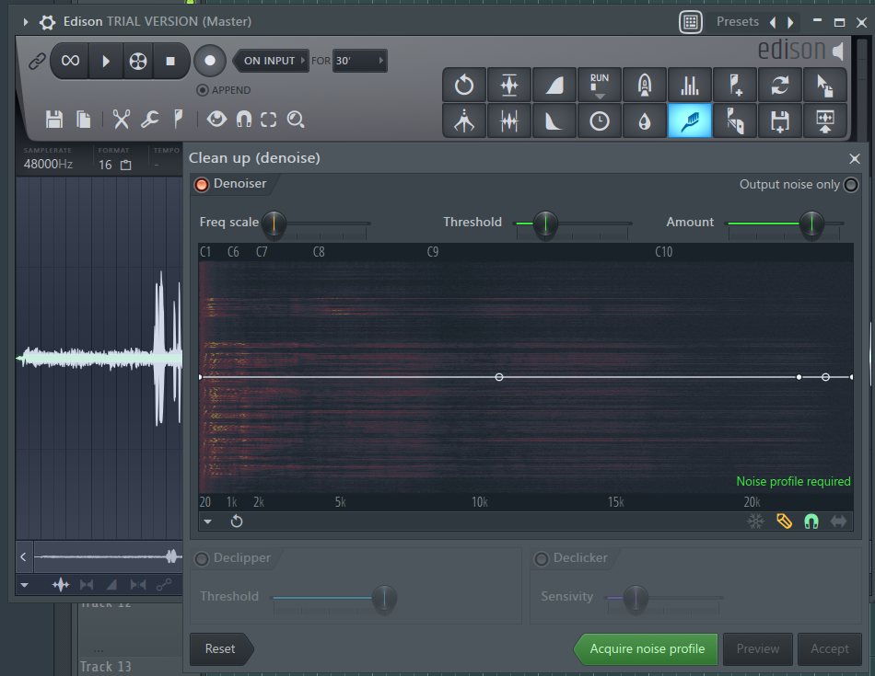

This resulted in eight dialog tracks that compose the podcast. I used FL Studio’s Edison preprocessing module to these recordings. I apply noise reduction and normalization. I found it better to re-record some of my intros at home using a different mic. I applied the same processing for those takes as well.

**Structuring**

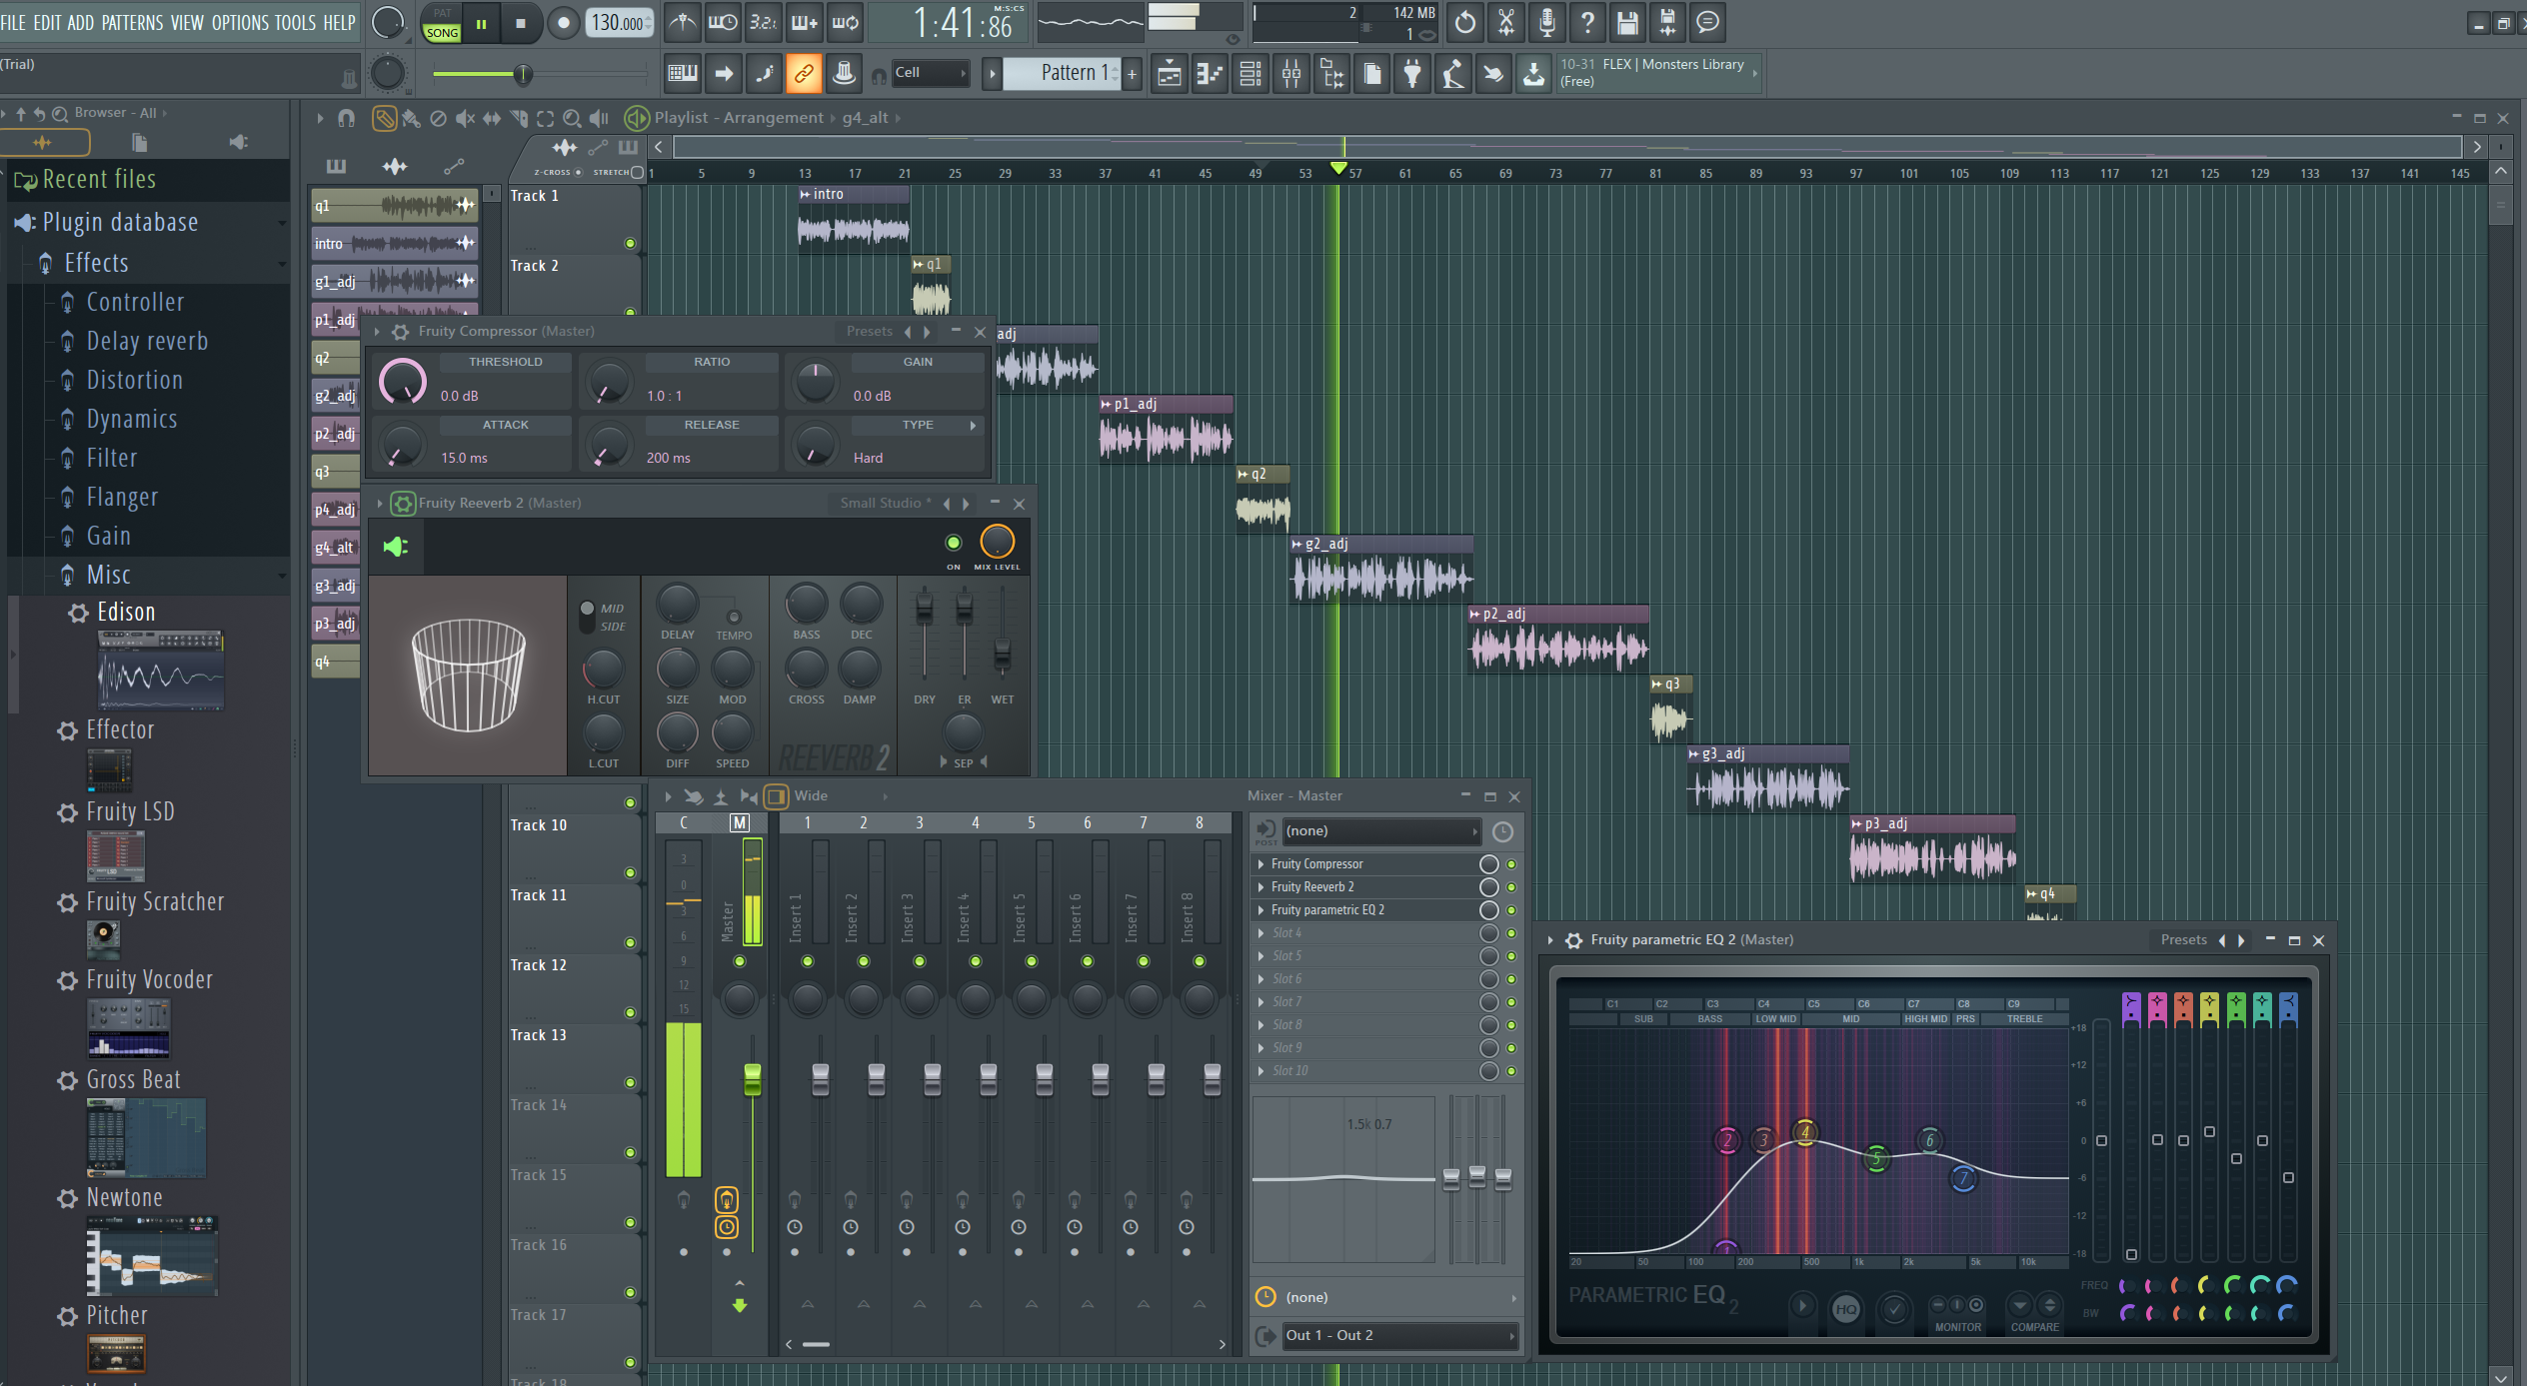

I planned out what I could at home using FL studio as I don’t own a Mac or Logic Pro X. I came out with the following structure, and I experimented with a couple of basic effects that could be easily reproduced in Logic. I decided to add a compressor to balance out differences in speaking volume and added some satisfying reverb. Lastly, I test out a couple of EQ settings to add clarity to the mix and to give volume to the dialog.

**Score**

1. What piqued your interest in cycling?
2. How was cycling changed your life?
3. Could you describe your bike and how you choose it?
4. What are your cycling plans and/or goals for the cycling season next year?

**Technical Aspects**

I had two recording options, I could use my Blue Yeti Pro microphone at home or the embedded microphone of my phone, the OnePlus 5T. I decided to use my phone’s mic due to the portability of it considering that I would be recording on campus. I used this for assignment two where it was noted for surprisingly good audio quality. This records 32-bit, 48000 Hz, .WAV files which gave me enough quality. I was not able to trace the technical specifications due to the nature of the microphone being a Chinese mobile phone component. I felt that the mic was more suited for recording ambient sounds for assignment two. The mic recordings had a thin sound that I attribute to either the nature of mic profile or some innate processing done by my phone (likely an aggressive noise cancellation scheme).

Contrasting this to my desk mic, the Blue Yeti pro is a three-sensor condenser microphone that supports various patterns including cardioid, stereo, omnidirectional, and bi-directional. For this podcast, I considered using the cardioid or bi-directional modes. I use this mic with a small DAC mostly to supply the phantom power required. Travel considerations aside, this type of condenser microphones is quite sensitive, perhaps too sensitive for recording in a public space. At home I use the minimal gain setting and even then, it picks up considerable ambient noise

.

**Conclusion**