(一) 執行結果

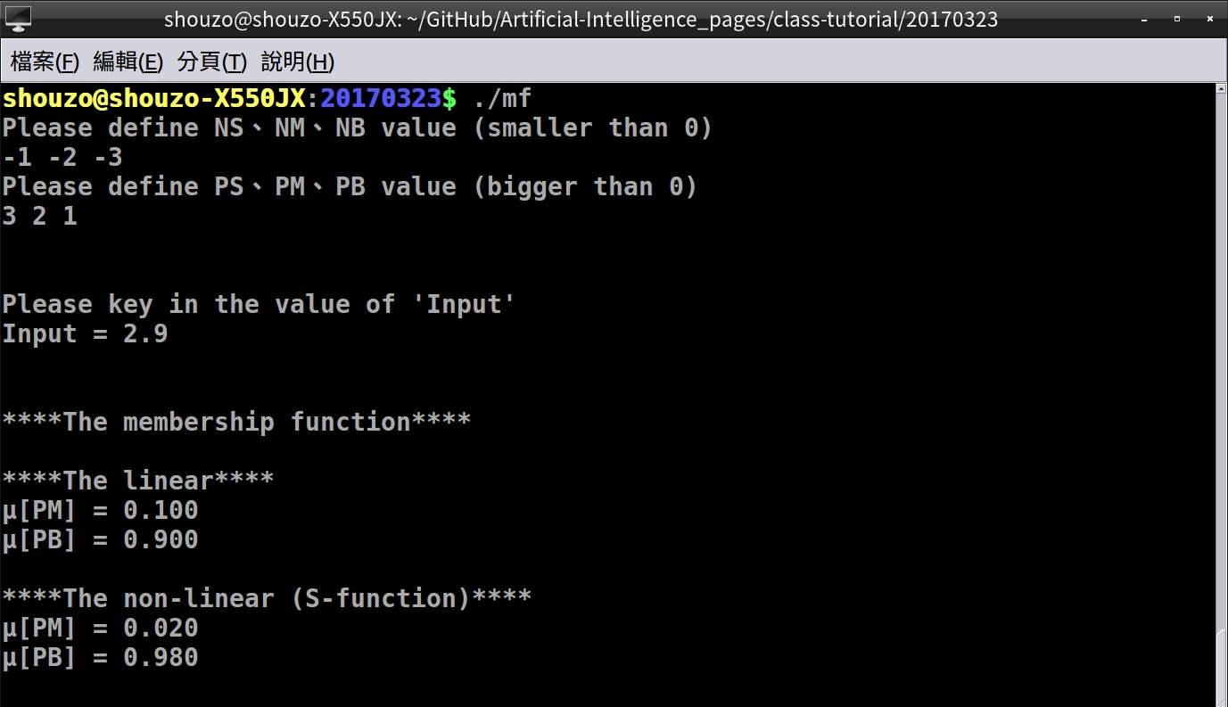

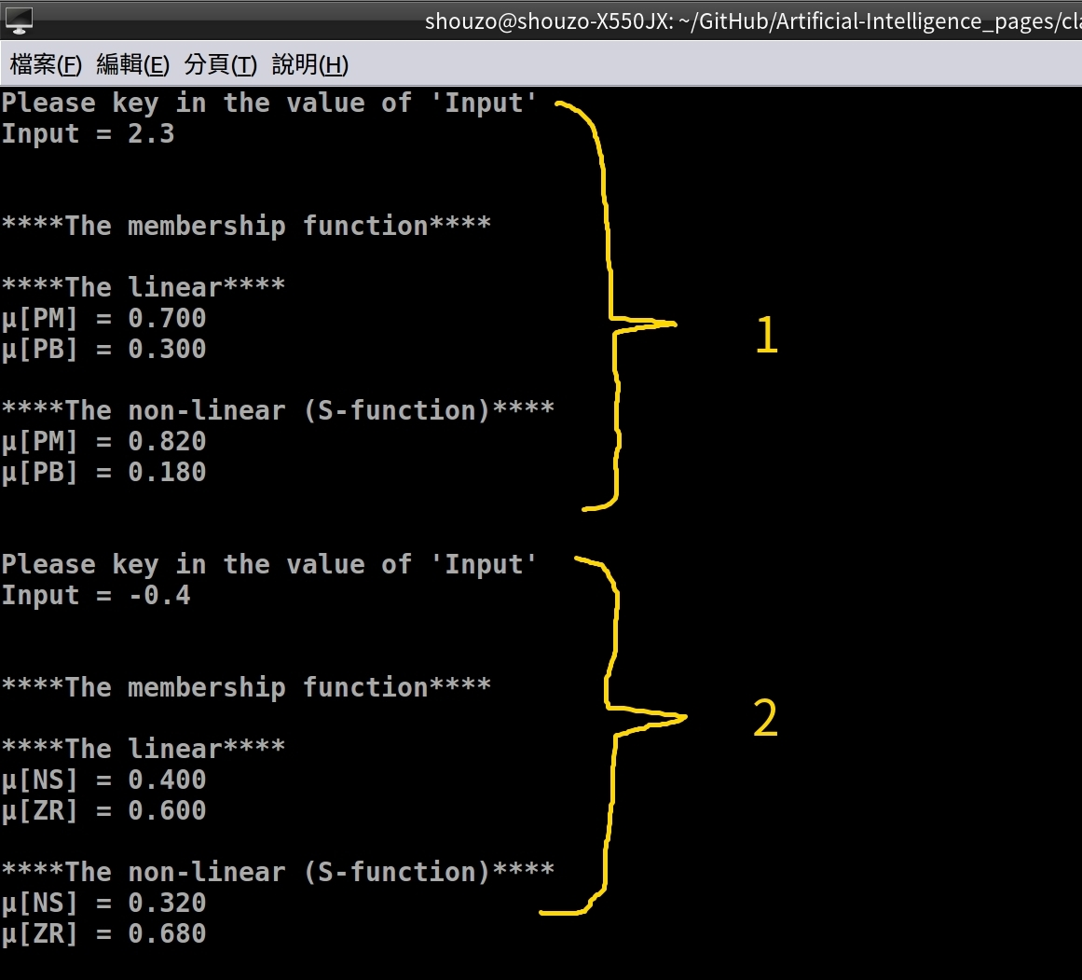
(二) 程式碼 - C語言
#include <stdlib.h>
#include <stdio.h>

int main(void) {
int i = 0, j = 0; // Set loop
float mf[7], tmp = .0, input = .0, sa = .0, ua = .0, ub = .0;
char name[7][3] = {"NB", "NM", "NS", "ZR", "PS", "PM", "PB"};

/* Key the value of name */
printf("Please define NS、NM、NB value (smaller than 0)\n");
for (i = 0; i < 3; i++) {
scanf("%f", &mf[i]);
}

printf("Please define PS、PM、PB value (bigger than 0)\n");
for (i = 3; i < 6; i++) {
scanf("%f", &mf[i]);
}

mf[6] = 0; // Set the ZR value

/* Sort the numbers */
for (i = 0; i < 7; i++) {
for (j = 0; j < 7; j++) {
if ((mf[j] > mf[i])) {
tmp = mf[i];
mf[i] = mf[j];
mf[j] = tmp;
}
}
}

/* The entry */
while(1) {
/* Key the value of x */
printf("\n\nPlease key in the value of 'Input'\n");
printf("Input = ");
scanf("%f", &input);

/* Calculate the linear μ */
printf("\n\n****The membership function****\n");
for (i = 0; i < 7; i++) {
// input = mf
if (((input == mf[i]))) {
printf("μ[%s] = %.f\n", name[i], (mf[i] / mf[i]));
break;
}

// input bigger than the max's mf
else if ((input > mf[6])) {
printf("μ[%s] = %.f\n", name[6], (mf[6] / mf[6]));
break;
}
// input smaller than the min's mf
else if ((input < mf[0])) {
printf("μ[%s] = %.f\n", name[0], (mf[0] / mf[0]));
break;
}

// Calculate...
else if ((input > mf[i]) && (input < mf[i+1])) {
/* linear area */
printf("\n****The linear****\n");
ua = (1 - (mf[i] - input) / (mf[i] - mf[i+1]));
ub = (1 - (input - mf[i+1]) / (mf[i] - mf[i+1]));
printf("μ[%s] = %.3f\n", name[i], ua);
printf("μ[%s] = %.3f\n", name[i+1], ub);

/* non-linear area */
printf("\n****The non-linear (S-function)****\n");
if (input < ((mf[i] + mf[i+1]) / 2)) {
sa = (((input - mf[i]) / (mf[i+1] - mf[i])));
ua = 1 - (2 * sa * sa);
ub = 1 - ua;
printf("μ[%s] = %.3f\n", name[i], ua);
printf("μ[%s] = %.3f\n", name[i+1], ub);
}

else if ((input >= ((mf[i] + mf[i+1]) / 2)) && (input < mf[i+1])) {
sa = (((input - mf[i+1]) / (mf[i+1] - mf[i])));
ua = (2 * sa * sa);
ub = 1 - ua;
printf("μ[%s] = %.3f\n", name[i], ua);
printf("μ[%s] = %.3f\n", name[i+1], ub);
}
break;
}
}
}
return 0;
}

