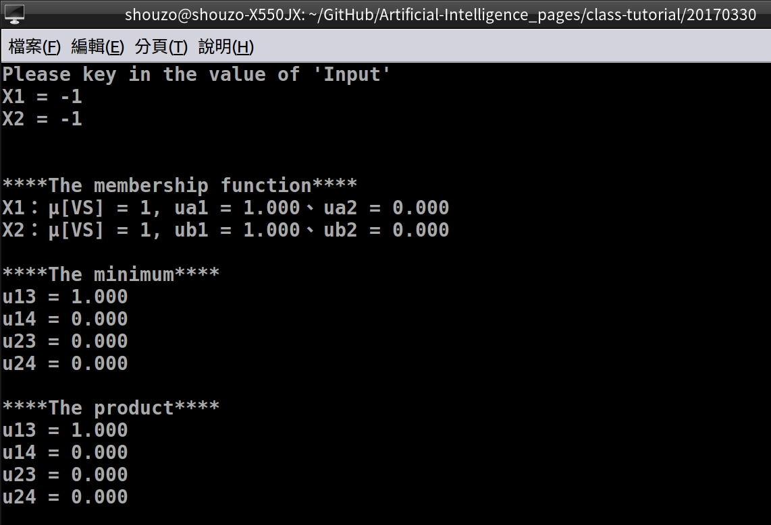
(一) 執行結果
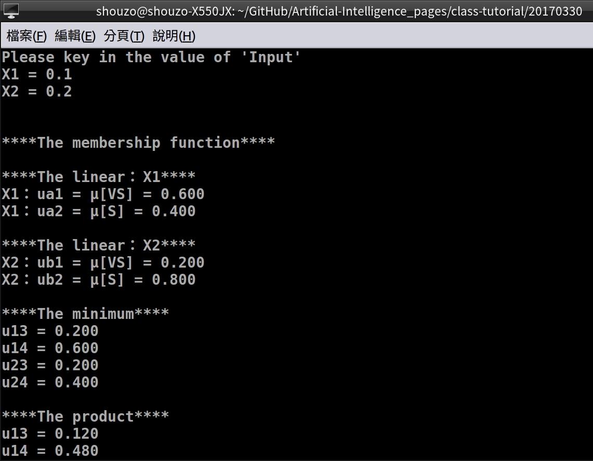

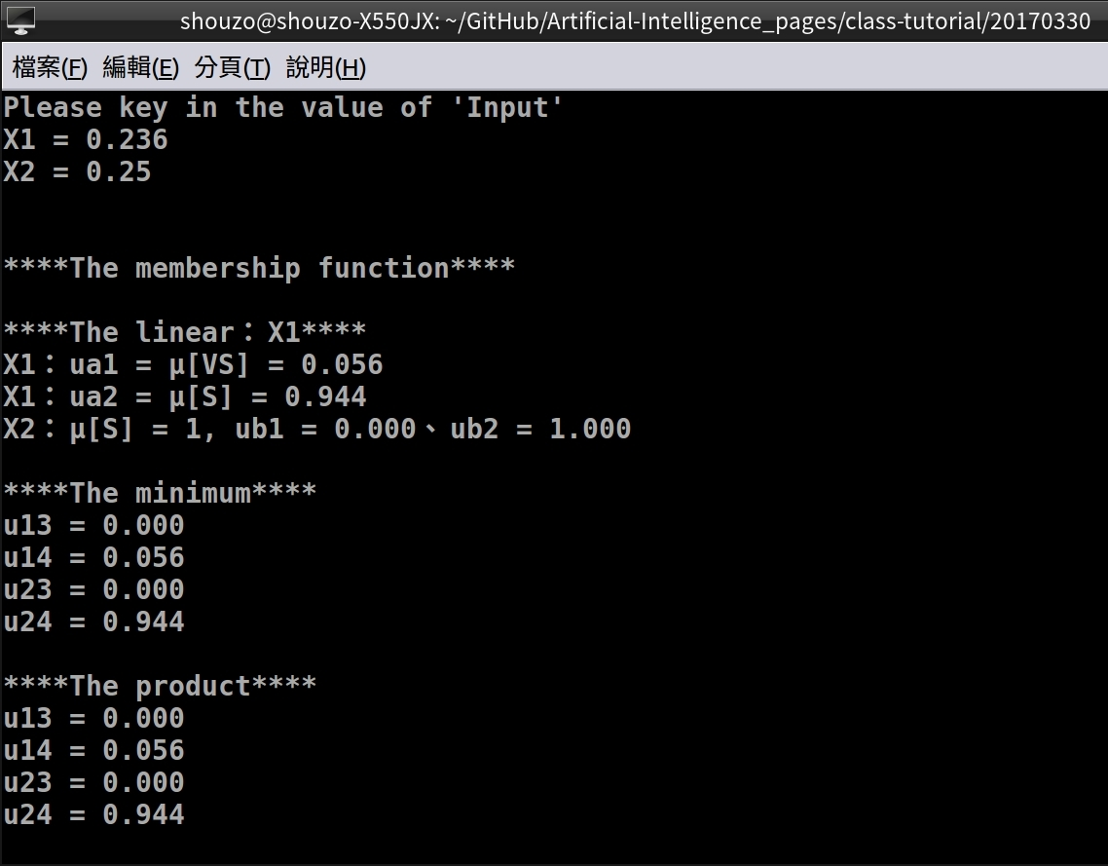
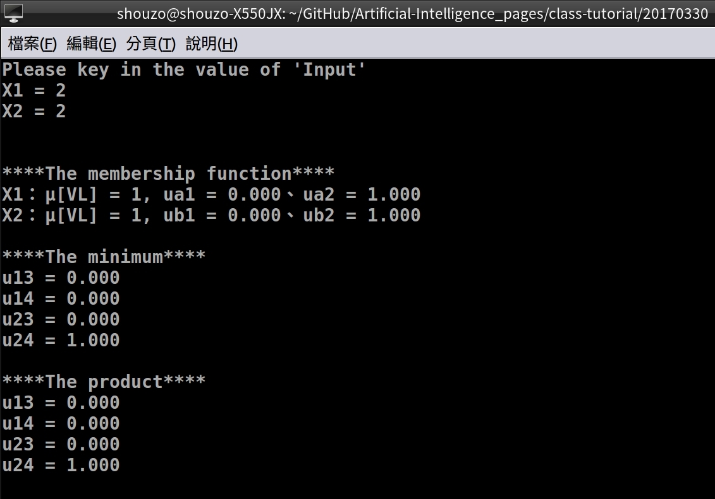

(二) 程式碼 - C語言
#include <stdlib.h>
#include <stdio.h>

int main(void) {
int i = 0, j = 0; // Set loop
float mf[5] = {0, 0.25, 0.5, 0.75, 1};
float X1 = 0, X2 = 0; // Input X1, X2
float ua1 = .0, ua2 = .0; // for X1
float ub1 = .0, ub2 = .0; // for X2
float u13 = .0, u14 = .0, u23 = .0, u24 = .0;
char name[5][3] = {"VS", "S", "M", "L", "VL"};

/* The entry */
while (1) {
/* Initial value */
ua1 = .0, ua2 = .0;
ub1 = .0, ub2 = .0;
u13 = .0, u14 = .0, u23 = .0, u24 = .0;

/* Key the value of x */
printf("\n\nPlease key in the value of 'Input'\n");
printf("X1 = "); scanf("%f", &X1);
printf("X2 = "); scanf("%f", &X2);

/* Calculate the linear μ */
printf("\n\n****The membership function****\n");
for (i = 0; i < 5; i++) {
// input = mf
if (((X1 == mf[i]))) {
ua1 = .0; ua2 = 1.;
printf("X1：μ[%s] = 1, ua1 = %.3f、ua2 = %.3f\n", name[i], ua1, ua2);
}
if (((X2 == mf[i]))) {
ub1 = .0; ub2 = 1.;
printf("X2：μ[%s] = 1, ub1 = %.3f、ub2 = %.3f\n", name[i], ub1, ub2);
break;
}

// input bigger than the max's mf
if ((X1 > mf[4])) {
ua1 = .0; ua2 = 1.;
printf("X1：μ[%s] = 1, ua1 = %.3f、ua2 = %.3f\n", name[4], ua1, ua2);
}
if ((X2 > mf[4])) {
ub1 = .0; ub2 = 1.;
printf("X2：μ[%s] = 1, ub1 = %.3f、ub2 = %.3f\n", name[4], ub1, ub2);
break;
}

// input smaller than the min's mf
if ((X1 < mf[0])) {
ua1 = 1.; ua2 = .0;
printf("X1：μ[%s] = 1, ua1 = %.3f、ua2 = %.3f\n", name[0], ua1, ua2);
}
if ((X2 < mf[0])) {
ub1 = 1.; ub2 = .0;
printf("X2：μ[%s] = 1, ub1 = %.3f、ub2 = %.3f\n", name[0], ub1, ub2);
break;
}

// Calculate (The linear)...
if ((X1 > mf[i]) && (X1 < mf[i+1])) {
printf("\n****The linear：X1****\n");
ua1 = (1 - (mf[i] - X1) / (mf[i] - mf[i+1]));
ua2 = (1 - (X1 - mf[i+1]) / (mf[i] - mf[i+1]));
printf("X1：ua1 = μ[%s] = %.3f\n", name[i], ua1);
printf("X1：ua2 = μ[%s] = %.3f\n", name[i+1], ua2);
}
if ((X2 > mf[i]) && (X2 < mf[i+1])) {
printf("\n****The linear：X2****\n");
ub1 = (1 - (mf[i] - X2) / (mf[i] - mf[i+1]));
ub2 = (1 - (X2 - mf[i+1]) / (mf[i] - mf[i+1]));
printf("X2：ub1 = μ[%s] = %.3f\n", name[i], ub1);
printf("X2：ub2 = μ[%s] = %.3f\n", name[i+1], ub2);
break;
}
}

// Get the minimun...
printf("\n****The minimum****\n");
u13 = (ua1 < ub1 ? ua1 : ub1); u14 = (ua1 < ub2 ? ua1 : ub2);
u23 = (ua2 < ub1 ? ua2 : ub1); u24 = (ua2 < ub2 ? ua2 : ub2);
printf("u13 = %.3f\n", u13); printf("u14 = %.3f\n", u14);
printf("u23 = %.3f\n", u23); printf("u24 = %.3f\n", u24);

// Get the product...
printf("\n****The product****\n");
u13 = ua1 * ub1; u14 = ua1 * ub2;
u23 = ua2 * ub1; u24 = ua2 * ub2;
printf("u13 = %.3f\n", u13); printf("u14 = %.3f\n", u14);
printf("u23 = %.3f\n", u23); printf("u24 = %.3f\n", u24);
}
return 0;
}

