Inkubate Platform Feedback
12-24-14
David Bass - Reviewer

Author Dashboard Feedback

Main Dashboard

- We need to switch the date from day, month, year sequence to month, day, year sequence. This is displayed throughout the entire UI. We should also consider making the date numeric (e.g., 12/24/14)
[DONE]
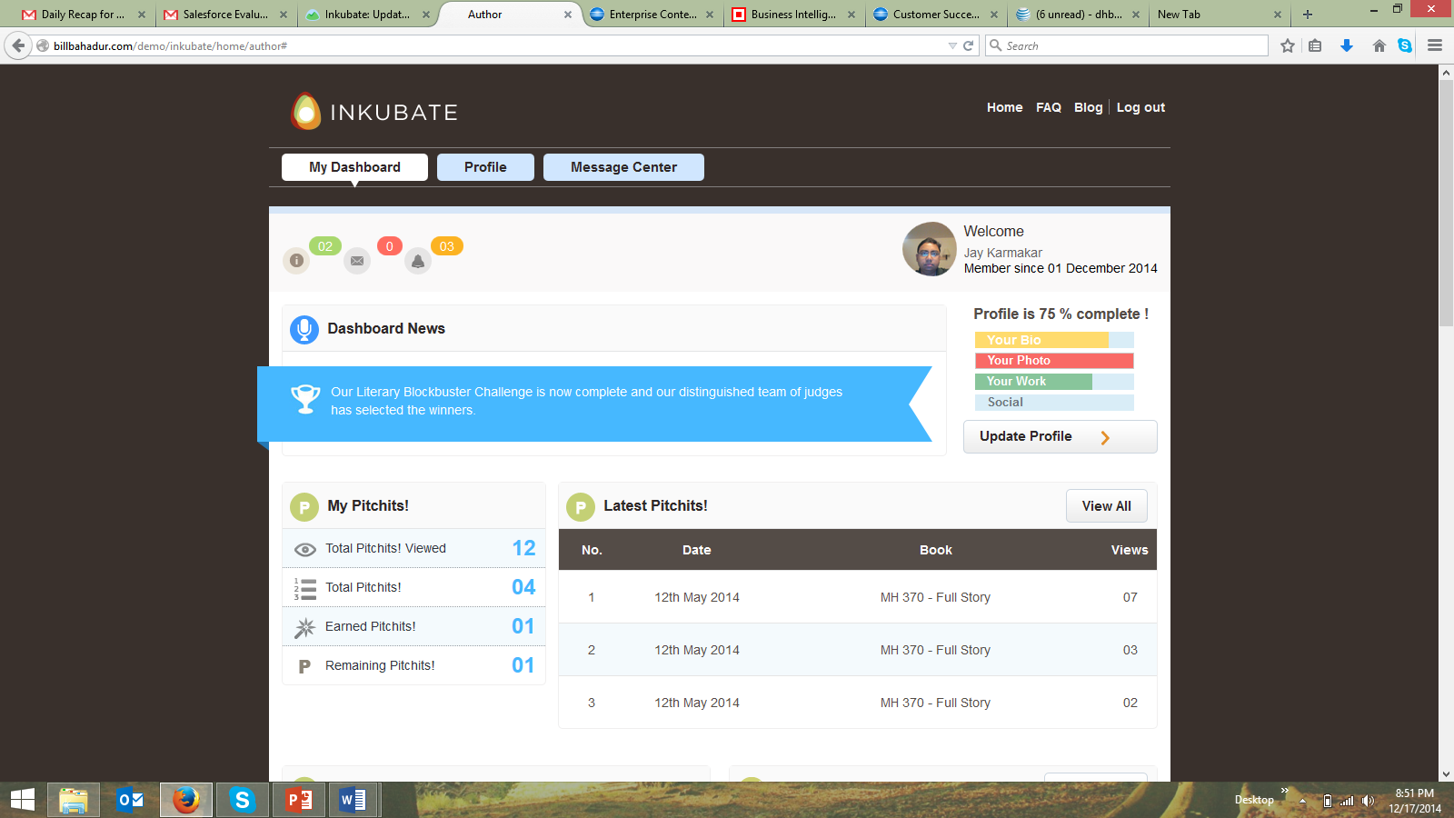

Invite Feature

- Stays open when selecting another function (e.g., email). Author has to click on icon again to close it. We need a tool tip to let the author know that they need to click the icon again to close the invite function and that this icon is the invite feature and what an author can do with it.
This is done
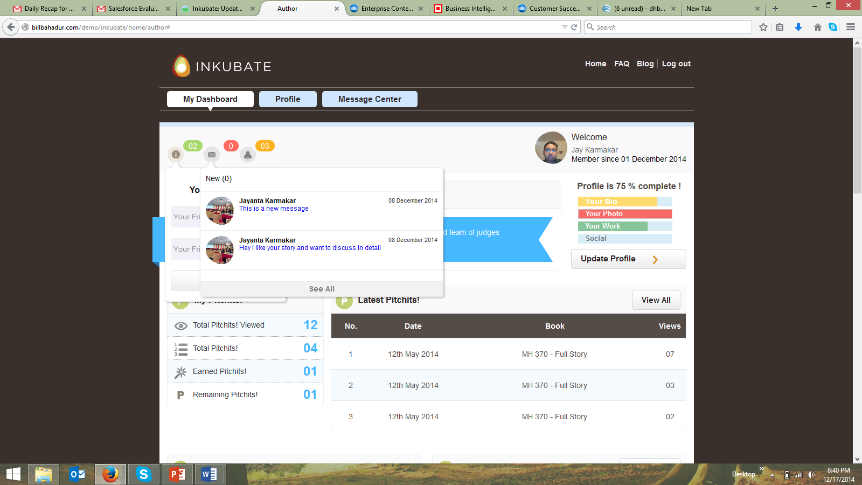

- The functionality to send messages to invite is working now (vs. 12-15-14).
  - When an author creates an invite and the email already exists within the systems as a registered (e.g., dhbass@sbcglobal.net), we need to let the author know that this person is already a member via a pop up tool tip, and if the author wants to connect with the existing member, the author should send the existing member a message via the email message center. This is done
  - Jay and I tested the invite message sent notification feature with davidbasssf@gmail.com email address and it worked perfectly from a functionality perspective, but we need to clean up the “form” (e.g., Jay Karmaker) so it reads “Join Inkubate”. This is done
  - The message “Hi David Bass” appeared in my davidbasssf@gmail.com inbox and read “Hey, I am using Inkubate. It is an awesome platform. Please join here (which takes the newly invited person to the Inkubate sign up page). This all works well, but we need to change the message to:
- “Your friend (insert Inkubate member’s name) invited you to join Inkubate, the world first social network for professional content creators, agents, and publishers. When you join Inkubate, you will have access to thousands of other professional writers, editors, agents, and publishers who are looking to collaborate with you and help you publish your content. Inkubate is free to join. Click here (links to sign up page) to sign up now. Kind Regards, The Inkubate Team.”this is done
  - We need a way to also measure on the back end (admin panel) to see who was invited by an Inkubate member and who actually signed up as a new invited author or AEP. Does something like this exist for us to track against? For admin section – need to do this
  - Is it possible to have an invite master list (e.g., stored messages with email address) for an author or AEP within a separate dashboard vs. their address book so any of these types of users can track and see who they have previously invited and who has responded? For admin section -Need to do this
- I would recommend placing an Invite tool tip (e.g., mouse over) to let the author know what the function is.this is done

Email Feature

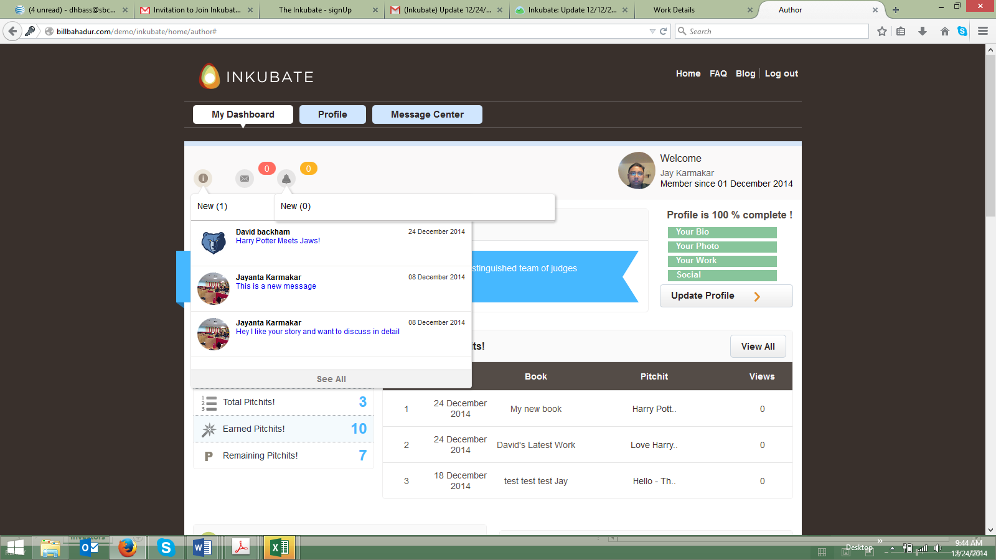

- When an author clicks on the email message icon. The Invite icon is displaying the email messages underneath it. It should display under the email message icon. (screen shot above) design issue – need to do this
- When an author clicks another function on the UI (e.g., the bell icon), both the email messages and the bell icon messages stay open simultaneously. It should close automatically when another button is clicked on by the author. (screen shot above)
- We need a tool tip to let the author know what the email icon function is and what an author can do with it.design issue – need to do this
- The “Compose Mail” feature takes the author to an entirely new UI screen. The transition takes a few seconds for the screen to render again. We need to make this transition happen without the delay and a new UI display. Selecting this feature to compose a message should simply toggle to this functionality within the existing UI without having to refresh the entire page. I would suggest having a “pop up” message in a new UI display in lower right hand corner of the exiting UI (e.g., how Google Mail works) so the author can create a new message. Need to discuss
  - The ability for an author to compose a new email in the “to” section is not working correctly. The author must select the “+” icon to select an email address. The author should have the ability to compose a message by typing in an address with an auto fill capability and use the “+” feature to look within the author’s address book. Need to do this
  - When the “+” icon is selected by the author, it displays a pop up address book with email addresses only for “authors”. (screen shot below)
    - I would suggest deleting the reference to “Select a Author” and make this list header “Your Address Book”. This is done
    - The navigation has “numeric” references to the number of email pages where there are stored emails for the author to select from are underneath the initial list of addresses displayed, but they disappear once an author selects one of the numbers below. Therefore, disabling the ability for the author to search for additional addresses after they select the first navigation feature. This functionality needs to be fixed. this is done
    - I would suggest “alphabetizing” the email address relationships and having a header navigation link for the author to select from vs. having the navigation within the footer of the address book (e.g. when the author sees the header Your Address Book directly underneath there are alphabetical links by last name underneath the main header THIS IS DONE
      - Your Address Book
A B C D E F G H I J K L M N O P Q R S T U V W X Y Z

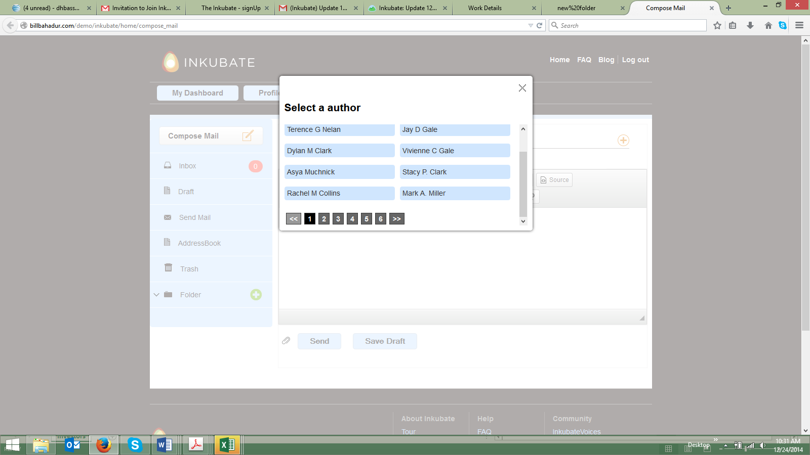

- The text editor within the compose email feature automatically “double spaces” the lines for the paragraphs. I would delete this functionality and make the line spacing single lines
.
- The text editor does not automatically detect incorrectly spelled words within the text. Can this type of feature be turned on within the CK Editor tool we are using? Need to discuss
- I saved a draft email (it worked perfectly, but, the notification within the left hand navigation pane “Draft”) does not display the numeric count of saved draft messages. (screen shot below) this is done
- The inbox notification displays a “0” as a reference. We should only display a numeric reference when there is a new message in the inbox. Most email systems do not display “0”. (screen shot below)this is done

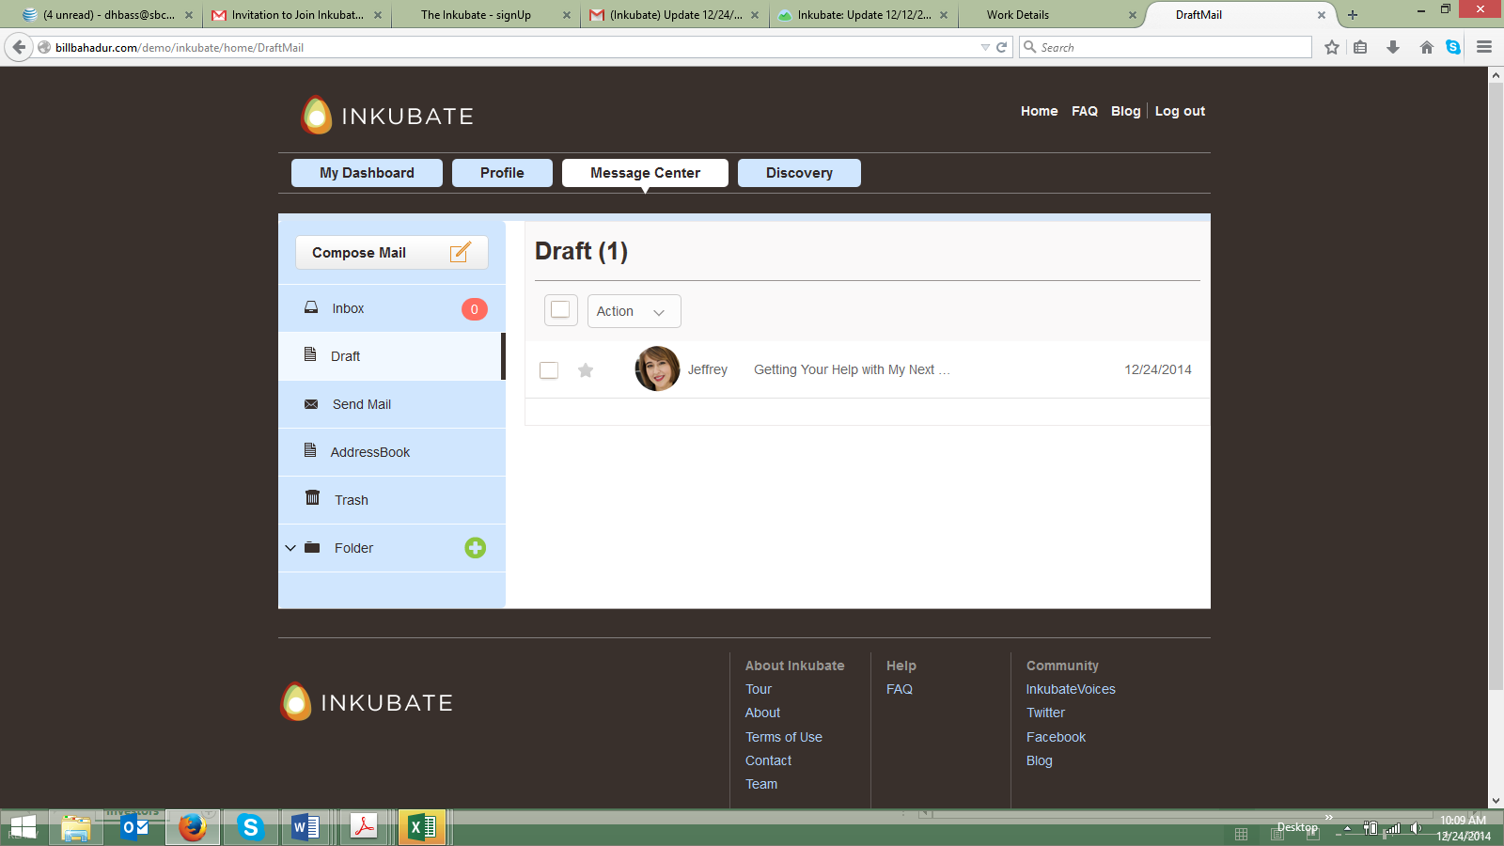

- The Send Mail header in the left navigation panel of the email function should be “Sent Mail”. (screen shot above) this is done
- The create/add a new folder feature “+” needs to be tightened up slightly (e.g. less horizontal space between Add a New Folder – Folder Name – Send – Cancel). This pop up box has too much white space between each of these areas. (screen shot below)(design)
  - The “Send” button should state “Create” or “Save”. Your choice. Either term is fine by me(desing issue)...need to do this

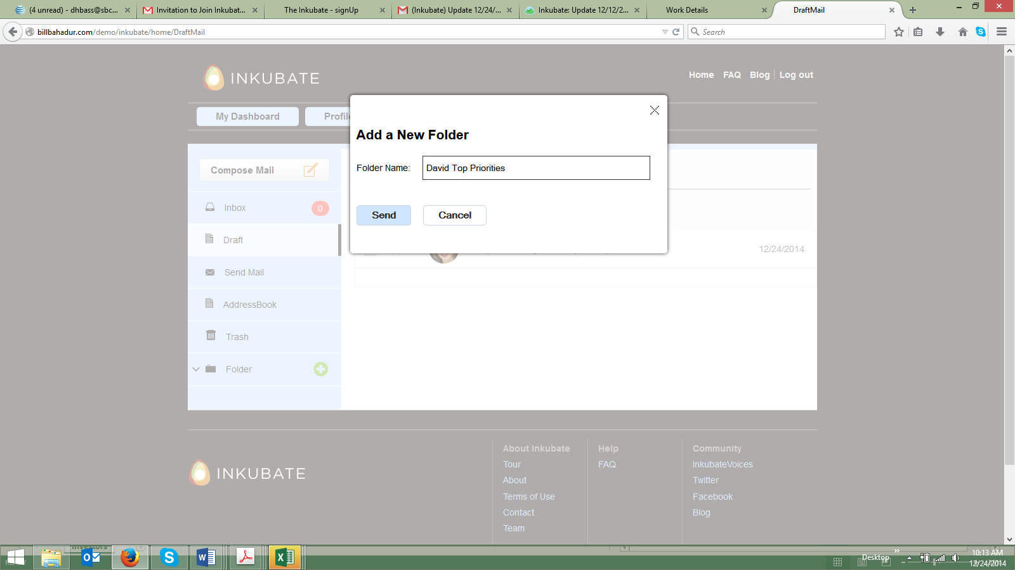

- When I went back into the Folders section, it displayed new folder (1), and David Top Priorities (0). What is an author placing in these folders? Saved emails? How do they know how to do that? How does an author delete a folder? (screen shot below)delete a folder is done
  - This is the UI display when I clicked Folders. I am assuming this is a mistake, as it is the draft email message I saved. Correct?this is done

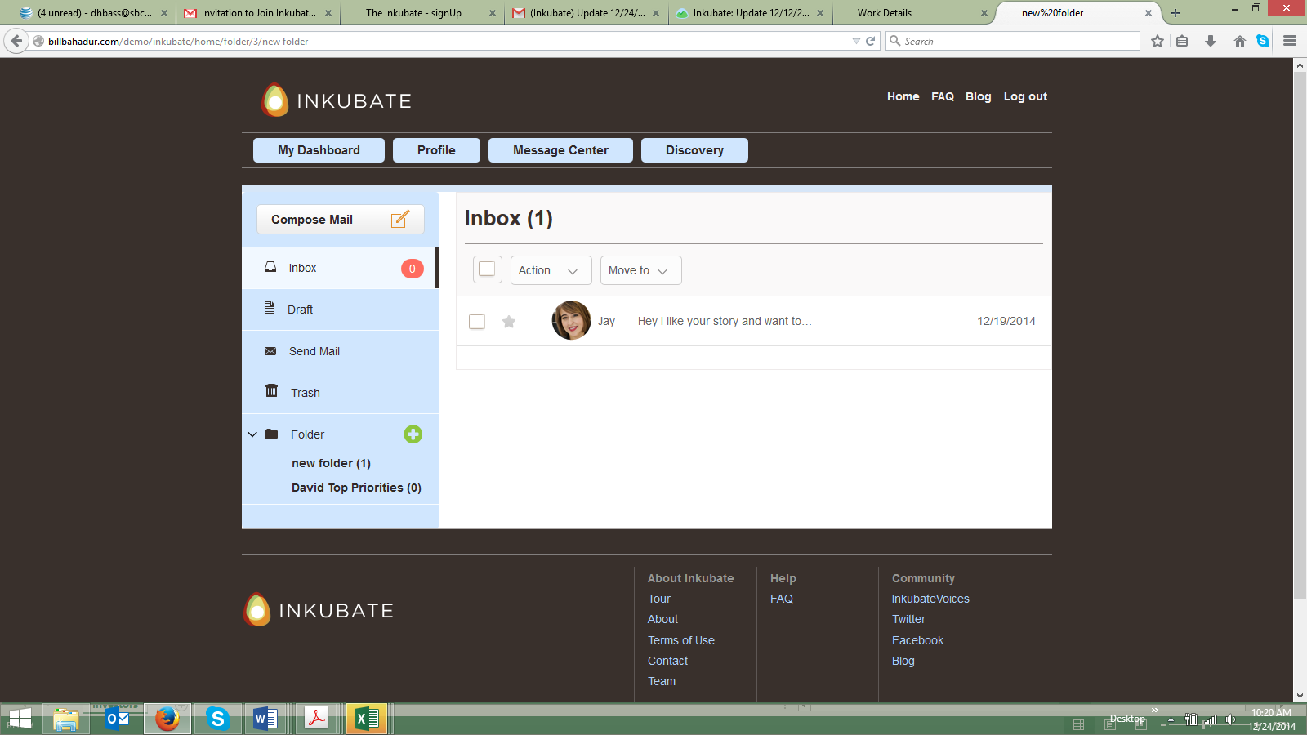

- When I was in the folder section and selected “Compose Mail” icon, a new tab opened up within Mozilla. This is a new functionality capability vs. when I wanted to “Compose Mail” previously. (see notes above). I am assuming this is a mistake. (screen shot below)
This is solved
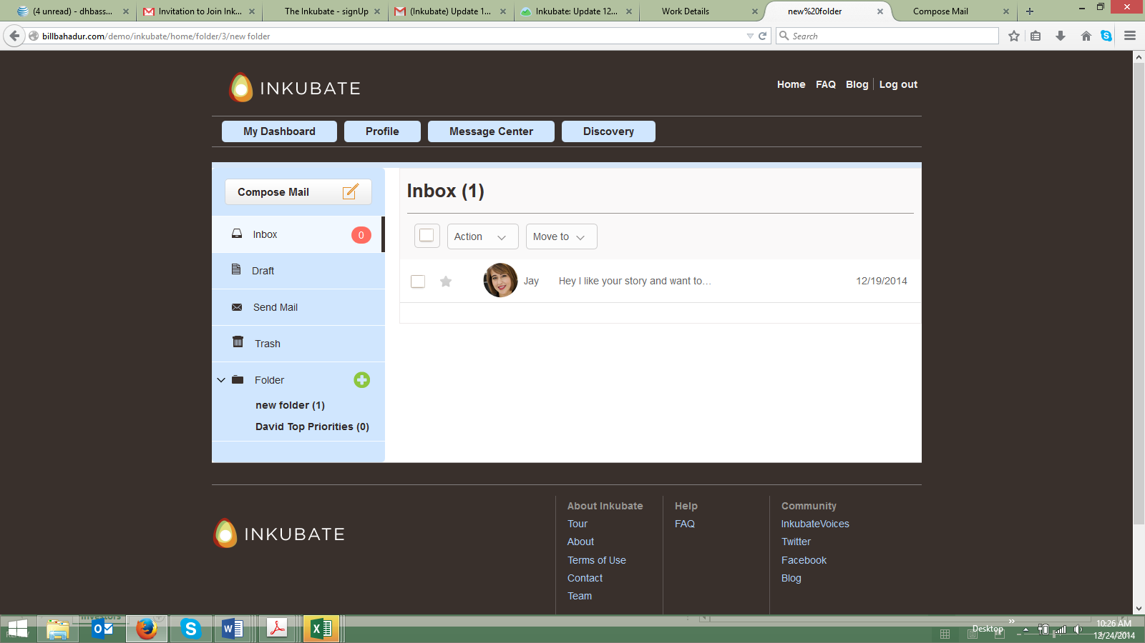

- When clicking on Action, the picklist should be Delete, or Mark (e.g., important “flag”). I am not sure we need to have “Action” repeated within the picklist.this Action in a drop down the Action word is not repeated rather its part of the dropdown. The mark is done

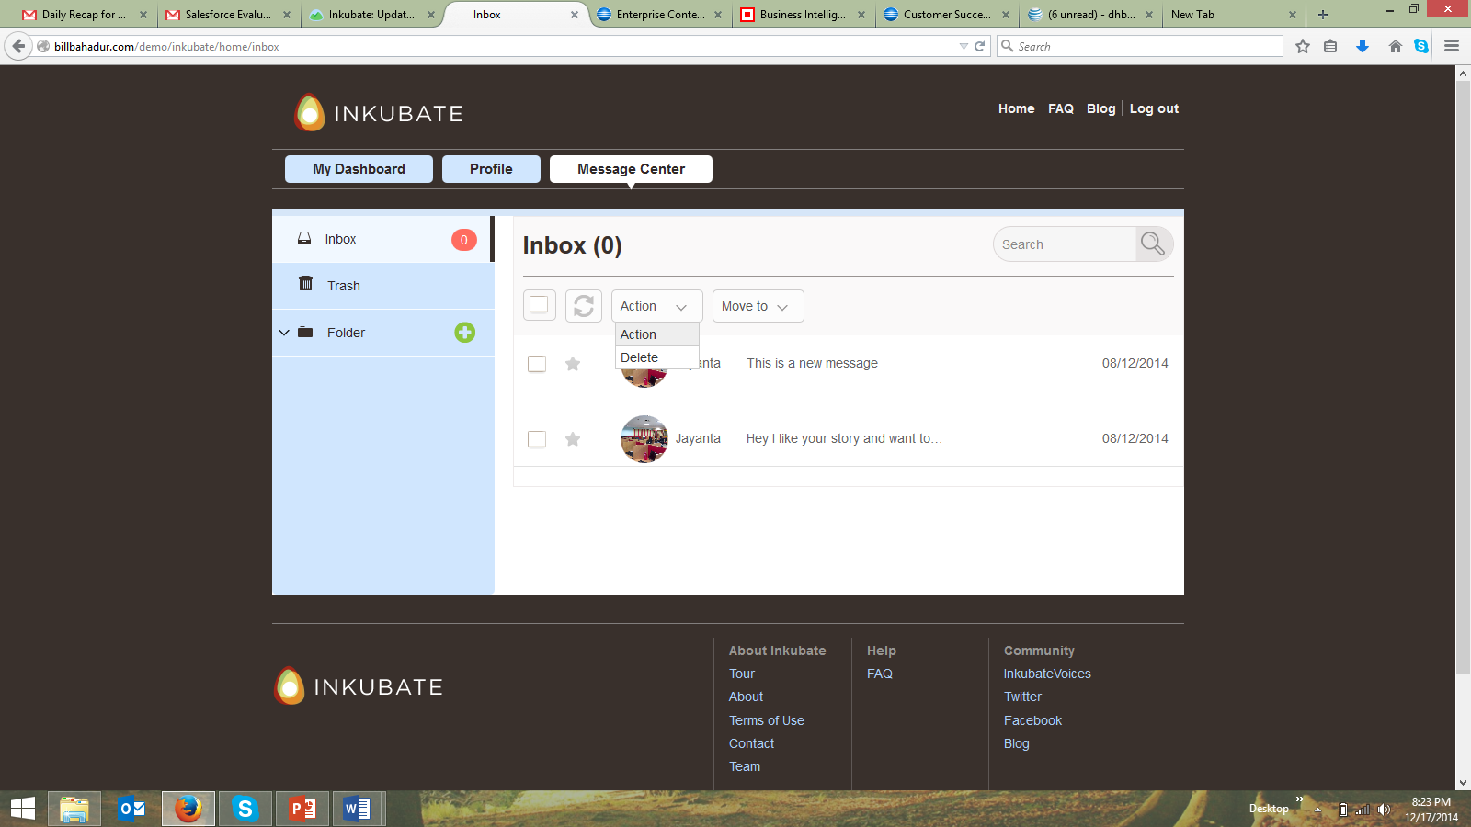

- The delete message function worked within the message center, but when I went back into the left side navigation, the message could not be placed back into the inbox folder or moved to any other folder. We need to fix this feature if an author accidently deletes a message and wants to place it back into another area within the email message center.
This is done
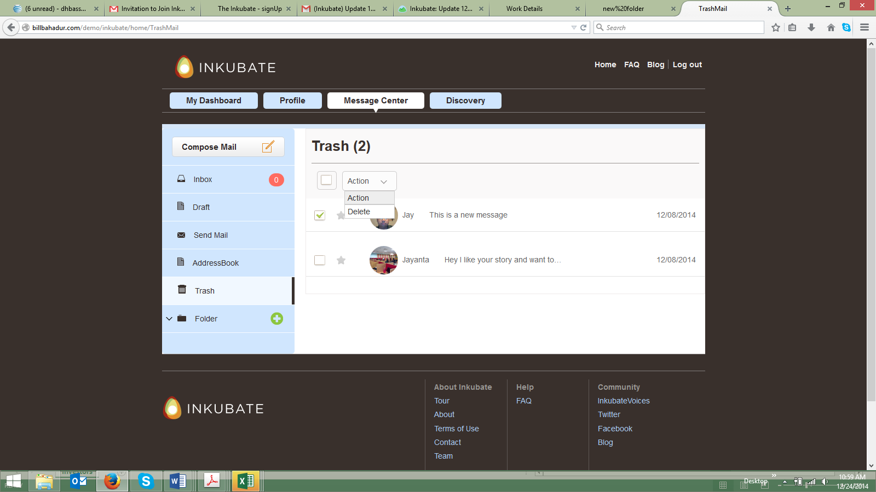

Bell Feature (what is this feature?) I am assuming Pitchit?

- When I clicked on the bell icon, it did not produce anything. We need a tool tip to let the author know that they need to click the icon again to close the email function and that this icon is the email feature and what an author can do with it. ..[DONE]

- When I clicked on the bell icon the information related to messages displayed under the email message icon. (screen shot below).[DONE]

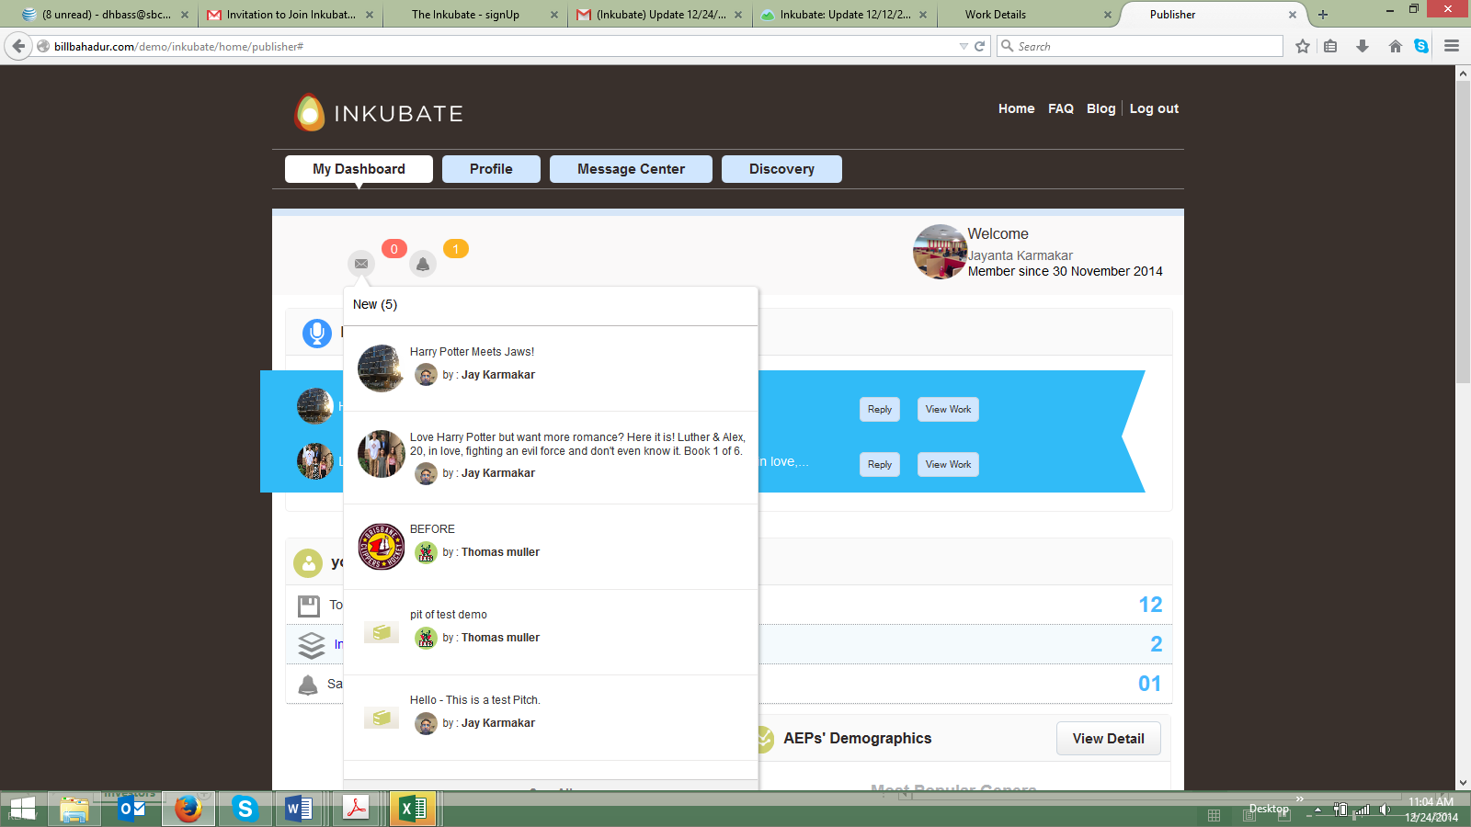

- When I closed the bell messages from under the email icon, the invites icon disappeared within the UI and the invite messages appeared and the screen log in switched to a publisher profile. I am not sure if this is because I am logged in on the same computer as an author and publisher, but this was strange. (screen shot below)..Need to discuss

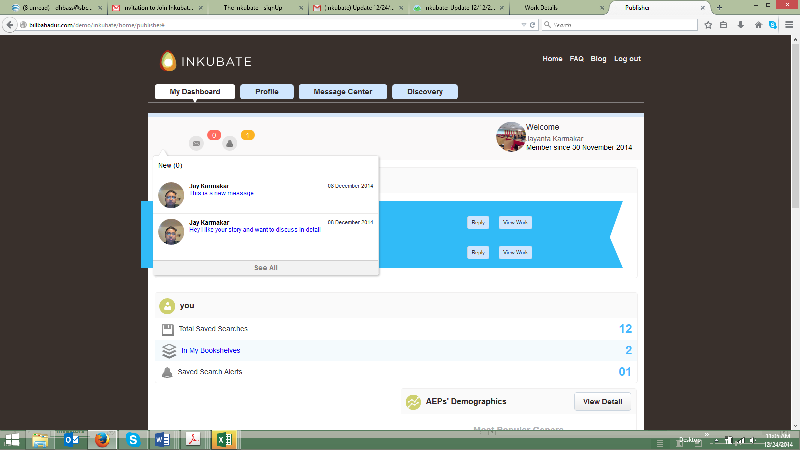

Pitchits Feature

- When I clicked View All, the UI did not change...need to discuss

- When I mouseover the Pitchit sections, the UI changes color to blue which would indicate if I click on the section (e.g., Total Pitchits), it would take me to a deeper level of information about the Pitchit totals. I would suggest we delete the mouseover color change...[DONE]

- I would suggest we move the Latest Pitchits and My Pitchits into one section vs. having 2 sections. If we combine the two sections and call it Pitchits we can then create Latest Pitchits as part of the main list and when clicked on it can take the author to a deeper level of information (e.g., what Latest Pitchits looks like currently) through a mouseover so the author can see the latest Pitchits he/she has sent to publishers. I would suggest the following layout UI design:

Pitchits (Header)

Latest Pitchits 4 Header should delete the number and just display Date, Book, Views
Total Pitchits 12
Total Pitchits Viewed 12
Earned Pitchits 2
Remaining Pitchits 1
Buy Pitchits Leads to an ecommerce transaction. We need to have this within the UI.
Create Pitchit Should mirror the same functionality in My Work section. See notes below...need to discuss

- We need to provide a tool tip as to what a Pitchit does for an author when the author mouses over the Pitchit “P” icon...[DONE]

My Clicks by Publishers Section

- None of the four main features do anything. I am assuming there is a next level of detail associated with each of these.
  - Are these going to be mouseover pop-ups? Or, lead to another screen?..[lead to another screen]
  - I would suggest adding tool tips to what each of these data presentations mean for the author when they mouseover them...[DONE]
    - 568 Search Returns – Your work has appeared in 568 searches by agents, editors, and publishers.
    - 127 Profile Views – Your profile has been looked at 127 times by various agents, editors, and publishers. Click here (links to a secondary dashboard) to see who has viewed your profile. The secondary profile dashboard should operate like Linked In’s “who has viewed your profile” dashboard and display only the last 5 profile pictures and their related Inkubate profiles (brief synopsis – name, email, and their persona type (e.g., writer, agent, editor, publisher) who has viewed the author within Inkubate and what day and time they viewed the author’s profile. When the author is within the secondary data screen related to profiles, we can have an offer to sign up for the “premium service” to be able to connect directly with the people who have viewed their profiles....[DONE]
    - 60 Downloads – Your work has been downloaded 60 times by various agents, editors and publishers. Click here (links to a secondary dashboard) to see which titles have been downloaded. The secondary downloads dashboard should display the titles downloaded and “who has downloaded your titles” dashboard display only the last 5 profile pictures and their related Inkubate profiles (brief synopsis – name, email, and their persona type (e.g., writer, agent, editor, publisher) who has downloaded the author’s titles within Inkubate and what day and time they downloaded the author’s profile. When the author is within the secondary data screen related to profiles, we can have an offer to sign up for the “premium service” to be able to connect directly with the people who have downloaded the author’s titles.
    - Bookshelf Editions – Great news! Your works have been placed on a bookshelf by various agents, editors and publishers for further review. Click here (links to a secondary dashboard) to see which titles have been placed within a bookshelf. The secondary bookshelf dashboard should display the titles which have been placed on a bookshelf and “who has placed the author’s titles within a bookshelf” dashboard display only the last 5 profile pictures and their related Inkubate profiles (brief synopsis – name, email, and their persona type (e.g., writer, agent, editor, publisher) who has place the author’s titles within a bookshelf within Inkubate and what day and time they bookshelved the author’s profile. When the author is within the secondary data screen related to profiles, we can have an offer to sign up for the “premium service” to PitchIts be able to pitch the agent, editor or publisher who has bookdshelved the author’s titles.

- I would suggest tightening up the horizontal spacing/alignment between the My Clicks and AEP Demographics section to the right. They are not equal with each other.

- I would suggest reducing the size of the font within this section so it matches the font sizes of the Pitchits, AEP Demographics, and My Work sections.

My Work Section

- I would recommend enabling the author’s name to be inserted into the “welcome message” within the blue ribbon vs. “welcome writer”. It would be much more personalized for the author’s name to be inserted.
  - I would also recommend re-writing the welcome message to:
    - Welcome David. This area of Inkubate is where you can upload and store your manuscripts for other Inkubate members to analyze and review your work. Please make sure to fill in as much detail as possible about your title, so your manuscripts and their associated metadata are easily discoverable by other Inkubate members. Please upload as many manuscripts as you like, there is no limit to what you can store within Inkubate. Thanks again for using Inkubate!

- Add work UI should display the term Genre vs. collection as a picklist under the Format radio buttons.

- The Categories (0/3) does not make sense? Why is there a (0/3) after the header Categories?

- There is a See All link next to the Categories header should be removed. It is redundant to the picklist feature and the pop up makes the UI too cluttered.

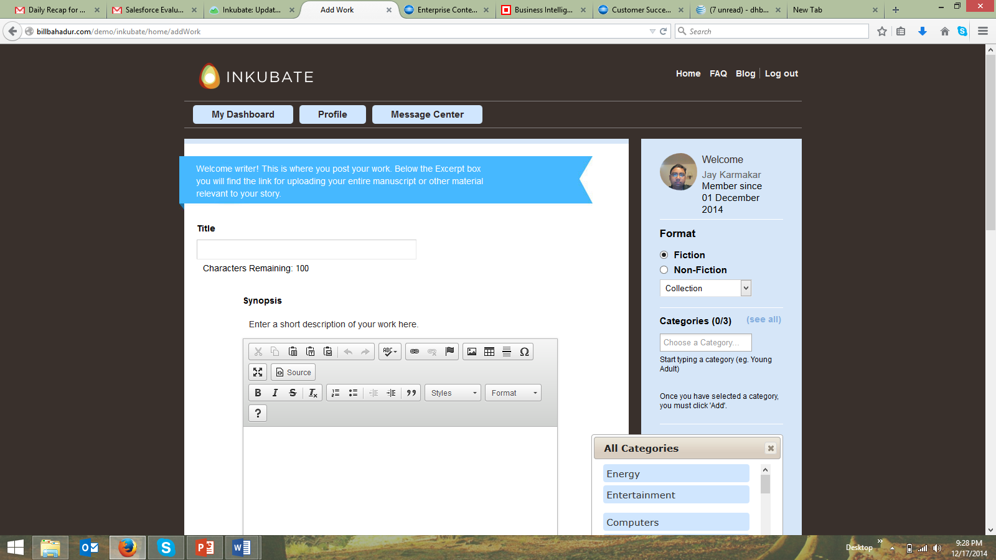

- We need to clean and tighten up the right side panel bold text size and non bold text size. There is too much UI real estate being used by the difference in font size and it makes uploading a work more cumbersome to have to scroll that much.

- The tool that pops up when an author selects Pitchit from the main My Work dashboard is not intuitive enough. The Pitchit should map all the key data points within the Pitchit sent to the Publisher.
  - The dialog box below should have a way for the author to select a specific agent, editor or publisher who is interested in their genre specific and category specific work (e.g., journalism and fiction). I would suggest having a picklist appear where agents, editors and publishers who are interested in this type of manuscript appear within the dialog box and enable the author to “checkbox” the specific agent, editor or publisher they want to send it to.
  - We need to create some type of artificial intelligence that mines and segments the agents, editors and publishers who are not only interested in fiction and genre type, but the other key data points we are extracting and mapping from the agent, editor or publisher (e.g., the agent, editor or publisher is looking for non reviewed manuscripts only, or the agent, editor, or publisher is looking for self published works only). Having this type of granularity within the segmentation would enable the author to send his/her work to agents, editors, or publishers who would likely want to review their work and make the Pitchit a valuable tool for the author vs. just a “message spamming” exercise for the author.
  - I also would suggest having the Pitchit Content dialog box contain a picklist (e.g., picklist with agent, editor, publisher, where the author selects the audience they want to send this to) in addition to the message the author wants to send.

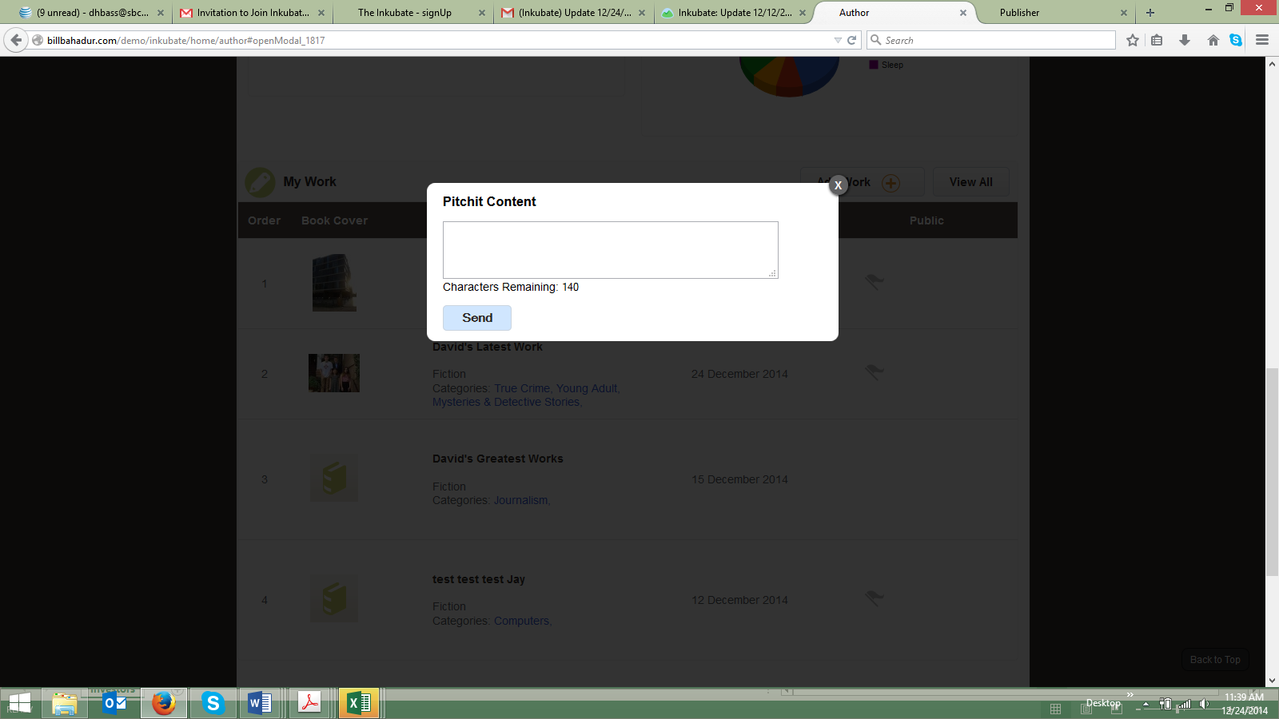

- The screen shot below is the message format an agent, editor or publisher receives as a Pitchit? The Pitchit comes to the agent, editor or publisher within their news feed inside the blue ribbon. I would suggest we create a new section above the You (not sure what this is?), Totaled Saved Searches, In My Bookshelves, Saved Search Alerts (not sure what this is?) which displays the Pitchits. It is too difficult to see the Pitchit in the news feed.

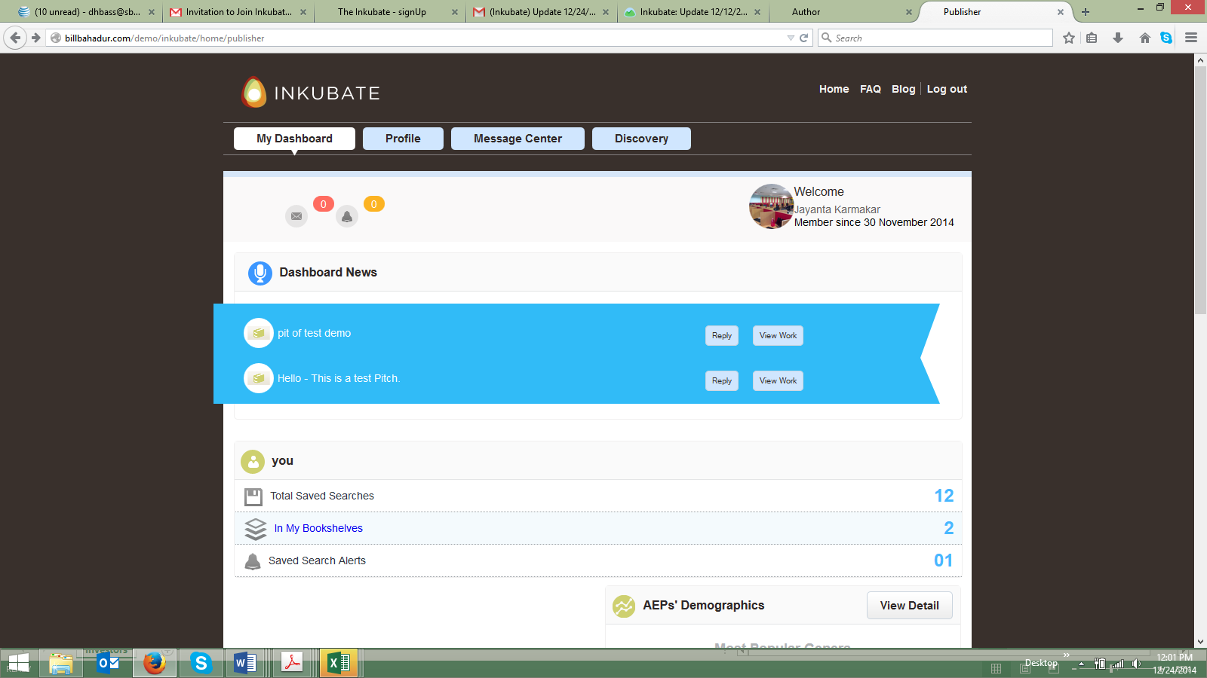

- The manner in which the Pitchit is being displayed for the agent, editor, or publisher does not provide enough granularity of the key data points for the agent, editor or publisher to make an educated decision about whether or not the author’s work is valuable? This UI needs to be tightened up as there is too much white space on the screen. I would suggest the following changes to the UI.
  - Jacket cover moves up to the left and underneath the jacket cover are the following:
    - Author name
    - Type (e.g., Fiction)
    - Genre (vs. Form)
    - Categories
    - Self Published (Yes/No)
    - Reviewed (Yes/No)
    - Delete Visibility
    - Delete Tags
  - I would move the Synopsis and Excerpt over the right side of the UI.
    - I would delete the word “Attachment” and insert “Download Manuscript” under the Excerpt.
    - I would move “Add to Bookshelf” under the Download Manuscript link.

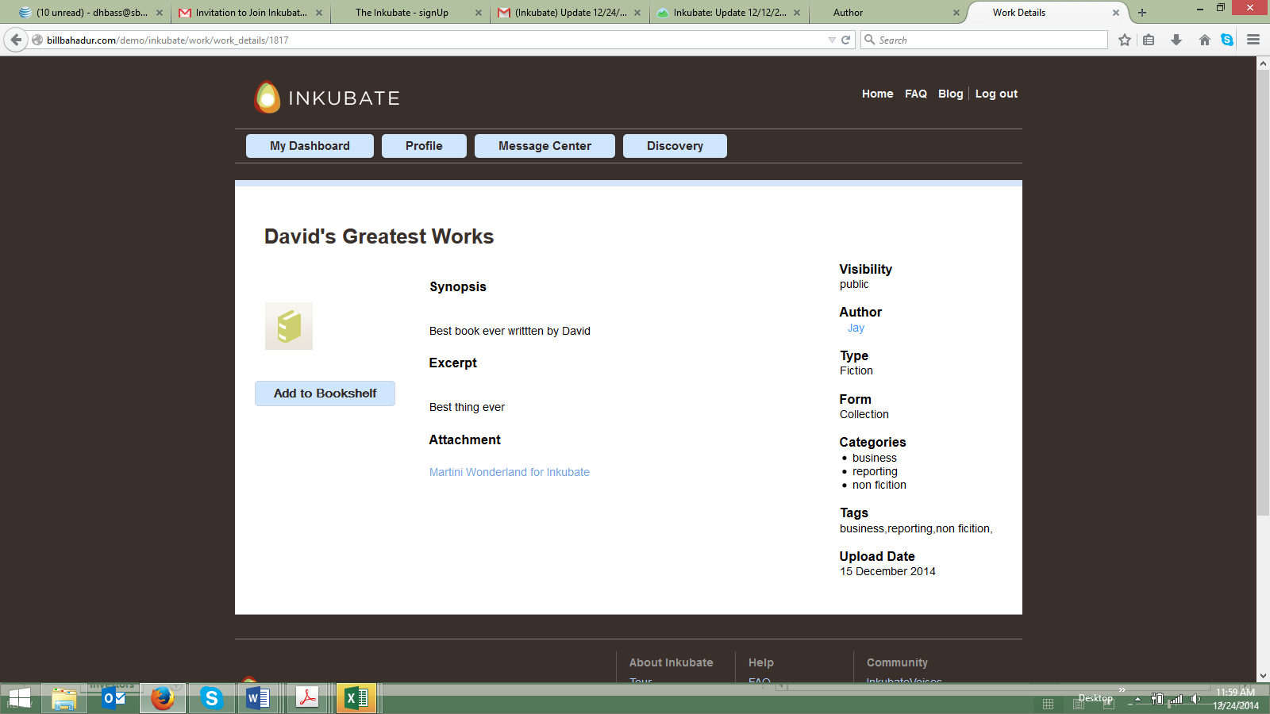

- When I clicked on the main My Work Dashboard to get back into the first book on my list “My New Book” the screen went to the following UI, not sure why?

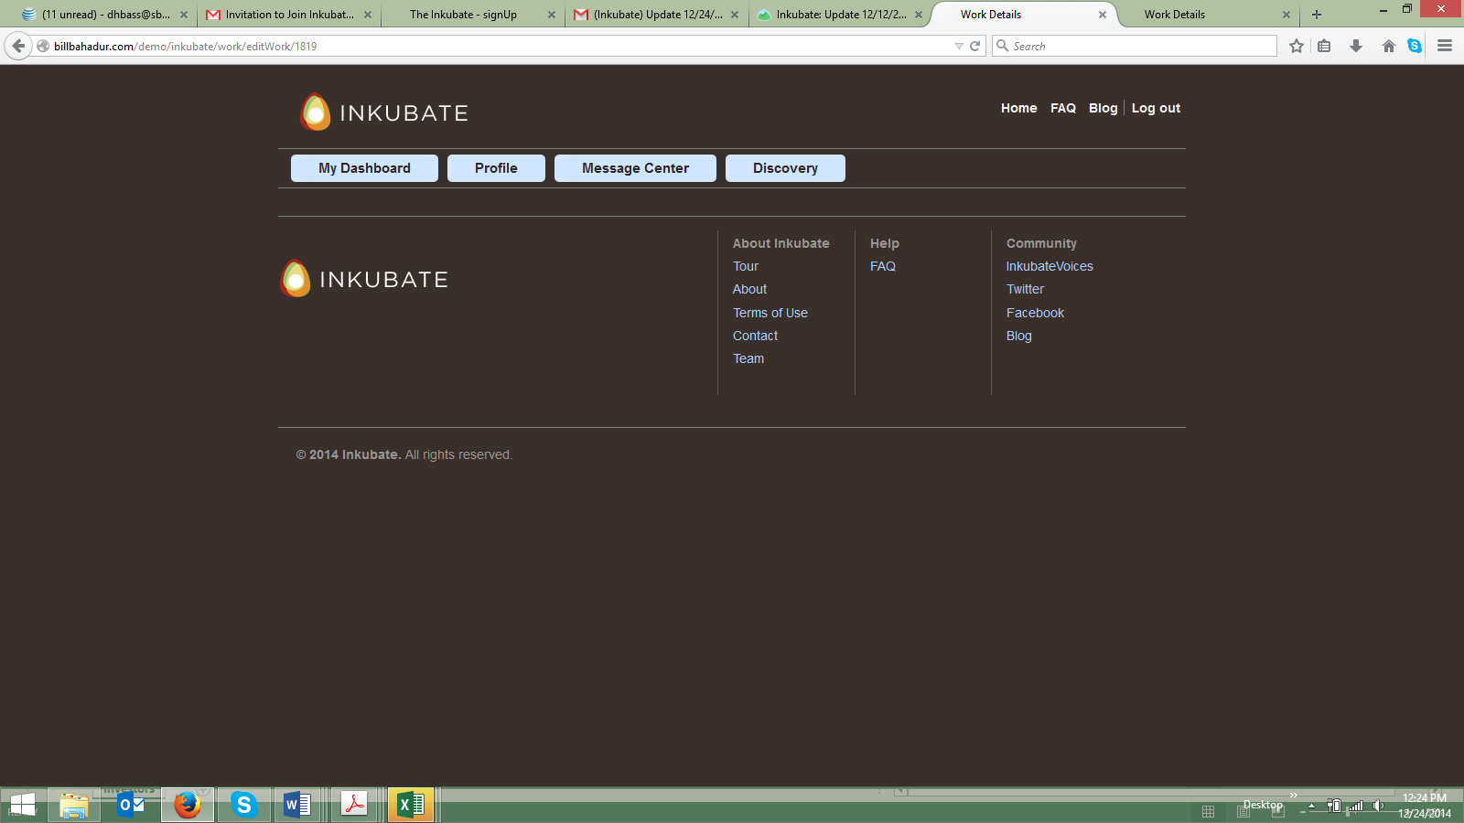

- The Tags feature’s Add button covers the directional text below the input box.

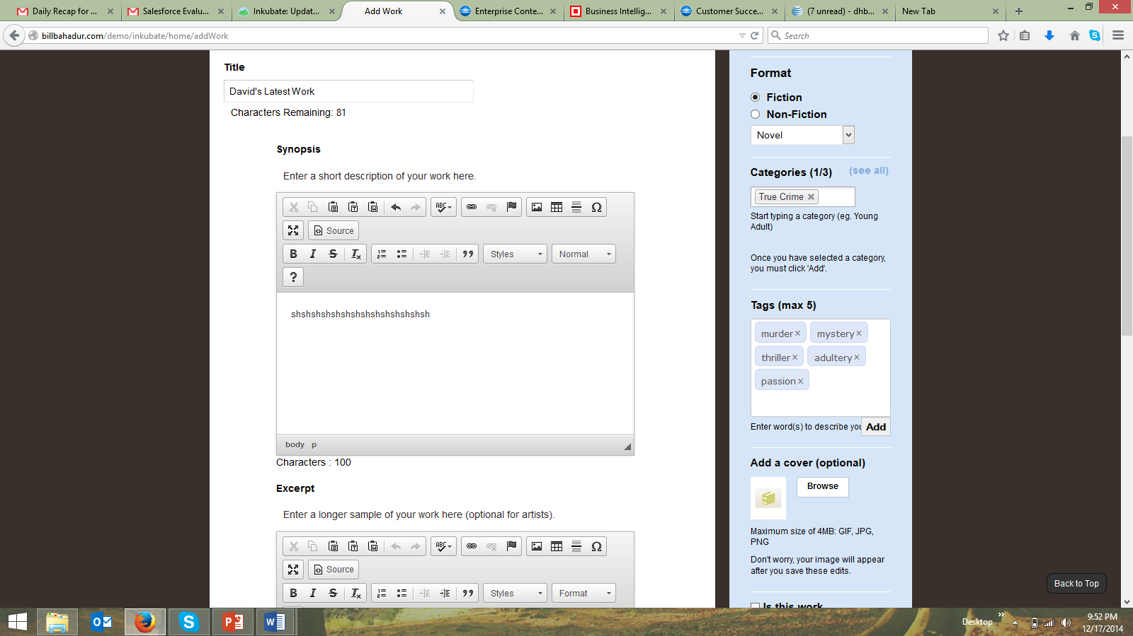

- What do the 100 Characters and 500 Characters references provide below the Synopsis and Excerpt input boxes? It should be the number of characters entered by the author, correct? If so, they are not summing correctly.

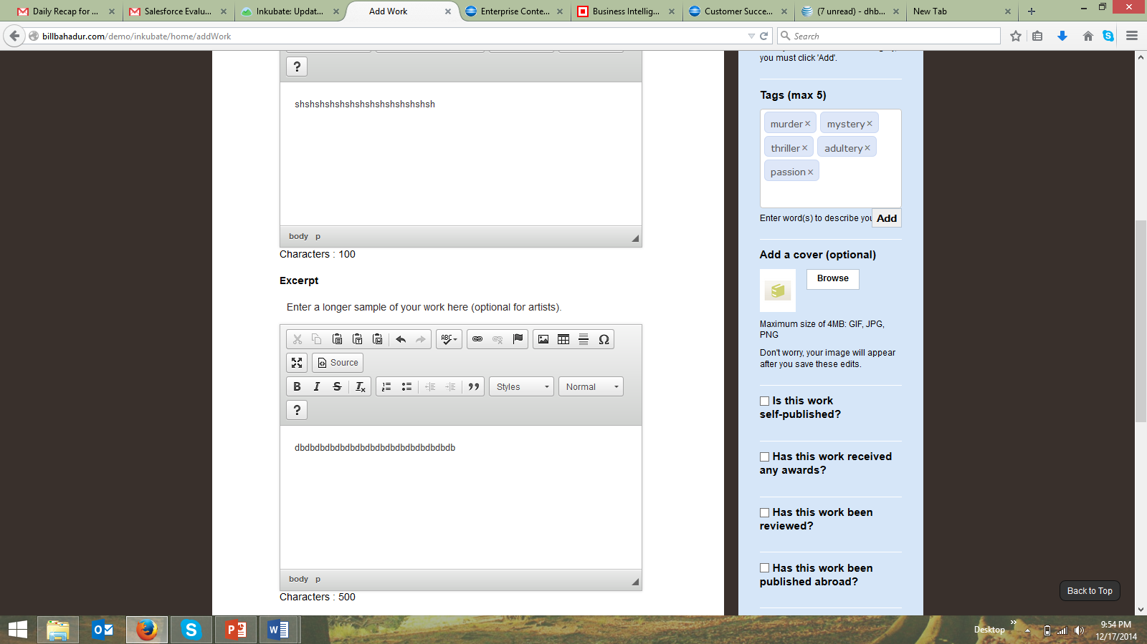

- The Upload File is optional, why? And what do the TEX, SCRIV and PAGES format refer to? We should only allow Word, PDF, and Quark file formats.

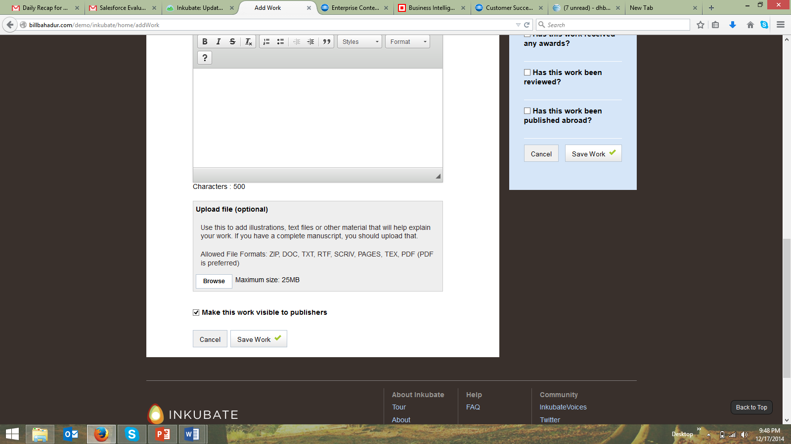

- When I uploaded my new work to my profile, it took 39 seconds. We need to improve this file and information transfer so it loads within 5-10 seconds at the most.
- We should delete the word Order from the header of My Work. It does not seem to be relative.
  - Also not sure what Public refers to?
  - I would suggest we map more key data points into the My Work UI and include Tags so an author can see what they are promoting.
  - Also would like to see a share to social network button in the header, so the author can share a post to their social network that they just uploaded a new work with a link back to the title.
  - I am not sure we need another link View All vs. just extending the list within the initial UI.
  - I would suggest condensing the horizontal height of each title uploaded, we are taking up a lot of real estate in the UI.

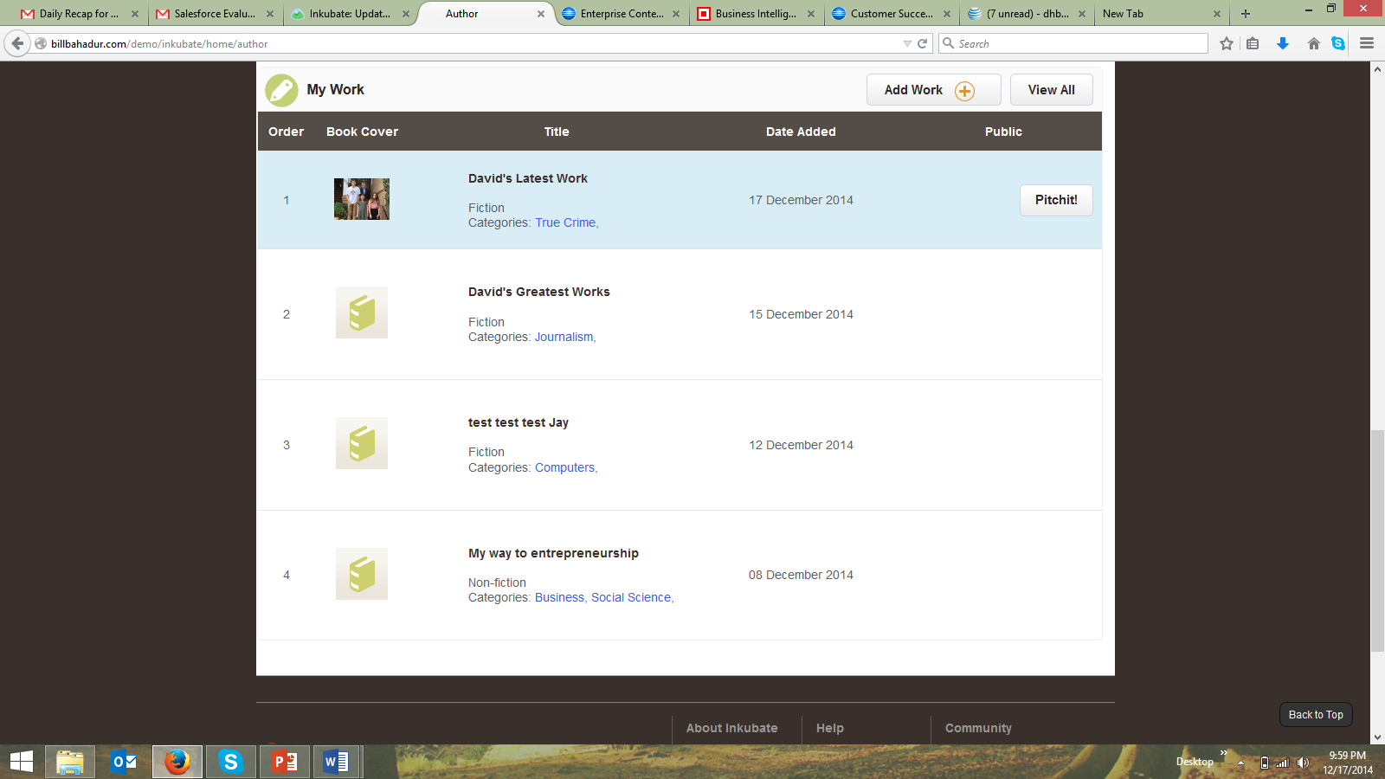

Profile Section

- I would suggest we condense this entire section. The real estate used within the UI is too sparse and the scrolling the author has to do to see all the key input and data field points is unnecessary. I realize the UI is laid out this way because of the text editor, but I would suggest making the text editor tools smaller.
  - I would suggest shrinking the profile picture.
  - I would suggest moving the social icons directly under the profile picture.
  - I would suggest moving up all the questions (e.g., “have you been traditionally published”). I would also suggest rephrasing this question to “Have you been published by a professional publishing house?”
  - We are also missing other key personal demographic data points from the profile questions.
    - Address
    - Phone
    - Personal email
    - Age
    - Gender
  - We are missing a way for the author to sign up for tools and pay with a credit card?
  - The author’s profile should also show their Pitchits available and the ability to buy Pitchits.
  - We are missing a radio button that enables the author to state they are open to being contacted by other professionals for collaboration opportunities.
  - We are also missing a way to publicly display their Inkubate profile (e.g., URL like LinkedIn provides). (Public profile was not the part of the scope but if you want to create one we have to take extra time and work on that. It is considerable amount of work which includes public profile UI, a section on the website to show them, search others profile, display profile without logging in to profile needs to enable without session display as well)
  - We are also missing the type of writer an author is (e.g., fiction writer, focuses on crime).

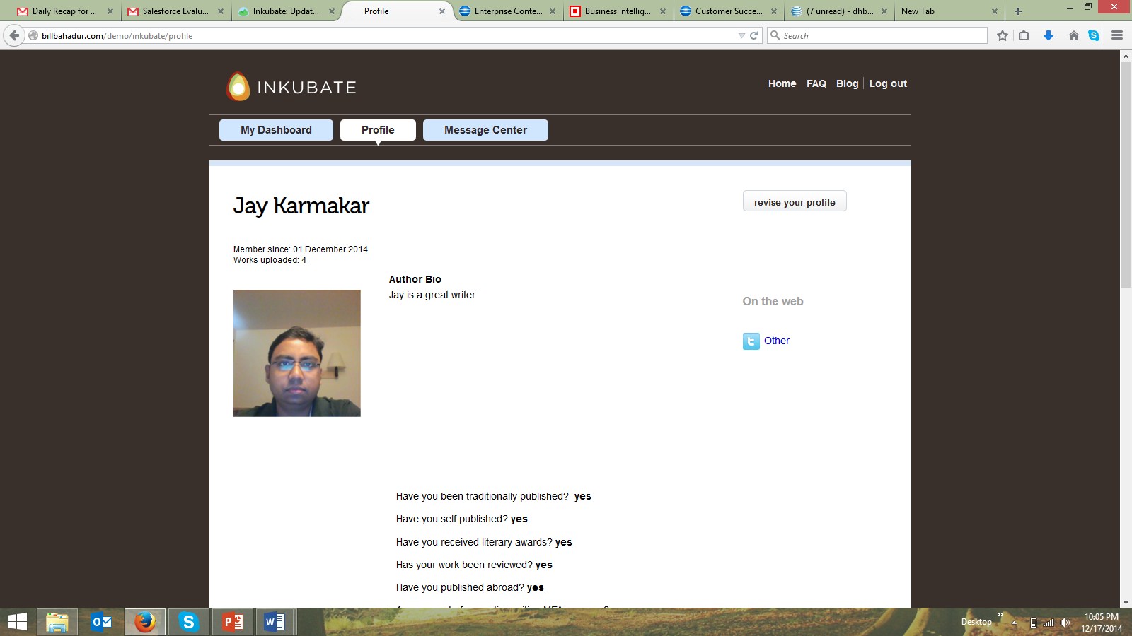

Agent, Editor and Publisher Dashboard Feedback

Main Dashboard

- The main dashboard is missing invite icon and feature/function. This feature/function should be available for agents, editors and publishers. (see screenshot below)

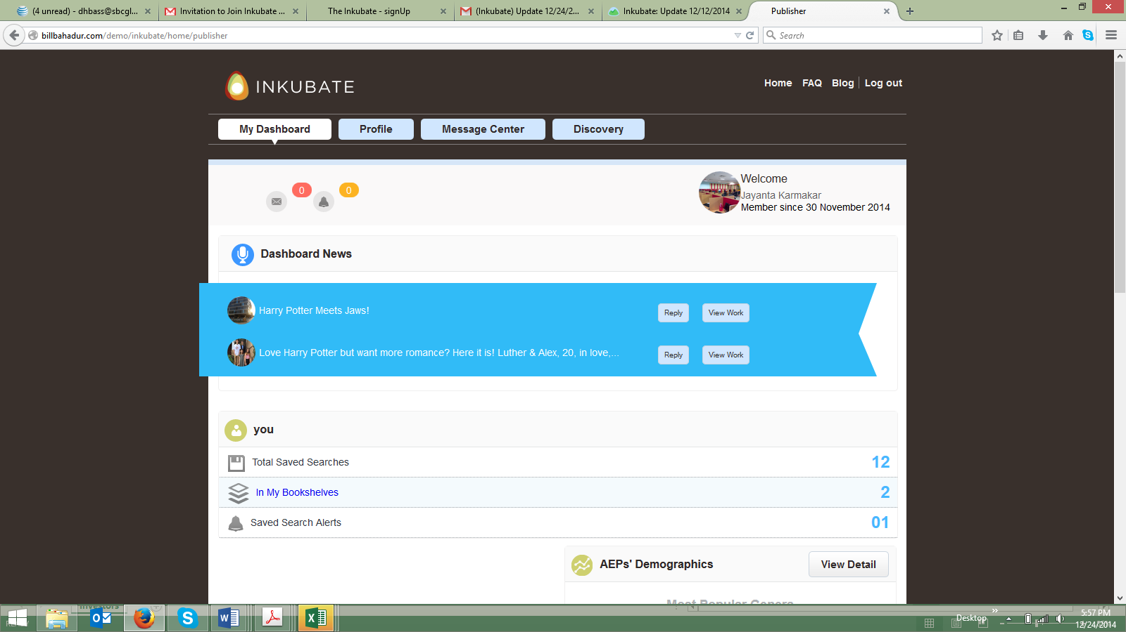

- I would recommend tightening up the UI so the agent, editor or publisher does not have to scroll so much to see the entire dashboard’s content.

- I would recommend we change the newsfeed font color from white to black. It is hard to read. I am not sure the font color is in white for the author dashboard, but I would make the same change there as well.

- The upper right hand corner fonts related to the agent, editor or publisher profile picture needs to be realigned. The text is too close to the image.
  - I would also recommend inserting the profile of the agent, editor, or publisher within the text in the upper right hand corner (e.g., Agent, Editor, Publisher).
  - I would also recommend we change the date to month, day year (same as previous note feedback for other UIs) within the profile reference in the upper right corner of the UI.

- I would recommend deleting the You from within the main dashboard section. It is not relevant and is confusing.

- Total Saved searches does not have a secondary level of data. What is this supposed to link to?
  - I would recommend the secondary screen show a list of authors who have works that the angent, editor or publisher wants to review with a reference header (e.g., Most Recent Horror Titles along with a date and time the search was saved.)

Bookshelves

- When I click on the Bookshelf it works to display a secondary level of information. The level of information displayed should be tightened up within the UI and some of the column data should be deleted in my opinion.
  - The number (e.g., 1, 2) should be deleted, as it has not reference to anything. The agent, editor or publisher has the name to the bookshelf already to reference.
  - The My Bookshelves text needs to be moved slightly lower and to the right to align with the icon. I am also not sure that the icon really demonstrates a bookshelf to the user. Perhaps we could change the image to one that shows the spines of books on several shelves. (Image below)

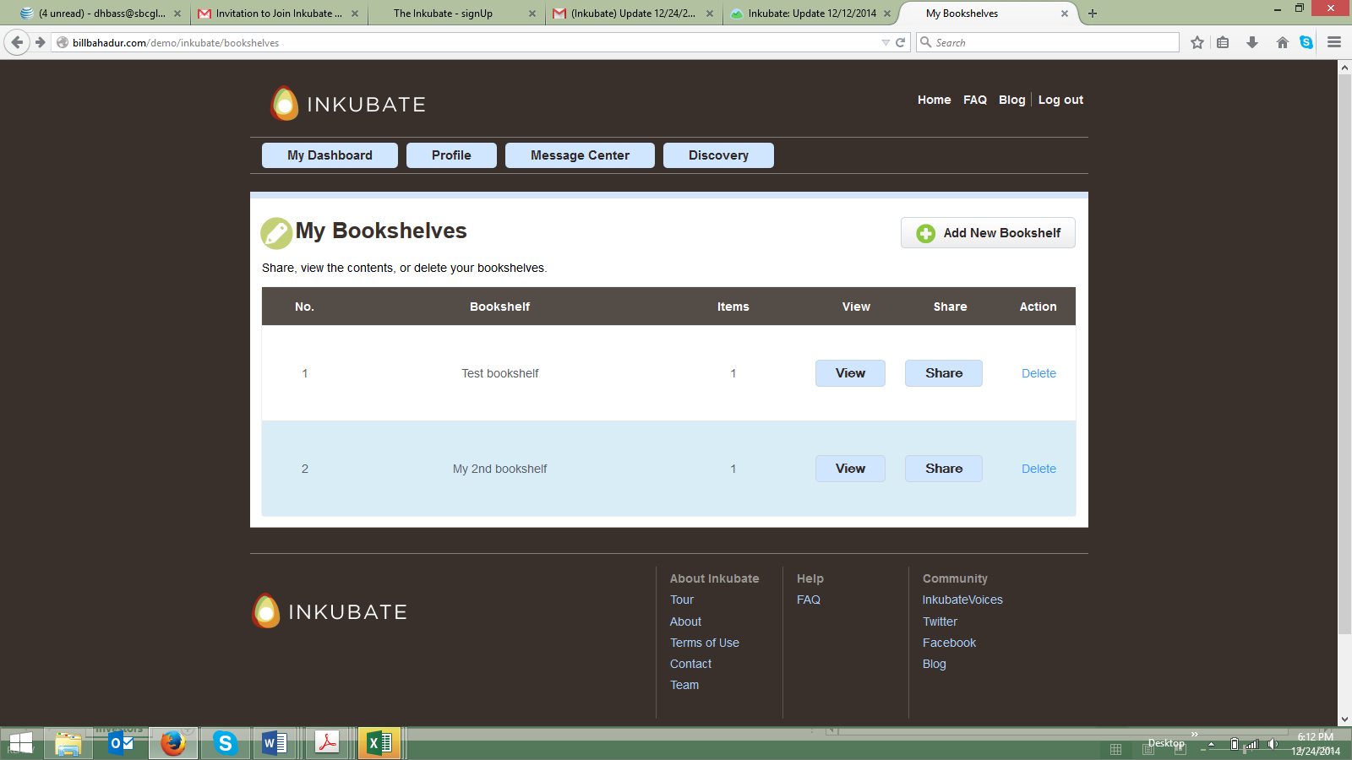

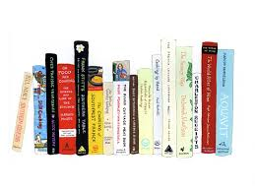

- When I clicked on the View radio button the text Bookshelf: Test Bookshelf displays. I would recommend deleting the word “Bookshelf:” from in fro of the name of the bookshelf. It is already implied this is a bookshelf.
  - The image under the header is broken and I am not sure we need an image here. The agent, editor or publisher will not likely add an image to this feature.
  - When I clicked on The Pitchfork 500 it linked me to the overview of the manuscript. This feature is useful, but we need to make sure we change the UI to resemble my notes within the author Pitchit view UI. Anytime an agent, editor or publisher views a manuscript it should be the same UI view.
  - I would recommend that we place the entire name of the author under the bookshelf title. If there are multiple titles, I think we should replicate the same sequencing (e.g., title name, author name).
    - I would recommend deleting the synopsis and categories references from underneath the title name and author’s name, as it is not relevant for the agent, editor or author at this time. The agent, editor or publisher will see this information when they click on the title and get to the next screen.
    - I would delete the radio button “Add to Bookshelf” from the right side of the UI. This title is already added to the bookshelf.

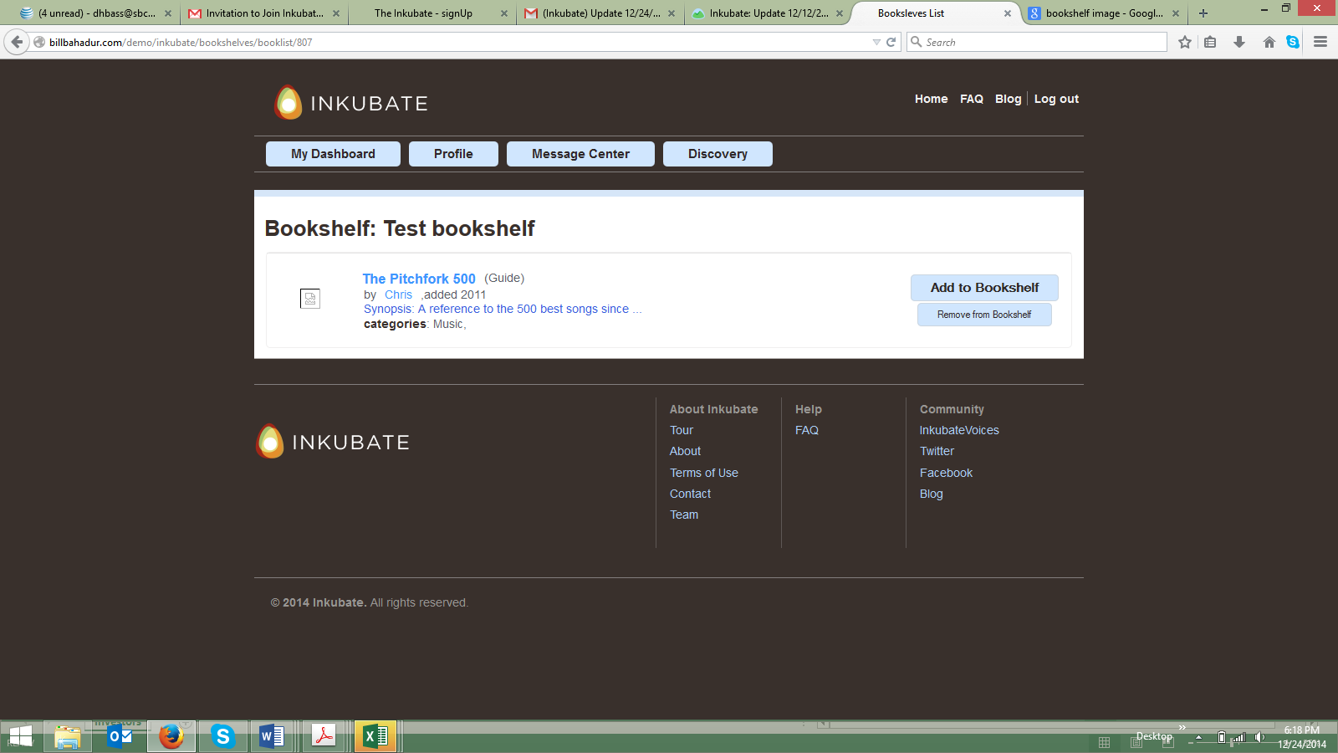

- The share UI should include sharing on Twitter, Facebook and Google + as well as email.
  - I also think the UI need to be cleaner. The whiteout of the background makes the screen look washed out.

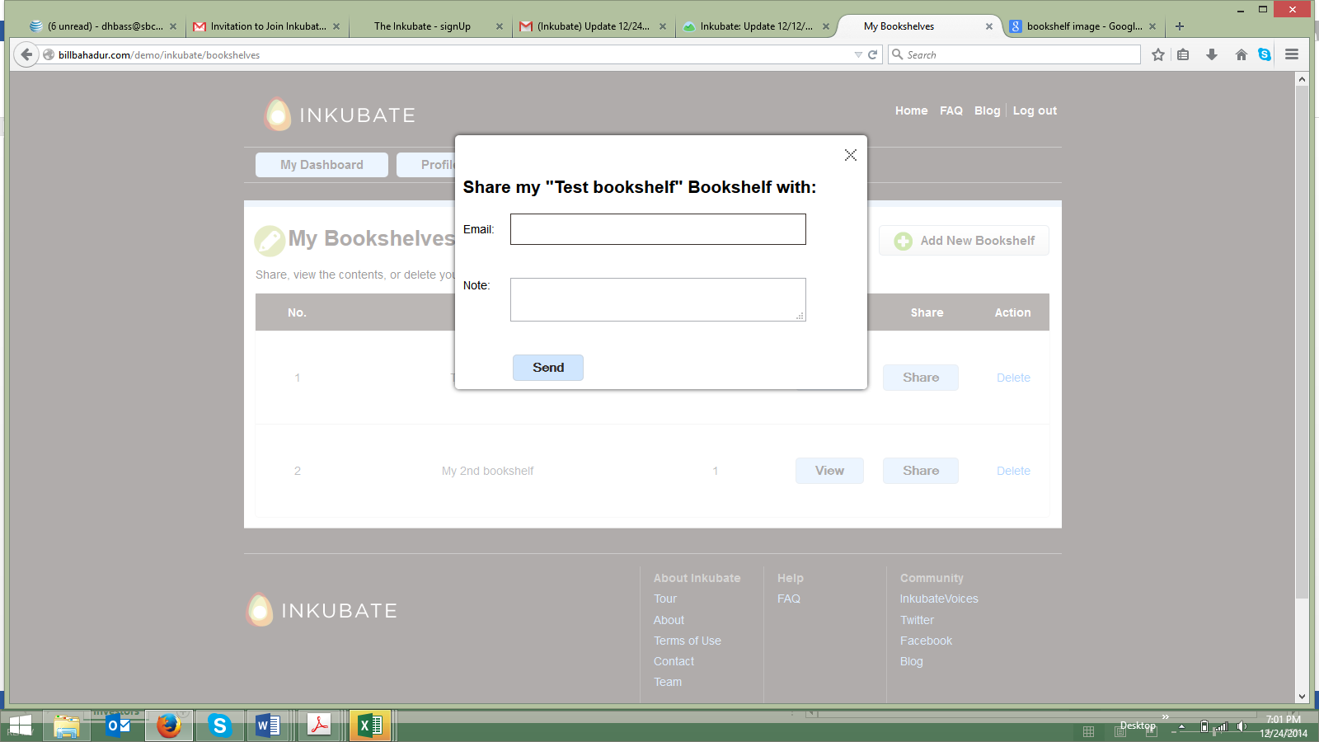

- The Saved Search Alerts does not have a secondary screen link. I am not sure what this data represents and why an agent, editor or publisher would need this feature in addition to Total Saved Searches?
  - I think we should delete this feature.

- When an agent, editor or publisher clicks on View Work within the news feed it displays a different level of data than what I saw in the author message sent to the publisher with the previous Pitchit above (e.g., author’s note section).
  - The text is running off the screen within the Tags section. I think the same UI change feedback provided above related to the Pitchit should be applied here.

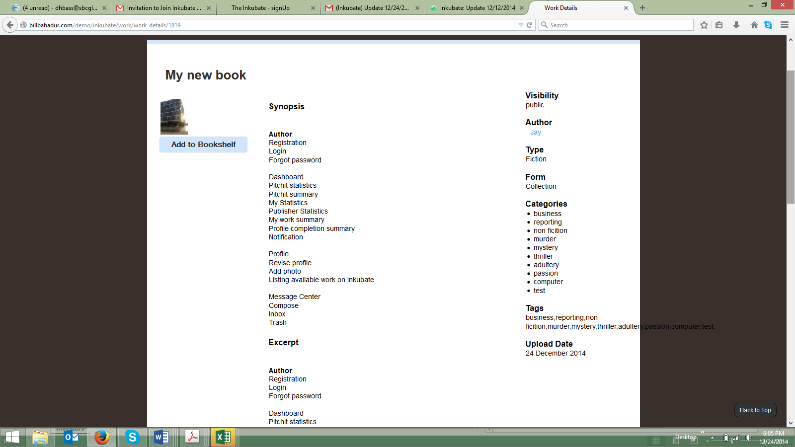

Latest Works Section

- The Latest works section should be deleted. It does not make sense to have this, as these titles will be in the agent, editor or publisher’s bookshelf for them to review.

Profile Section

- I would recommend using the same UI feedback related to the author profile (above) for the agent, editor and publisher profile UI.

- Agents, editors, and publishers do not have Categories, but should have a way to categorize the type of agent, editor, or publisher they are (e.g., romance).

- I think it would be a good idea to provide a number of other data points for the agent, editor or publisher to have within their profile (similar to what we collect from Salesforce.com forms)
  - Books published annually (editors and publishers)
  - Total books published to date (editors and publishers)
  - Book marketing budget (publishers only)
  - Number of authors represented (agents)

Message Center Section

- I would use all the same updates and feedback presented in the author feedback section related to the message center.

Discovery Section

- I am not sure what this section is providing vs. just having a search capability where an agent, editor or publisher can save their searches within a bookshelf.

- I think this entire section could be a single UI with multiple picklist to help the agent, editor or publisher segment their criteria for what they want to find. I would recommend the following:
  - Keywords (searches across all he main segmentation picklist and within the manuscript synopsis and excerpts cotent)
  - Writer Name (if an agent, editor or publisher knows who they are searching for)
  - Format (same as all the other UI references to this data set)
  - Genre (same as all the other UI references to this data set)
  - Category (same as all the other UI references to this data set)
  - Self Published Works
  - Published Works with Loss of Rights
  - Reviewed Works
  - Awarded Works
  - I would delete Contest Entry and Published Abroad

- Once the agent, editor or published enters the various data points (e.g., checkboxes) related to the data points above, I would have a single UI that shows a list of the results and then the agent, editor, or publisher has a new set of check boxes next to the returned titles that enable the agent, editor or publisher to save it within the following areas:
  - Add to Bookshelf
  - Add to Saved Searches

