AEP Application Feedback

3-28-15

David Bass

Upper Dashboard

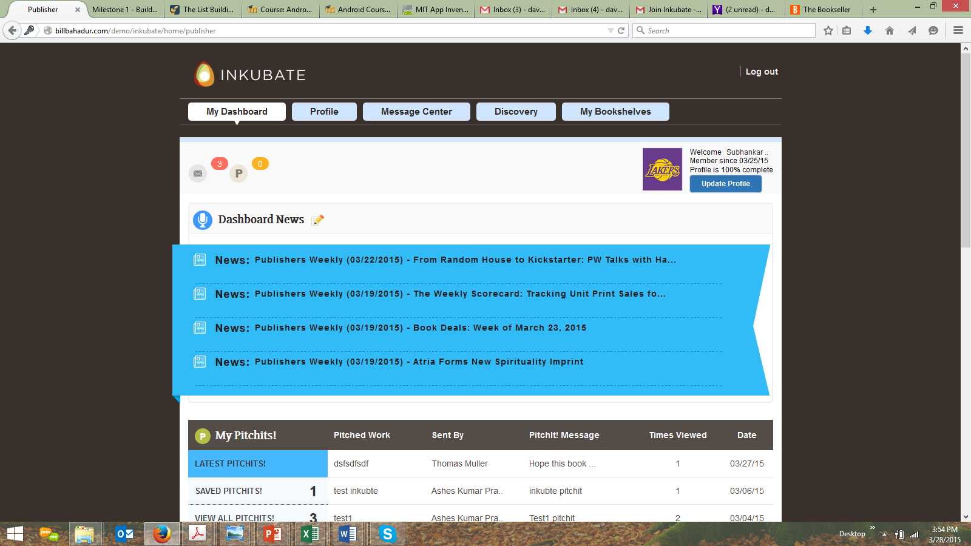

1. Subhankar’s last name is not displayed in upper portion of the profile section. We need to make sure there are enough character spaces available within this area of the style sheet to allow for a longer name of the AEP to be displayed.
   1. I would suggest creating a style sheet that enables the section area to have a minimum of 25 characters and automatically have the area resize itself to the right (decrease in size to the right) when a name has less characters than 25.
2. The % related to the profile is not working correctly. It displays 100%, even though the entire profile is not filled out completely. We need to create a “weighting” system to determine how much of the profile is actually filled out. We need to point out to the AEP that their profile needs to be updated. **This is the same issue with the writer side of the application.**
3. I would suggest adding the Invite feature next to the messages and PitchIts! notification icon links in the upper left corner. There is no reason not to have the AEPs invite other AEPs to join.
   1. We (Alex and I) will create a special landing page for AEPs to sign up with a picklist vs. going to the 3 individual sign up forms we have created on the Inkubate website.
4. The links to the message center work correctly, but there are still issues with the Message center “delete” checkbox function and the Re: message subject area of the message field layouts.**This is the same issue with the writer side of the application.**
   1. I will reference any different issues from what I found in the writer side of the application within in the Message section notes below.
5. The only PitchIt! message within the PitchIt! notification icon (upper left corner of the UI) is from Thomas Muller, but when you see the PitchIt! dashboard below (default UI of Latest PitchIts!) there are 3 PitchIt! messages from Thomas Muller. And, there are several other PitchIts! from other writers within the PitchIt! dashboard. We need to make sure that the PitchIt! notification count matches the number that are in the PitchIt! dashboard based upon who sent them.

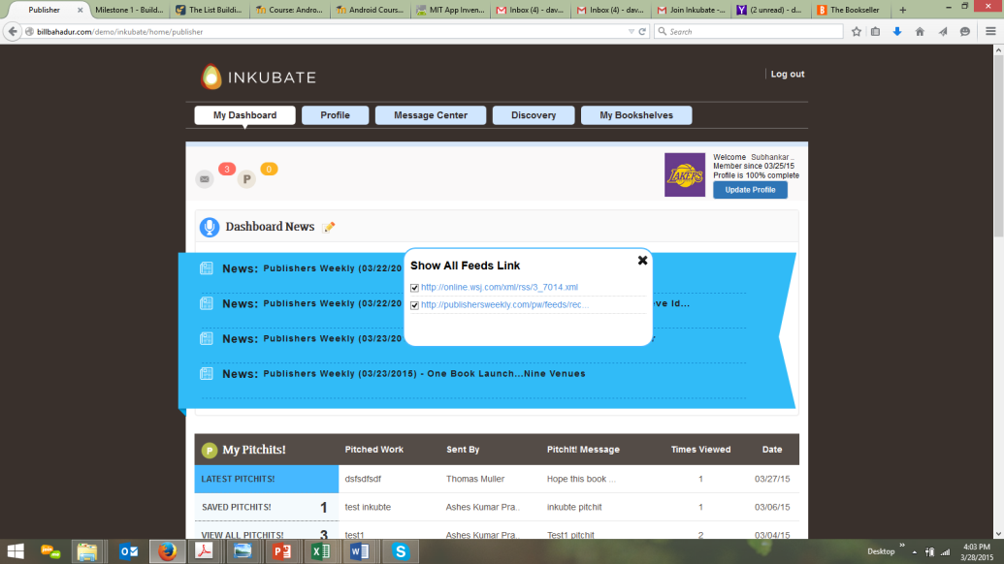

1. The Dashboard Newsfeed text for the word “News” has become larger for some reason.
2. The “:” after the word News is not one character space away from the “s” in the word News for some reason.
3. The DashboardNewsfeed ability to link to the RSS site’s article does not work anymore when I click on any piece of the text. The linking only happens when I click on text after the date (e.g., 3/19/14).
4. The Dashboard Newsfeed image is not displaying.
5. The Dashboard Newsfeed stops scrolling after 3 seconds.
6. Within the Dashboard Newsfeed, the user cannot add RSS feeds to their dashboard. I thought this was a feature that we were going to offer?
7. Within the Dashboard Newsfeed, I do not see the single PitchIt! message that was sent to the AEP from Thomas Muller in the newsfeed for me to test the ability to click on the PitchIt! within the newsfeed and link to the PitchIt! message.

**My PitchIts!**

**Global Issue** – There are no conversation icons next to any PitchIts! within the entire section within the PitchIt! Message column, so there is no way to see conversation between AEPS and writers and test the validity of the capability/function.

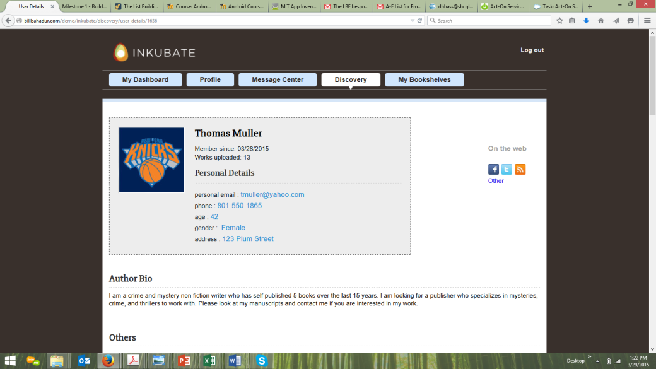

1. When I clicked on the 1st PitchIt! message’s author name (Thomas Muller) within the Latest PitchIts! section, it linked to the old profile of the writer. Why? This should link to the updated profile UI which is part of the writer and AEP profiles.

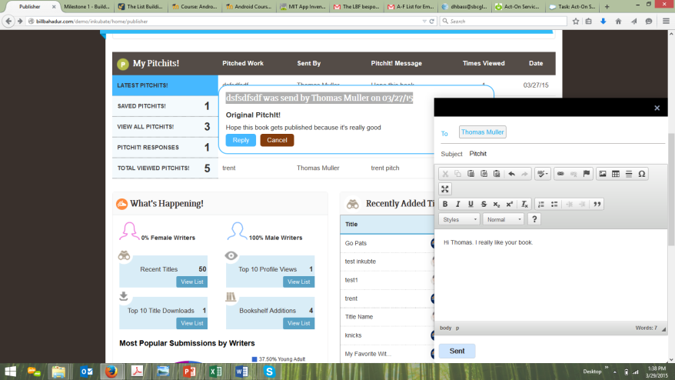

1. When I clicked on the PitchIt! message within the 1st PitchIt! message (dsfsdfsdf was send by Thomas Muller on 03/27/15) from Thomas Muller. It still displays the word “send” vs. “sent”, in the message header.
   1. This header issue occurs within every PitchIt! pop-up message.
2. The radio button at the bottom of the PitchIt! message back to Thomas Muller displays “Sent” vs. “Send” in the text of the radio button.
3. I then clicked on Reply in the PitchIt! message pop-up and the subject is “PitchIt”, but the message name within the PitchIt! message pop-up is “dsfsdfsdf”. The subject should be “Thomas Muller has pitched the title dsfsdfsdf to you”.
   1. This specific issue occurs in every PitchIt! message response pop-up.
4. The brown radio button “Cancel” is supposed to display “Close” and be colored green.
   1. This specific issue occurs in every PitchIt! message pop-up.

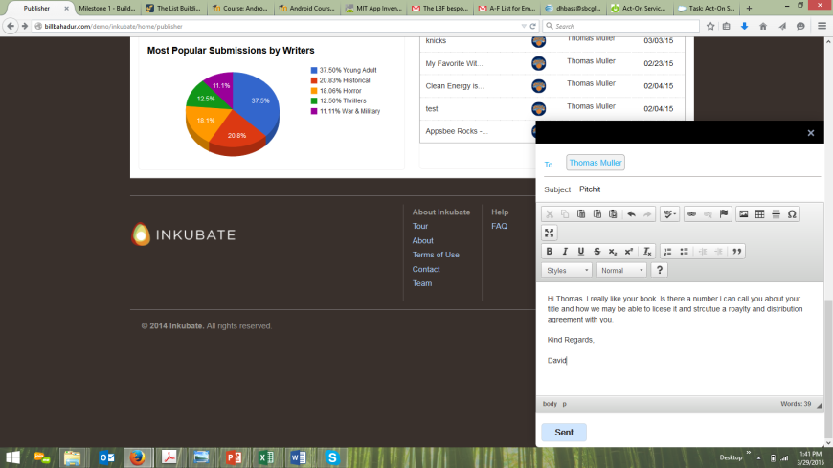

1. When I clicked on the PitchIt! message within the 1st PitchIt! message (dsfsdfsdf was send by Thomas Muller on 03/27/15) from Thomas Muller, and started to type my reply, the message center pop-up shifted vertically down the page when I hit the return button on my keyboard to write “Kind Regards” and then shifted down the page again when I hit the return button to type in “David”. This is a bug and needs to be fixed. The PitchIt! message should be right next to the PitchIt! section, not the bottom of the UI.
   1. This specific issue occurs in every PitchIt! message response within the Message Center.

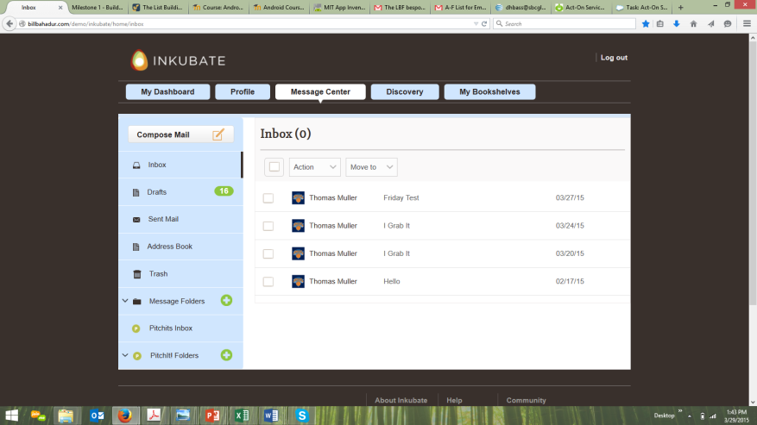

1. When I hit the “Sent” button within my response to Thomas Muller from the PitchIt! message (dsfsdfsdf was send by Thomas Muller on 03/27/15) the screen again turned entirely white in color and then the UI took me directly to the PitchIt! Inbox within the Message Center. This is the exact same bug I reported over the last several communications and it is still not fixed.
   1. This specific issue occurs in every PitchIt! message response within the Message Center.
   2. And, the PitchIt! Inbox should display “PitchIt! Inbox” vs. “Inbox”. It is confusing as to whether or not the user is in their Message Center Inbox or their PitchIt! Inbox.

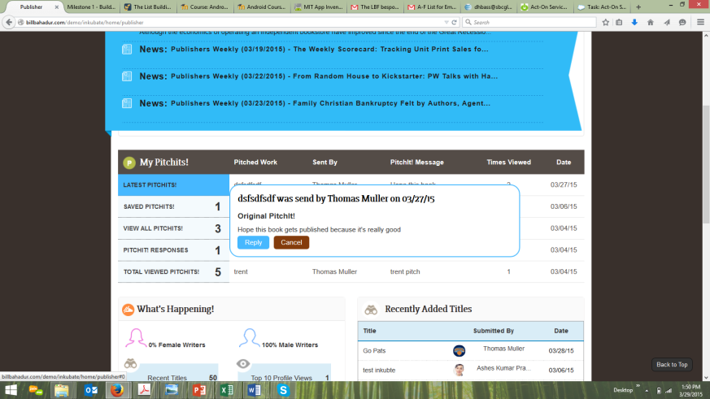

1. I then went back to the Latest PitchIts! section to see if my response to Thomas Muller (dsfsdfsdf was send by Thomas Muller on 03/27/15), I just sent back to him was recorded within the PitchIt! communication and it is not there as a conversation icon in the PitchIt! pop-up message.
   1. This specific issue occurs in every PitchIt! message response within the pop-up.

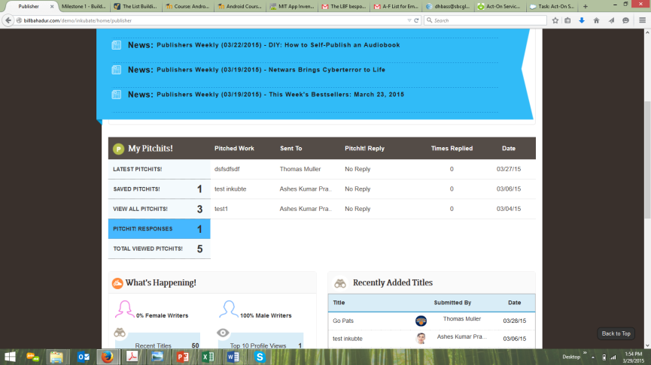

1. I also went into the PitchIt! Reponses to see if the PitchIt! message response to Thomas Muller (dsfsdfsdf was send by Thomas Muller on 03/27/15) was registered in the list and it was not.
   1. This specific issue occurs in every PitchIt! message response I sent back.

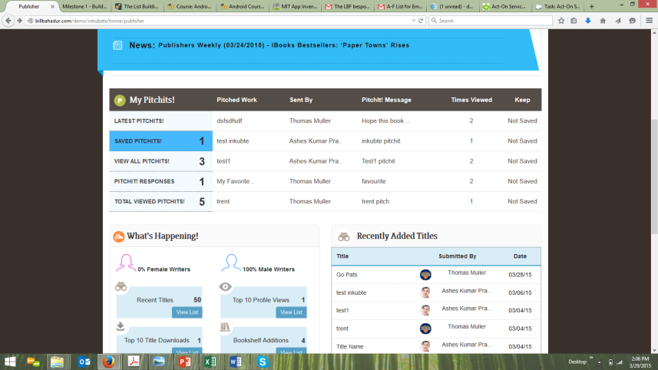

1. The Saved PitchIts! section is displaying “1” when there are “5” saved PitchIts! in the list. This is incorrect. The counting feature is not working.
2. All the same linking and display issues (e.g., to Thomas Muller profile page, pop-up message header text, etc…) that occurred within the Latest PitchIts! section occur within Saved PitchIts!.
   1. I am sure the global issues occurring within Latest PitchIts! are affecting all the PitchIts! sections.
3. The 2nd to last column within the Saved PitchIts! section should not display Times Viewed in the header. The column header should be Ranking and the feature should enable to rank the importance of the PitchIt! they have saved on a scale of 1, 2 or 3. This functionality does not exist within this section. Why?Please look at the PPT dated 1-16-15 (Inkubate PitchIt! UI Updates) to see what the functionality/feature should look like.
4. The last column of the Saved PitchIts! section is supposed to let the AEP either keep or delete the PitchIt! from their UI. This functionality does not exist within this section. Why?Please look at the PPT dated 1-16-15 (Inkubate PitchIt! UI Updates) to see what the functionality/feature should look like.

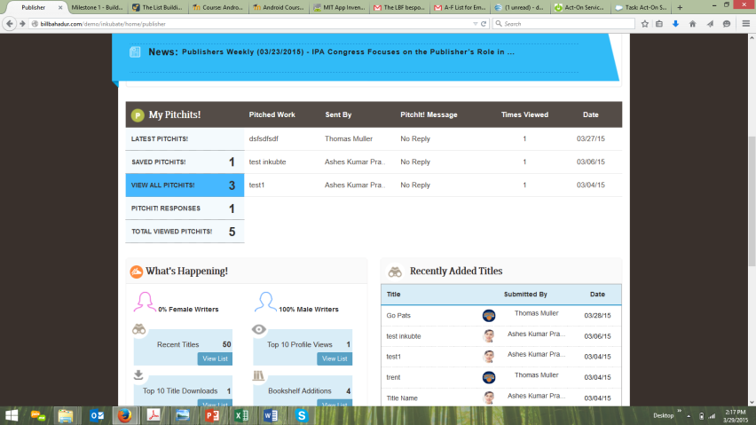

1. All the PitchIt! messages within the list of the View All PitchIts! display “No Reply” in the PitchIt! Message column and the PitchIt! messages themselves cannot be clicked on an opened up. This section should display the PitchIt! repsonses from the AEP to the writer and when the AEP opens up the PitchIt! message the pop-up should show the conversation icon within the pop-up PitchIt! message.
   1. This specific issue is a global PitchIt! message functionality error.
2. When I click on any of the writers names’ (e.g., Thomas Muller, Ashes Kumar, Ashes Kumar) within the Sent By column of the View All PitchIts! Section, they ALL link to the old profile UI of Thomas Muller.

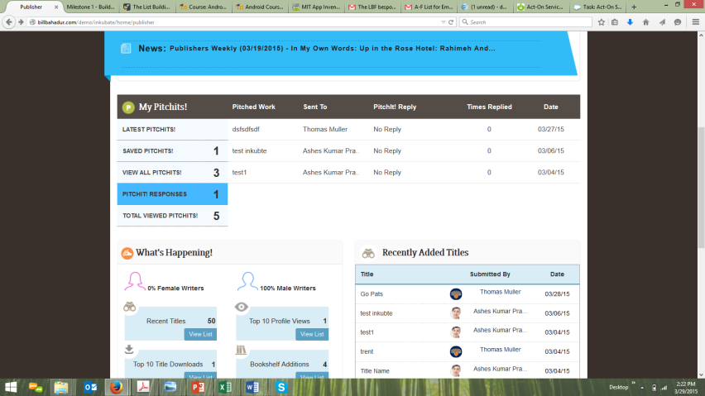

1. The PitchIt! Reponses section states there is “1” response, yet there are “3” PitchIt! messages within the section. The counter is off and needs to be corrected.
2. All the PitchIt! messages within the list of the PitchIt! responses have “No Reply” in the PitchIt! Message column and the PitchIt! messages themselves cannot be clicked on an opened up. This section should display the PitchIt! responses from the AEP to the writer and when the AEP opens up the PitchIt! message the pop-up should show the conversation icon within the pop-up PitchIt! message.
   1. This specific issue is a global PitchIt! message functionality error.
3. When I click on any of the writers names’ (e.g., Thomas Muller, Ashes Kumar, Ashes Kumar) within the PitchIts! ReponsesSent By column, NONE of these names link to a profile.

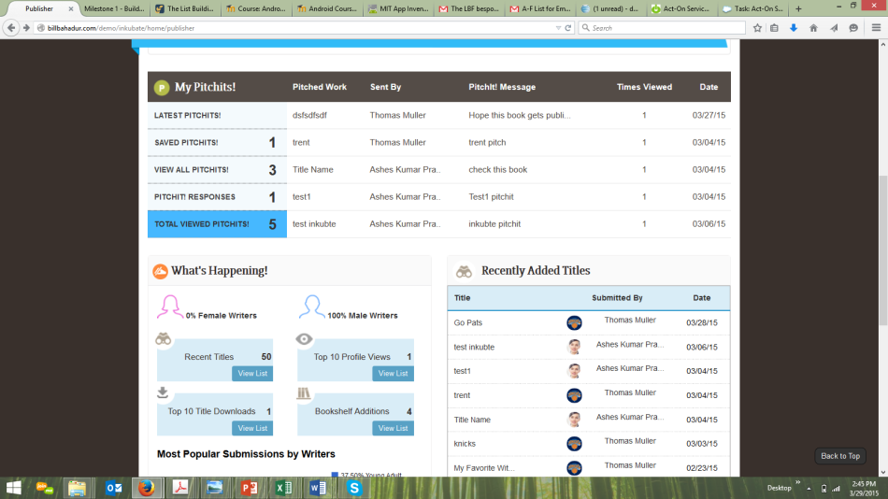

1. When I click on any of the writers names’ (e.g., Thomas Muller, Ashes Kumar, Ashes Kumar) within the Total Viewed PitchIts! Sent By column, NONE of these names link to a profile, but display a mouseover pop-up.

What’s Happening?

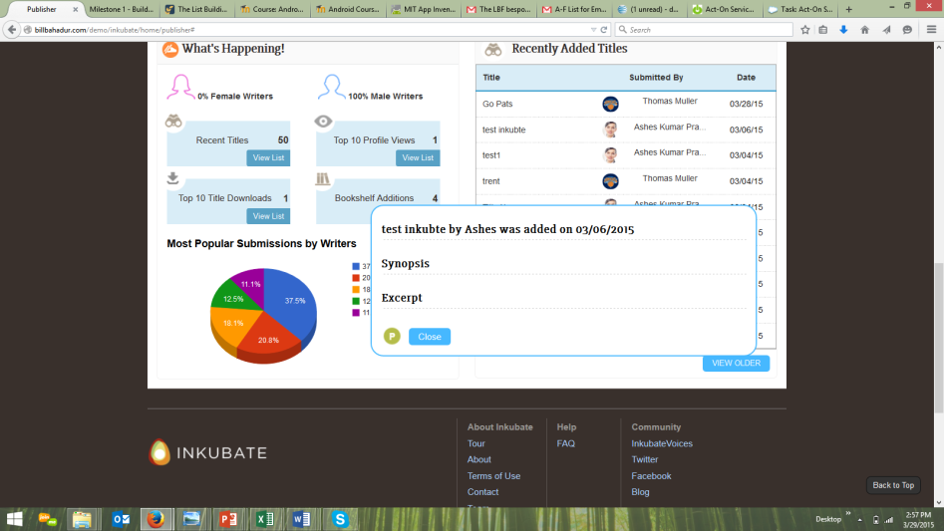

1. Within the Recently Added Titles section, I clicked on the title name and it did not display a Download Title radio button.
   1. This specific issue is a global What’s Happening section functionality error within the other 3 sections (Top 10 Title Downloads, Top 10 Profile Views, and Bookshelf Additions).
2. When I clicked on the “P” PitchIt! icon, the UI took me to the Newsfeed section.
   1. This specific issue is a global What’s Happening section functionality error within the other 3 sections (Top 10 Title Downloads, Top 10 Profile Views, and Bookshelf Additions).
3. Within the Title pop-ups that do have a Download Title radio button, the button’s color is blue, and then the Close radio button is also colored blue. The correct sequence of colors for these radio buttons should be:
   1. Download Title – Blue color
   2. Close – Green color
   3. These specific issues are a global What’s Happening section functionality error within the other 3 sections (Top 10 Title Downloads, Top 10 Profile Views, and Bookshelf Additions).

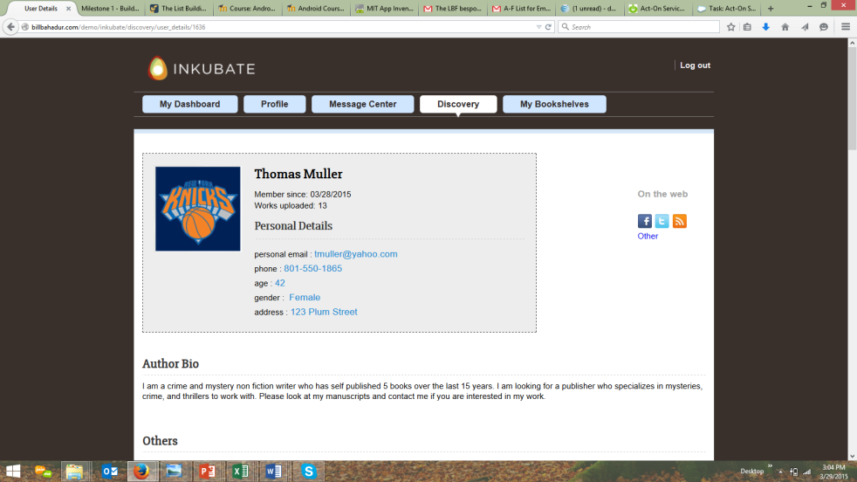

1. Within the Recently Added Titles section, I clicked on the writer profile imagelinked me to the old profile UI. This was working perfectly previously. Why is this so broken again?
   1. This specific issue is a global What’s Happening section functionality error within the other 3 sections (Top 10 Title Downloads, Top 10 Profile Views, and Bookshelf Additions).

**Profile**

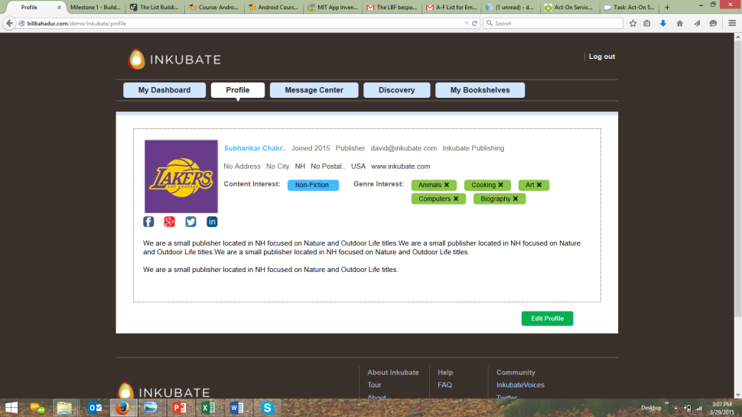

1. This profile view has reverted backwards and the social links are not working at all. Same as the writer section. This was working perfectly only a few days ago. Why have we reverted backwards here?
2. Each time I click on the social tag icons (Facebook, Google+, Twitter, LinkedIn), they produced a 404 page error message.

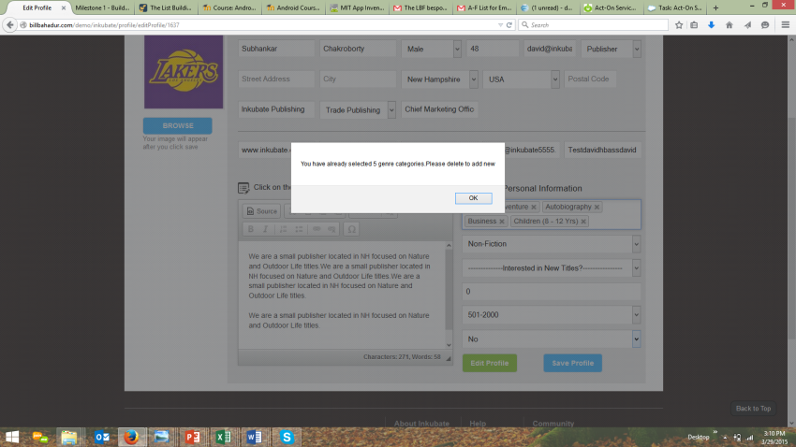

1. I went into the Edit Profile section and the error message “You have already selected 5 genre categories. Please delete to add new”. This message now makes more sense to me, but it needs to be more descriptive:
   1. “Your profile already has 5 genre categories selected. To change or add different genre categories to your profile, please delete the current genre categories on your profile page and then go back to the Edit Profile section’s What is your genre interest picklist to add more or different genres to your profile”

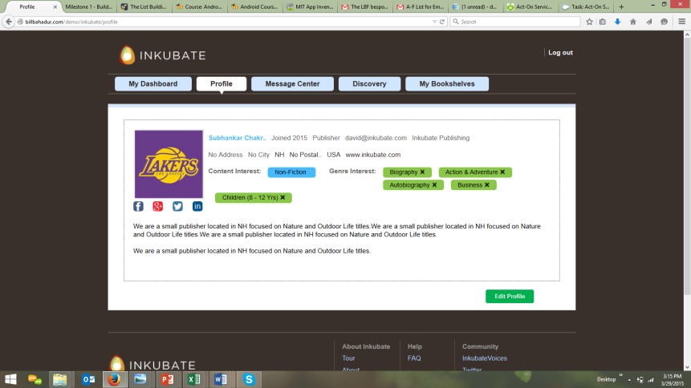

1. After I updated the genres within the Edit Profile to adjust the categories because I saw the error message about having 5 genre categories already assigned to my profile, the next time I looked at my completed profile the UI displayed the last genre in the incorrect section. Again, we have reverted backwards in this functionality. Why?

**Message Center**

This section’s issues are the exact same ones within the writer side of the application. I am hoping the updates on the writer side will carry over to the AEP side with the message center.

**Discovery**

This section was working perfectly the other day and now it is completely broken. Why?

NONE of the left side navigation’s filtering capabilities are working. Why?

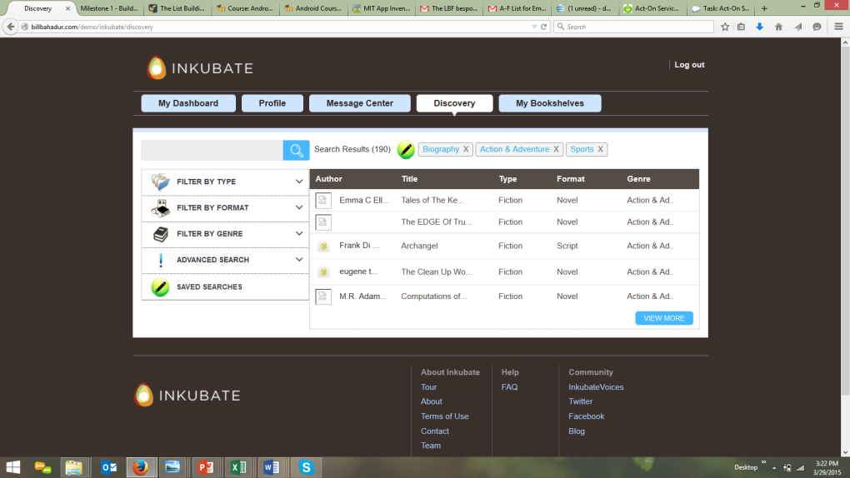

1. Within the Saved Searches section of Discovery, the title jacket covers are not appearing. This was working the other day.
2. Within the Saved Searches section of Discovery, when I click on the writer’s name I cannot link to their profile page. This was working the other day.

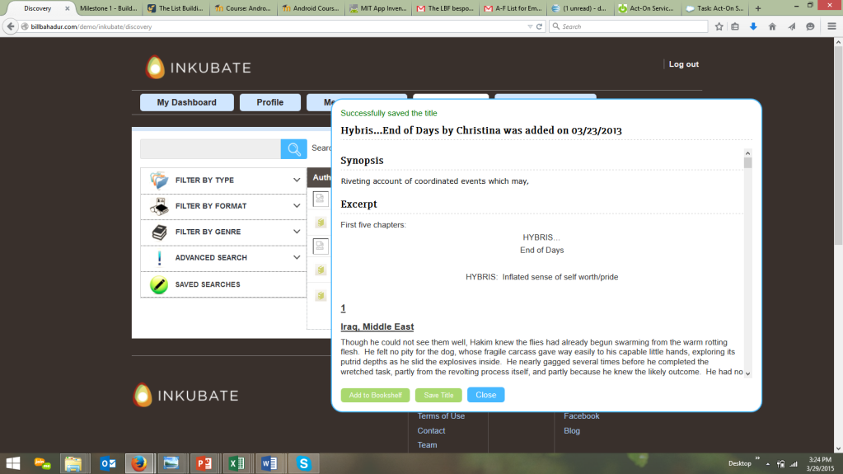

1. Within the Saved Searches section of Discovery, the 3 radio buttons (Add to Bookshelf – green button, Save Title – green button, and Close – blue button) need to conform to the other color schemas we have created elsewhere within the application. Please make the following updates to the 3 radio buttons:
   1. Add to Bookshelf – Blue colored
   2. Save Title – Brown colored
   3. Close – Green colored
2. Within the Saved Searches section of Discovery, I clicked on the title (Hybris…End of Days by Christina added on 3/23/2013) and saved it to the Saved Titles section (this feature worked when I went into the Saved Titles section of My Bookshelves), there is a message in green text at the top of the pop-up.
   1. I like this design feature, even though we did not have this in our design documents. But, the text does not display in a place where the AEP knows this title has been saved. I would suggest deleting the text and creating another pop-up message that appears for 3 seconds within the middle of the title pop-up UI that tells the AEP – “This Title has been Saved”.
3. The name “Christina” within the Title header (Hybris…End of Days by Christina added on 3/23/2013) should be her first and last name, not just her first name.

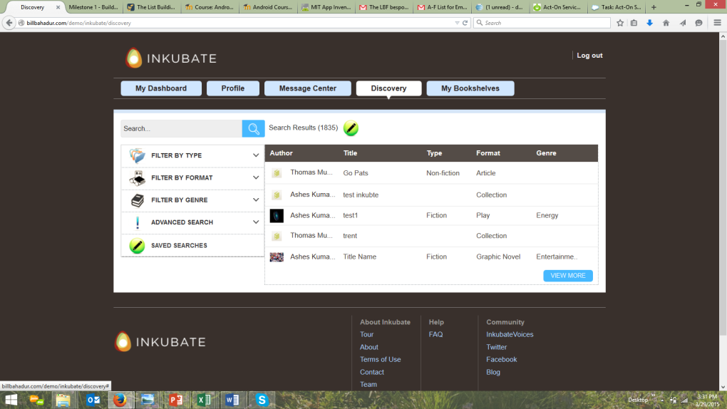

1. When I added the previous title (Hybris…End of Days by Christina added on 3/23/2013) to David Bass Favorite Bookshelf (this function did transfer the title onto my bookshelf), the screen turned white for 1.5 seconds and then took me back to this screen. This is not what I asked for in my comments the other day. I asked for the screen to remain the same (e.g., with the title pop-up open) so the AEP could go right back into the title pop-up that displays the synopsis and excerpt. This is still not working correctly.

**My Bookshelves**

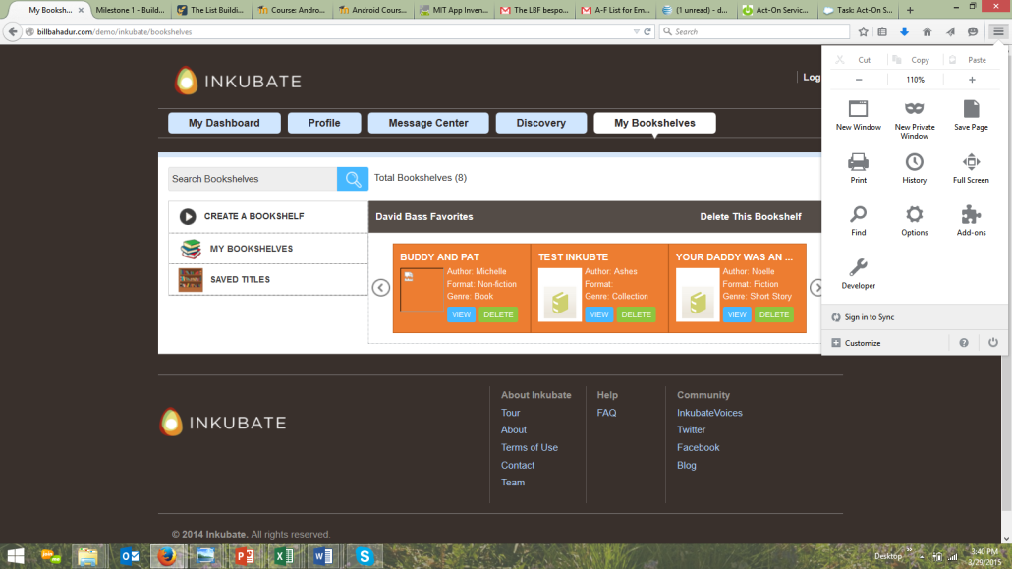

1. The bookshelf scroll bar is not displaying the book jacket image.
   1. Jay K’s bookshelf displays the default jacket cover images, but my bookshelf does not.
2. The bookshelf scroll bar is ONLY displaying the book jacket image and full view of the book metadata in 110% browser view. This was working perfectly in 100% browser view last week. We reverted backwards. Why?

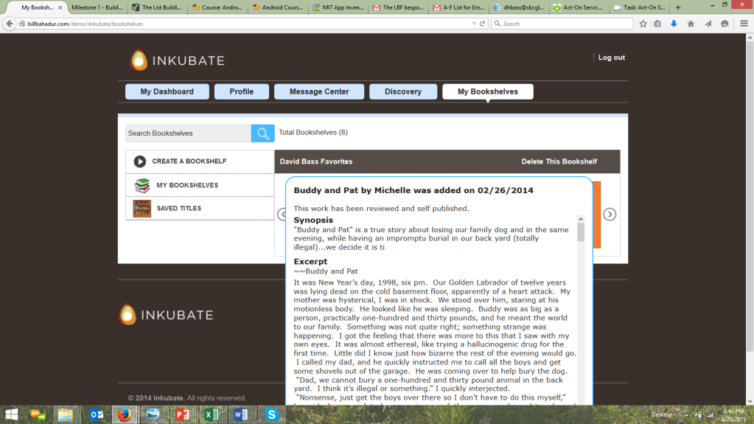

1. The title pop-up for Buddy and Pat by Michelle was added on 2/26/2014. The header is missing Michelle’s last name. The header should display the first name and last name.
2. When I scrolled down to the bottom of the title pop-up and clicked on the conversation icon, it popped open the Message Center’s message UI (which is correct), but when I closed the message pop up, the screen completely changed and took me back to the main My Bookshelves UI. This was not my instruction last week. My instruction was to keep the title pop-up open so the AEP could back and continue to choose to either read the synopsis and excerpt, save the title, add it to another bookshelf, or share the bookshelf with another AEP (sharing is currently not available in ANY Bookshelf feature). This entire functionality set needs to be fixed so anytime an AEP clicks on a radio button or icon at the bottom of a title pop-up, the pop-up stays open.