**Email Feature**

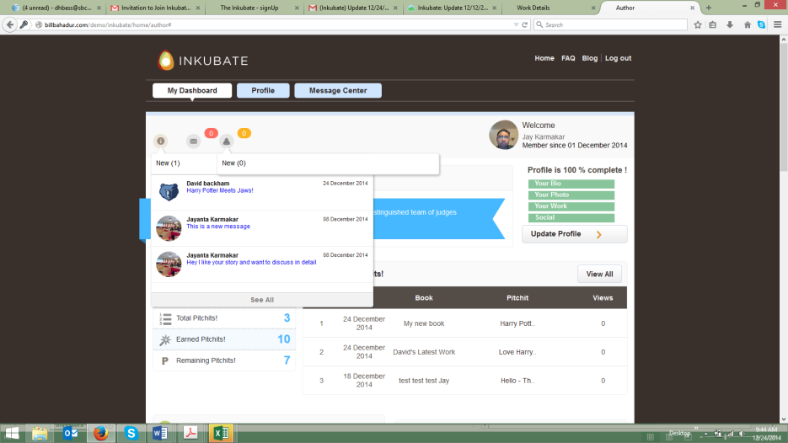

1. When an author clicks on the email message icon. The Invite icon is displaying the email messages underneath it. It should display under the email message icon. (screen shot above)Fixed
2. When an author clicks another function on the UI (e.g., the bell icon), both the email messages and the bell icon messages stay open simultaneously. It should close automatically when another button is clicked on by the author. (screen shot above)
3. We need a tool tip to let the author know what the email icon function is and what an author can do with it. Fixed.
4. The “Compose Mail” feature takes the author to an entirely new UI screen. The transition takes a few seconds for the screen to render again. We need to make this transition happen without the delay and a new UI display. Selecting this feature to compose a message should simply toggle to this functionality within the existing UI without having to refresh the entire page. I would suggest having a “pop up” message in a new UI display in lower right hand corner of the exiting UI (e.g., how Google Mail works) so the author can create a new message. Fixed
   1. The ability for an author to compose a new email in the “to” section is not working correctly. The author must select the “+” icon to select an email address. The author should have the ability to compose a message by typing in an address with an auto fill capability and use the “+” feature to look within the author’s address bookDone
   2. When the “+” icon is selected by the author, it displays a pop up address book with email addresses only for “authors”. (screen shot below)
      1. I would suggest deleting the reference to “Select a Author” and make this list header “Your Address Book”. This is done
      2. The navigation has “numeric” references to the number of email pages where there are stored emails for the author to select from are underneath the initial list of addresses displayed, but they disappear once an author selects one of the numbers below. Therefore, disabling the ability for the author to search for additional addresses after they select the first navigation feature. This functionality needs to be fixed. **this is done**
      3. I would suggest “alphabetizing” the email address relationships and having a header navigation link for the author to select from vs. having the navigation within the footer of the address book (e.g. when the author sees the header Your Address Book directly underneath there are alphabetical links by last name underneath the main header **THIS IS DONE**
         * Your Address Book

A B C D E F G H I J K L M N O P Q R S T U V W X Y Z

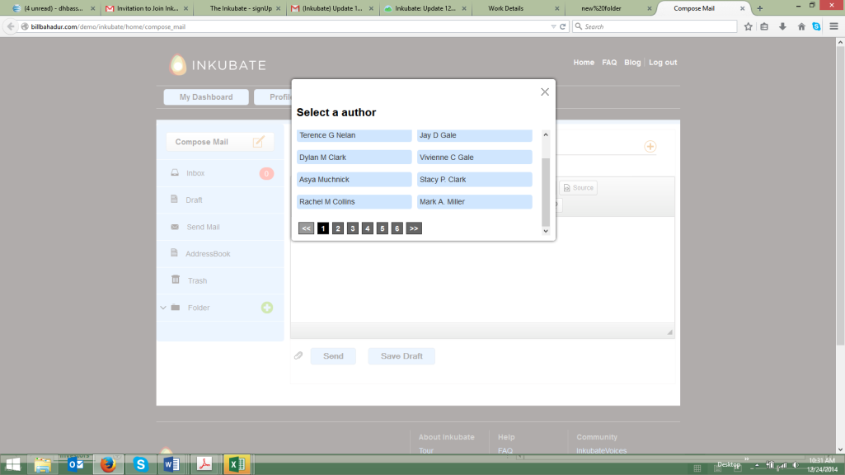

1. The text editor within the compose email feature automatically “double spaces” the lines for the paragraphs. I would delete this functionality and make the line spacing single lines...[need to do R & D]

.

1. The text editor does not automatically detect incorrectly spelled words within the text. Can this type of feature be turned on within the CK Editor tool we are using? [need to do R & D]
2. I saved a draft email (it worked perfectly, but, the notification within the left hand navigation pane “Draft”) does not display the numeric count of saved draft messages. (screen shot below) this is done Author is missing it.
3. The inbox notification displays a “0” as a reference. We should only display a numeric reference when there is a new message in the inbox. Most email systems do not display “0”. (screen shot below)this is done

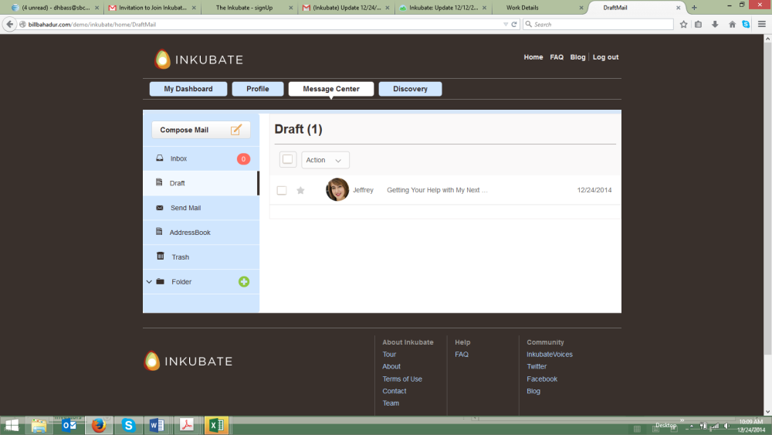

1. The Send Mail header in the left navigation panel of the email function should be “Sent Mail”. (screen shot above) this is done Author is missing it.
2. The create/add a new folder feature “+” needs to be tightened up slightly (e.g. less horizontal space between Add a New Folder – Folder Name – Send – Cancel). This pop up box has too much white space between each of these areas. (screen shot below)(design)
   1. The “Send” button should state “Create” or “Save”. Your choice. Either term is fine by me(desing issue)...need to do this

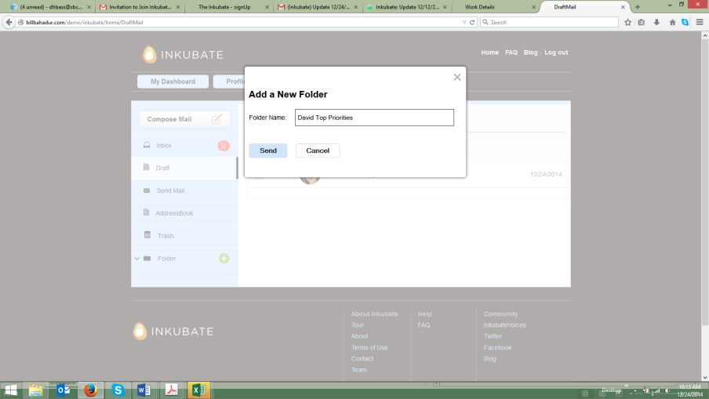

1. When I went back into the Folders section, it displayed new folder (1), and David Top Priorities (0). What is an author placing in these folders? Saved emails? How do they know how to do that? How does an author delete a folder? (screen shot below)delete a folder is done – Once a folder is created, it should show up automatically. Expanded. Alignment issue on long folder name. We should truncate them. Full name should come on mouseover.
   1. This is the UI display when I clicked Folders. I am assuming this is a mistake, as it is the draft email message I saved. Correct?this is done. We need to hide it from inbox while moving to a new folder but when a folder is deleted, the emails should cme back to inbox.
2. The popoup should read “Are you sure to delete the folder? “Deleting of folder will not delete the messages, they will be moved to your inbox. Messages must be deleted individually.””

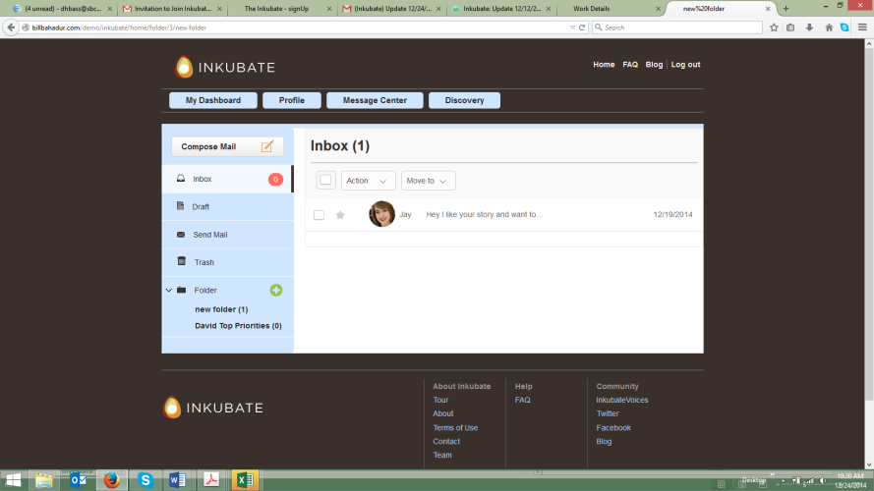

1. When I was in the folder section and selected “Compose Mail” icon, a new tab opened up within Mozilla. This is a new functionality capability vs. when I wanted to “Compose Mail” previously. (see notes above). I am assuming this is a mistake. (screen shot below)

This is solved

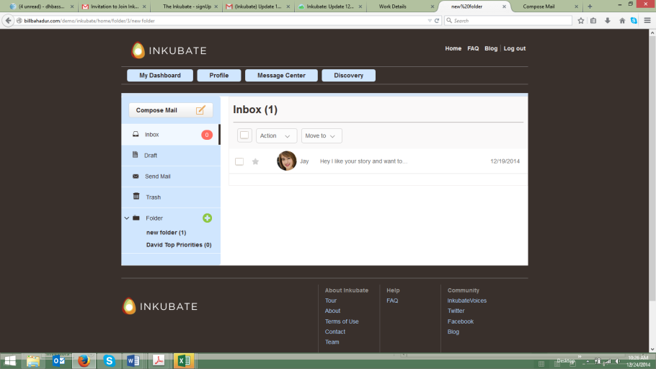

1. When clicking on Action, the picklist should be Delete, or Mark (e.g., important “flag”). I am not sure we need to have “Action” repeated within the picklist.Need to do this
2. Same issue with Move to. It repeats.

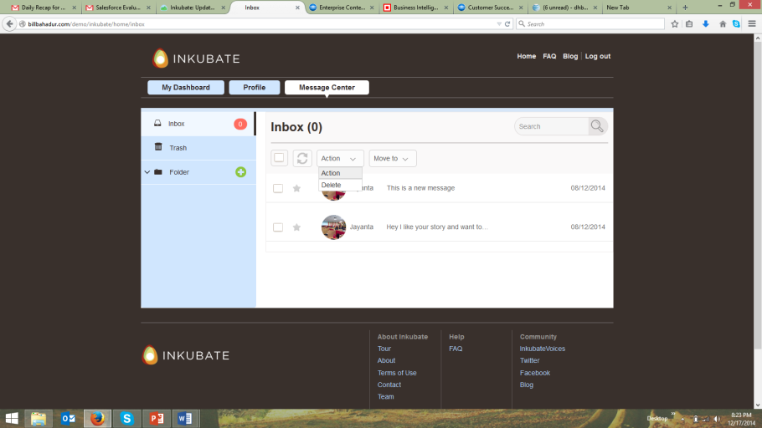

1. The delete message function worked within the message center, but when I went back into the left side navigation, the message could not be placed back into the inbox folder or moved to any other folder. We need to fix this feature if an author accidently deletes a message and wants to place it back into another area within the email message center.

This is done