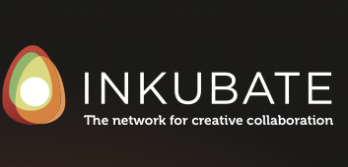

**INKUBATE’s Sponsorship of the Woodstock Writers Festival Makes Every Writer & Agent, Editor and Publisher (AEP) a Winner!**

(Portsmouth, N.H.) March 16, 2015. For its 4th consecutive year, INKUBATE pulls out all the stops to support writers and one of its own founder’s—Stacy Clark—who will be a featured author and presenter at the weekend’s fabled Story Slam.

As part of INKUBATE’s sponsorship, over 300 Prize-Winning [Golden Tickets](http://www.inkubate.com/WWF) will be distributed at the Festival. For full-weekend pass holders, workshop writers and featured panelists, Golden Tickets will be discovered inside of a handcrafted, custom wrapped Fruition Chocolate bar. One grand-prize winner will receive a ‘Year of Books’ from The Golden Notebook, Ulster County’s beloved independent literary hub.

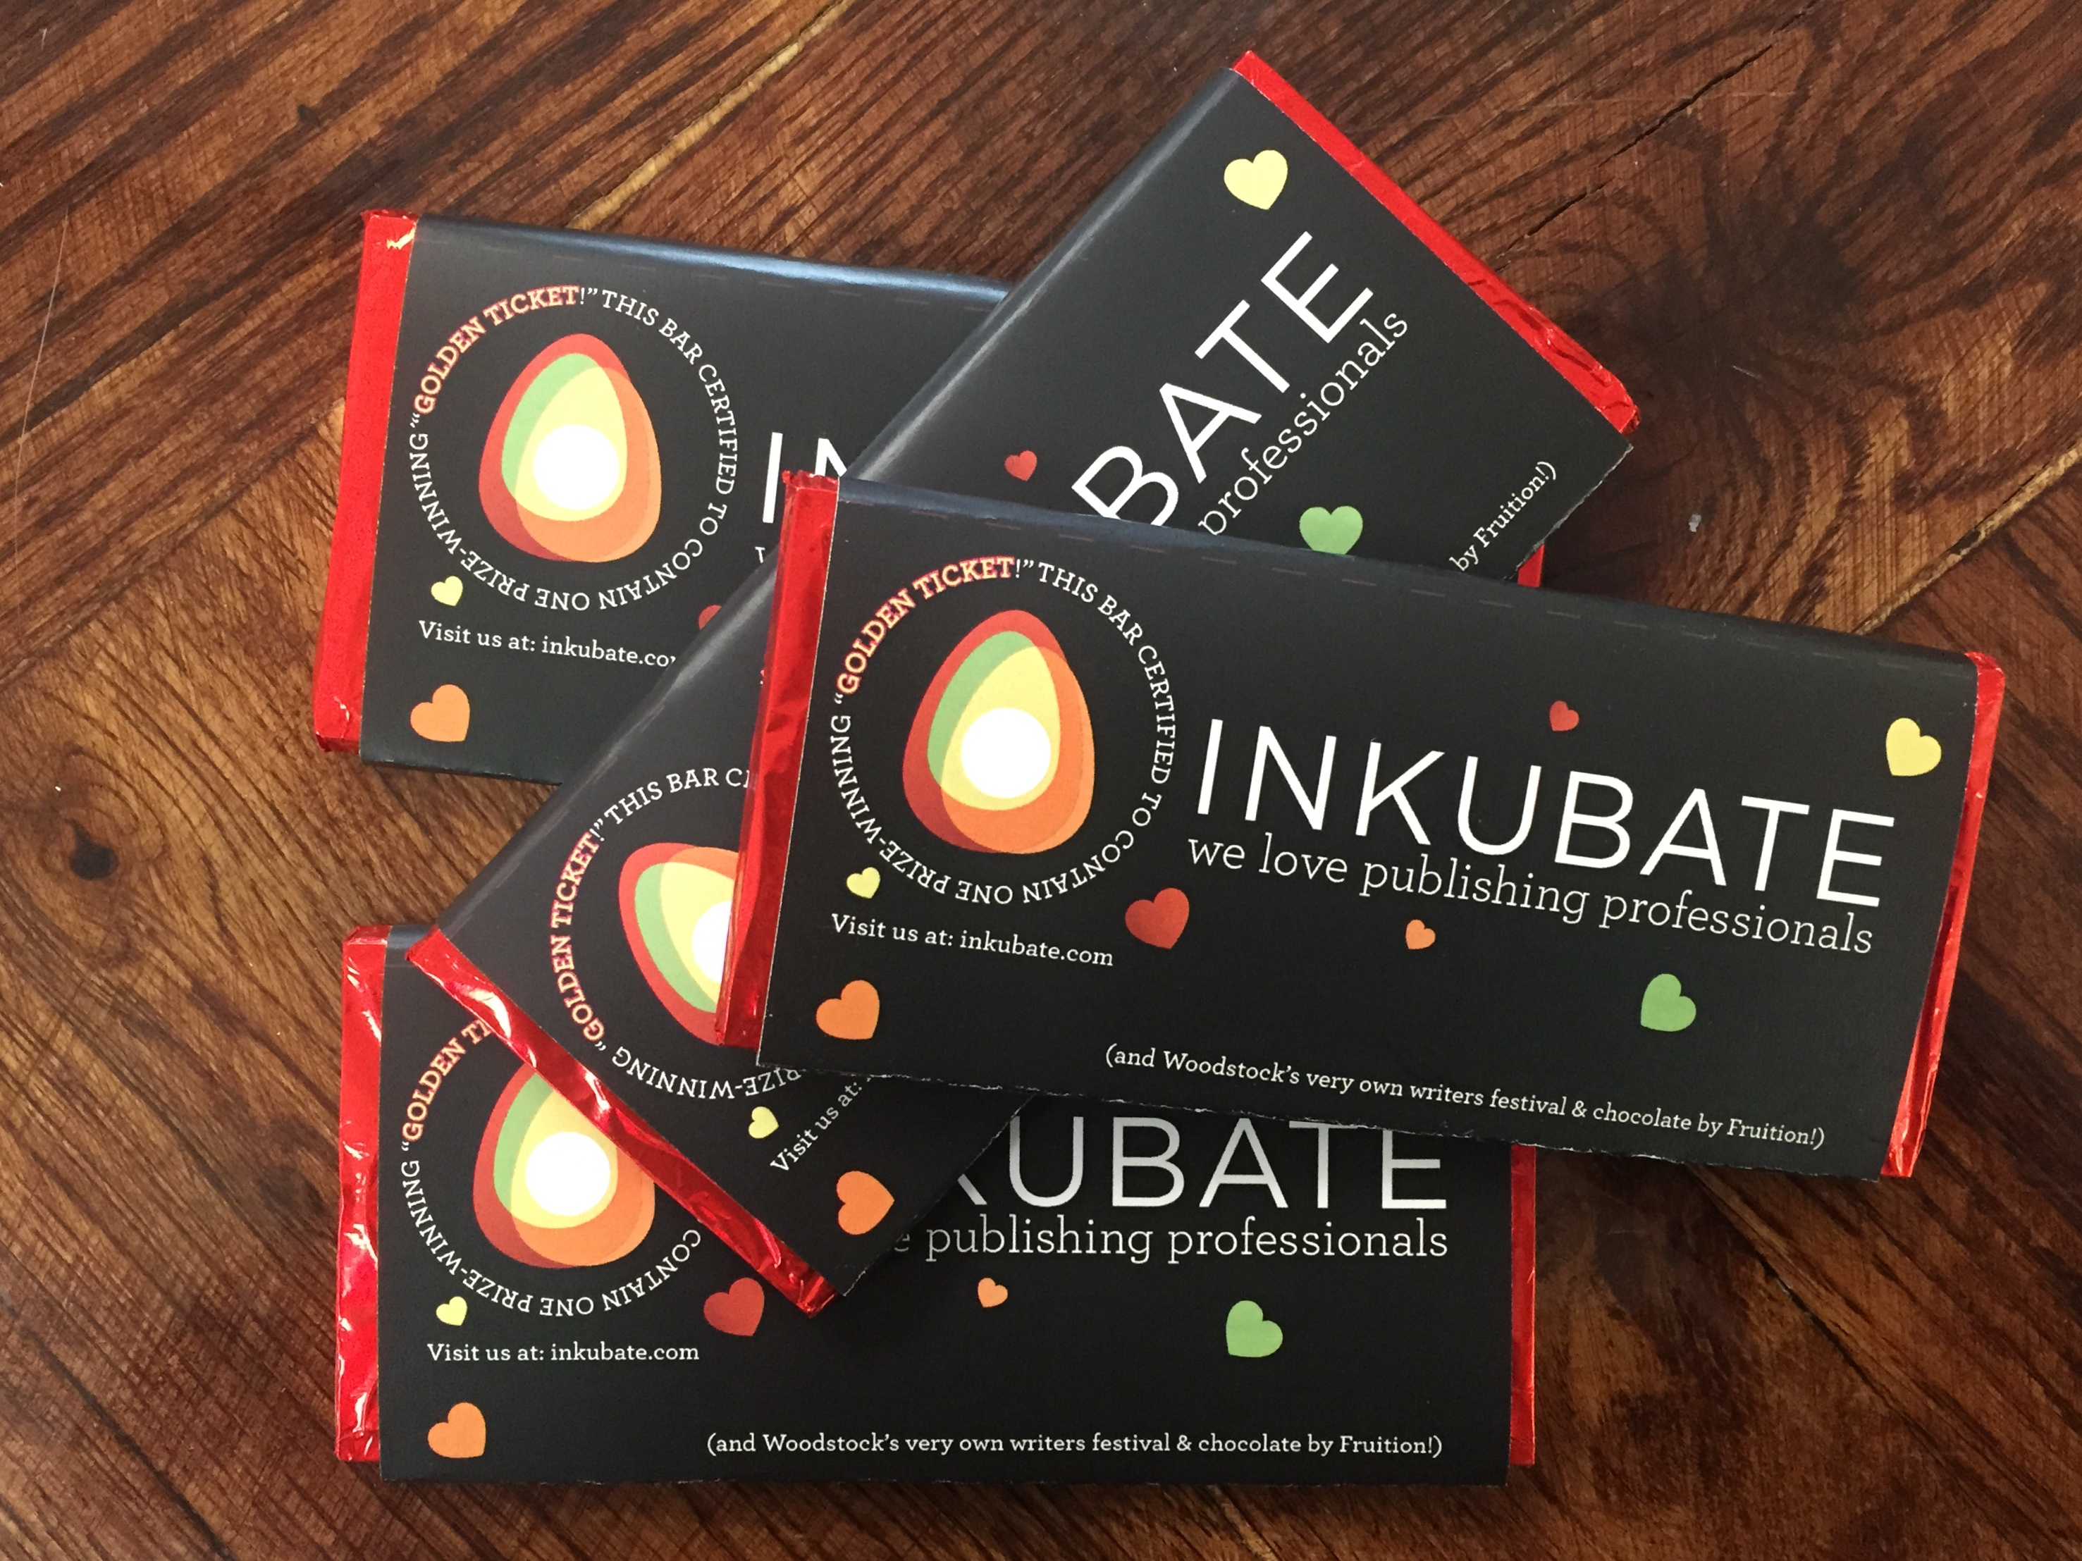INKUBATE’s groundbreaking technologies for the publishing industry will be front and center at the conference. INKUBATE will be providing a “sneak peak” of its soon to be released SaaS application that connects Writers to mainstream Agents, Editors & Publishers (AEPs) with the first of its kind [B2B social networking platform.](http://www.inkubate.com)

Showcased two week’s ago at the Independent Publishers Guild’s ([IPG](https://www.facebook.com/pages/Independent-Publishers-Guild/206413202758947)) Spring Conference in Oxfordshire UK, INKUBATE was featured as a Top Innovator in the content creation and commercialization space receiving high praise from leading independent publishers interested in receiving targeted mini-pitches from aspiring and established writers.

The IPG will be promoting INKUBATE’s “Network for Creative Collaboration” as part of its “Meet the Innovators” series at the London Book Fair (LBF) on April 14-16, 2015. INKUBATE’s CEO Jay Gale and CMO David Bass will be showcasing the next version of the INKUBATE platform at Stand 6E10 to explore why Inkubate is "The Place to Go for Talent.”

**About Inkubate**

INKUBATE is the world’s first B2B collaborative network enabling writers to upload, categorize, edit and pitch original manuscripts to traditional agents, editors and publishers looking to discover and market successful projects that sell.

Inkubate was created by CEO, Jay Gale, who was frustrated by the difficulty that college friend, Stacy Clark, was having pitching her children’s book manuscript to mainstream publishers. Jay went to work brainstorming how a well-organized online platform could help launch the careers of worthy writers. With three co-founders and Inkubate’s skilled finance and marketing team, Gale designed the user interface that writers love and the tools and functionality that AEPs need. Since Inkubate’s V.10 launch, Oakland, CA literary agent Andy Ross spotted Clark’s work on INKUBATE, signed her as a writer, and three days later sold her story, *When the Wind Blows,* to Holiday House.

Media Inquiries: Stacy Clark, EVP Corporate Communications/Founder

[stacy@inkubate.com](mailto:stacy@inkubate.com)

Investor Inquiries: Jay Gale, CEO/Founder

[jdgale@inkubate.com](mailto:jdgale@inkubate.com)