1. Introduction

This document describes the modules and the requirements for developing the platform for home management. This will be typically a clone of homezada.com both in terms of functionality and mobile app activity. Basic home management sections are for the moment as with HomeZada

1) INVENTORY, 2) TODOS , 3) PROJECTS. These specific functionalities

of these sections have to be specified more closely, since we have

some features that we don't want to add, others that we would like to

add that HomeZada doesn't have.

We will be developing the same. Alex will provide the bootstrap template for the website.

2. Objective

The objective of this document is to identify the requirements to a level of detail that will allow a project schedule to be generated for all the project phases and fixed price proposal. It is expected that follow-on phases, especially the Design Phase, will result in more detailed definition and also some changes to the requirements expressed in this document. These changes are a normal part of the software development process.

3. Scope

The system will be completely database driven. The major tables of the database will be user, inventory, to-dos, alerts, accounting(debit/credit), projects etc. The database design will come up with multiple set of entity-relationship model.

Content pages, email templates can be generated from the administrative panel.

I am providing you with some quick details of some Master Databases as example and for your understanding. You may elaborate or recommend your suggestions, to improve and also for the other Tabs (sections) not elaborated here, in your **“Proposal”** and **“Design”** please.

**Sprint 01:**

1. Planning the site layout and correction according to information architecture practices.
2. Appsbee site planning team will do a competitive study.
3. The information architecture team will communicate with your team in multiple session to understand the target audience of the site, if the previous analytics data available that will help greatly to figure out user flow and where the users used to drop off. That way, in the new site we can avoid those mistakes.
4. From those above mentioned parameters, the UE team will define what content of your site can be placed on which position to increase user experience and how to make people adhere to the site.
5. Team will create/modify template/pages on the given bootstrap theme.

**Sprint 02:**

1. Administrative panel development :

Dash Board

o Number of accounts created, hyper linked to the user list.

o Number of projects created

o Number of to-dos

o Number of apps downloaded

o Number of errors reported

7. Inventory

-Admin can create default inventory category.

-Admin can create default items under each category.

-Can view all the inventory items added by different users

8. User management

- Manage Users/Ban Users

- Can login to any user account by using listed userid/password in the administrative panel.

- Can send notification to all the user to their email.

9. Manage To-dos

- Admin can create default To-dos category.

-Admin can create default items under each category.

-Can view all the to-dos items added by different users

10. Manage Projects

- Admin can create default/sample projects types along with sample pictures.

-Can view all the projects added by different users

- Change settings. This includes notification setting, site

settings (result per page, page title etc.).

10. Admin can edit all content driven pages.

**Sprint 03:**

* Main Page
* What is TheSmarterPlace
* Sign Up/Log in
* How it works
* Testimonial
* Pricing
* Contact Us
* FAQ
* Signup / login. Facility to login via facebook.
* Capacity to add home.
* Create inventory. Each inventory items can be added with the fields shown in the following screenshot. People will be able to upload document, picture of the related item.

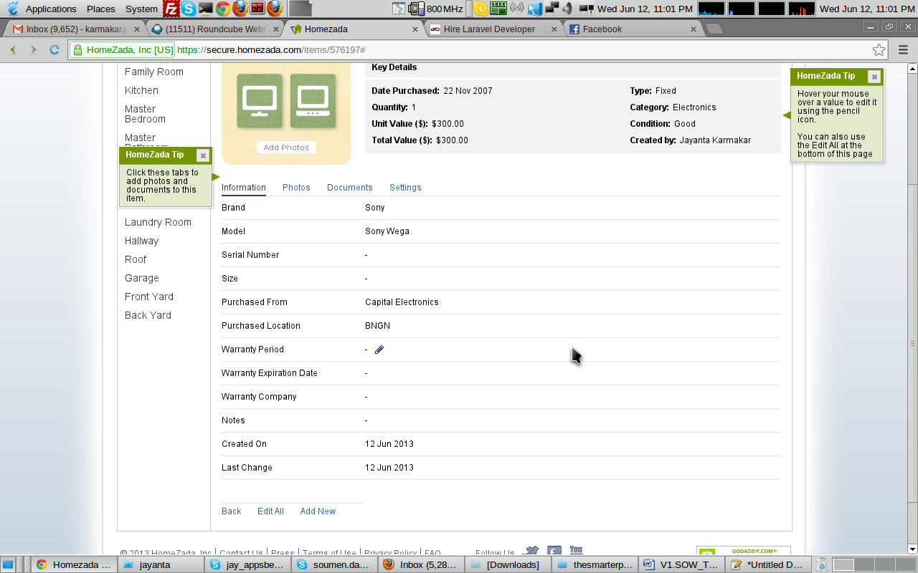

* Export inventory to PDF.
* Export inventory to Xls.
* List all the inventory data – top level. Please check the following screen.
* 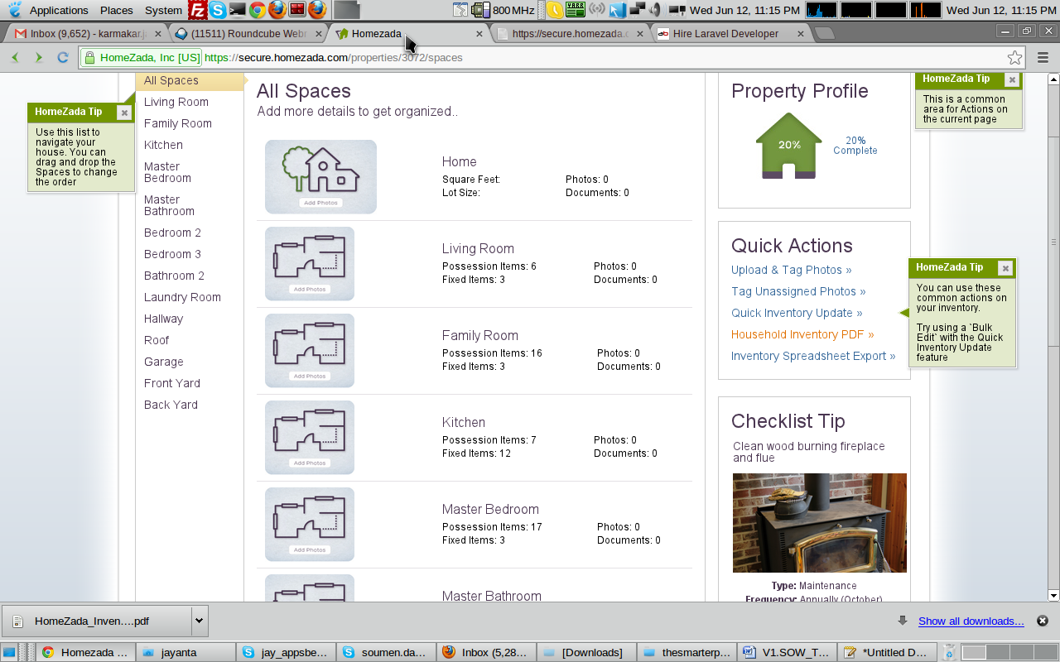

**To-dos**

* Todo dashboard – that will consists of all type of to-dos. For example maintenance > “Check the fireplace dumper is working”, “Inspect grading around the house” etc.
* 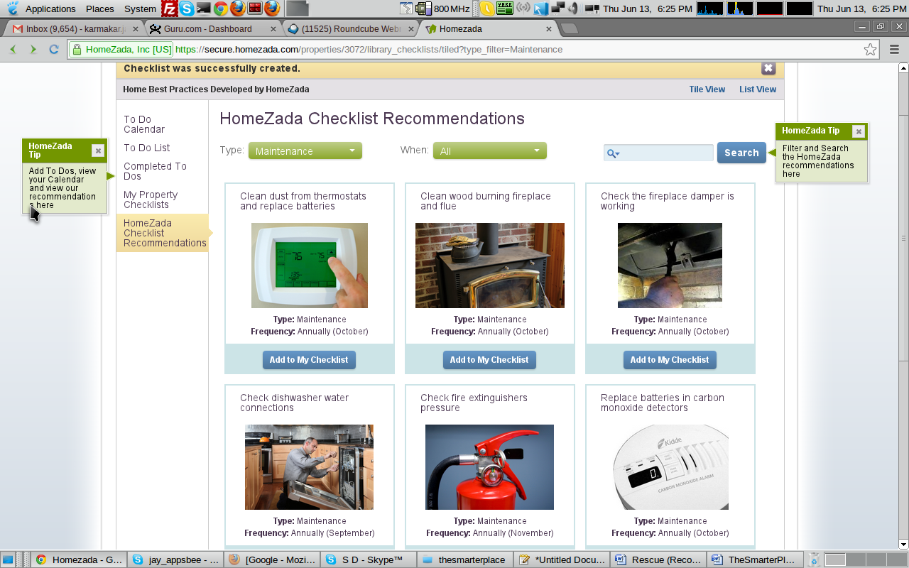
* We can add todos either from calendar or by clicking on add to my checklist.
* 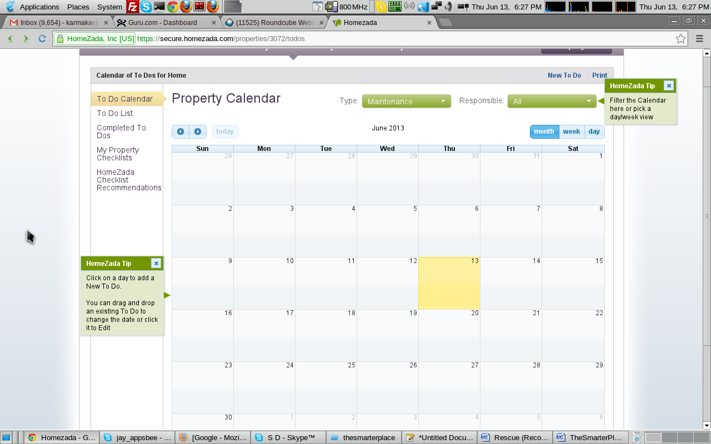
* The to-do list will show the to-dos I enter.
* 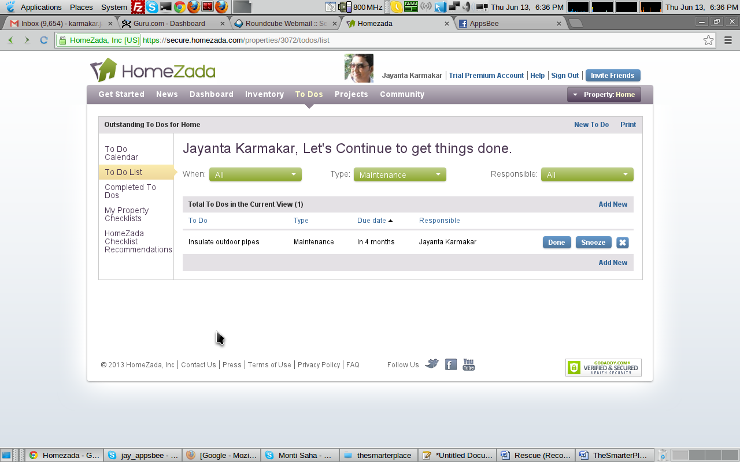

**Sprint 04:**

Projects

* Choose a type of project you are intending to do or already started. Those types are coming from backend or from pinterest.
* 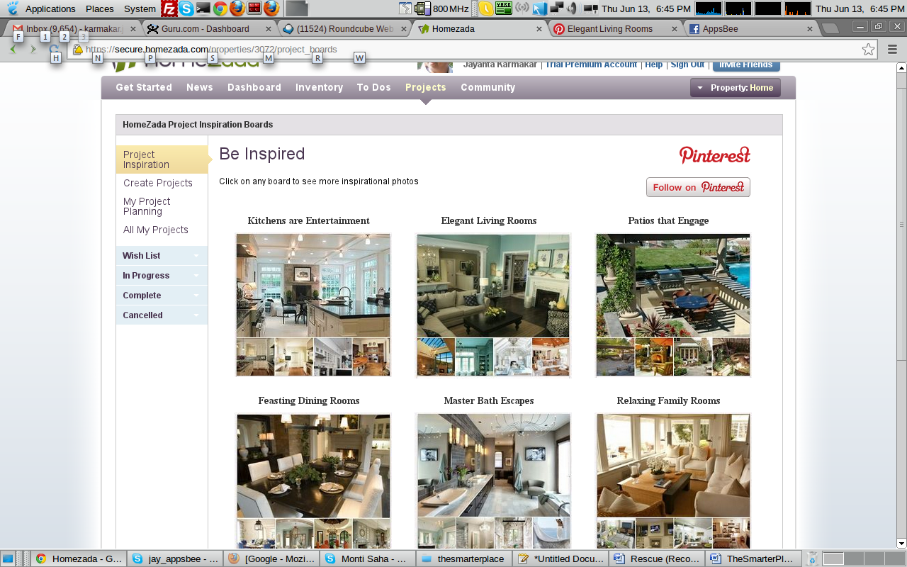
* We can create our own project and add elements to it. Plan a cost and month to month cost for the project. The following shows the item addition screen to a specific project. We can add document and picture to an item.
* 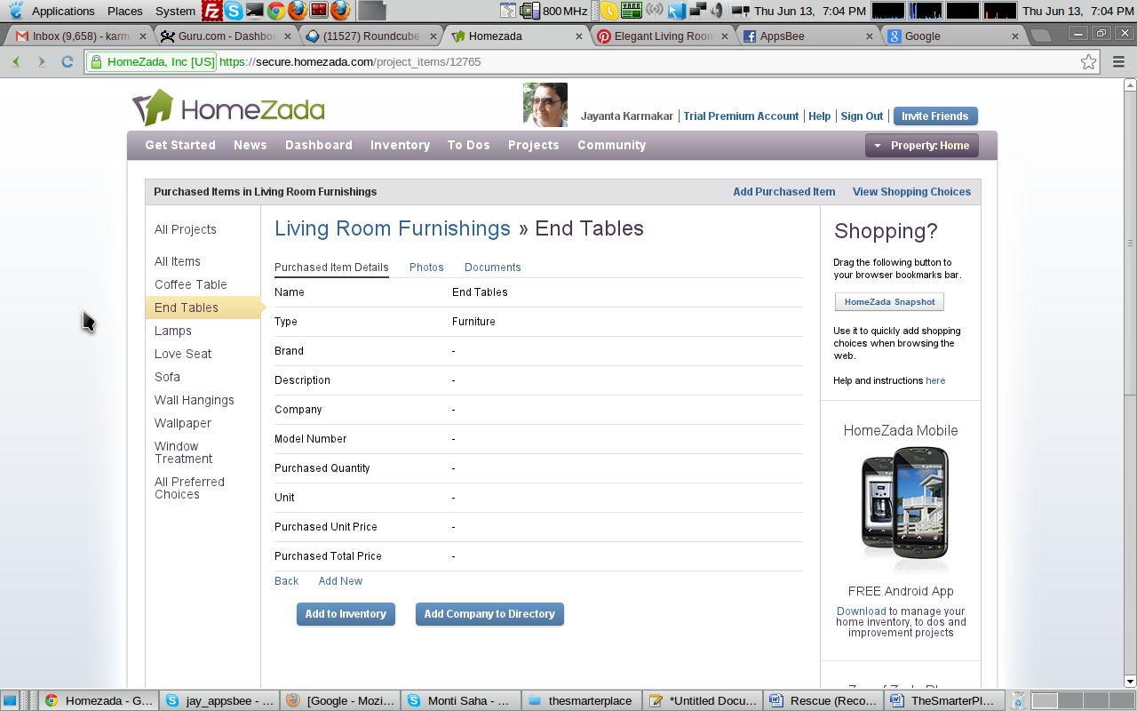
* The dashboard for project will show the items purchased, remaining to purchase, money spent, yet to spent and different representation of the chart & graph.
* People will be able to see all the list of projects and their present status from project list.
* 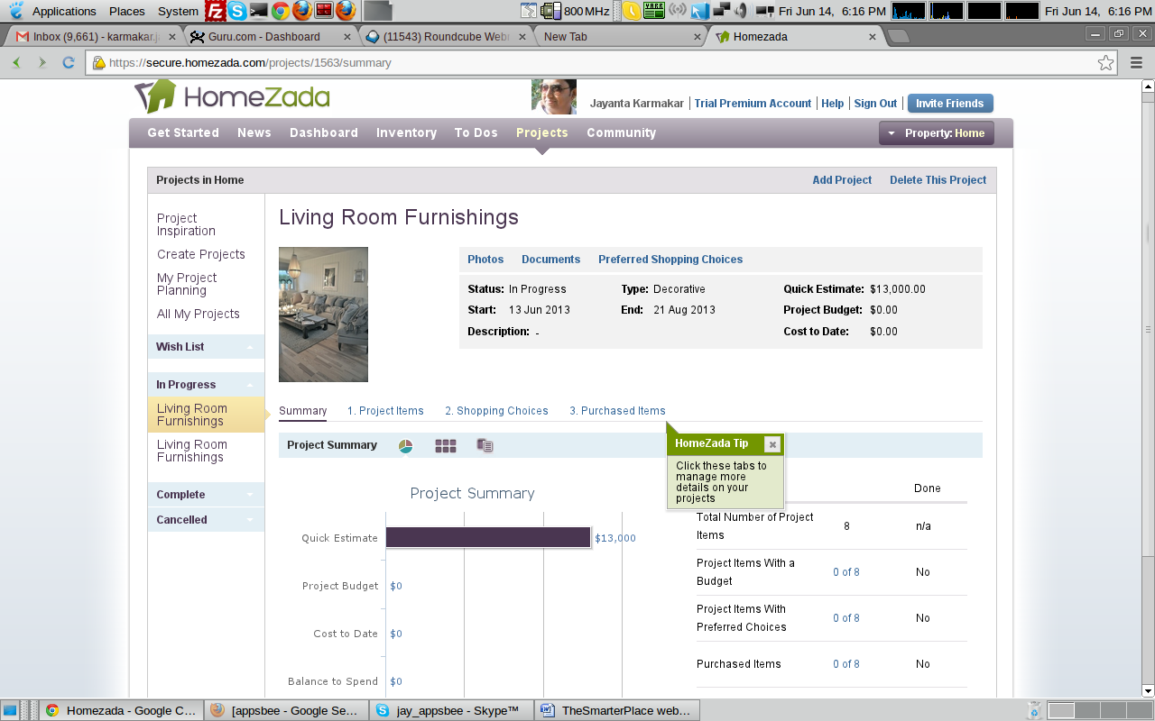
* Clicking on each of them will take back to the specific project dashboard.
* People will have the capability to delete/update projects as well.

Other Items

* Community – this will essentially function similar to the homezada.
* How it works – That will explain the functionality module by module with pictorial view/presentation.
* About us and other static pages.

Sprint 05

Build mobile app of the whole application. The app will have all features of the web plus capacity to scan documents and take picture of the items, push them to the relevant folder associated with each account and feature. The app will interact with the web server via JSON. The app will show push notification for any type of alert created in the user account.

5. Testing

* Integration testing
* Stabilization of the developed modules
* Load/Stress Testing
* User Acceptance Testing for all modules

## 8.1. Project Development:

Assumption 5 days / Week

|  |  |  |
| --- | --- | --- |
| Modules present | Duration in Man days | Start Date / End Date |
| Project Start | - | 06/17/2013 |
|  |  |  |
| Sprint 01 | 7 days | TBD |
| Sprint 02 | 15 days | TBD |
| Sprint 03 | 28 days | TBD |
| Sprint 04 | 20 days | TBD |
| Sprint 05 | 30 days |  |
| Testing and bugfix | 20 days | TBD |
| Go live (server deployment) | 2 days | TBD |

Module Output: WEBSITE LIVE

**(Approx. 120 working days )**