Flow Variation:
1605066
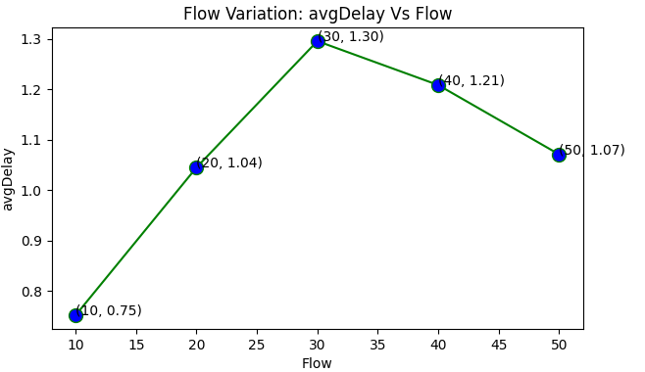
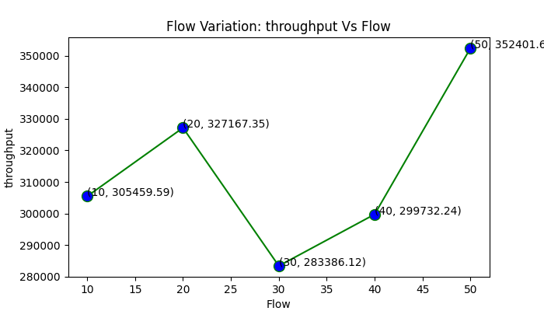
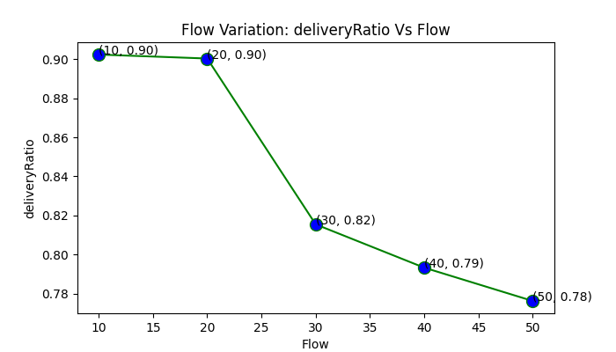
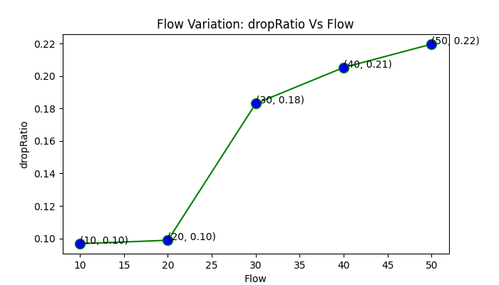

Node Variation

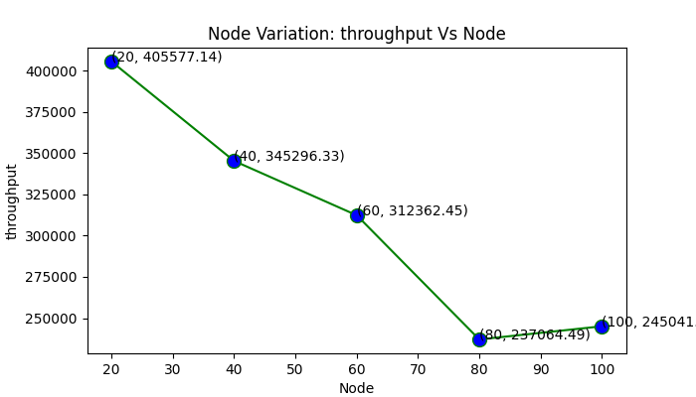
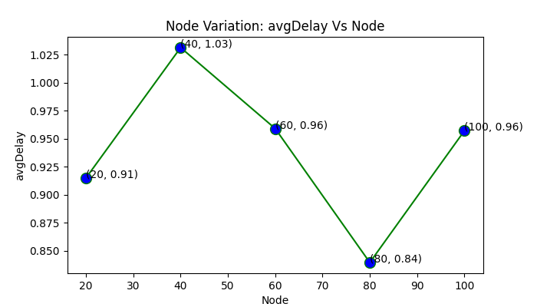
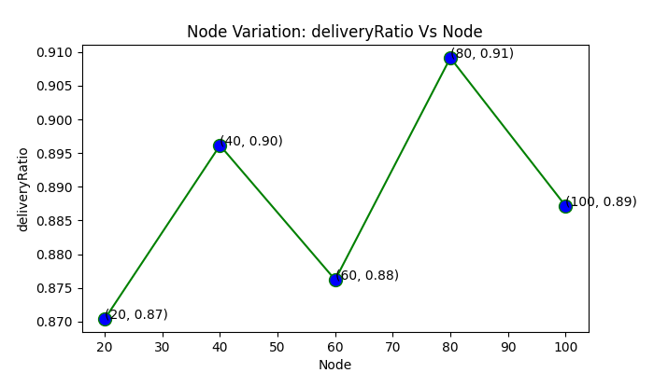
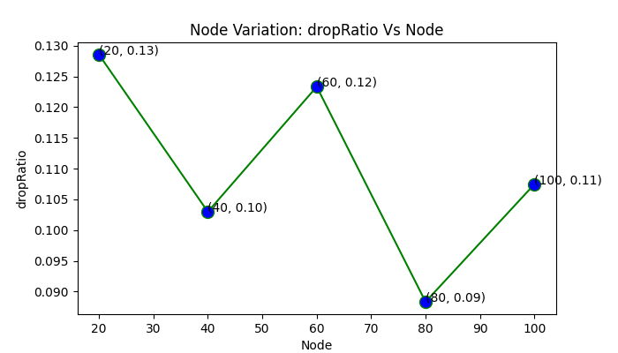
Area Variation
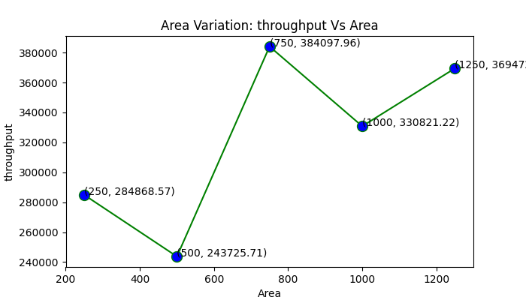
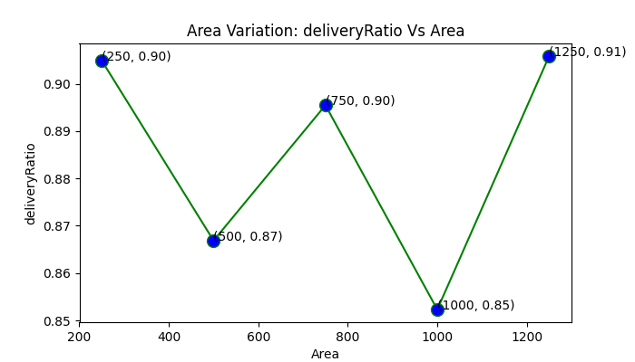
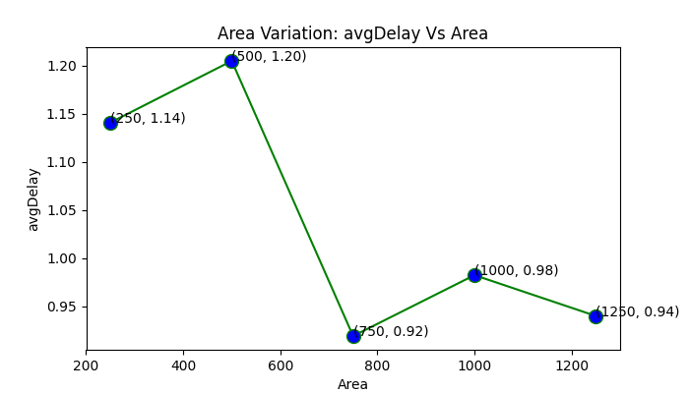
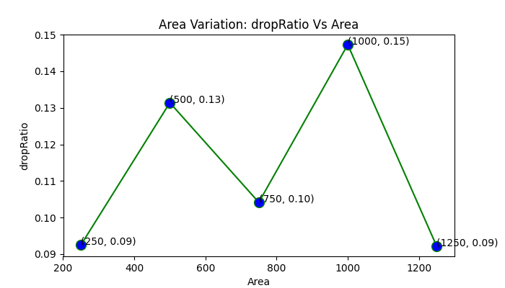
MAC type:The 802.11 family consists of a series of half-duplex over-the-air modulation techniques that use the same basic protocol. The 802.11 protocol family employs carrier-sense multiple access with collision avoidance whereby equipment listens to a channel for other users (including non 802.11 users) before transmitting each packet.
Routing protocol: AODV (Ad-hoc On-demand Distance Vector) is a loop-free routing protocol for ad-hoc networks. It is designed to be self-starting in an environment of mobile nodes, withstanding a variety of network behaviors such as node mobility, link failures and packet losses. At each node, AODV maintains a routing table. The routing table entry for a destination contains three essential fields: a next hop node, a sequence number and a hop count. All packets destined to the destination are sent to the next hop node. The sequence number acts as a form of time-stamping, and is a measure of the freshness of a route. The hop count represents the current distance to the destination node.
Agent Type: TCP Reno
Application: FTP

Observation:

Flow Variation:
- throughput increases when the flow is greater than 30
- for flow=30 avgDelay is maximum
- avg delivery ratio decreases when the flow is greater than 20
- avg drop ratio increases when the flow is greater than 20

Node Variation:
- throughput decreases gradually when number of node icreases
- For node=40 avgDelay is maximum, and continue to decrease until the number of node reaches to 80
- For node=80 delivery ratio is maximum
- or node=80 drop ratio is minimum
Area Variation:
- for area=750*750 throughput is maximum
- For area=500*500 avgDelay is maximum, and continue to decrease until the area reaches to 800*800
- For area=1250*1250 delivery ratio is maximum
- For area=1250*1250 drop ratio is minimum

