Name 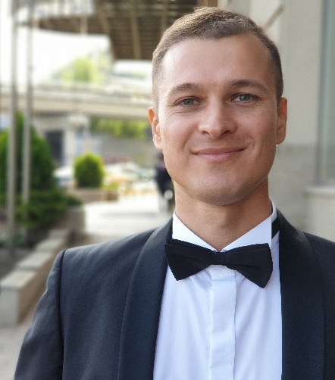 **Ziabarov Serhii**

DOB 25/02/1988

Address Kyiv, Ukraine

Phone +380636829274, +380984581540

Email [ziabarov@ukr.net](mailto:ziabarov@ukr.net)

LinkedIn [linkedin.com/in/serhii-ziabarov-a54930258](https://www.linkedin.com/in/serhii-ziabarov-a54930258?lipi=urn%3Ali%3Apage%3Ad_flagship3_profile_view_base_contact_details%3BJNNoATuPSdG5EurpO7MDCg%3D%3D)

**DESIRED POSITION**

Junior Test Engineer.

**SUMMARY**

I want to develop in the field of IT technologies. I take responsibility for tasks, I like to communicate with team members, and I learn new things with enthusiasm. In addition, I am an optimistic and kind person.

**TECHNICAL SKILLS**

**RDBMS/Database servers**

* SQL Server
* My SQL

**Operating Systems**

* Microsoft Windows XP/7/8/10
* MacOS

**Tools and Technologies**

* Jira
* Fiddler Classic/Fiddler Everywhere
* HTML/CSS
* Technical Documentation
* XML
* JSON
* Git
* SourceTree
* Jenkins
* Selenium IDE
* Rest API
* Postman

**CAREER HISTORY**

**Company, Position,**

**Period Responsibilities OS, Tools**

OBG Search for personnel for customers. Windows

**Recruiter** Communication with clients. Facebook

Since September 2019 Assistance in the adaptation of employees. Telegram

Promo Group Search for clients for cooperation with our company. Windows

**Account Manager** Communication with customers. Microsoft

September 2016 – Office

July 2019

**EDUCATION**

2007 - 2012 Ukrainian State University of Chemical Technology

**Faculty of Economics, Enterprise Economics**

**LANGUAGES**

**English** – Intermediate.

**INTERESTS**

Swimming, cycling, writing poetry, football, hiking, yoga.