**CONFIDENTIAL**

**[Your company name here]**

*Your tagline*

**Business Plan**

Prepared [date]

**Contact Information**

Jane Smith

[jane@yourcompany.com](mailto:jane@yourcompany.com)

111-222-3333

[www.yourcompany.com](http://www.yourcompany.com/)

1234 Main St.

Anywhere, OR 12345, USA

**Your Business Name Here**

**Table of Contents**

Executive Summary 1

Opportunity 1

Expectations 1

Opportunity 3

Problem & Solution 3

Target Market 3

Competition 3

Execution 4

Marketing & Sales 4

Operations 4

Milestones & Metrics 5

Company 6

Overview 6

Team 6

Financial Plan 7

Forecast 7

Financing 9

Statements 10

i

**CONFIDENTIAL - DO NOT DISSEMINATE**. This business plan contains confidential, trade-secret information and is shared only with the understanding that you will not share its contents or ideas with third parties without the express written consent of the plan author.

Your Business Name Here



**Executive Summary**

**Opportunity**

**Problem Summary**

INSTRUCTIONS: Describe very briefly why your business needs to exist. What problem do you solve for your customers?

**Solution Summary**

INSTRUCTIONS: Briefly summarize what your company does. The executive summary should be very short and you can go into more detail later in the plan.

**Market**

INSTRUCTIONS: Describe your target customer or market segments. Again, keep things very brief in the executive summary and add more detail later in the plan.

**Competition**

INSTRUCTIONS: Summarize your key competition. Who will your customers also consider?

**Why Us?**

INSTRUCTIONS: Write a brief overview of you and your team. Why are you the right people to build this business?

**Expectations**

**Forecast**

INSTRUCTIONS: Write a brief overview of your financial targets. How much do you plan to sell in the next year? What are your long-term sales goals?

1

**CONFIDENTIAL - DO NOT DISSEMINATE**. This business plan contains confidential, trade-secret information and is shared only with the understanding that you will not share its contents or ideas with third parties without the express written consent of the plan author.

Your Business Name Here

**Financial Highlights by Year**

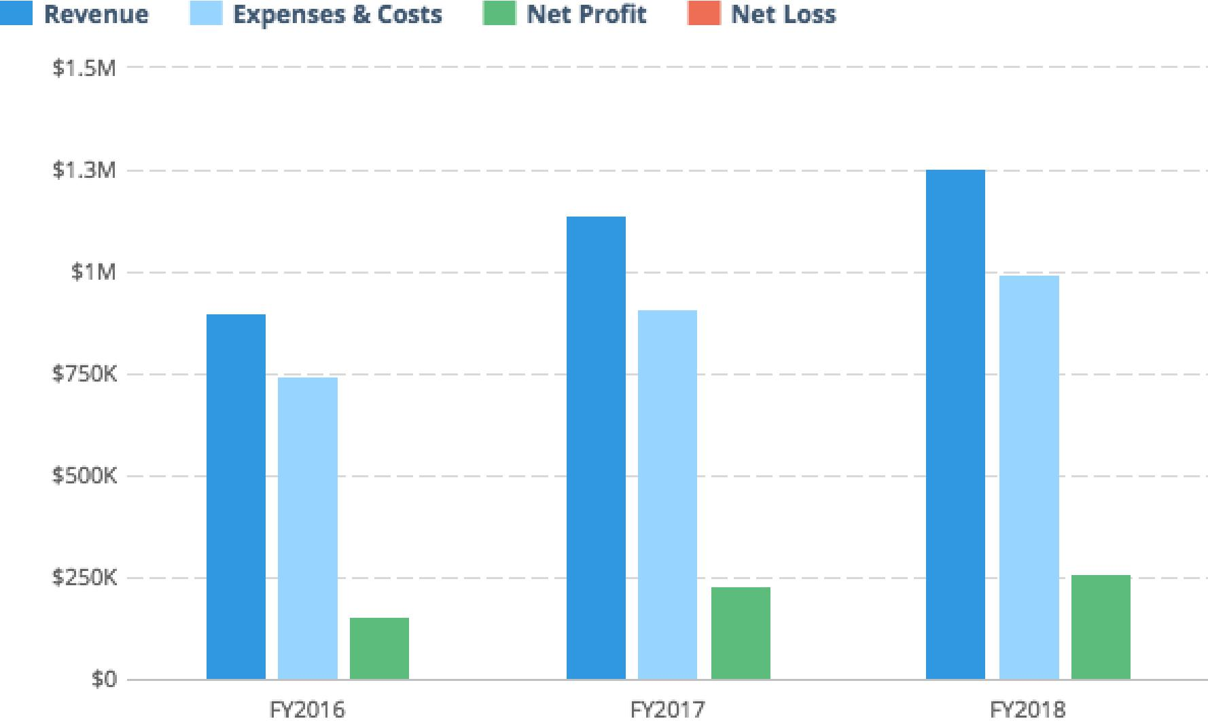

INSTRUCTIONS: Insert a chart of your key financial metrics here. Tools like [LivePlan](http://pln.rs/48) will do this for you automatically.

**Financing Needed**

INSTRUCTIONS: If you are writing a business plan to raise money for your business, include a brief summary of what you are looking for. If you aren’t raising money or getting a loan, you can delete this section.

2



**CONFIDENTIAL - DO NOT DISSEMINATE**. This business plan contains confidential, trade-secret information and is shared only with the understanding that you will not share its contents or ideas with third parties without the express written consent of the plan author.

Your Business Name Here



**Opportunity**

**Problem & Solution**

**Problem Worth Solving**

INSTRUCTIONS: Write a little more detail than you provided in the Executive Summary about the problem you are solving. What do your customers need? Do they need a better product, a cheaper product, or just a store in a better location? Describe why customers will want to buy from you.

**Our Solution**

INSTRUCTIONS: Provide additional detail, beyond what you wrote in the Executive Summary, about your product or service. What is unique and special about your company that’s going to set it apart from the competition?

**Target Market**

**Market Size & Segments**

INSTRUCTIONS: Describe your key customers – who they are and what their key attributes are. If your company is targeting multiple customer groups (also called ‘segments’), describe each group here. If you can, include details about how many people are in each segment and how large the total market is.

**Competition**

**Current Alternatives**

INSTRUCTIONS: Describe your current competition. What products and services are people using instead of yours?

**Our Advantages**

INSTRUCTIONS: Explain why your product or service is better than the others. Also, be sure to describe any competitive advantages you may have, such as a patent or other unique component to your business.

3

**CONFIDENTIAL - DO NOT DISSEMINATE**. This business plan contains confidential, trade-secret information and is shared only with the understanding that you will not share its contents or ideas with third parties without the express written consent of the plan author.

Your Business Name Here



**Execution**

**Marketing & Sales**

**Marketing Plan**

INSTRUCTIONS: Explain how you plan on getting the word out about your product to your target market(s). Will you use advertising? Perhaps you are developing a content marketing strategy. Whatever your marketing plans may be, describe them here.

**Sales Plan**

INSTRUCTIONS: If your company relies on sales people to close sales deals, you need a sales plan. Your sales plan should explain how you convert people who express interest in your product or service into paying customers. If you are opening a food truck, this section is less important and you can consider removing it. However, if you are starting a sales-heavy business like enterprise software or a car dealership, then you need to document how you will nurture leads and close deals.

**Operations**

**Locations & Facilities**

INSTRUCTIONS: Describe your company’s physical locations. This might be your office, store locations, manufacturing plants, storage facilities — whatever is relevant to your business. How much space do you have available, and how well will it meet your current and future needs?

**Technology**

INSTRUCTIONS: Describe any important software, hardware, or other information technology that you use now or plan to use later to operate your business. That might include a point-of-sale system to take payments, an e-commerce engine for your website, a CRM solution for managing your pipeline, marketing tools for generating leads, and so on.

**Equipment & Tools**

INSTRUCTIONS: List any specialty equipment that you have or plan to acquire to do your work. This is an important component of the business plan for many industrial companies.

4

**CONFIDENTIAL - DO NOT DISSEMINATE**. This business plan contains confidential, trade-secret information and is shared only with the understanding that you will not share its contents or ideas with third parties without the express written consent of the plan author.

Your Business Name Here

**Milestones & Metrics**

**Milestones**

INSTRUCTIONS: List your key milestones and the dates that you hope to accomplish them by. If you’ve already accomplished key goals for your business, list them here as evidence that your business is getting traction – in other words, it’s getting positive attention from potential customers.

**Key Metrics**

INSTRUCTIONS: Explain which performance metrics are most important for understanding how your business is doing. What does success mean for you, and how will you know it when you see it?

5



**CONFIDENTIAL - DO NOT DISSEMINATE**. This business plan contains confidential, trade-secret information and is shared only with the understanding that you will not share its contents or ideas with third parties without the express written consent of the plan author.

Your Business Name Here

**Company**

**Overview**

INSTRUCTIONS: Use this area to specify who owns your company. If there are multiple owners, describe each of them and how much of an ownership stake they have. Also, identify your company’s legal structure. Is it a sole proprietorship — that is, just you working for yourself? Or a partnership, such as a limited-liability corporation (LLC) or partnership (LLP), where the profits pass through to the partners involved? Or a nonprofit organization? Or a proper S- or C-type corporation with its own tax obligations and the rest?

**Team**

**Management Team**

INSTRUCTIONS: List the members of the management team, including yourself. Describe each person’s skills and experience and what they will be doing for the company. It’s OK if you don’t have everyone for a complete management team yet. In that case, make sure to identify gaps in your team that you intend to fill over time.

**Advisors**

INSTRUCTIONS: Describe any mentors, investors, former professors, industry or subject-matter experts, knowledgeable friends or family members, small-business counselors, or others who can help you as a business owner.

6



**CONFIDENTIAL - DO NOT DISSEMINATE**. This business plan contains confidential, trade-secret information and is shared only with the understanding that you will not share its contents or ideas with third parties without the express written consent of the plan author.

Your Business Name Here



**Financial Plan**

**Forecast**

**Key Assumptions**

INSTRUCTIONS: Describe how you came up with the values in your financial forecast. Did you project your revenue based on past results, market research, your best guess at how many people who visit your store and what percentage of them might buy, or some other method? What kind of growth are you assuming? What are your key hires and notable expenses? What level of profit do you expect to generate?

**Revenue by Month**

INSTRUCTIONS: Include a chart that shows your projected revenue. A tool like [LivePlan](http://pln.rs/48) can help you create a chart like this and automatically include it in your business plan.



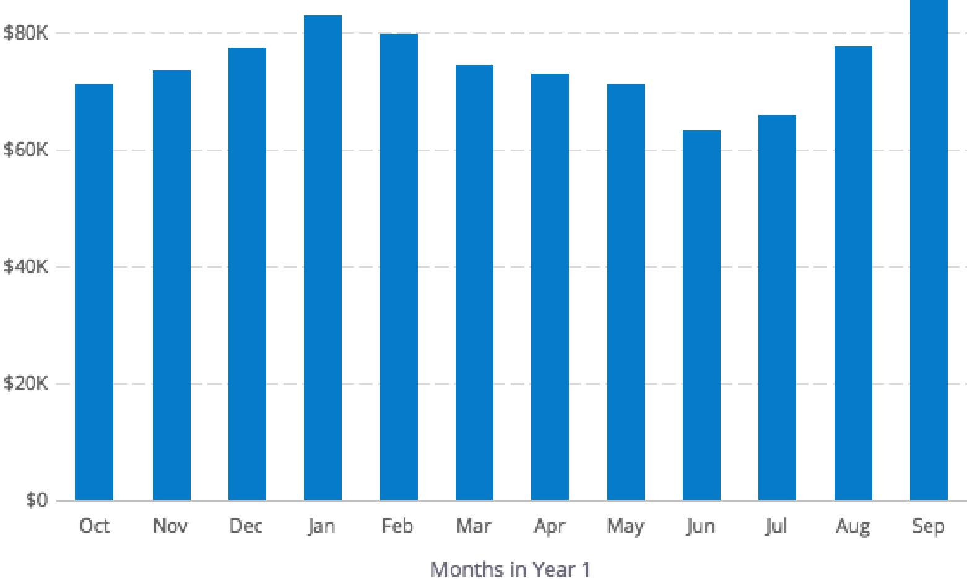

7

**CONFIDENTIAL - DO NOT DISSEMINATE**. This business plan contains confidential, trade-secret information and is shared only with the understanding that you will not share its contents or ideas with third parties without the express written consent of the plan author.

Your Business Name Here

**Expenses by Month**

INSTRUCTIONS: Include a chart that shows your projected expenses. A tool like [LivePlan](http://pln.rs/48) can help you create a chart like this and automatically include it in your business plan.

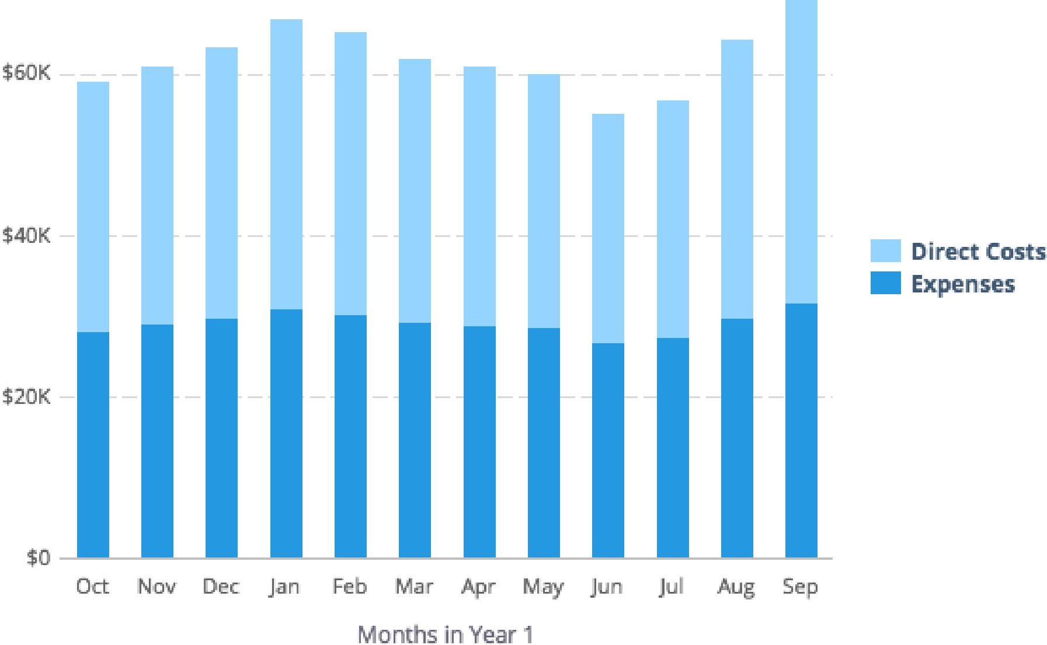



**CONFIDENTIAL - DO NOT DISSEMINATE**. This business plan contains confidential, trade-secret information and is shared only with the understanding that you will not share its contents or ideas with third parties without the express written consent of the plan author.

Your Business Name Here



**Net Profit (or Loss) by Year**

INSTRUCTIONS: Include a chart that shows your projected expenses. A tool like [LivePlan](http://pln.rs/48) can help you create a chart like this and automatically include it in your business plan.

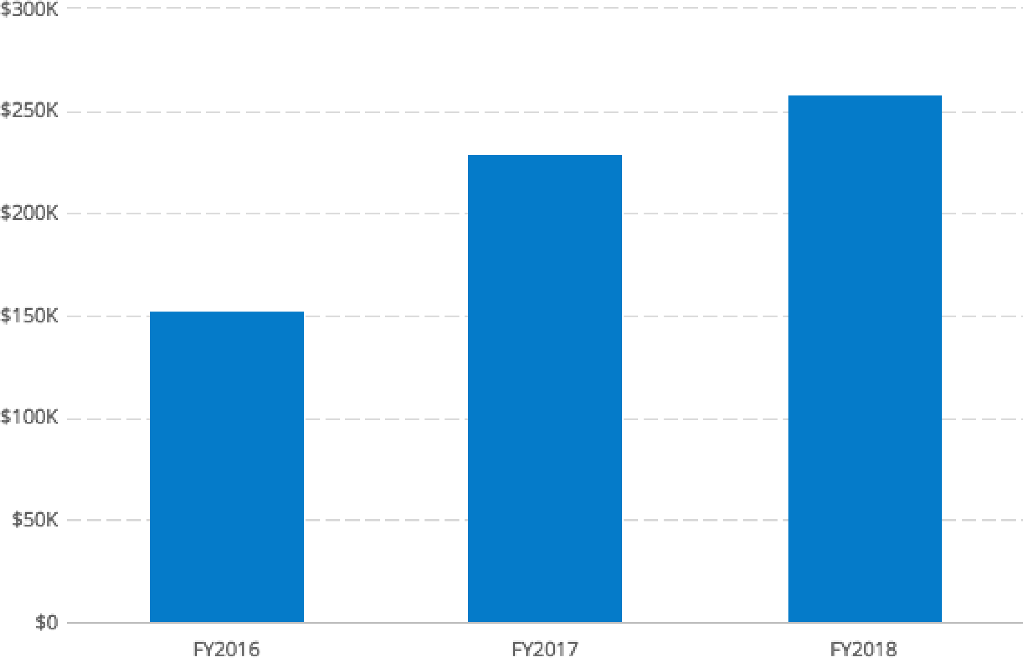

**Financing**

**Use of Funds**

INSTRUCTIONS: If your forecast includes loans, investments, or other financing, use this space to explain what you plan do with that money.

**Sources of Funds**

INSTRUCTIONS: Describe your financing plans. Are you investing your own money in the business? Do you have a credit card or line of credit? What other types of funds — personal or business loans, equity investments from others, etc. — do you expect to receive and when? If you do not have the full detail of future financing worked out yet, that is understandable. Just explain what you do know and when you expect to sort out the details.

9

**CONFIDENTIAL - DO NOT DISSEMINATE**. This business plan contains confidential, trade-secret information and is shared only with the understanding that you will not share its contents or ideas with third parties without the express written consent of the plan author.

Your Business Name Here

**Statements**

**Projected Profit & Loss**

INSTRUCTIONS: Provide a summary of your financial forecast here. You can certainly do this by yourself, but tools like [LivePlan](http://pln.rs/48) make it much easier.

**FY2018 FY2019 FY2020**

**Revenue**

**Direct Costs**

Gross Margin   
**Gross Margin %**

**Operating Expenses**

Salary

Employee Related Expenses

**Total Operating Expenses**

**Operating Income**

Interest Incurred

Depreciation and Amortization

Income Taxes

**Total Expenses**

**Net Profit**

**Net Profit / Sales**

10



**CONFIDENTIAL - DO NOT DISSEMINATE**. This business plan contains confidential, trade-secret information and is shared only with the understanding that you will not share its contents or ideas with third parties without the express written consent of the plan author.

Your Business Name Here



**Projected Balance Sheet**

INSTRUCTIONS: Include your balance sheet here.

**FY2018 FY2019 FY2020**

Cash

Accounts Receivable

Inventory

Other Current Assets

**Total Current Assets**

Long-Term Assets

Accumulated Depreciation   
**Total Long-Term Assets**

**Total Assets**

Accounts Payable

Income Taxes Payable

Sales Taxes Payable

Short-Term Debt

Prepaid Revenue

**Total Current Liabilities**

Long-Term Debt

**Total Liabilities**

Paid-in Capital

Retained Earnings

Earnings

**Total Owner's Equity**

**Total Liabilities & Equity**

11

**CONFIDENTIAL - DO NOT DISSEMINATE**. This business plan contains confidential, trade-secret information and is shared only with the understanding that you will not share its contents or ideas with third parties without the express written consent of the plan author.

Your Business Name Here

**Projected Cash Flow Statement**

INSTRUCTIONS: Include your cash flow statement here.

**FY2018 FY2019 FY2020**

**Net Cash Flow from Operations**Net Profit

Depreciation and Amortization   
Change in Accounts Receivable   
Change in Inventory

Change in Accounts Payable   
Change in Income Tax Payable   
Change in Sales Tax Payable   
Change in Prepaid Revenue

**Net Cash Flow from Operations**

**Investing & Financing**Assets Purchased or Sold   
Investments Received   
Change in Long-Term Debt   
Change in Short-Term Debt   
Dividends & Distributions

**Net Cash Flow from Investing &   
Financing**

Cash at Beginning of Period

Net Change in Cash

**Cash at End of Period**

12



**CONFIDENTIAL - DO NOT DISSEMINATE**. This business plan contains confidential, trade-secret information and is shared only with the understanding that you will not share its contents or ideas with third parties without the express written consent of the plan author.

Your Business Name Here

**Appendix**

**Profit and Loss Statement (With Monthly Detail)**

**FY2018 Mar '17 Apr '17 May '17 Jun '17 Jul '17 Aug '17 Sep '17 Oct '17 Nov '17 Dec '17 Jan '18 Feb '18**

13



**Revenue**

**Direct Costs**

Gross Margin **Gross Margin %**

**Operating Expenses**

Salary

Employee Related Expenses

**Total Operating Expenses**

**Operating Income**

Interest Incurred

Depreciation and Amortization

Income Taxes **Total Expenses Net Profit**

**Net Profit / Sales**

**CONFIDENTIAL - DO NOT DISSEMINATE**. This business plan contains confidential, trade-secret information and is shared only with the understanding that you will not share its contents or ideas with third parties without the express written consent of the plan author.

Your Business Name Here

**Profit and Loss Statement (Annual Detail)**

**FY2018 FY2019 FY2020**

**Revenue**

**Direct Costs**

Gross Margin   
**Gross Margin %**

**Operating Expenses**Salary

Employee Related Expenses   
**Total Operating Expenses**

**Operating Income**

Interest Incurred

Depreciation and Amortization

Income Taxes

**Total Expenses**

**Net Profit**

**Net Profit / Sales**

14

**CONFIDENTIAL - DO NOT DISSEMINATE**. This business plan contains confidential, trade-secret information and is shared only with the understanding that you will not share its contents or ideas with third parties without the express written consent of the plan author.

Your Business Name Here

**Balance Sheet (With Monthly Detail)**

**Mar**

**FY2018 Apr '17 May '17 Jun '17 Jul '17 Aug '17 Sep '17 Oct '17 Nov '17 Dec '17 Jan '18 Feb '18**

**'17**

Cash

Accounts Receivable

Inventory

Other Current Assets

**Total Current Assets**

Long-Term Assets

Accumulated Depreciation   
**Total Long-Term Assets**

**Total Assets**

Accounts Payable

Income Taxes Payable

Sales Taxes Payable

Short-Term Debt

Prepaid Revenue

**Total Current Liabilities**

Long-Term Debt

**Total Liabilities**

Paid-in Capital   
Retained Earnings   
Earnings

**Total Owner's Equity**

**Total Liabilities & Equity**

15

**CONFIDENTIAL - DO NOT DISSEMINATE**. This business plan contains confidential, trade-secret information and is shared only with the understanding that you will not share its contents or ideas with third parties without the express written consent of the plan author.

Your Business Name Here

**Balance Sheet (Annual Detail)**

**FY2018 FY2019 FY2020**

Cash

Accounts Receivable

Inventory

Other Current Assets

**Total Current Assets**

Long-Term Assets

Accumulated Depreciation   
**Total Long-Term Assets**

**Total Assets**

Accounts Payable

Income Taxes Payable

Sales Taxes Payable

Short-Term Debt

Prepaid Revenue

**Total Current Liabilities**

Long-Term Debt

**Total Liabilities**

Paid-in Capital   
Retained Earnings   
Earnings

**Total Owner's Equity**

**Total Liabilities & Equity**

16

**CONFIDENTIAL - DO NOT DISSEMINATE**. This business plan contains confidential, trade-secret information and is shared only with the understanding that you will not share its contents or ideas with third parties without the express written consent of the plan author.