**Post Lab Question Answer**

Answer to question no 6(a-1):

#include <stdio.h>

int main()

{

int average, sum = 0, i, x, age[100];

printf("\nenter age of 10 sudents: ");

for (i = 0; i < 10; i++)

{

scanf("%d", &age[i]);

sum = sum + age[i];

}

average = sum / 10;

printf("average age of students: = %d\n",average);

return 0;

}

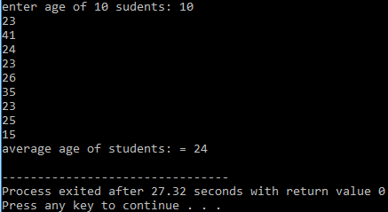

#include <stdio.h>

int main()

{

int average, sum = 0, i, x, age[100];

printf("\nenter age of 10 sudents: ");

for (i = 0; i < 10; i++)

{

scanf("%d", &age[i]);

sum = sum + age[i];

}

average = sum / 10;

printf("average age of students: = %d\n",average);

printf("Enter a specific age: ");

scanf("%d",&x);

for (i = 0; i < 10; i++)

{

if(x==age[i])

{

printf("age matched in the array");

break;

}

else if(i==9)

printf("age does not matched in the array");

}

return 0;

}

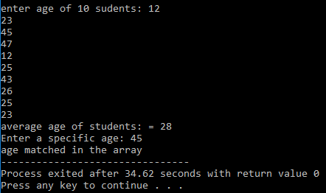

Answer to question no 6(a-2):

I faced problem in the second part of the program to match a data from the array. I have to use a condition not to match in the array. If I do not use it in the program my output ’’age does not match in the array” print many times.

Answer to question no 6(b-1):

#include<bits/stdc++.h>

#include<conio.h>

int main()

{

char sub[5], subjects[][10] = { "C", "DS", "EC", "JAVA"} ;

int n,i,j,a;

for(i=0; i < 4; i++)

{

printf("\n%s",subjects[i]);

}

printf("\nEnter any(char type) value: ");

for(j=0; j<1; j++)

{

scanf("%s",sub);

n=strlen(sub);

}

a=0;

for(j=0; j<4; j++)

{

for(i=0; i<n; i++)

{

if(sub[i]==subjects[j][i])

a++;

}

if(a==n)

{

printf("\n\n matched");

break;

}

}

if(a>n || a<n)

printf("not matched");

}

