Analytical Models to Determine Desirable Blood Acquisition Rates

Rajendra V. Boppana¹ and Suresh Chalasani²
¹Computer Science Dept., University of Texas at San Antonio, San Antonio, TX, USA
²School of Business & Technology, University of Wisconsin−Parkside, Kenosha, WI, USA
boppana@cs.utsa.edu, chalasan@uwp.edu

Abstract – We consider the problem of strategic planning for availability of blood and related products in the event of a national emergency. We apply the well-known Markov models to determine suitable rates of blood acquisition so as to minimize the amount of blood collected and processed and also to minimize wastage due to short life-time of some blood products. Though there has been extensive work on efficient supply and distribution of blood products in normal circumstances, strategic planning to cope up with shortages during emergencies has not been addressed. As an example of the proposed model, we show how to determine minimum blood acquisition rates that meet a given availability level and how to trade off acquisition rates and maximum amount of blood stored.
Keywords: Blood Distribution, Blood Banks, Healthcare System of Systems, Markov Models, and strategic planning.

Introduction
Blood banks and the associated hospitals can be thought of as a healthcare system of systems (SoS) based on the commonly used definitions of such systems [5], [6]. Blood centers or blood banks store blood in different forms: whole blood, blood plasma, platelets, etc. Fifty percent of the blood in blood banks is collected by the Red Cross. Each state has several blood banks. Several products derived from blood have short life times ranging from one week (platelets) to four weeks (whole blood); some other products such as plasma can be preserved indefinitely. Owing to the critical need for blood and the related products, an extensive system involving inter-regional and regional blood banks and local hospitals has been developed to facilitate blood acquisition, storage and distribution [1], [2], [3], [4].
In this paper, we discuss the problem of modeling the availability of blood as a general continuous-time Markov chain [7], [8]. Based on this, we propose the simpler M/M/1/k queuing model to study the desirable rate of acquisition as a function of consumption, minimum amount that must be made available, and maximum storage capacity for blood. Using this model, we present an example of determining acquisition rates for various maximum storage capacities for a specified availability level. Though there have several studies on blood supply and distribution, they are primarily focused on managing daily demand and consumption at hospitals and blood banks. To the best of our knowledge, there have been no studies on planning and determining suitable acquisition and storage levels to meet an unexpected high demand due to emergency. The analytical models proposed in literature are too fine-grain for national or inter-regional planning. We believe that the coarse-grain model proposed in this paper will be useful in this regard.
The rest of the paper is organized as follows. Section 2 presents a literature survey of existing work on blood acquisition and distribution. Section 3 describes the system of systems design in blood supply management. Section 4 presents a model for balancing the blood supply in anticipation of an emergency event. Section 5 concludes this paper.

Related work
Many aspects of blood supply, cost and availability have been extensively studied in literature. Several studies indicate that the cost of blood and related products is very high. Glengaard et al. estimate that the societal cost of blood transfusion in Sweden can be as high as 373 euros [9]. Kemper et al. [10] indicate that the cost of blood acquisition in 1993-94 is approximately $429 per unit of blood. In addition to being expensive, blood is a critical product used in health care, and many of the products derived from are perishable. Therefore, inventory management of blood and its products have been extensively investigated in literature. In particular, the previous studies on blood supply and distribution are primarily focused on managing daily demand and consumption at hospitals and blood banks [1], [2].
One of the early works used computers to manage blood inventory among various hospitals [11]. Several simulation studies also examine these aspects [12], [13], [14]. Costs and benefits of redistributing unused blood are investigated in [3], [4], [15], [16]. The results on analytical models are the most relevant to our work.
Most analytical models in literature address minimization of outdating and spoilage as functions of inventory and demand, though a few models incorporate forecasting blood acquisition at regional level. Pegels and Jelmert study the evaluation of blood inventory policies suitable for a hospital using discrete-time Markov chains with absorbing states [22]. Frankfurter et al. describe the design of a short term blood inventory level forecasting system [20]. They use exponential function models to forecast the blood supply rates and the blood transfusion rates. Bordheim et al. study a class of inventory policies that can be applied to perishable products such as blood [18]. They use a discrete-time Markov chain model to determine such measures as probability of shortage and average units of discarded blood. Cumming et al. present a Markov chain based planning model that can predict acute shortage periods of blood at regional blood centers [19]. Chazan and Gal also address the general problem of inventory management for perishable products with blood as an example [17]. Prastacos and Brodheim present an optimization model to centrally manage and redistribute blood among blood banks subject operational constraints [15]. Nahmias presents a review of inventory management theories that are applicable to perishable products such as blood [21]. All of these models attempt to optimize the operation of a hospital or a local or regional blood bank in terms of minimizing wasted blood, reducing cost of distributing blood, or minimizing the probability of shortages. Most of them are based on discrete-time Markov chains and subdivide units of blood based on their age. No literature exists on modeling the acquisition and consumption of blood in national emergencies.

Systems view of blood supply and management
The current blood supply and management can be viewed as a healthcare system of systems (HSoS) [23]. In general, the phrase ‘system of systems’ (SoS) is widely used for describing complex systems. While, there is no single definition of system of systems, we use a few commonly used definitions to show that blood supply and management system is a SoS. Sage and Cuppan [5] require a SoS to exhibit a majority of the following five characteristics: operational & managerial independence, geographic distribution, emergent behavior, and evolutionary development. Kotov [24] defines a SoS as “large scale concurrent and distributed systems that are comprised of complex systems.” Carlock and Fenton [25] discuss enterprise system of systems engineering as being “focused on coupling traditional systems engineering activities with enterprise activities of strategic planning and investment analysis.” Luskasik [6] describes system of systems engineering as the “the integration of systems into systems of systems that ultimately contribute to evolution of the social infrastructure.”
Sage and Cuppan’s definition of system of systems applies to the blood storage and distribution systems. These systems exhibit the following characteristics.
Operational and Managerial Independence: Each individual blood bank and the associated hospital exist on their own independent of the other systems. In addition, each has its managerial independence.
Geographical Distribution: Blood banks and hospitals are inherently distributed with no central organizational structure.
Evolutionary Development: Technological and scientific advances in the healthcare arena are evolutionary. The infrastructure for hospitals and blood banks evolves with time and new discoveries.
Emergent Behavior: An example of emergent behavior is to track the availability of blood in response to an emergency event. For example, in response to a large scale terrorist attack, blood may be needed from various sources. In such cases, blood banks and associated systems may adapt to satisfy the victims’ needs — example of behavior that was not originally planned for.
Based on the above discussion, Sage and Cuppan’s definition applies to blood banks. Luskasik’s definition discusses systems of systems ultimately contributing to the evolution of the social infrastructure. This is the case for blood banks and hospitals since each individual system is intricately tied to the patient population and the social infrastructure.

Modeling blood supply
The cost of acquiring and purifying blood is expensive, and the life-time of blood products can be as short as a week (platelets) to three weeks (whole blood), which leads to outdating. Therefore, it is desirable that blood acquisition rates are controlled and adequate supplies are maintained. We are more interested in strategic issues relevant to an inter-regional or national blood program that deals with availability during periods of high demand. When viewed at such a level, acquisition of blood from donors, productive consumption (in transfusion), and blood lost due to spoilage and outdating may be modeled as Poisson processes with specific rates. Therefore, we use a general continuous-time Markov chain model [7], [8] for a single blood product acquisition and consumption — productive usage and losses due to outdating and spoilage. This model may be used determine suitable rate of acquisition so that anticipated demand may be met with a high probability for a given blood related product.
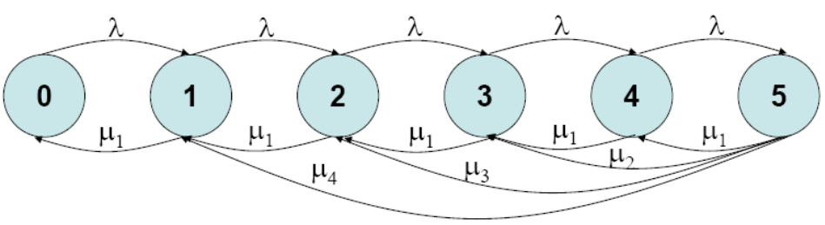
In the proposed Markov chain model, there are k+1 states, denoted S₀,…,S_{k}, where k is the maximum number of units of blood that can be stored and maintained. State S_{i} denotes that there are i units of blood available. Depending on the acquisition, consumption, or spoilage of blood, the number of available units may increase or decrease. This can be represented by transitions from one state to another. Let q_{i,j} , i≠j, denote the rate of transition (the inverse of the frequency with which it occurs) from S_{i} to S_{j}. We assume that the Markov chain is time homogenous, which means that q_{i,j} is independent of the time at which it occurs.
Figure 1. Example of Markov chain model for acquisition and consumption of blood with up to 5 units of storage. Each circle indicates a state with supply given by the number of units inside it. Acquisition during interval (0,t] is modeled by a Poisson process with parameter λt. Supply is reduced by consumption or expiration. The consumption demand is assumed to be 1 to 4 units. The rate of blood wastage is modeled as Poisson and is combined with consumption demand for 1 unit. Transitions from a state to its neighbor are indicated and, also, from state 5 to other states due to higher consumption demands are shown. The transitions from states 2, 3 and 4 due to higher consumption demands are not shown to avoid cluttering the diagram.
The number of units of blood acquired by a blood bank may be modeled as a Poisson process with a nominal rate of λ [1]. Then, q_{i,i+1} is λ, for i<k. Furthermore, q_{i,j} = 0, for j>i+1. This rate λ can be estimated based on the prior blood collection data.
The consumption of blood is dependent on the requests which could be 1, 2 or more units of blood at a time. Majority of the requests are for 2 units or less [3]. The rate of loss of units due to outdating and spoilage can be combined with the 1-unit request rate. Let μ_{i} denote the rate at which demands for i units of blood are made. Therefore, q_{j,i} = μ_{j-i}, where i<j. Based on the current consumption patterns, it is reasonable to expect that μ_{i}≅0, where i>m for some m. For a system in equilibrium, the following holds.
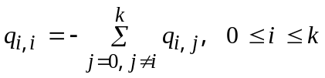
The (k+1)×(k+1) matrix Q = (q_{i,j}) denotes state transition rate matrix of the continuous-time Markov chain model. Error: Reference source not found indicates an example Markov chain with a maximum of 5 units of storage and each request for blood is four units or less.
It is easy to show that the Markov chain is finite (has a countable number of states), irreducible (any state can be reached from any state), and aperiodic (there exists a state that can be returned to in 2 or 3 steps). Therefore, the Markov chain is ergodic and limiting state probabilities exist. Let π_{i} denote the probability that the system is in state S_{i} in steady state. Then π = [π₀ π₁ … π_{k}] is the limiting state probability vector, which satisfies the following equations.
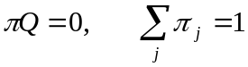
Solving these equations (possibly, using numerical methods) yields the desired limiting state probabilities. Once the limiting state probabilities are calculated, it is easy to determine the probability of shortages (defined as being in a certain state or lower numbered states) and optimal supply levels that need to be maintained. Also, we can estimate the value of λ that will maintain the supplies at optimal level with respect to cost and ability to meet anticipated demands.
Next, we provide a greatly simplified birth-death M/M/1/k queuing model [7], [8], which facilitates preliminary exploration of rates of acquisition as a function of consumption, minimum threshold and maximum available storage for a given product. Once again we assume that up to k units of blood may be stored and maintained. Acquisition of blood is modeled as a Poisson process with a nominal rate of λ. Instead of having multiple consumption levels, we assume that one unit at a time is consumed with the mean rate μ. This mean rate approximates the overall rate of consumption and wastage of blood. This is the well-known M/M/1/k queuing model — a single server with exponentially distributed service and interarrival times with finite storage. The Markov chain corresponding to this simplified model is shown in Error: Reference source not found.
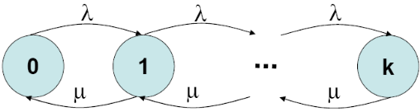
Figure 2. M/M/1/k queuing model for blood availability. Transitions are between adjacent states only. The rate of acquisition is λ and the rate of consumption including wastage is μ.
Once again the Markov chain is ergodic and limiting or steady-state probabilities exist. It can be easily shown that [8]
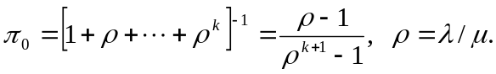
If at least m units of blood need to be kept in stock, then we can calculate the desired rate of acquisition, λ, as a multiple of consumption rate, μ. That is, we can calculate the desired ρ, which should be greater than 1 to avoid frequent shortages.
We define shortage as the case when the number of available blood units is below some threshold, m. In literature shortage is defined only for the case m=1, which represents no stock of blood. However, for strategic reasons, especially when planning at inter-regional level, it is desirable that m>1. Let P[shortage] denote the case of less than m units of blood in stock, and P[availability] = 1-P[shortage] the probability that anticipated demands will be met. They can be calculated using the following equations.
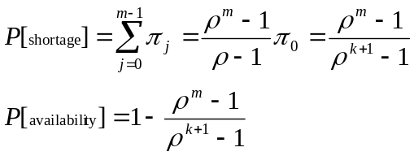
If the desired availability level is not satisfactory, the acquisition rate should be increased, since consumption rate cannot be reduced unless there is a shortage.
The graph in Figure 1 shows the probability of maintaining adequate levels of blood for various values of ρ, m and k. It is noteworthy that if the availability should be 0.99 or higher with a minimum supply level of 500, then acquisition rate has to be 105% of the consumption rate (including wastage) when maximum storage is 600 units. However, if the maximum storage is increased to 700 units, then acquisition rate can be lowered to 102.5% of consumption rate.
In a typical M/M/1/k model, where λ denote the demand for service and μ service capacity, it is desirable that ρ<1. However, in modeling the blood supply and consumption, we purposefully modeled demand λ to be supply and consumption to be capacity μ. Compared to the analytical models in literature, our model differs by using a continuous-time Markov chain and providing a rather simpler model for shortages at global level.
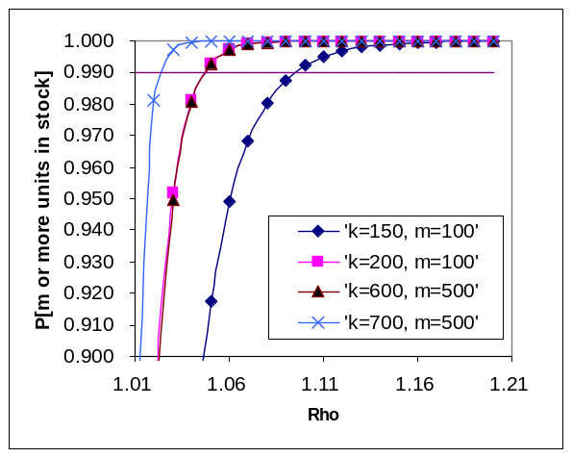
Figure 1. Probability of maintaining adequate units of blood, P[availability], for different minimum threshold levels as a function of relative acquisition rates and maximum available storage.
One shorting coming of the model is the assumption that the outdating and spoilage rates are independent of the number of units in stock. This can be easily corrected by having the consumption rate to be consisting of two parts: average productive usage rate and a variable rate that is a monotonically increasing function of number of units in stock (or the current state). In that case, the formulae given above for P[shortage] and P[availability] change, but the characteristics of the results remain the same.

Concluding remarks
The infrastructure for blood acquisition, distribution, and consumption forms an important example of healthcare system of systems. Owing to the critical needs of the blood and related products, and highly variable and unpredictable demands, various aspects of this SoS were investigated in the past. The previously studied aspects include low-cost distribution strategies, modeled as optimization problems, minimizing outdating and spoilage, minimizing shortage from a hospital's perspective, and redistributing for improved utilization of the products. However, none of the previous works investigated the issue of planning for emergency situations when the demand for blood goes up significantly. Using a continuous-time Markov model, we show how to trade-off acquisition rates and maximum storage of a given blood product for a given level of availability.
Though, the proposed model is simple, we believe that it will be useful in strategic planning for disaster relief efforts in future. Finally, the proposed model is for a single blood product. For each desired product, one such model should be developed. However, due to the dependencies among the blood products (derived from one source and keeping more of one type of product means less of another for a given level of blood availability), the interactions between different models should be investigated. We intend to do this in future.

Acknowledgment
Boppana’s research has been partially supported by NSF grants EIA-0117255 and CRI-0551501.

References
- G.P. Prastakos, “Blood Inventory Management: An Overview of Theory and Practice,” Management Science, vol. 30, no. 7, July 1984, pp. 777-800.
- B.E. Fries, “Bibliography of Operations Research in Health-Care Systems,” Operations Research, Vol. 24, No. 5, Sep.-Oct. 1976.
- S. Selin, “Inter-regional Blood Redistribution,” Summary Report, Provincial Blood Coordinating Office, Vancouver, Canada, May 1999. Online: www.bloodlink.bc.ca/images/stories/redistrpt.pdf, retrieved February 2007.
- M.C. Jacson, “Systems Methodology for the Management Sciences,” Plenum Press, New York, 1991. Chapter 8.
- Sage, A.P. and C.D. Cuppan, "On the Systems Engineering and Management of Systems of Systems and Federations of Systems," Information, Knowledge, Systems Management, Vol. 2, No. 4 (2001), pp. 325-345.
- Luskasik, S.J., "Systems, Systems of Systems, and the Education of Engineers," Artificial Intelligence for Engineering Design, Analysis, and Manufacturing, Vol. 12, No. 1 (1998), pp. 55-60.
- K.S. Trivedi, “Probability and Statistics with Reliability, Queuing and Computer Science Applications,” 2nd ed., John Wiley & Sons, New York, 2002.
- L. Kleinrock, “Queueing Systems, Volume 1: Theory,” John Wiley & Sons, New York, 1975.
- A.H. Glenngard et al., “Costs associated with blood transfusions in Sweden --- the societal cost of autologous, allogeneic and perioperative RBC transfusion,” Transfusion Medicine, 2005, Vol. 15, pp. 295–306.
- R.R. Kemper et al., “Cost analysis of intraoperative blood salvage during orthotopic liver transplantation,” Liver Transplant Surgery, 1995, 3(5):513-7.
- D. Singman et al., “Computerized Blood Bank Control,” J. of American Medical Association, vol. 194, November 1965, pp. 583-6.
- J.B. Jennings, “Blood Bank Inventory Control,” Management Science, vol. 19, no. 6, February 1973.
- M.A. Cohen and W.P. Pierskalla, “Simulation of Blood Bank Systems,” ACM SIGSIM Digest, vol. 10, no. 4, 1979, pp. 14-8.
- K. Katsaliaki and S.C. Brailsford, “Using Simulation to Improve the Blood Supply Chain,” J. Operational Research Society, vol. 58, 2007, pp. 219-27.
- G.P. Prastacos and E. Brodheim, “PBDS: A Decision Support System for Blood Management,” Management Science, Vol. 26, No. 5, May 1980.
- V. Hemmelmayr et al., “Delivery Strategies for Blood Product Supplies,” unpublished document. Online: http://www2.isye.gatech.edu/~mwps/publications/bloodVMI9.pdf, retrieved February 2007.
- D. Chazan and S. Gal, “A Markovian Model for Perishable Product Inventory,” Management Science, Vol. 23, No. 5, January 1977.
- E. Brodheim et al., “On the evaluation of a class of inventory policies for perishable products such as blood,” Management Science, Vol. 21, No. 7, July 1975.
- P.D. Cumming et al., “A Collections Planning Model for Regional Blood Suppliers: Description and Validation,” Management Science, Vol. 22, No. 9, May 1976.
- G.M. Frankfurter et al., “Management Control of Blood Through a Short-Term Supply-Demand Forecast System,” Management Science, Vol. 21, No. 4, Dec. 1974.
- S. Nahmias, “Perishable Inventory Theory: A Review,” Operations Research, Vol. 30, No. 4, Jul-Aug. 1982.
- C.C. Pegels and A.E. Jelmert, “An Evaluation of Blood Inventory Applications: A Markov Chain Model,” Operations Research, Vol. 18, 1970, pp. 1087-1098.
- N. Wickramasinghe et al., “Healthcare System of Systems,” Proceedings of the IEEE International Conference on System of Systems, April 2007.
- Kotov, V., "Systems of Systems as Communicating Structures," Hewlett Packard Computer Systems Laboratory Paper HPL-97-124, (1997), pp. 1-15.
- Carlock, P.G., and R.E. Fenton, "System of Systems (SoS) Enterprise Systems for Information-Intensive Organizations," Systems Engineering, Vol. 4, No. 4 (2001), pp. 242-261.

